**5.1 SYSTEM DESIGN**

System design is a reduction of an entire system by studying the various operations performed and their relationships within the system and the requirements of its success. One aspect of design is defining the boundaries of the system and determining whether or not the candidate system should consider other related system. System can be defined, as an orderly grouping of interdependent components can be simple or complex.

The idea of the systems has been most practical and necessary in computerizing the interrelationships and integration of operations, especially when using computers.Thus,it’s a way of thinking organizations and their problems. An organization consists of several interrelated and interlocking components.

The most creative and challenging phase of the system life cycle is system design. The term design describes a final system and the process by which it is developed. It refers to the technical specifications that will be applied in implementing the candidate system. It also includes the construction of programs and program testing.

The first step in the system design is to determine how the output is to be produced and in what format. Samples of the output and the inputs are also presented. In the second step, input data and master files are to be designed to meet requirement of the proposed output. The processing phase’s system’s objectives and complete documentation.

Finally details related to justification of the system and an estimate of the impact of the candidate system on the user and organization are documented and evaluated by management as a step towards implementation. The final report prior to the implementation phase includes procedure flow chart, record lay outs, and a workable plan for implementing the KDMS system.

System design has two phases:

* Logical
* Physical

The logical design reviews the present physical system, prepares the input and output and also prepares a logical design walk- through. We have to deal with how to take entries required and whether and how to process the user data. Also, we have to deal with how to present the data in an informative and appealing format. This design also involves the methodology to store, modify and retrieve data from the data base as per the requirement.

Physical design maps out the details of the physical system, plans the system implementation, devices a test and implementation plan and new hardware and software. We have to decide how and where to store the input data and how to process it so as to present it to the user in an easy, informative and attractive manner. A major step in the design is the preparation of input and output report in a form acceptable to the user. In this a data entry operator can feed the relevant details asked by the system for a particular task as input.

**Modules:**

1. Smart Checkout System using AI
2. Customer Classification using AI
3. Manager Module
4. Product Locator Module

**Module Description**

* **Smart Checkout System using AI**

Smart checkout system is a main part in this project where it will scan image using camera and identify product using google vision API. This module will detect and classifies multiple products including the location of each product within the camera position ie. within images captured by the camera. Other than this it will load price and assign discount price applicable if any from server API and display it automatically on the screen. Load total bill on the screen after getting confirmation from user .The final bill will get displayed and the customer can now pay bill using payment gateway/card reader. After getting confirmation from payment gateway out pass will get generated and the customer can now leave the shop. And at last, it will automatically send a copy of invoice in checking area to cross check the bill (this feature is applicable in trial run period and will remove based on accuracy).

* **Customer Classification using AI**

This module can add new customer/register with auto face image capture and register and will save the data on to the database for future purpose. Here for registering customers face detection is done using Open CV with the help of a machine learning algorithm called CNN (Convolutional Neural Network).A stored database of the customers is manipulated using image processing techniques to accomplish this task. This module will identify the fraud customers and send alerts to security personnel’s.

* **Manager Module**

Manager module is the module which can access all other modules. It can add customers, edit customer details when needed and can also view the details of customers. They can access not only customer details but also employee details ie;they can add,edit and view the details of employees.Almost all power is vested with manager module which include managers can block/unblock customers and also employees.When looking into products section there also this module can add products,edit product details,remove the products from ERP to smart checkout module.Another speciality with this module is queue management -handles the customers queue section ordering also and also can view fraud detection alerts from customer classification module.

* **Product Module**

This module handles all about productsin that particular shop.This can add products,edit and view them.This is the module which locate the misplaced products/search for the products that are missing using camera images.Locate the misplaced products using object detection API Google vision,and shows the correct product location.

* **Convolutional Neural Network (CNN)**

CNN’s were first developed and used around the 1980s. The most that a CNN could do at that time was recognize handwritten digits. It was mostly used in the postal sectors to read zip codes, pin codes, etc. The important thing to remember about any deep learning model is that it requires a large amount of data to train and also requires a lot of computing resources. This was a major drawback for CNNs at that period and hence CNNs were only limited to the postal sectors and it failed to enter the world of machine learning.

In deep learning, a **convolutional neural network** (**CNN/ConvNet**) is a class of deep neural networks, most commonly applied to analyze visual imagery. Now when we think of a neural network we think about matrix multiplications but that is not the case with ConvNet. It uses a special technique called Convolution. Now in mathematics **convolution** is a mathematical operation on two functions that produces a third function that expresses how the shape of one is modified by the other.

**5.2 Data Flow Diagram**

A data flow diagram is a graphical technique that depicts information flow and transforms that are applied as data move from input to output. The DFD is used to represent increasing information flow and functional details. A level 0 DFD also called fundamental system model represents the entire software elements as a single bible with input and output indicated by incoming and outgoing arrows respectively.

The DFD is one of the most important tools used by the system analyst. It can be used for the visualization of data processing. DFD provides a graphical representation of the flow of data through an information system. DFD illustrates how data is processed by a system in terms of inputs and outputs. It is a picture of system processing and flow without excessive concern for details.

The DFD showing the top level of the system is called “Context Diagram”. It should be overview including basic inputs, processes and outputs. Then it is exploded in to more detailed lower level diagram that shows additional features of the system.

The purpose of DFD is to provide a semantic bridge between users and system developers. The diagrams are graphical, eliminating thousands of words, logical representations, modeling what system does; hierarchical, showing system at any level of details; and Jargon less, allowing user interaction and reviewing.

Data Flow Diagrams Notations

**Process** : 

**Input/output** : 

**Flow of direction** : 

**Database/File** :

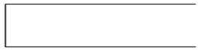

Figure 5.1 DFD Components

**5.2.1 Project DFD**

**Level 0 (Context Level):**

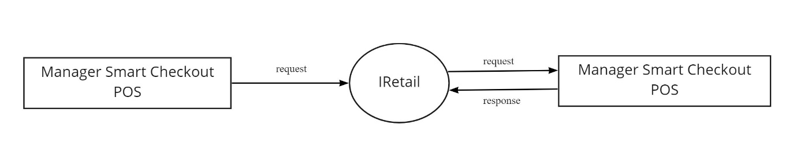

Figure 5.2 Context Diagram (Level 0)

**Level 1 :**

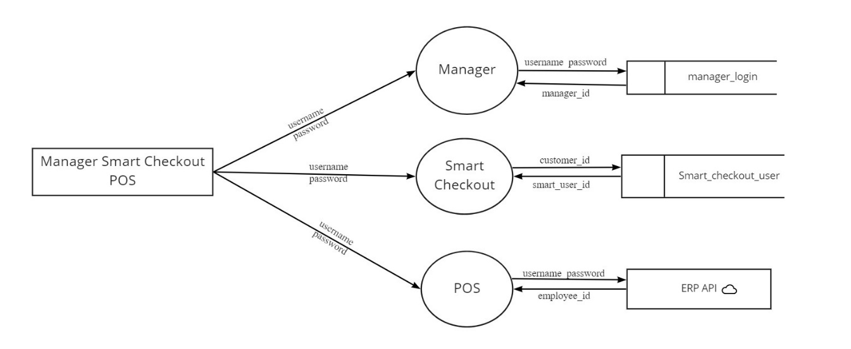

Figure 5.3 Module Description (Level 1)

**Level 1.0: Manager Module**

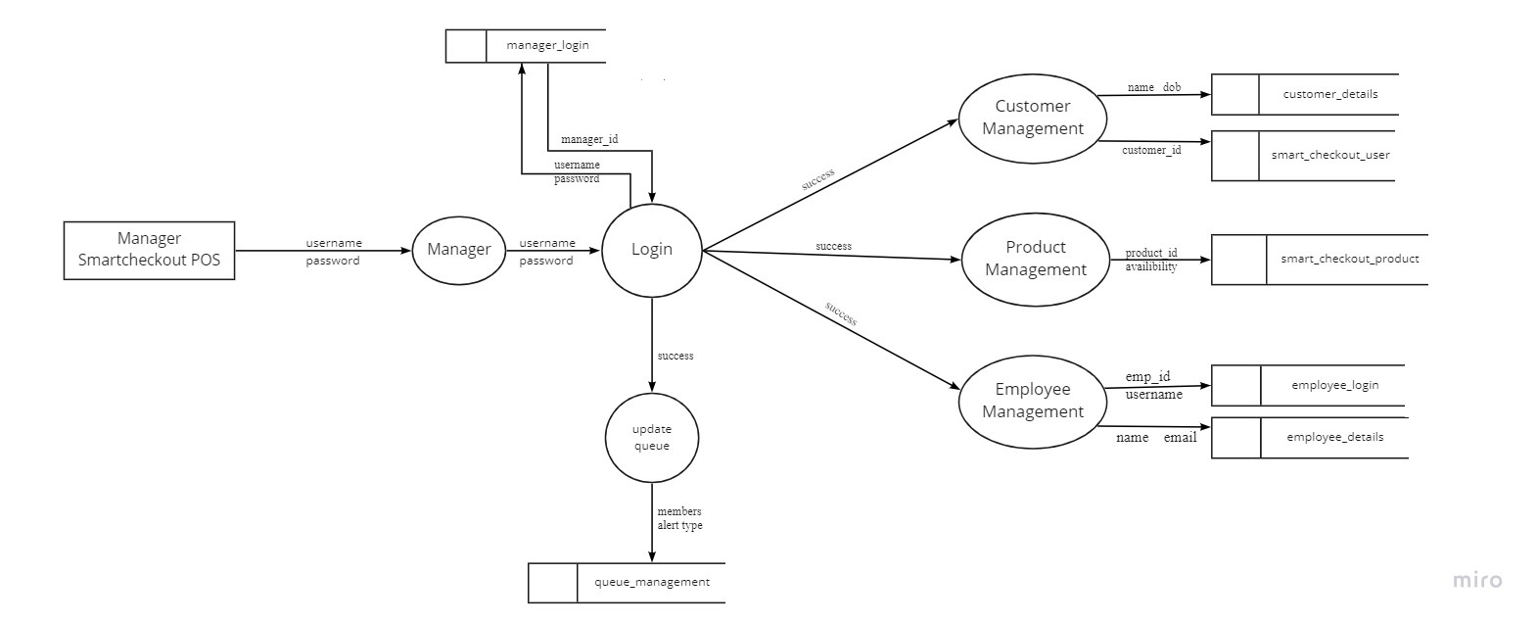

Figure 5.4 Manager Login (Level 1.0)

**Level 1.0.1: Customer Management**

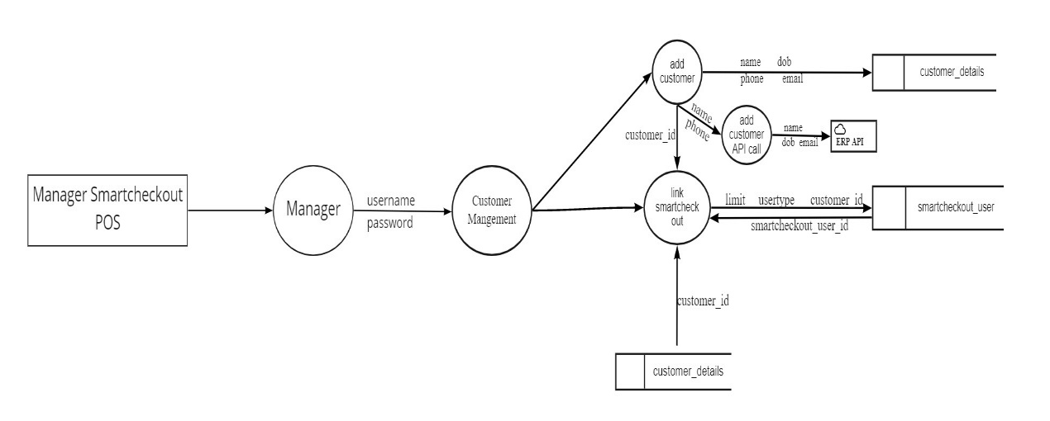

Figure 5.5 Customer Management (Level 1.0.1)

**Level 1.0.2 : Product Management**

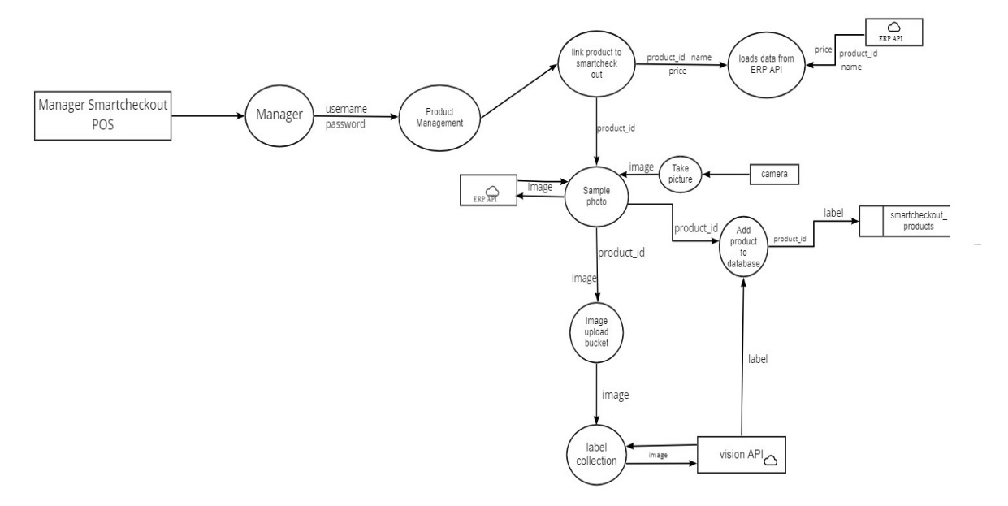

Figure 5.6 Product Management (Level 1.0.2)

**Level 1.0.3: Employee Management**

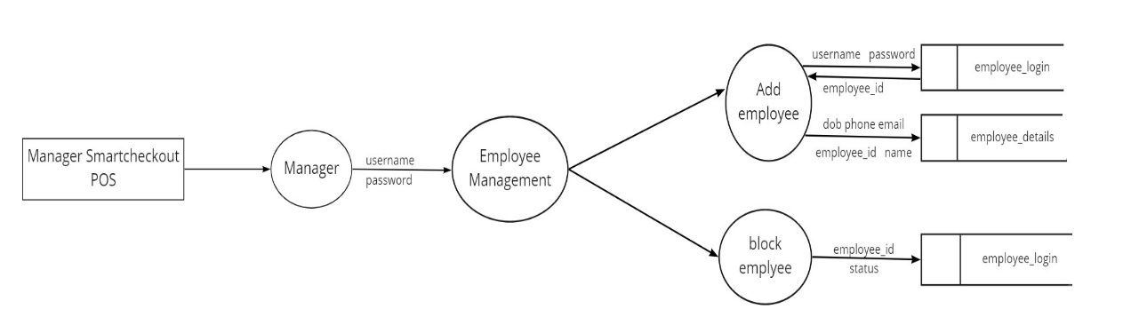

Figure 5.6 Employee Management (Level 1.0.3)

**Level 1.1: Smart Checkout**

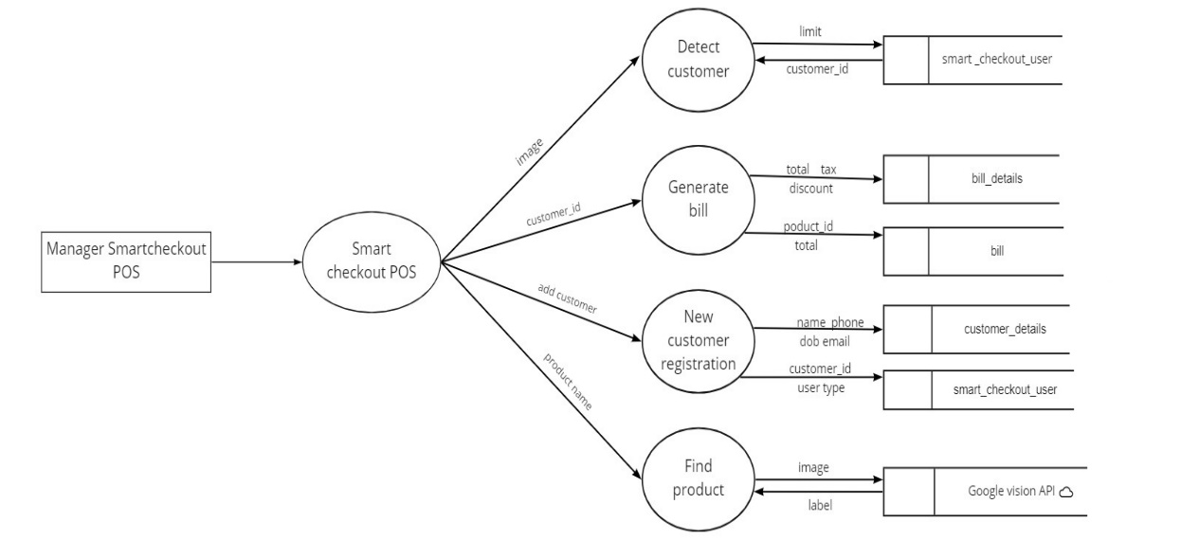

Figure 5.7 Smart Checkout (Level 1.1)

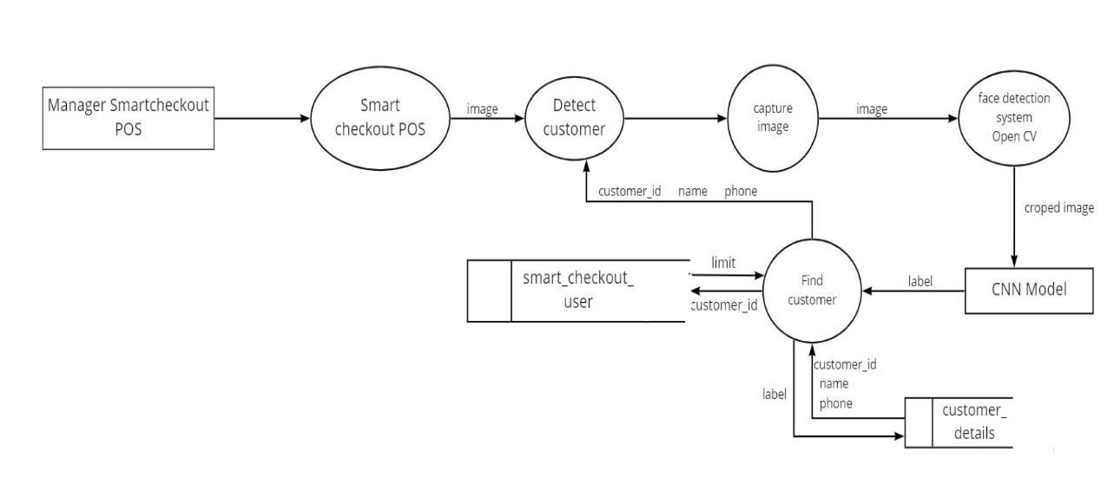

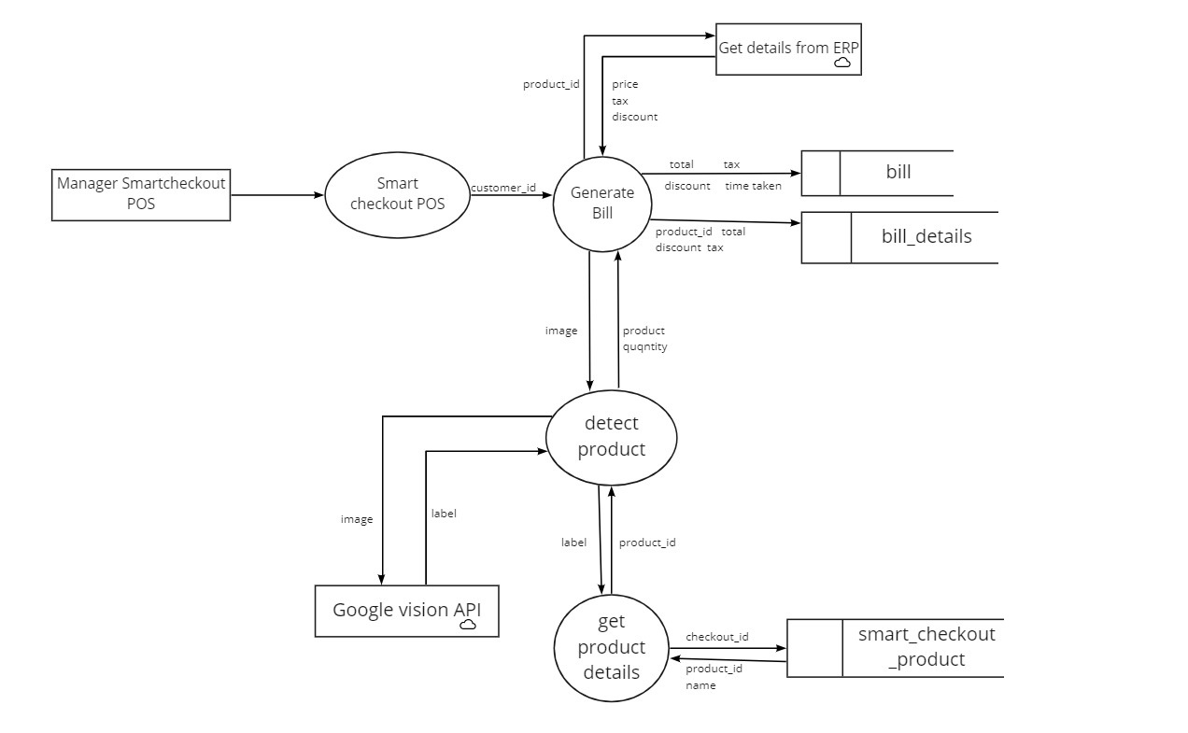

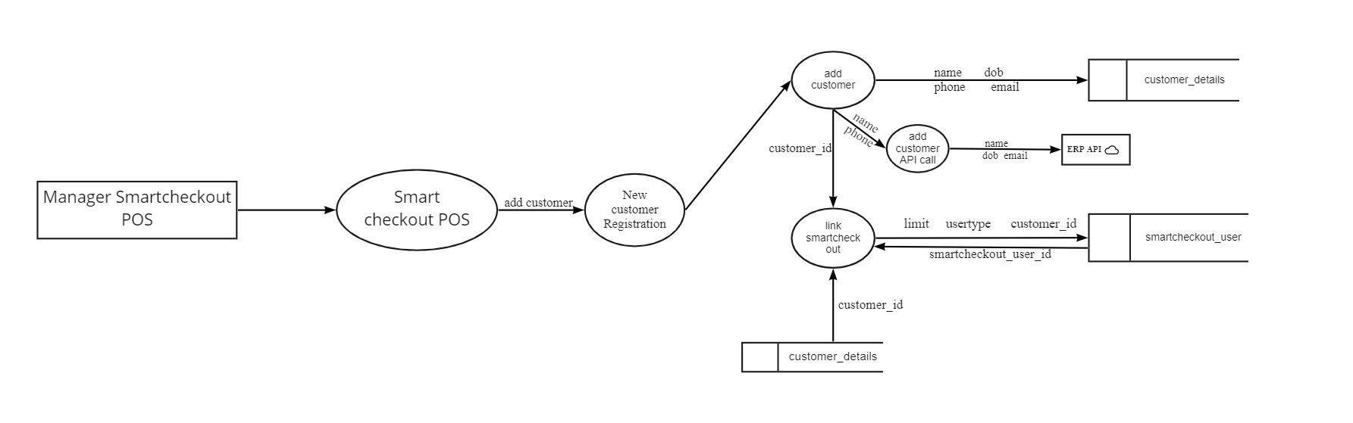

**Level 1.1.1: Find Product (Google Vision API)**

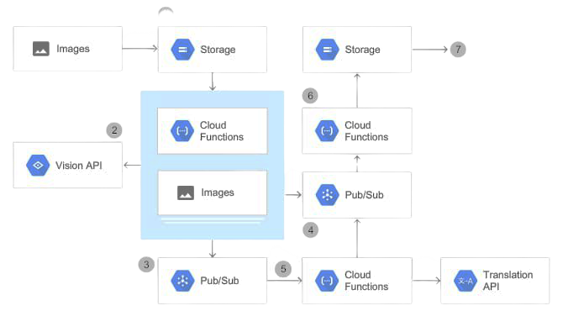

Figure 5.8 Find Product (Level 1.1.2)

**Level 1.2: POS**

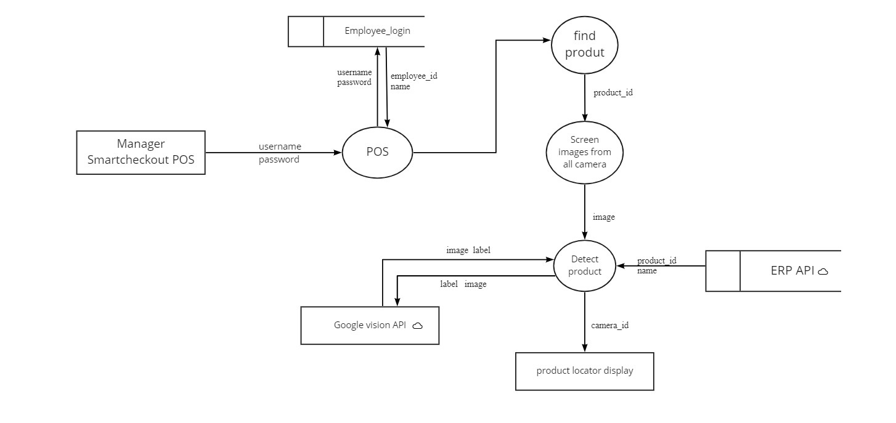

**5.3 DATABASE DESIGN**

The database design is a logical development in the methods used by the computers to access and manipulate data stored in the various parts of the computer systems. Database is defined as an integrated collection of data. The overall objective in the development of database technology has been to treat data as an organizational resource and as an integrated whole. The main objectives of databases are data integrity and data independence. A database is a collection of interrelated data stored with minimum redundancy to serve many users quickly and effectively. The database serves as the repository of data, so a well-designed database can lead to a better program structure and reduce procedural complexity. In a database environment, common data are available and used by several users Database Management System (DBMS) allow the data to be protected and organized separately from other resources like hardware, software, and programs. DBMS is a software package, which contains components that are not found other data management packages. The significant of DBMS is the separation of data as seen by the programs and data as stored on the direct access storage devices. That is the difference between the logical and physical data.

The main objectives covered in database design are:

• Controlled redundancy

• Data independence

• Accuracy and integrity

• Privacy and security

• Performance.

**Manager Login**

Table Number: 5.1

|  |  |  |  |
| --- | --- | --- | --- |
| **Table Name: Manager_login Primary Key: manager_id** | | | |
| **Description:** Details of Manager login | | | |
| **Field** | **Data Type** | **Constraint** | **Description** |
| manager_id | Integer | Primary Key | Id of manager |
| manager_username | String |  | User name of manager |
| manager_password | String |  | Password of manager |

**Queue Management**

Table Number: 5.2

|  |  |  |  |
| --- | --- | --- | --- |
| **Table Name: queue_management Primary Key: queue_id** | | | |
| **Description:** Details of Manager_login | | | |
| **Field** | **Data Type** | **Constraint** | **Description** |
| queue_id | Integer | Primary Key | Id of queue |
| queue_number | Integer |  | Number of queue |
| queue_alerttype | String |  | Alert type of queue |

**Customer Details**

Table Number: 5.3

|  |  |  |  |
| --- | --- | --- | --- |
| **Table Name: Customer_details Primary Key: customer_id** | | | |
| **Description:** Details of Customer details | | | |
| **Field** | **Data Type** | C**onstraint** | **Description** |
| customer_id | Integer | Primary Key | Id of customer |
| customer_name | String |  | Name of customer |
| customer_dob | String |  | Date of birth of customer |
| customer_phone | String |  | Phone number of customer |
| customer_email | String |  | Email id of customer |
| customer_city | String |  | City of customer |
| customer_status | Boolean |  | Status of customer |

**Smart Checkout Products**

Table Number: 5.4

|  |  |  |  |
| --- | --- | --- | --- |
| **Table Name: Smartcheckout_products Primary Key: smart_product_id** | | | |
| **Description:** Details of Smart checkout products | | | |
| **Field** | **Data Type** | C**onstraint** | **Description** |
| smart_product_id | Integer | Primary Key | Id of smart checkout product |
| product_id | Integer |  | Id of product |
| product_displayname | String |  | Display name of product |
| product_availability | Boolean |  | Availability of product |
| product_identifier | String |  | Identifier of product |

**Smart Checkout User**

Table Number: 5.5

|  |  |  |  |
| --- | --- | --- | --- |
| **Table Name: Smartcheckout_User Primary Key: smart_user** | | | |
| **Description:** Details of Smart checkout user | | | |
| **Field** | **Data Type** | C**onstraint** | **Description** |
| smart_user_id | Integer | Primary Key | Id of smart checkout user |
| smart_user_limit | Double |  | Limit of smart checkout user |
| smart_user_usertype | String |  | User type of smart checkout user |
| smart_user_customer_id | Integer | Foreign Key | Customer id of smart checkout user |
| smart_user_no_of_bills | Integer |  | Number of bills of smart checkout user |

**Employee Login**

Table Number: 5.6

|  |  |  |  |
| --- | --- | --- | --- |
| **Table Name: Employee_login Primary Key: emp_id** | | | |
| **Description:** Details of Employee login | | | |
| **Field** | **Data Type** | C**onstraint** | **Description** |
| emp_id | Integer | Primary Key | Id of employee |
| emp_username | String |  | Name of employee |
| emp_password | String |  | Password of employee |
| emp_status | Boolean |  | Status of employee |

**Employee Details**

Table Number: 5.7

|  |  |  |  |
| --- | --- | --- | --- |
| **Table Name: Employee_details Primary Key: emp_details_id** | | | |
| **Description:** Details of Employee | | | |
| **Field** | **Data Type** | C**onstraint** | **Description** |
| emp_details_id | Integer | Primary Key | Id of employee details |
| emp_id | Integer | Foreign Key | Id of employee |
| emp _name | String |  | Name of employee |
| emp _address | String |  | Address of employee |
| emp_email | String |  | Email id of employee |
| emp_phone | String |  | Phone number of employee |
| emp_dob | String |  | Date of birth of employee |

**Bill**

Table Number: 5.8

|  |  |  |  |
| --- | --- | --- | --- |
| **Table Name: bill Primary Key: bill_id** | | | |
| **Description:** Details of Bill | | | |
| **Field** | **Data Type** | C**onstraint** | **Description** |
| bill_id | Integer | Primary Key | Id of bill |
| smart_user_id | Integer | Foreign Key | User id of smart checkout |
| bill_total | Double |  | Total for the purchase |
| bill_tax | Double |  | Tax for the purchase |
| bill_discount | Double |  | Discount for the purchase |
| time_taken | Double |  | Time taken for the purchase |

**Bill Details**

Table Number: 5.9

|  |  |  |  |
| --- | --- | --- | --- |
| **Table Name: bill_details Primary Key: bill_details_id** | | | |
| **Description:** Details of Bill | | | |
| **Field** | **Data Type** | C**onstraint** | **Description** |
| bill_details_id | Integer | Primary Key | Id of bill details |
| bill_id | Integer | Foreign Key | Id of bill |
| smart_product_id | Double | Foreign Key | Id of smart checkout product |
| bill_total |  |  | Total for the purchase |
| bill_discount | Double |  | Discount for the purchase |
| bill_tax | Double |  | Tax for the purchase |
| Bill_amount | Double |  | Bill amount in the bill |

**5.4 Input Design**

Input design is the process of converting user inputs into computer-based format. The goal of designing input data is to make the data entry, logical and error free. Input data are collected and organized into groups of similar data. The project requires a set of information from the user for processing. The various factors to be considered during input designs are input data to the system, methods for performing input validation and steps to follow when error occurs, medium to use, arrangement of data etc. For providing a good input design for the application easy data input and selection features are adopted. The input design requirements such as user friendliness, consistent format and interactive dialogue for the right message and help for the user at the right time are also considered for the development of this project.

In this project all the fields are validated. If any field then error message will be displayed, so as to help the user while giving inputs. The drop-down lists are used to reduce the user inputs and to select a preferred item from the list easily. Check boxes are used for user’s category selection. User just needs to click the preferred category from the checkbox list. User will select one of the items in list boxes. The following design guidelines will result in a friendly and deficient interface. Minimize the number of input actions required from user. This can be accomplished by using the mouse to select from the predefined set of inputs. In application user can select the options.

In the project “IRetail -Smart Store with enhanced security powered by AI” the input design is done in such a way that the users of the system will never get confused or enter wrong data. The simplicity and ease of use lies in the act that the desired objectives can be accomplished with a few mouse clicks.The main objectives that are guiding as in the input stages are:

* Controlling the amount of inputs
* Avoiding inordinate delay
* Controlling errors 50
* Avoiding extra steps
* Keeping the process simple
* To achieve highest level accuracy.

**Output Design**

Output refers to the results and information that are generated by the system. Here determine information to be present, decide layout and select output medium, arrange presentation of information in accepted format of column headings and pagination are specified. Output design plays a major role in providing the user with the required format. The major function of the output is to convey information and so its layout and design are careful considerations. Information must be carefully considered to the needs of the user. Standards for printed output suggest giving each output a name or title, providing a sample of the output layout, and specifying the procedure for providing the accuracy of the output data.

The output devices to consider depends on the compatibility of the devices with the system, response time requirement and printed quality required. 27 The design output form, attention is given to proper identification and wording, readability and use, composition and layout, order of data items and clarity of instructions. A well-designed form with clarity stated captions should be self-instructing. An organizations form must be centrally controlled for efficient handling. Computer output is the most important and direct information source to the user. Output design is a process that involves designing necessary outputs in the form of reports that should be given to the users according to the requirements. Efficient, intelligible output design should improve the systems relationship with the user and help in decision making.

|  |  |  |
| --- | --- | --- |
| **Process** | **Input design** | **Output design** |
| Login page for manager | Enter user name, password | Show home page |
| Login page for smart checkout | Enter user name, password | Show home page |
| Login page for POS | Enter user name, password | Show home page |
| Add customer | Enter customer details | Customer added successfully |
| Link smart check out | Enter smart check out details | Linked successfully |
| Link product to smart check out | Select product details | Linked successfully |
| Take photo | Using camera | Show product details |
| Add employee | Enter employee details | Employee added successfully |
| Block employee | Enter employee details | Blocked successfully |
| Find customer | Enter customer details | Customer identified successfully |
| Detect product | Enter product image | Product identified successfully |

Table 5.10

###### **5.4 Program Design**

###### i. Manager

Step 1: Start

Step 2: Once logged in the manager has the privilege to manage customer, queue management, employee management, product management.

Step 3: In manager function mangers can login, update queue, monitor customers, can identify fraud customers, details about employees like login, edit their details, delete, view.

Step 4: In customer function manager can add customers, link smart checkout system, add customer API call from ERP API, capture image of customers and store their details in a dataset.

Step 5: In product function manager can link products to smart checkout, detect products, loads data from ERP-API, add products to API.

Step 6: In employee function manager can add, update, delete, block and view the employee details.

Step 7: Stop

###### ii. Smart Checkout

Step 1: Start

Step 2: Once logged in the manager has the privilege to manage billing,detect customer,new customer registration,find product.

Step 3: Smart checkout function can capture images,face detection of the customers,bill generation,find product details,detect the products at the time of billing .

Step 3: Stop

###### iii. POS

Step 1: Start

Step 2: In this function POS will find the products that are misplaced

Step 3: Stop

iv. User

Step 1: Start

Step 2: Once logged in the user can add their details and this details will be stored in the database of the shop for further classifications.

Step 3: User get their allotted queue

Step 4: User can the collect the products needed, and can generate bill by showing products to the camera.

Step 5: If any products are not clearly captured by the camera will be notified by the software.

Step 6: If step 4 repeats again and again the software will classify that customer as fraud customer. And the user can no longer use this facility.

Step 7: After users can check out after paying the bill

Step 8: Stop