Infosys Springboard Virtual Internship 7.0 Completion Report
Batch Number: 01

Start date: 29-06-2026

Internship Duration: 6 Weeks

Project Title: Talent Management Platform for Employee Performance and Career Growth

Internship Duration: 6 weeks

Project Title
Talent Management Platform for Employee Performance and Career Growth

Project Objective
The primary objective of this project is to engineer a privacy-aware, enterprise-grade AI platform designed to modernize talent management. The system architecture integrates multi-role access control, real-time performance analytics, and a sophisticated RAG (Retrieval-Augmented Generation) document search engine. Key functional pillars include automated AI exam generation, 6-day intensive study sprint orchestration, and the "Sphere" Voice AI Assistant. The platform is underpinned by a high-concurrency, lock-free SQLite WAL (Write-Ahead Logging) architecture to ensure data integrity and seamless performance under enterprise-level load.

Project Description in Detail
The platform serves as a unified ecosystem for employee development. At its core, the Document Ingestion & RAG Engine utilizes BGE-Large embeddings stored in ChromaDB to facilitate semantic search across sensitive enterprise documentation. This allows employees to query proprietary knowledge bases with high precision while maintaining data security via strict multi-role authentication protocols.
To support decision-making, the platform features a dynamic Performance Analytics Dashboard powered by Chart.js. This module visualizes KPIs and employee metrics, enabling leadership to gain actionable insights into talent performance trends. The dashboard is seamlessly integrated with the platform’s role-based access control (RBAC), ensuring sensitive data is only accessible to authorized personnel.

The AI Exam & 6-Day Study Sprint Orchestrator automates the learning cycle. By analyzing competency gaps, the system auto-generates tailored exam content and structures accelerated 6-day learning sprints. This feature provides a scalable, personalized learning path for employees, directly mapping company training goals to individual career progression.
Interaction is revolutionized by the Sphere Voice AI Assistant. This module enables hands-free navigation and querying, incorporating advanced Speech-to-Text (STT) and Text-to-Speech (TTS) capabilities. Sphere utilizes sophisticated tool calling to interface with the backend, allowing users to initiate complex actions—like scheduling a training review or querying a performance metric—using natural language.
Finally, the backend leverages FastAPI and Uvicorn ASGI to provide high-performance, asynchronous endpoints. The integration of SQLite WAL (Write-Ahead Logging) mode ensures that read and write operations do not block each other, delivering robust concurrency management essential for enterprise multi-user environments.

Timeline Overview

Week | Activities Planned | Activities Completed
Week 1 | Requirement analysis, Database schema design, Auth setup | Initialized SQLite WAL architecture and Multi-role Auth
Week 2 | Document ingestion engine and RAG pipeline | Integrated BGE-Large embeddings & ChromaDB vector store
Week 3 | Analytics dashboard & Performance metrics | Developed Chart.js dashboard integration
Week 4 | Exam generation & Sprint orchestrator logic | Built AI-driven study sprint generator
Week 5 | Sphere Voice AI Assistant development | Implemented Web Speech API/TTS integration
Week 6 | System stress testing & Deployment | Finalized FastAPI/ASGI concurrency hardening

Key Milestones & Project Execution Details 5a. Key Milestones
Milestone | Description | Status
Milestone 1 | Document Ingestion, Vector Indexing & Retrieval | Completed
Milestone 2 | RAG Chatbot, Talent Portal, AI Exams & Announcements | Completed
Milestone 3 | Sphere Voice AI Assistant & AI Study Sprints | Completed
Milestone 4 | Automated Notifications, DB-Aware Intelligence & Concurrency | Completed

5b. Project Execution Details
The project followed an agile methodology, prioritizing modular development to manage the complexity of integrating AI services with traditional enterprise backends. We utilized a Flask MVC design pattern to decouple the UI from the underlying business logic, which was later optimized for high-performance service delivery via FastAPI and Uvicorn ASGI. Database integrity was a critical focus; we implemented SQLite WAL mode to handle concurrent read/write requests, effectively eliminating file locking issues during high-load periods. Each module, from the RAG pipeline to the Voice AI Assistant, underwent rigorous unit testing to ensure the hybrid architecture remained stable and performant.

Snapshots / Screenshots
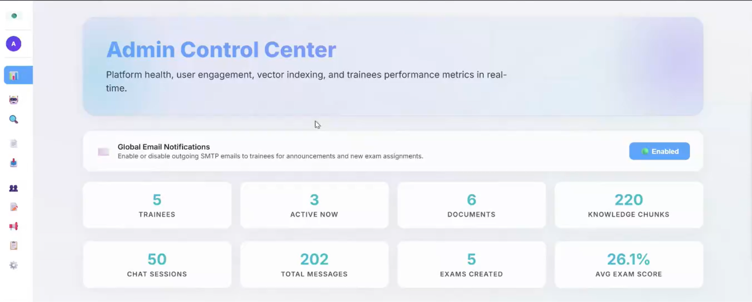

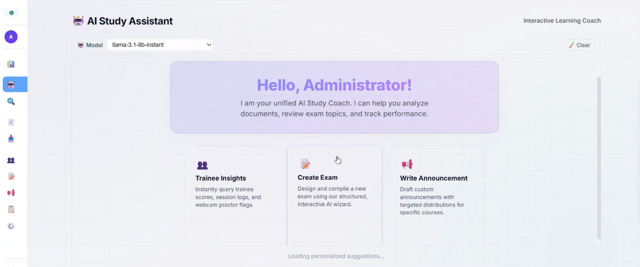

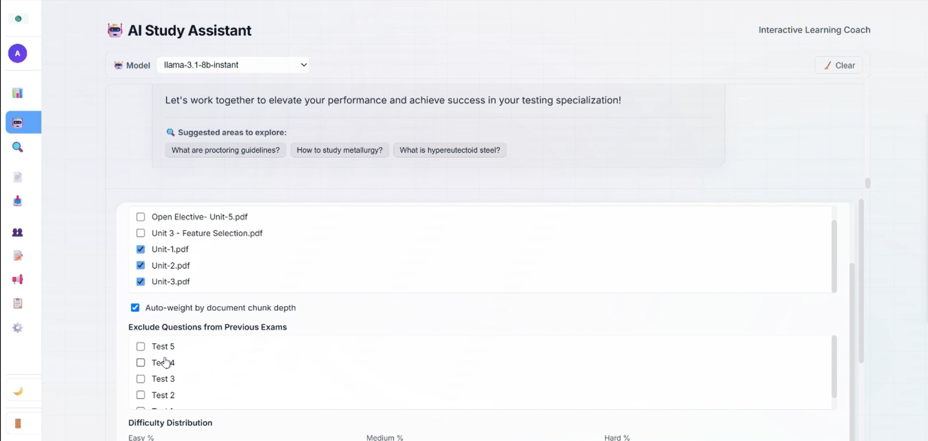

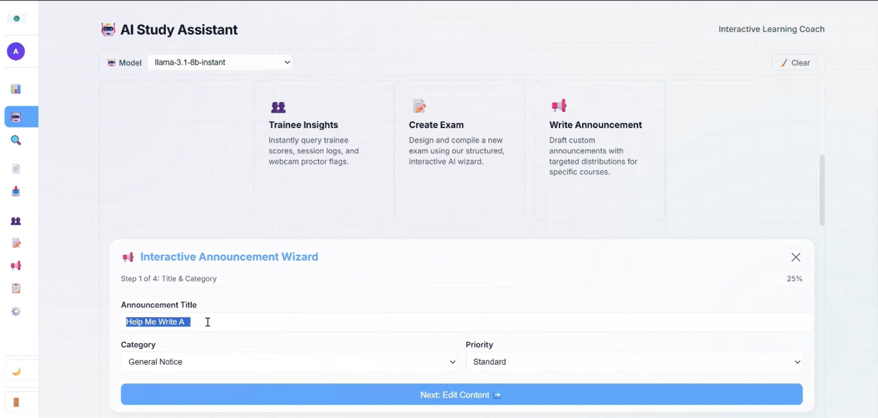

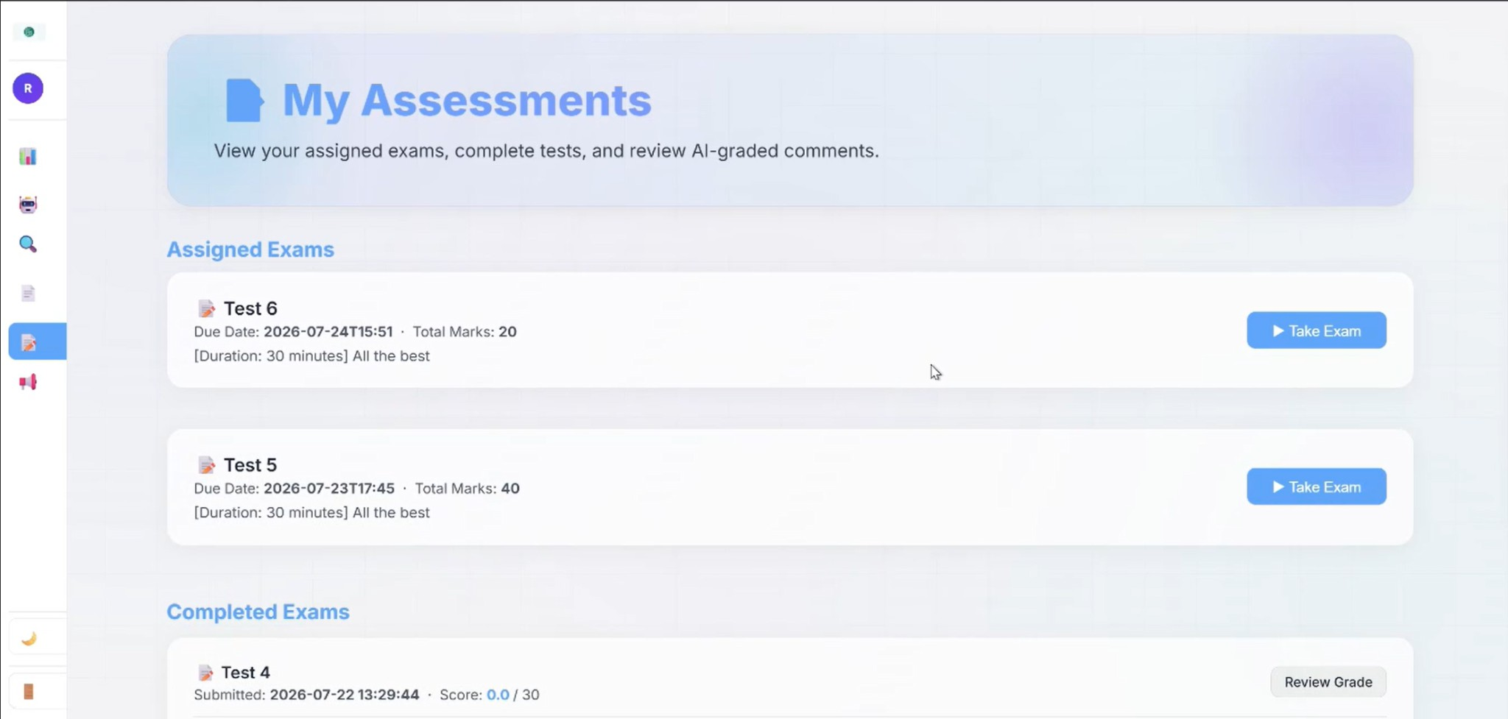

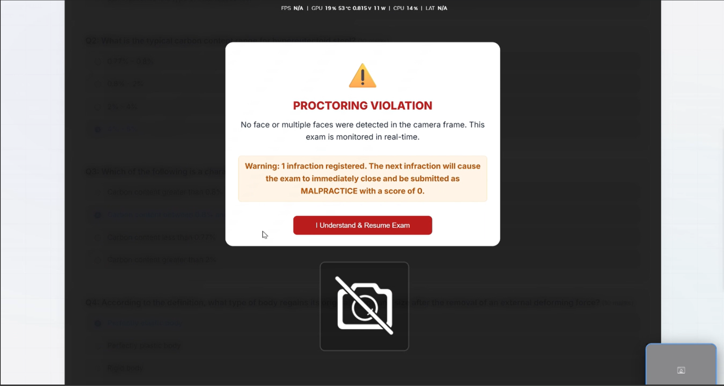

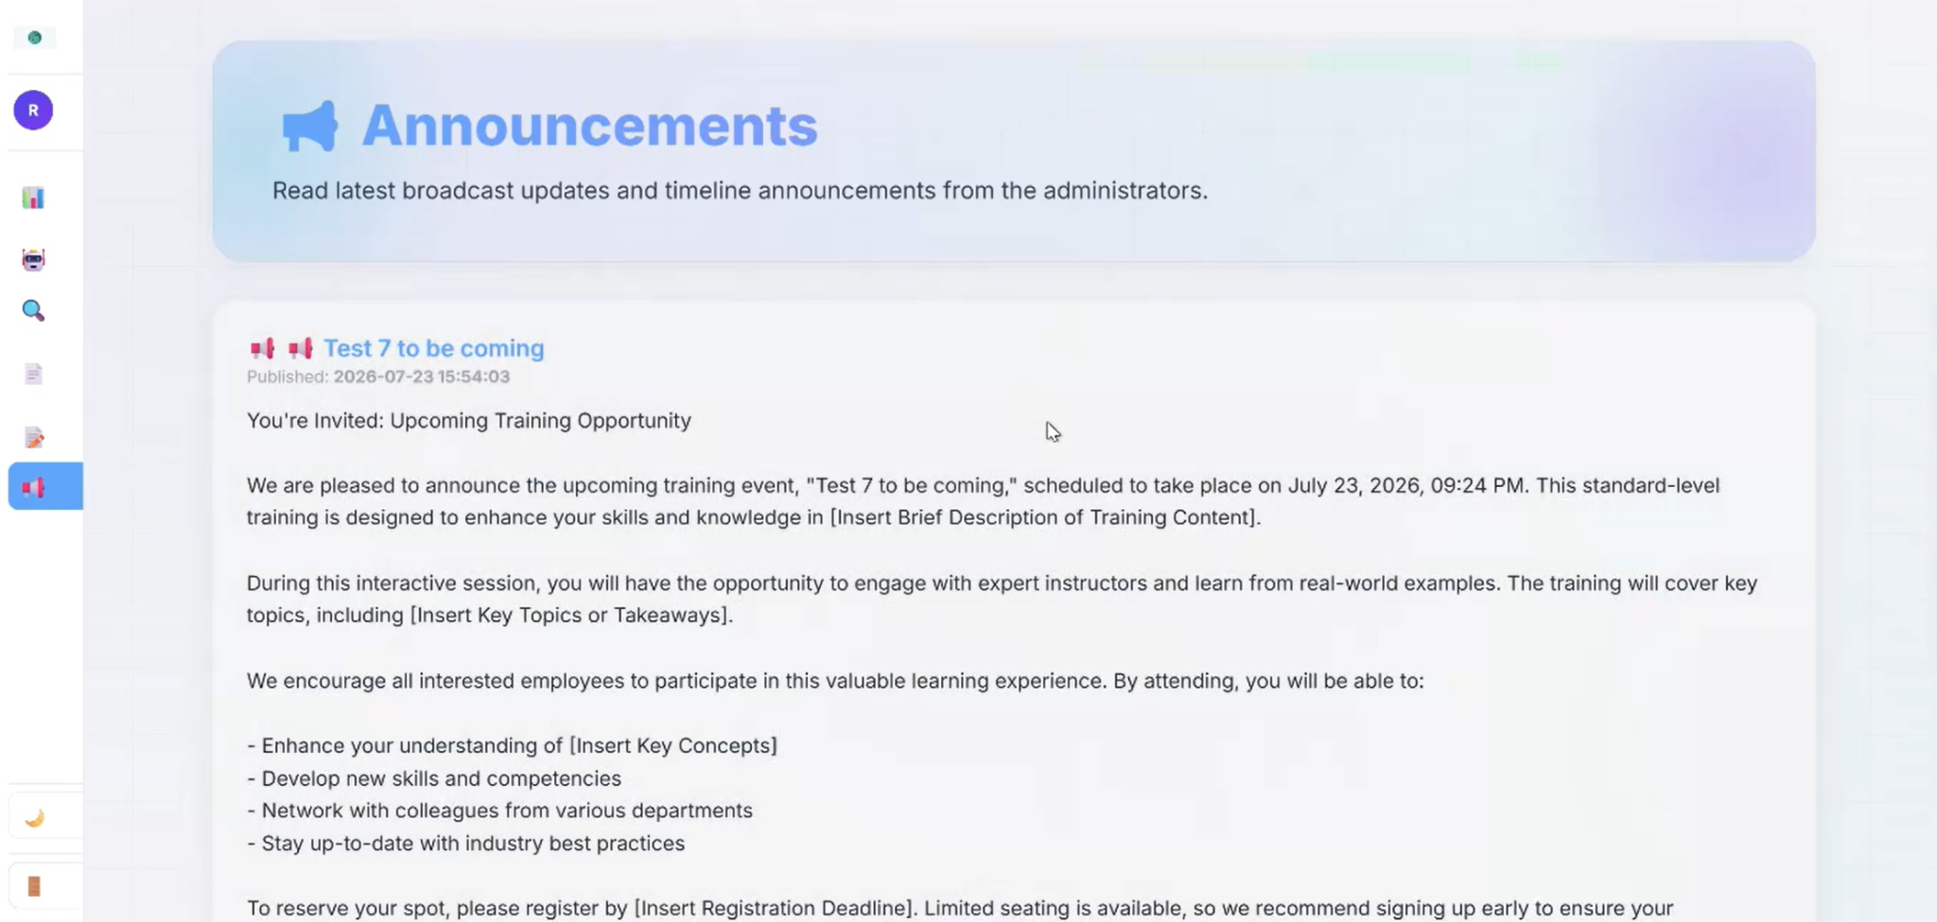

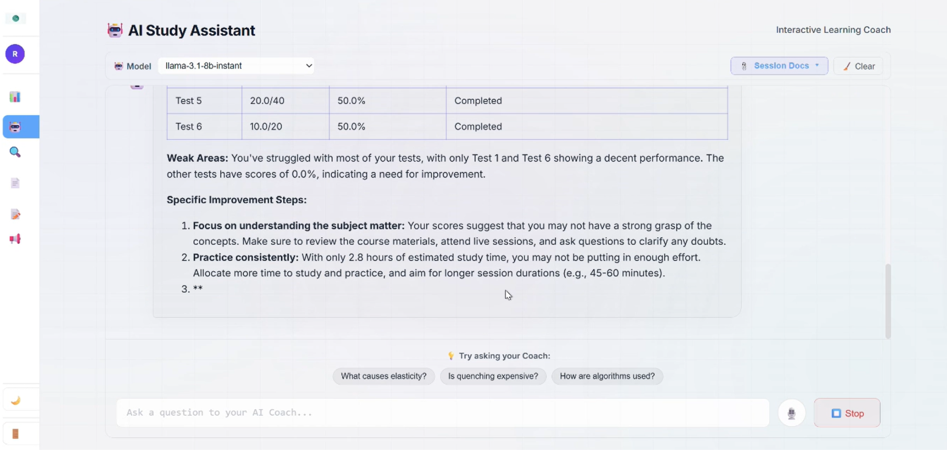

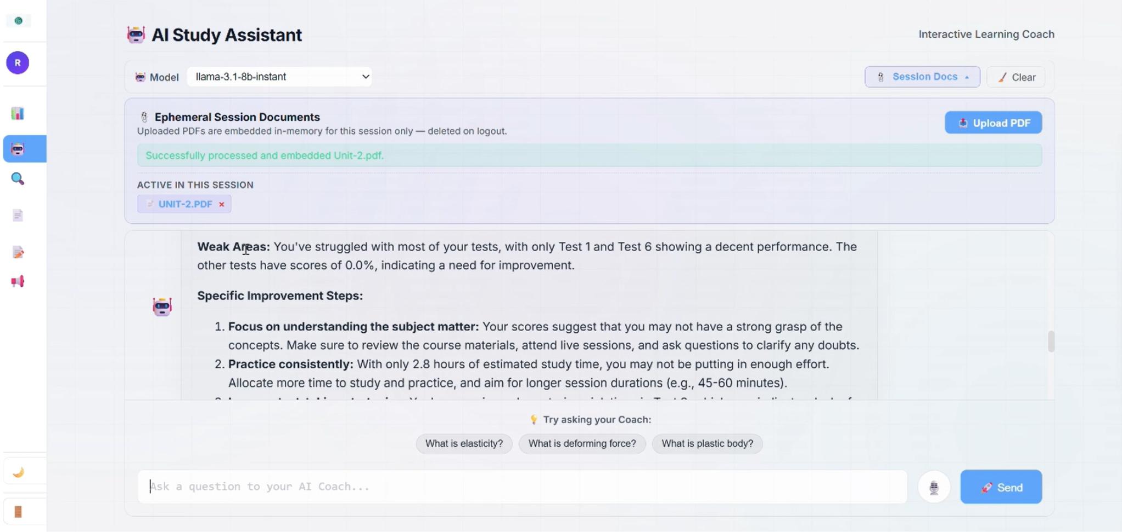

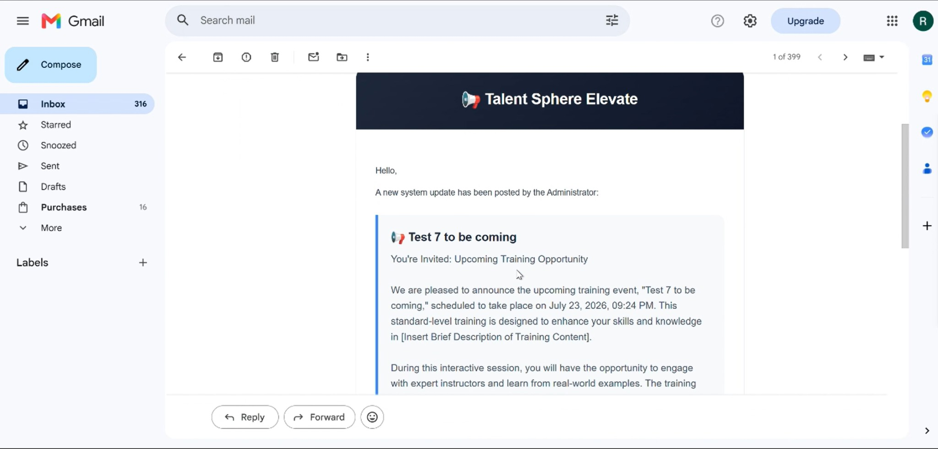

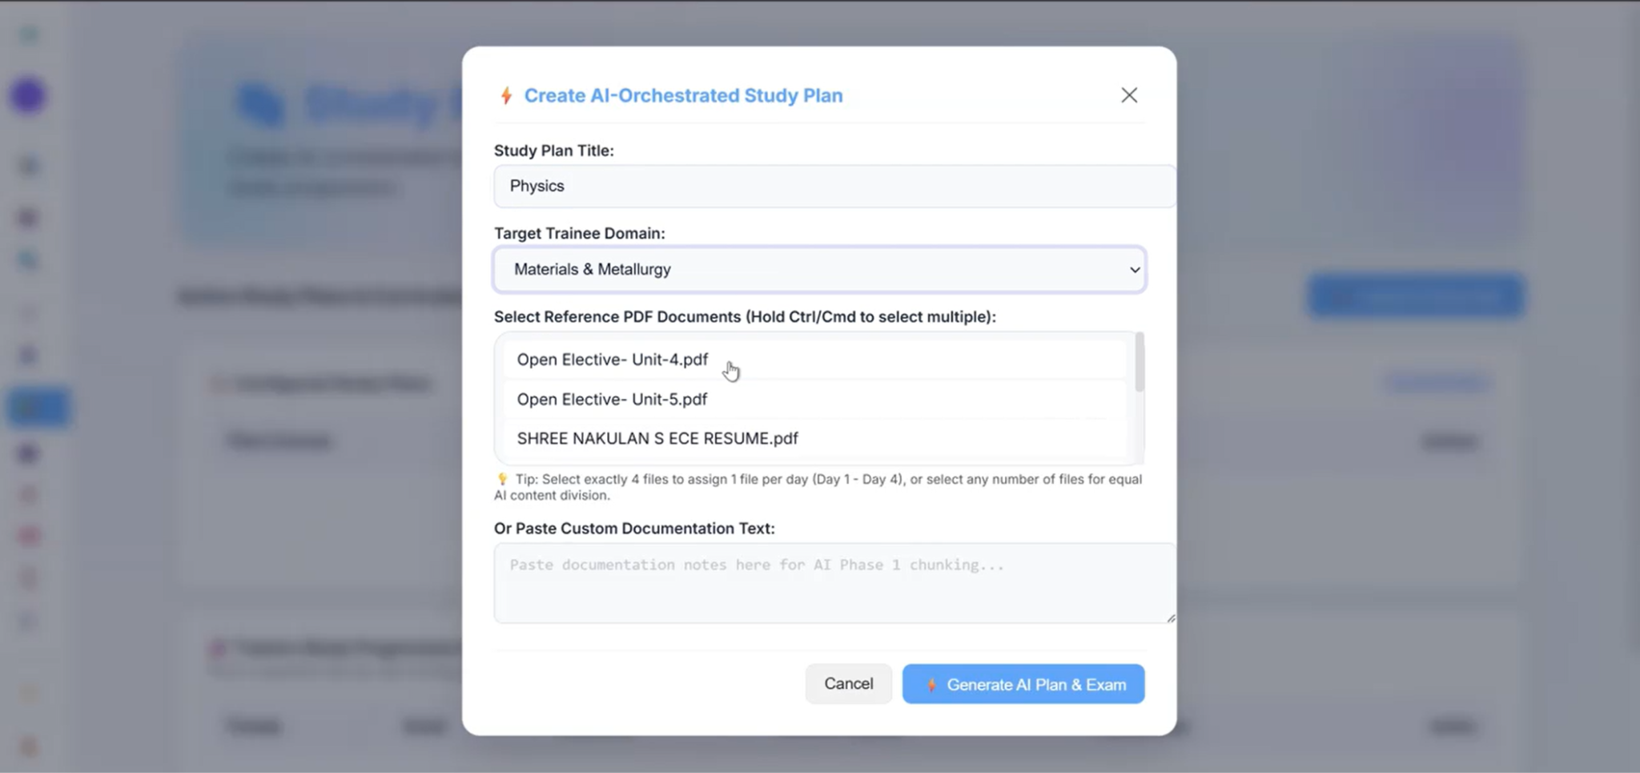

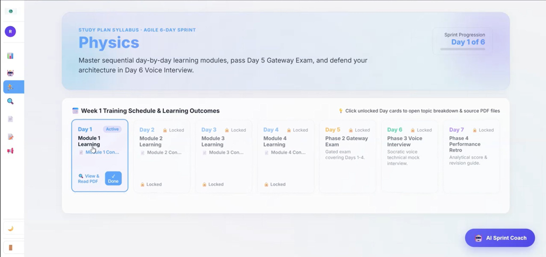

Challenges Faced
  - SQLite Concurrency: Initial development faced file-lock errors under load, which we successfully resolved by implementing SQLite’s Write-Ahead Logging (WAL) mode, allowing simultaneous read/write operations.
  - ChromaDB Blocking: High-frequency vector queries caused thread blocking in the main loop; this was solved by offloading inference tasks to a dedicated ThreadPoolExecutor.
  - Document Extraction: We encountered significant noise when parsing complex scanned PDFs; we integrated a robust OCR fallback pipeline to maintain high-quality data ingestion.
  - Voice Timing Latency: Synchronizing audio playback with AI processing events caused UI jitters. This was resolved using event-based synchronization hooks between the frontend and the Voice AI Assistant's backend.

Learnings & Skills Acquired
  - RAG/AI Pipeline: Mastery of BGE-Large models, vector database architecture, and RAG optimization using ChromaDB.
  - Backend Engineering: Advanced proficiency in FastAPI, Uvicorn ASGI, and asynchronous Python programming.
  - Database Optimization: In-depth experience in SQLite WAL mode optimization and transactional data management.
  - Voice AI: Practical implementation of Web Speech API and integrating LLMs for real-time natural language voice interactions.

Conclusion
The Talent Management Platform for Employee Performance and Career Growth represents a significant leap forward in enterprise learning and development. By successfully transforming static company documentation into actionable intelligence, the platform bridges the gap between raw data and employee career progression. The integration of
RAG-based search, AI-orchestrated learning sprints, and real-time voice assistance creates a proactive ecosystem that empowers employees to own their growth while providing leadership with unprecedented visibility into talent metrics. This project demonstrates the tangible impact of applying enterprise AI to solve complex organizational challenges.

