Infosys Springboard Virtual Internship 7.0 Completion Report
Batch Number - 01
Start date- dd mm 2026
Names:
Team A

Internship Duration: 6 weeks

1.Project Title
AI Powered Code Reviewer and Code Quality Assistant

2. Project Objective
The objective of this project is to develop an AI-powered platform that automates the analysis, validation, and generation of Python docstrings. The system uses AST-based parsing and multi-layer validation to detect documentation issues and ensure compliance with standards like PEP 257.
It also leverages large language models to generate and improve docstrings, reducing manual effort and improving code maintainability. Additionally, the tool provides coverage insights and supports automated test generation, enabling better documentation practices and seamless integration into modern development workflows.

3. Project description in detail
The AI Code Reviewer & Quality Assistant is a comprehensive, AI-powered platform designed to improve the quality and consistency of Python code documentation across entire codebases. The system allows users to upload individual Python files or complete project archives, which are then automatically analyzed using an Abstract Syntax Tree (AST) parsing engine to extract functions, methods, and existing docstrings.
Once the code is parsed, the platform performs a multi-layer validation process by combining industry-standard tools and custom logic to identify issues related to missing, incomplete, or non-compliant docstrings. These validations ensure adherence to documentation standards such as PEP 257 and verify the correctness of parameter and return descriptions.
A key feature of the system is its integration with large language models, which enables intelligent docstring generation, correction, and style conversion. The platform can automatically generate docstrings for undocumented functions, fix existing documentation issues, and convert between different formats such as Google, NumPy, and reST styles. Users are provided with side-by-side comparisons to review and apply changes safely.
In addition to documentation improvement, the system supports automated test generation using AI, creating pytest-based test cases for functions with proper handling of edge cases. The application also includes an interactive dashboard that presents coverage metrics, validation results, and detailed insights at both file and function levels. Users can filter, search, and export reports in multiple formats for further analysis.
Built using Streamlit, the platform offers an intuitive, IDE-like interface with real-time updates and zero setup requirements. Overall, the system transforms documentation from a manual and error-prone task into an automated, intelligent, and scalable process, improving code maintainability, collaboration, and overall software quality.

4. Timeline Overview
Week | Activities Planned | Activities Completed
Week 1 | Setup environment, design UI, implement AST parsing | Completed IDE-like UI and AST-based function extraction
Week 2 | Build validation system (PEP 257, darglint) | Implemented multi-layer validation engine
Week 3 | Develop AI-based docstring generation & style conversion | Integrated Groq LLM for generation, fixing, and conversion
Week 4 | Add dashboard, testing, and export features | Completed dashboard, pytest generation, filters, and reports

5a. Key Milestones
Milestone | Description | Status
Project Kickoff | Defined problem, objectives, and system design | Completed
Core Prototype | Built UI and AST-based parser | Completed
Validation Integration | Implemented PEP 257 and parameter validation | Completed
AI Integration | Added LLM-based docstring generation and fixing | Completed
Final System | Dashboard, testing, export, and optimization | Completed

5b. Project execution details
The project was developed using a modular and milestone-based approach, ensuring each component was independently built and tested before integration. The system combines AST-based static analysis with AI-powered docstring generation and validation, creating a hybrid architecture that balances accuracy and intelligence.
The development began with building the core parsing engine and UI, followed by integrating validation tools like pydocstyle and darglint. In later stages, Groq LLM was incorporated to enable automated docstring generation, fixing, and style conversion. Finally, advanced features such as dashboard analytics, automated test generation, and report export were implemented.
This structured approach ensured scalability, reliability, and smooth integration of all components into a unified platform.

6. Snapshots / Screenshots
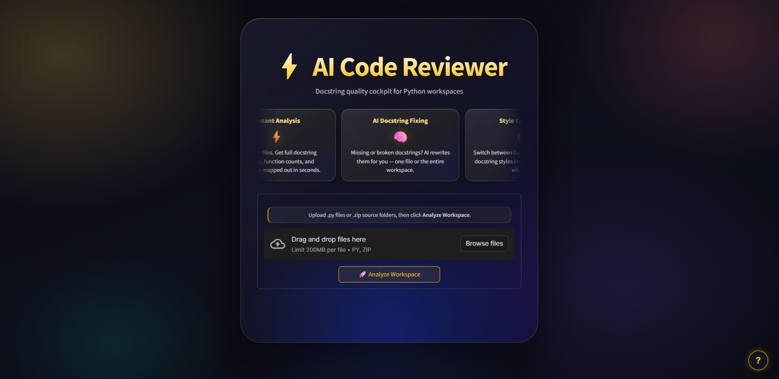
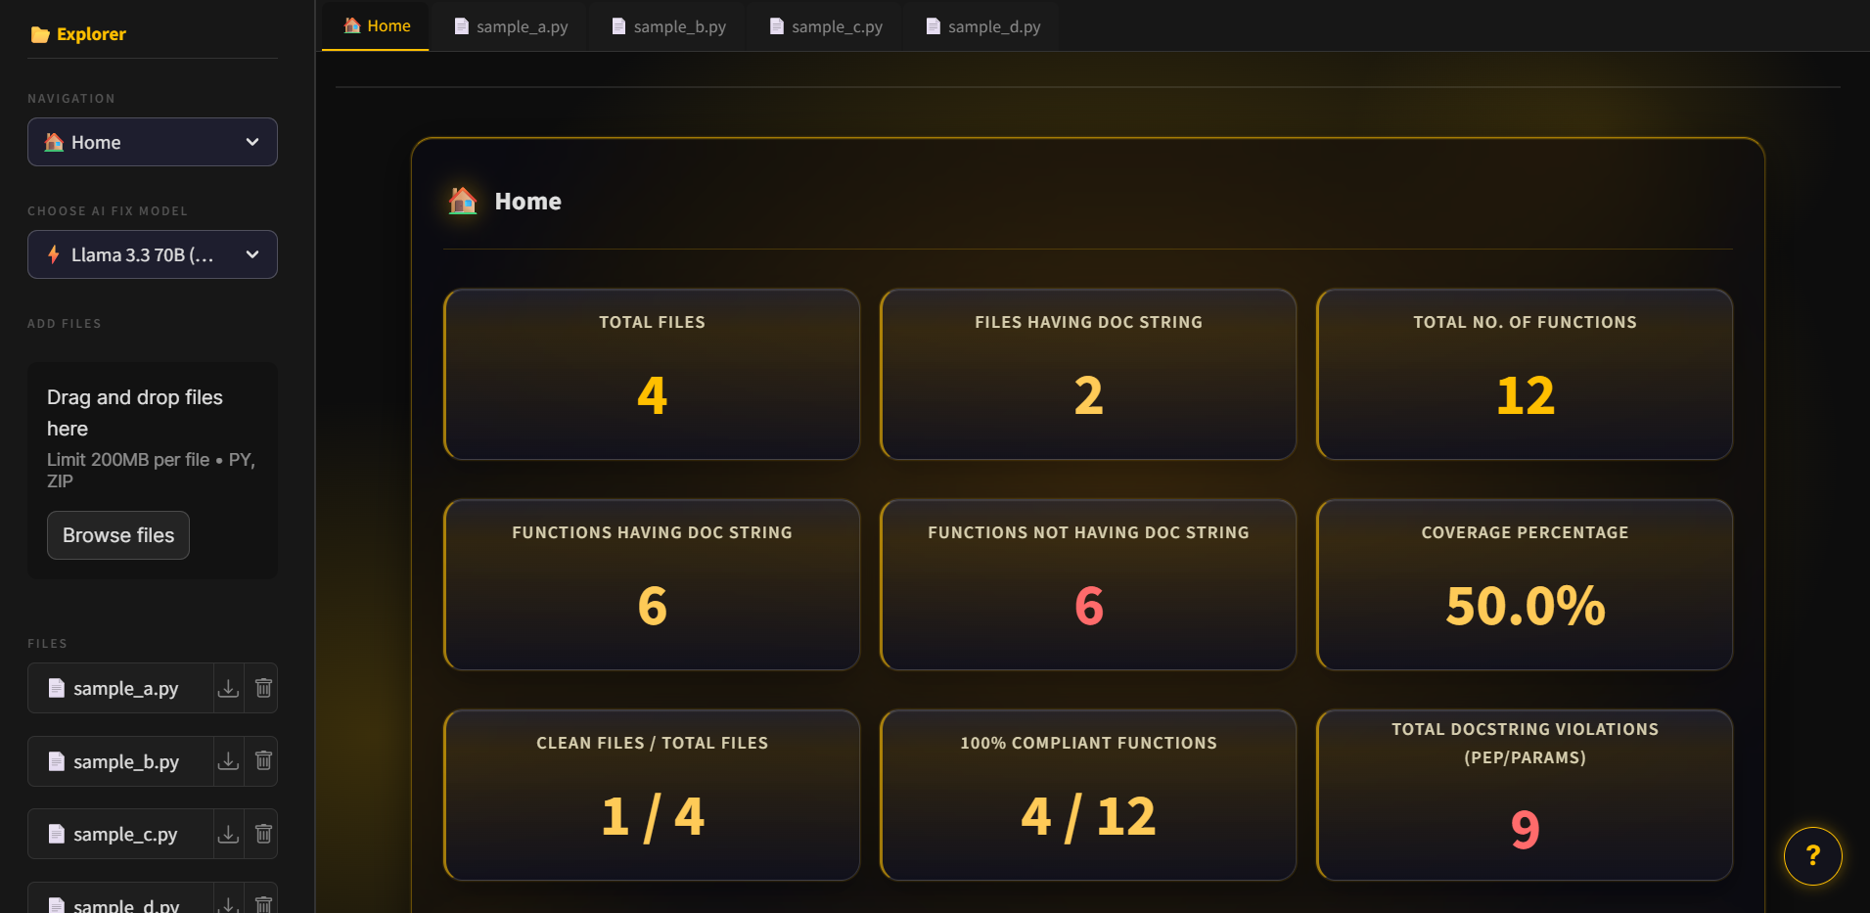
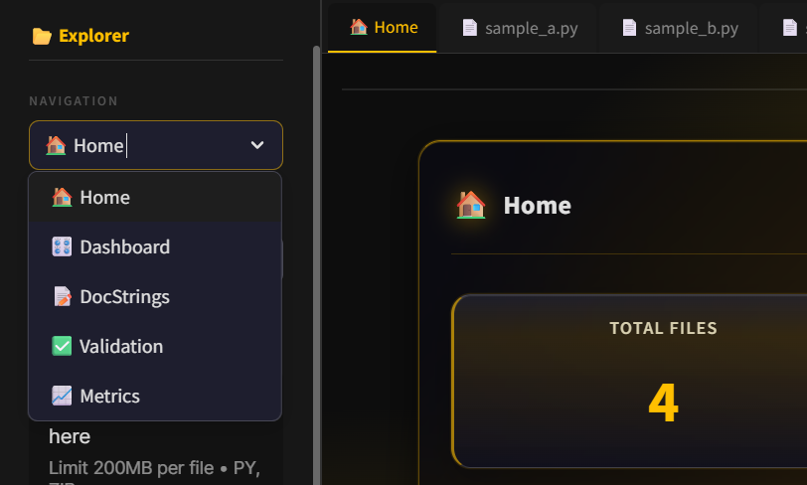

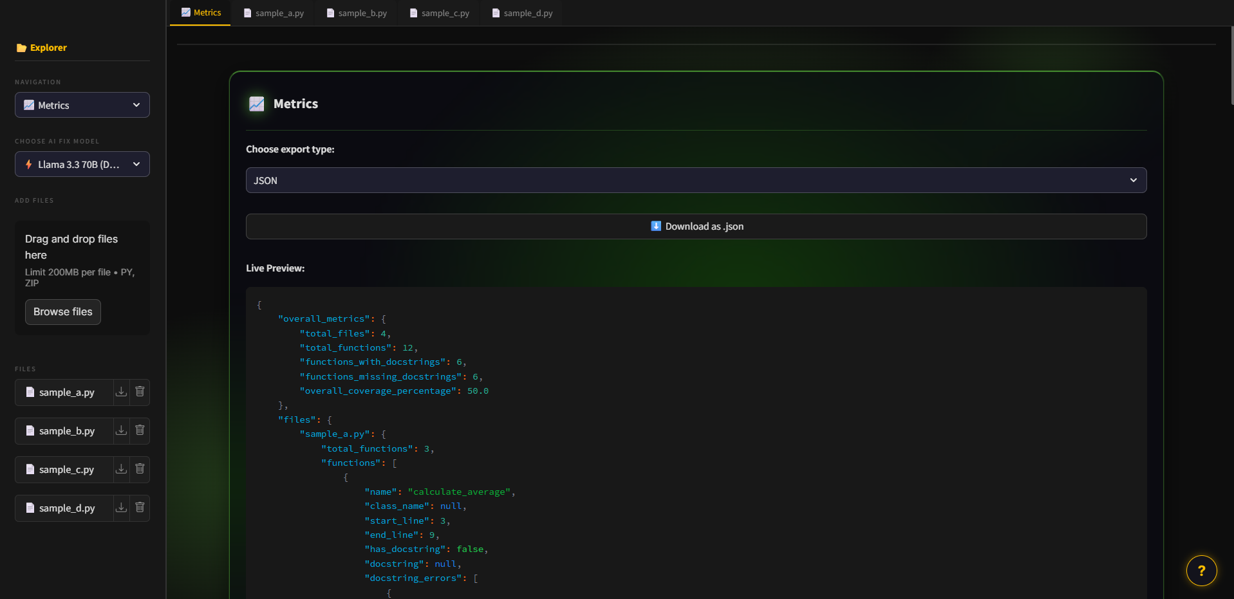

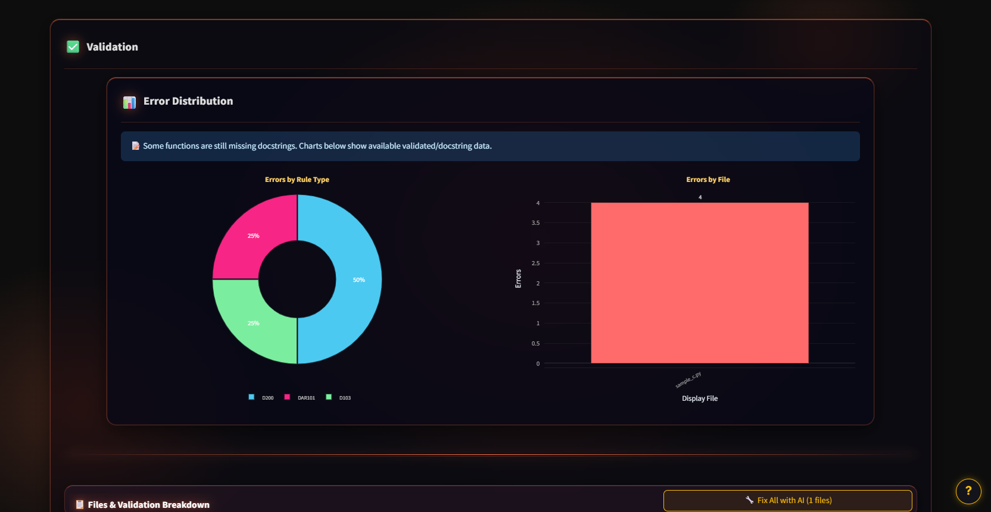

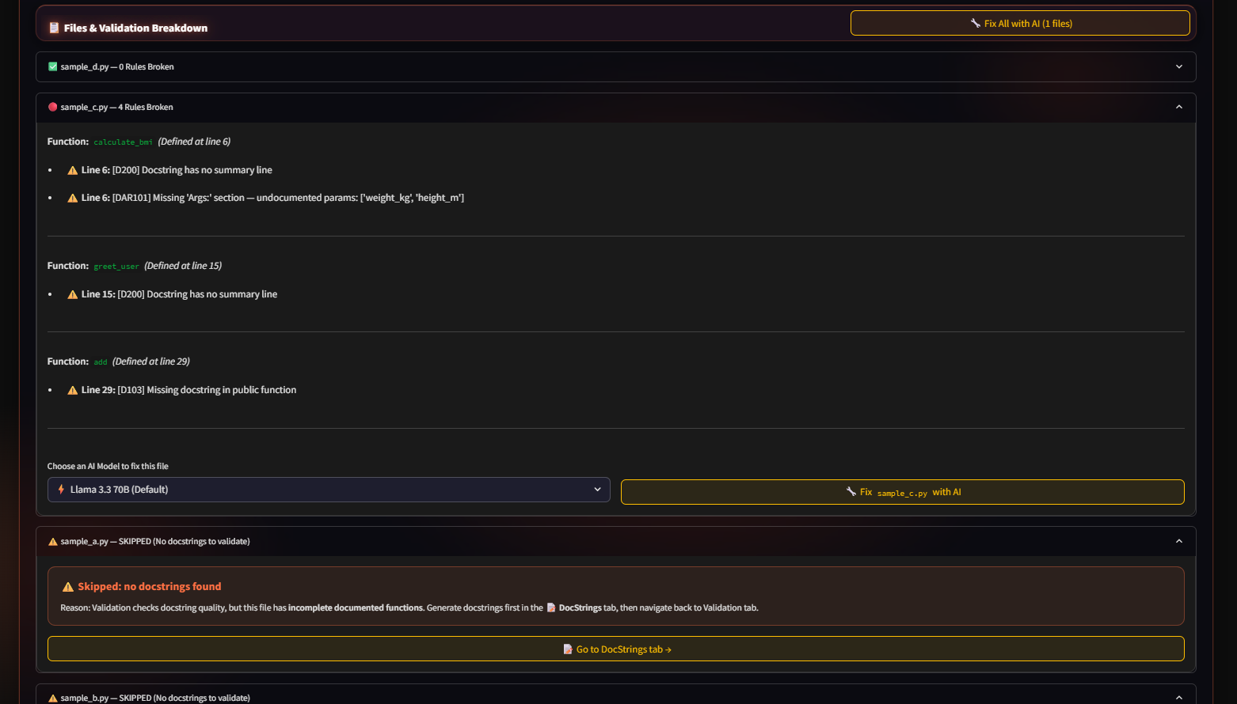

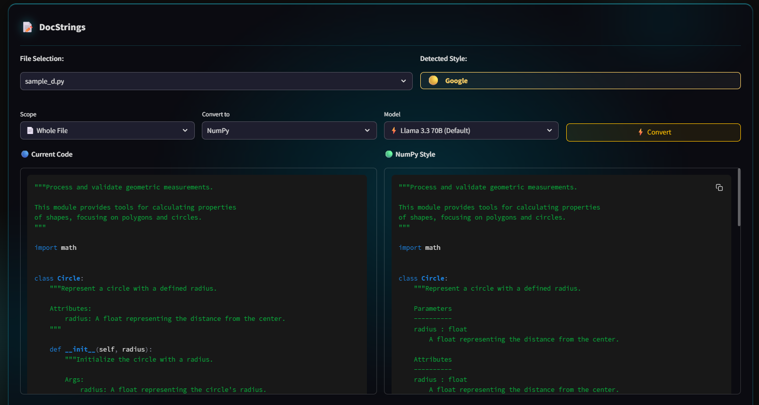

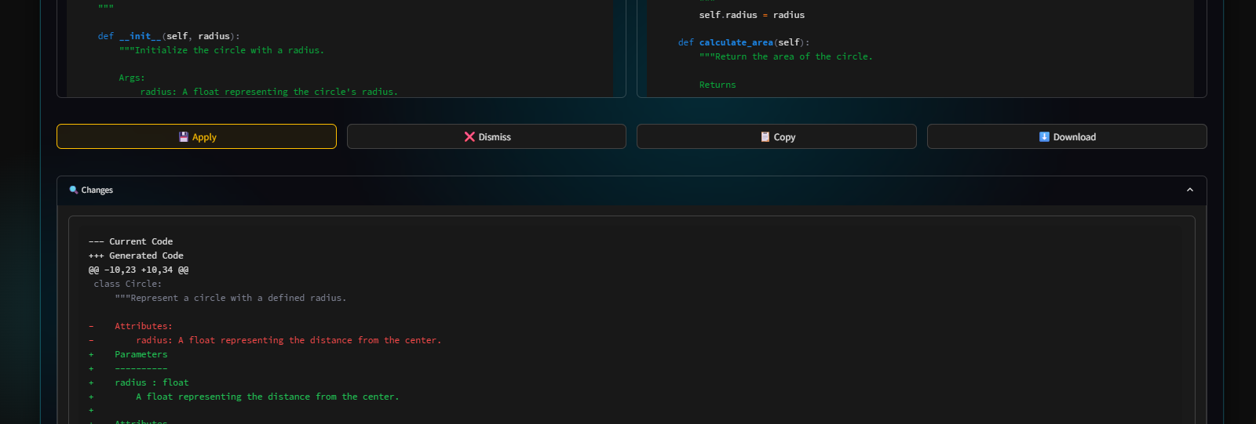
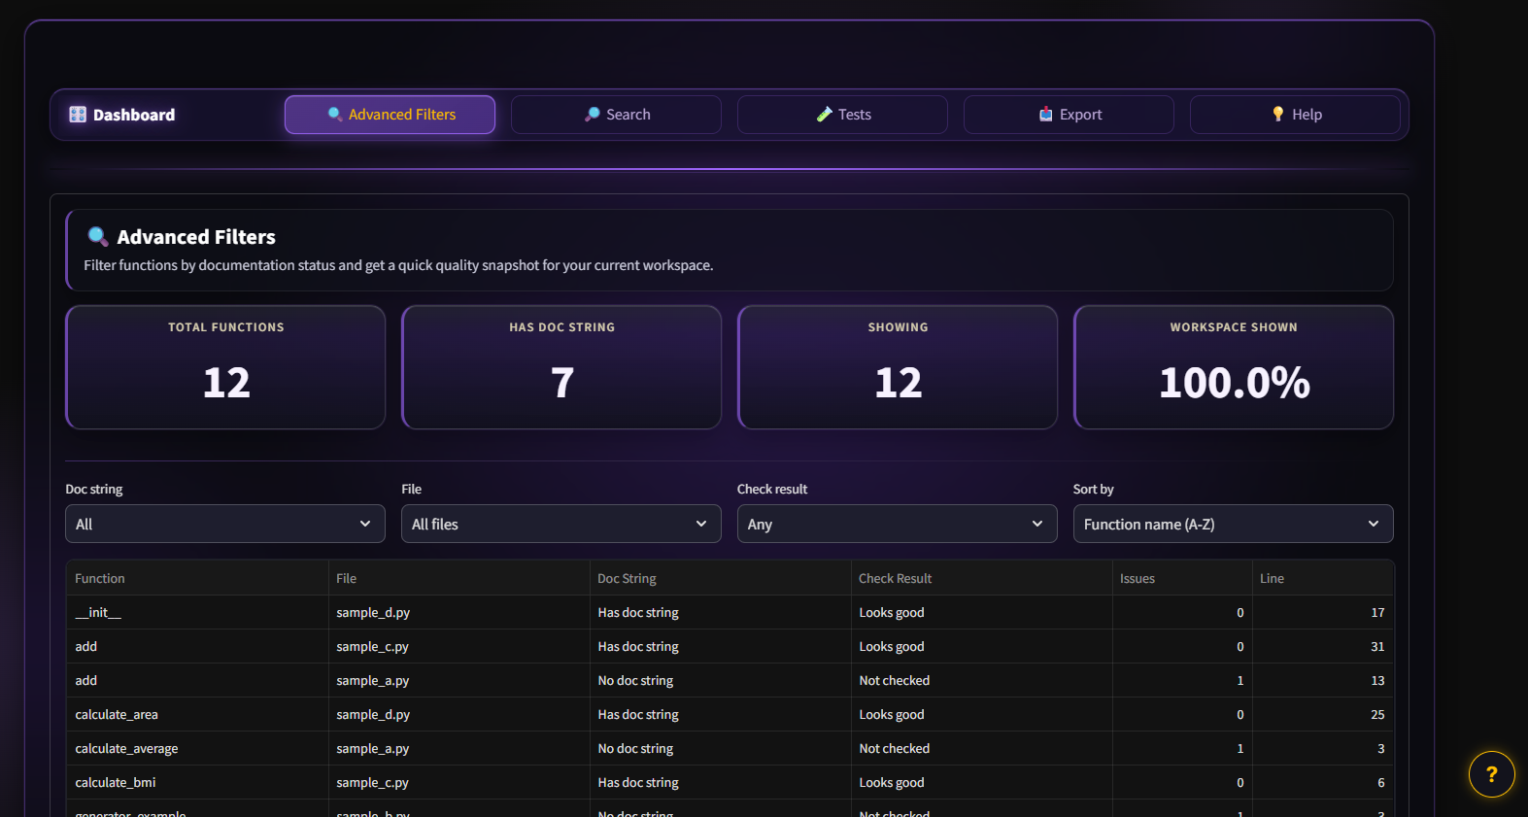

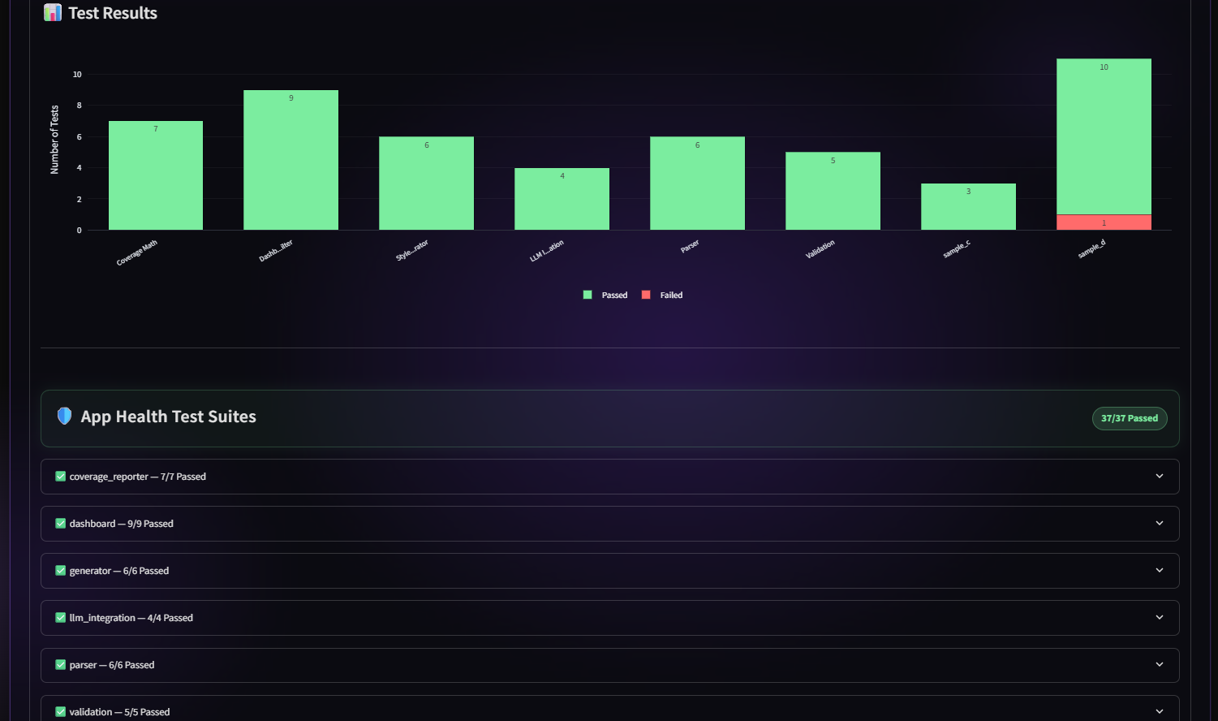

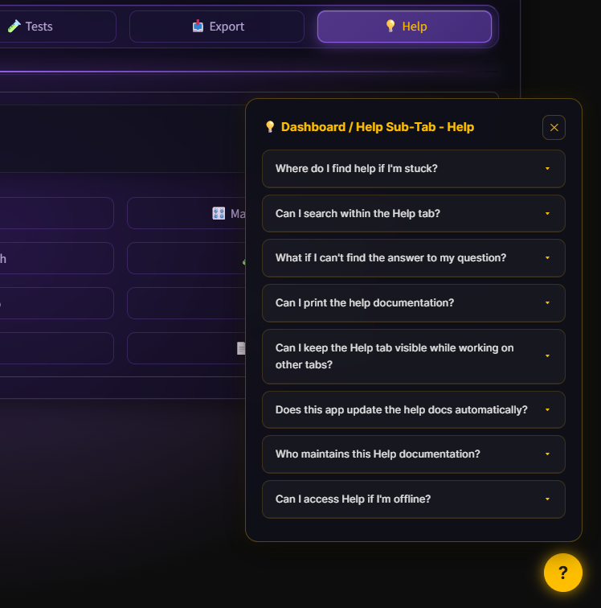

7. Challenges Faced

- Integrating LLM APIs required handling response inconsistencies, latency, and fallback mechanisms.
- Ensuring accurate validation by combining multiple tools without redundancy was complex.
- Managing different docstring styles (Google, NumPy, reST) within the same codebase was challenging.
- Handling large codebases efficiently while maintaining performance and responsiveness.
- Preventing incorrect AI-generated outputs and ensuring safe code modifications.

8. Learnings & Skills Acquired

- Gained hands-on experience with LLM integration (Groq API) and AI-driven automation.
- Developed strong understanding of AST-based code analysis and validation techniques.
- Improved skills in Streamlit UI development and dashboard design.
- Learned software architecture design using modular and scalable approaches.
- Enhanced knowledge in test automation (pytest) and CI/CD-ready workflows.

9. Testimonials from the Team
“This project enhanced our understanding of combining AI with traditional software engineering to solve real-world problems.”
“We gained practical experience in building scalable systems and integrating LLMs effectively.”
“Working on this platform improved our ability to design user-centric tools with real impact on developer productivity.”

10. Conclusion
The AI Code Reviewer & Quality Assistant successfully addresses the challenges of inconsistent and missing documentation in Python projects. By combining static analysis with AI-powered automation, the system transforms docstring management into an efficient and scalable process. The project demonstrates how modern AI technologies can enhance software quality, reduce manual effort, and improve collaboration, making it a valuable tool for developers and organizations.

11. Acknowledgements
We sincerely thank Infosys Springboard, our mentors, and academic faculty for their continuous guidance and support throughout the development of this project. Their encouragement and insights played a crucial role in successfully completing this work.

