HACKWITHAMYPO 2026
Technical Documentation
Stage 1 — Approach, Architecture & Module Breakdown
Team Name | TEAM INFY (AMY00107)
College | KPR Institute of Engineering and Technology
Team Leader | Sanjai M S | sanjaims103@gmail.com | 9342672711
Teammate | Reshekumar V
Problem Statement | PS#7 — LOCAL DATABASE QUESTION-ANSWERING SYSTEM (NO THIRD-PARTY API)
Version / Date | v1.0 — August 2026

1. Approach Summary
This self-hosted hybrid engine routes queries between ChromaDB for unstructured documents and SQLite for structured academic records. Role-based access control secures data access while a local Qwen2.5 model via Ollama synthesizes precise natural language answers. Integrated dual-way voice interaction and dynamic concept mapping enhance campus accessibility. The fully offline deployment guarantees total data privacy, zero internet dependency, and zero hallucinations on structured data.

2. System Architecture

2.1 Architecture Diagram

. 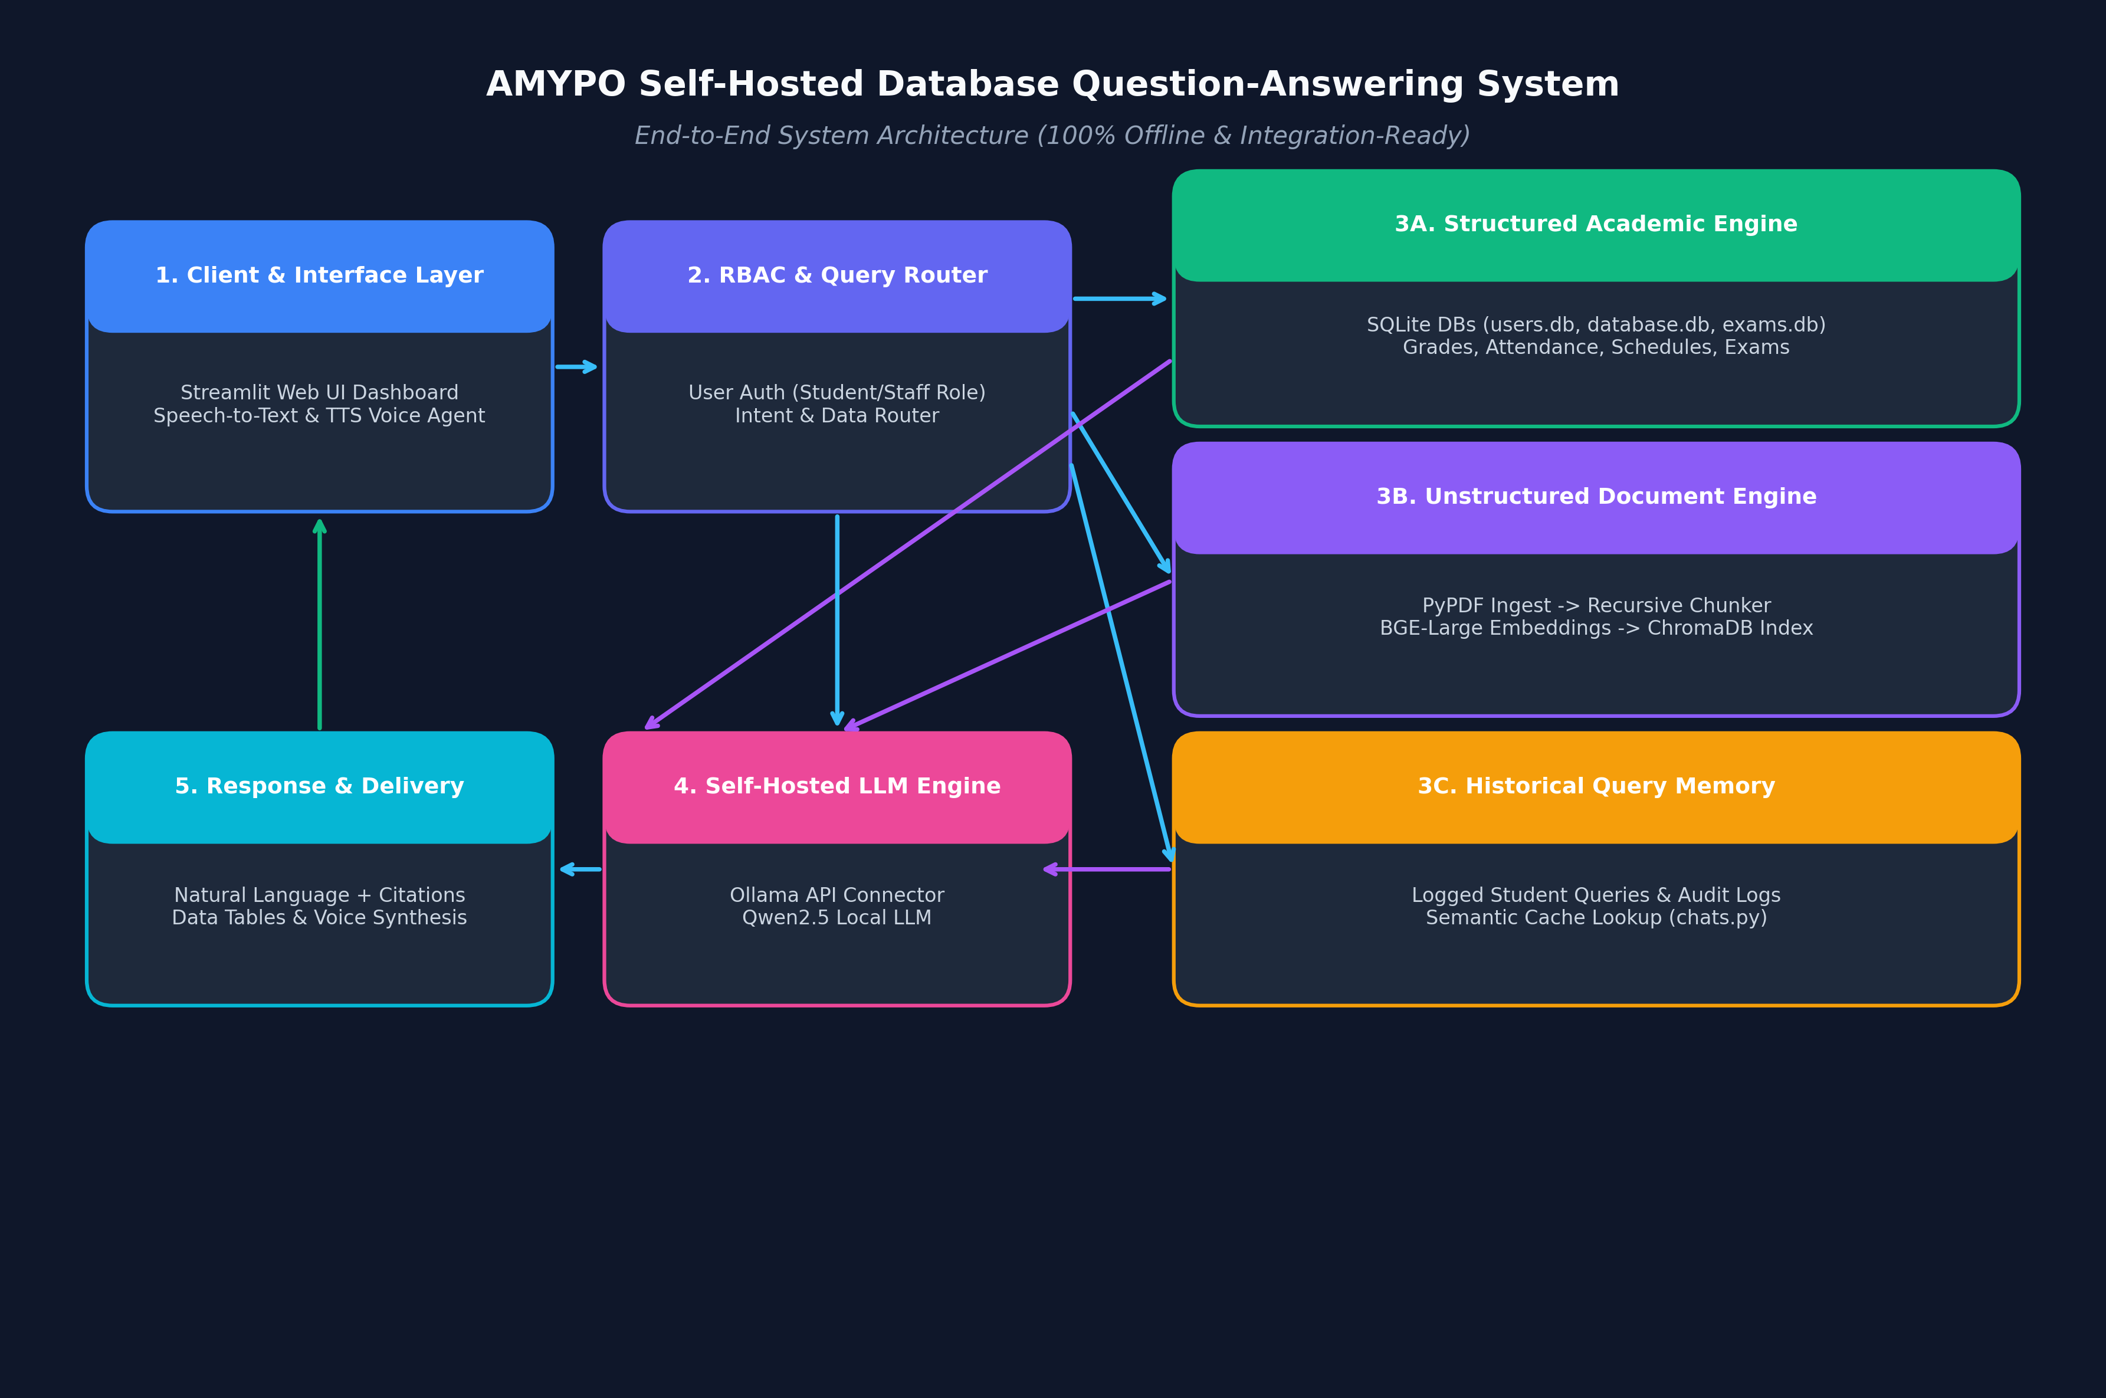

2.2 Architecture Narrative
1. User Interaction & RBAC Authentication: A student or staff member submits a query via the Streamlit web dashboard or voice agent. The security layer validates user credentials and assigns role-based data visibility scopes.
2. Query Ingestion & Intent Routing: The query router evaluates the request intent to classify it into a structured query (grades/attendance/schedules), unstructured query (policies/course FAQs), or historical query lookup.
3. Multi-Engine Retrieval Dispatch:
• Structured Path: Translates natural language questions into safe, parameterized SQL queries executed against SQLite databases to retrieve exact student performance and schedule records.
• Unstructured Path: Generates a 1024-dimensional dense vector embedding via BAAI/bge-large-en-v1.5 and performs metadata-filtered similarity search in ChromaDB to retrieve top-K relevant text passages.
• Historical Path: Performs semantic similarity search against previously logged student queries in chats.py to enable instant cached responses.
4. Context Assembly & Security Filtering: Relevant SQL tables, document excerpts, and query context are assembled into a structured system prompt, filtering out restricted data based on user authorization.
5. Local LLM Answer Generation: The prompt is dispatched to a locally hosted LLM (via Ollama API). The model generates a grounded, accurate natural language response complete with document source citations.
6. Response Delivery & Audit Logging: The UI renders formatted Markdown text, interactive data tables, source badges, and synthesizes audio via TTS if voice mode is active. The request, response, and performance metrics are logged into database for continuous system auditing.

3. Module Breakdown

Module | Responsibility | Key Inputs / Outputs | Depends On
Document Ingestion & Chunking | Extracts text from PDFs/DOCXs/CSVs, handles OCR fallback, and splits text into chunked passages with metadata. | Input: PDF/DOCX files → Output: Clean Text Chunks + Metadata | PyPDF, LangChain
Vector Index & Storage Engine | Generates dense embeddings using BAAI/bge-large-en-v1.5 and manages persistent ChromaDB collections with metadata filters. | Input: Text Chunks / Query → Output: 1024-dim Embeddings / Top-K Passages | Sentence-Transformers, ChromaDB
Structured Academic Engine | Manages SQLite relational databases for student grades, attendance, exam records, schedules, and user authentication. | Input: Student ID / Query → Output: Filtered SQL Records / Academic Metrics | SQLite3, Pandas
Historical Query Logger & Memory | Logs student/staff questions, feedback ratings, and chat history; provides semantic matching for FAQ lookups. | Input: User Question & Context → Output: Audit Logs / Similar QA Pairs | SQLite3, ChromaDB
Local LLM & RAG Synthesizer | Constructs context-augmented prompts and interfaces with local Qwen2.5 LLM via Ollama for natural language answers. | Input: Question + Context + SQL Data → Output: Natural Language Answer + Citations | Ollama API, Qwen2.5 LLM
Voice Interaction Agent | Enables hands-free Speech-to-Text query input and Text-to-Speech voice answer rendering. | Input: Audio Speech → Output: Transcribed Text Query / Spoken Audio | SpeechRecognition, gTTS/pyttsx3
Concept & Sprint Visualizer | Renders interactive knowledge graphs of course topics and tracks academic sprint milestones. | Input: Syllabus / Student ID → Output: Knowledge Graph & Sprint Timelines | PyVis, Streamlit Components
Streamlit Web UI & Security Layer | Provides multi-page glassmorphic web portal, RBAC view isolation, document upload tools, and search lab. | Input: User Web Interactions → Output: Interactive Dashboard & UI Panels | Streamlit, Custom CSS

4. Tech Stack

Layer | Technology | Justification
Frontend / UI | Streamlit + CSS (assets/styles.css) | Delivers an intuitive, responsive multi-page web dashboard with interactive tables, voice controls, and glassmorphic aesthetics without web server complexity.
Backend / Engine | Python 3.10 + Flask / Streamlit Engine | Offers seamless integration with ML libraries, database connectors, and asynchronous task execution in a highly modular pipeline.
AI / Embeddings Model | BAAI/bge-large-en-v1.5 (Sentence-Transformers) | Provides state-of-the-art 1024-dimensional dense semantic retrieval locally on CPU/GPU, capturing domain-specific academic terminology accurately.
AI / Local LLM Inference | Qwen2.5 (7B/14B Quantized via Ollama API) | Exceptional open-weight model for multi-step reasoning and Text-to-SQL; runs 100% offline with zero API costs and full institutional data privacy.
Data & Vector Storage | ChromaDB (Local Persistent Vector Database) | Lightweight, file-system-backed vector database enabling fast cosine similarity searches and hybrid metadata filtering (course, policy, role).
Relational Data & Logs | SQLite3 | Zero-configuration, ACID-compliant embedded database ideal for managing structured student records, grades, timetables, and audit query logs locally.

5. Assumptions & Constraints
• Data Format Availability: Assumes course syllabi, policy manuals, and FAQs are provided in standard PDF, DOCX, TXT, or CSV formats.
• Network & Deployment Environment: Assumes local deployment on institutional campus hardware or secured internal network with role credentials.
• Hardware Compute Baseline: Assumes host machine meets minimum hardware requirements (16GB+ RAM, multi-core CPU, optional CUDA GPU) to run quantized local LLM inference efficiently.
• Offline & Self-Hosted Constraint: Strictly operates without external cloud API dependencies (e.g., OpenAI, Claude, Google Cloud APIs), ensuring complete data privacy and offline compliance.
• RBAC Security & Privacy Constraint: Student grades, personal attendance, and academic records are isolated via strict Role-Based Access Control (RBAC).
• Out of Scope: Real-time integration with external third-party cloud Learning Management Systems (LMS) beyond direct database ingest, and public internet web scraping.

6. References (Optional)
• Xiao, S., Liu, Z., Zhang, P., & Muennighoff, N. (2023). C-Pack: Packaged Resources for General Chinese Embeddings (BAAI BGE Models). arXiv:2309.07597.
• Alibaba Cloud Qwen Team. (2024). Qwen2.5 Technical Report: A Comprehensive Open-Source Large Language Model Family.
• Chroma Core Team. (2023). Chroma: The Open-Source Embedding Database. https://github.com/chroma-core/chroma
• Reimers, N., & Gurevych, I. (2019). Sentence-BERT: Sentence Embeddings using Siamese BERT-Networks. Proceedings of EMNLP 2019.
• Lewis, P., et al. (2020). Retrieval-Augmented Generation for Knowledge-Intensive NLP Tasks. Advances in Neural Information Processing Systems (NeurIPS), 33.

