Circus Social (Assignment)

------------------------------------------------------------------------------------------------------------------------

Problem Statement

Jahanna Chronicle, a technology company based in Lunakick, has reached out to you with a task that involves predicting the impact of a tweet and prepare a report on your analysis. You could think about ‘impact’ as a value that could help Jahanna Chronicle decide if the tweet could go viral.
Chronicle’s data team has worked hard and prepared a dataset for you. They compiled the data and decided to share it via HTTP. So here is the link, directly from the Chronicle’s data team!

There are 15 features and 1 dependent variable (also called as the output variable; Here it is named as ‘impact’).

- Post Content - The text in the tweet
- Sentiment score - Ranges from -20 to +20 (0 - neutral)
- Post Length - The length of the tweet
- Hashtag Count - The number of hashtags used in the tweet
- Content URL Count - The number of URLs mentioned in the tweet
- Tweet Count - The total number of tweets posted by the author of the tweet
- Followers Count - The number of followers of the author of the post
- Listed Count - the number of lists the post author is a part of
- Media Type - The media type of the post (Text, image, video)
- Published Datetime - The published time of the tweet
- Mentions Count - The number of user mentions in the tweet
- Post Author Verified - 1 if author is a verified user
- Likes - Likes received for the tweet
- Shares - Retweets received for the tweet
- Comments - Number of comments for the tweet

As Chronicle’s engineering team has recommended to explore the modeling of above problem statement a decision tree (with some form of boosting and pruning), neural network and linear regression but give the model that fits best.

------------------------------------------------------------------------------------------------------------------------

Steps followed to solve the problem statement

1. Understanding the dataset
2. Getting the Summary of the dataset
3. Preprocessing (EDA)
4. Feature Transformation
5. Visualization
6. Model Training and Evaluation
- Feature Extraction
- Feature Selection
- Neural Network
7. Conclusion

------------------------------------------------------------------------------------------------------------------------

1. Understanding the dataset

On observing the dataset, we could find that there is one additional column in the beginning which consists of some random ids and it doesn't has any header assigned to it. Apart from that there are 16 columns in the dataset out of which Post Content and Media Type are Categorical column and rest are Numeric. And your target column is Impact which is Numeric and its not set of defined values to its a 'Regression problem'.

The dataset consists of 50000 records which is a decent amount in order to build a model to predict the impact of the tweet having a set of features.

------------------------------------------------------------------------------------------------------------------------

2. Summary of the dataset

Following was the summary generated from the data which shown how the data is distributed like what is the mean and different quartiles present in the database and following things:

- Total Samples
- Total Features
- Total Categorical Features
- Total Numerical Features
- Stats of Numerical Features
- Value Count of Categorical Features
- Unique Values DataFrame
- Null Values DataFrame

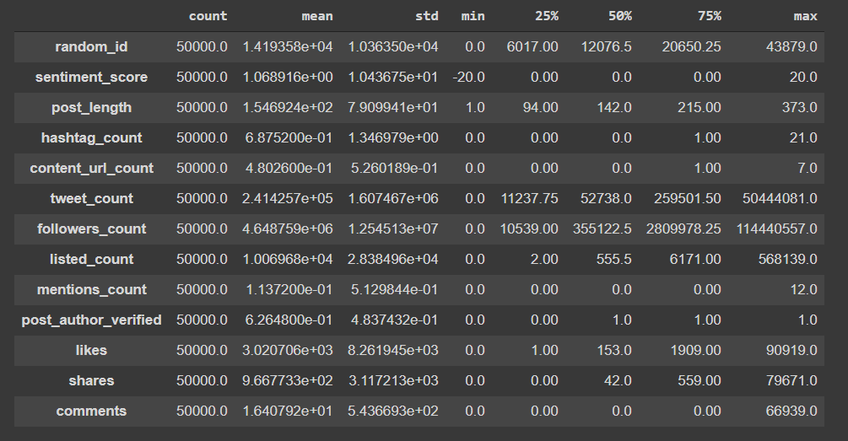
------------------------------------------------------------------------------------------------------------------------

3. Preprocessing (EDA)

In this step following operations were performed:

- Drop Duplicates
- Drop uninformative columns
- Drop Columns with single unique values
- Outlier Analysis and Removal
- Drop Columns with single unique values again after outlier analysis

Drop Duplicates - The dataset was checked for duplicates values if any as those duplicates values won't help in training the model they will just add bias to the model.
Drop uninformative columns - As we can see that the random column in the beginning of the dataset, id, post content and publish date don't actually help us to predict the *Impact* of the tweet. Though the post content does but the team has already extracted information out of it like sentiment, post length, like, shares, etc.
Drop Column with single unique values - Next the dataset was check if any column had single unique. As it would really help in model building as no new information is provided through such column (feature).
Outlier Analysis and Removal - Later on the dataset was checked for outliers using Inter Quartile Ratio (IQR)
This is very important step as outliers increases the variance and in turn affect the model performance.

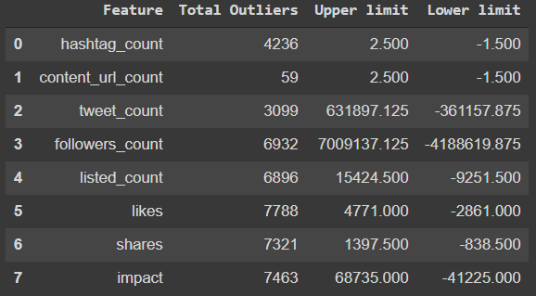

Drop Columns with single unique values again after outlier analysis - After removing the outliers we again check for column having single unique values and if it exists we will be dropping that column (feature).

------------------------------------------------------------------------------------------------------------------------
4. Feature Transformation

At this step we perform Gaussian (normal) transformation (predictive analysis) on our numerical features. The Gaussian distribution is the limit distribution for the sum of many independent random variables. Then we have used Power transforms like the Box-Cox transform and the Yeo-Johnson transform provide an automatic way of performing these transforms on your data and are provided in the scikit-learn Python machine learning library. In this case, we have used Yeo-Johnson power transformation, Unlike the Box-Cox transform, it does not require the values for each input variable to be strictly positive. It supports zero values and negative values. This means we can apply it to our dataset without scaling it first.

------------------------------------------------------------------------------------------------------------------------
5. Visualization

Visualization helps us to understand your data more better. It helps us to establish what sort for relationship is better dependent and independent variables and in storytelling. Check out the notebook for visuals like scatterplot, bar chat, box plot, distribution plots, pairplots and correlation matrices.

------------------------------------------------------------------------------------------------------------------------

6. Model Training and Evaluation

As in this problem statement, we want to predict the Impact of the tweet so the problem was approached was followed as predictive modelling problem. So a pipeline was created specifying the model and it’s parameter and K-fold Cross Validation was used as the evaluate the performance of the model. Following models were trained and following were the cross validation score when model was trained without Feature selection and Extraction:
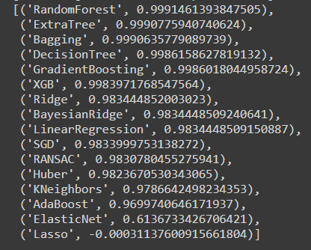

So based on cross validation score we can see that most of the models are overfitting the data. So next Feature Extraction was performed on the data using PCA (Principle Component Analysis). Before performing PCA we scaled the data. PCA is an unsupervised statistical technique that is used to reduce the dimensions of the dataset. After performing PCA and reducing the features from 14 to 12 and then providing the data to the model we see that now the Cross Validation Score is relevant.

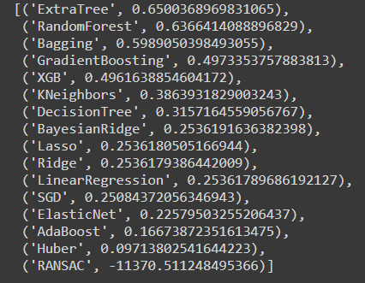

Next we performed Feature Selection by selecting the Strong Numerical Features using Pearson’s Correlation Coefficient and Strong Categorical feature using ANOVA (though we don’t had many categorical feature after feature engineering)
After selecting the best numerical features, we again feed the data to the model pipeline and following results were obtained:
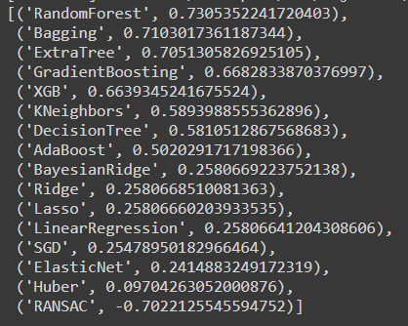

We can see that models cross validation score improved as compared to cross validation score obtained in case of Feature Extraction.
Feature Selection was better than the Feature Extraction (PCA). Hence feature selection through f-test ANOVA and pearson correlation test is best here to select strong features than the dimensionality reduction method using PCA.

Next is we tried implementing Neural Network on the data, a simple model Keras Sequential model was trained using with 5 dense layer and using ReLU as Activation Function. But the performance of the model on test data wasn’t as good compared to Random Forest and Bagging trained on Feature Selection data.

------------------------------------------------------------------------------------------------------------------------
7. Conclusion

From the above output we can see that the Random Forest and Bagging model trained using Feature Selection were the best model based on Cross Validation Score of the model.
Future Work: 1. Implement CatBoosting, and Ensemble models.
2. Train more complex Neural Network models and can also try pre-trained models using Transfer Learning.

