**Enhanced Diagnosis of Alzheimer's Disease through Predictive Progression Analysis of Neuro Imaging Sequences**

# A MINOR PROJECT REPORT

***Submitted by***

## V. R. Rishendra [RA2111026010221]

**Rangineni Yukthamukhi[RA2111026010262]**

***Under the guidance of***

**Dr. KARPAGAM M ASSISTANT PROFESSOR**

**DEPT. OF COMPUTATIONAL INTELLIGENCE**

***in partial fulfillment for the award of the degree of***

**BACHELOR OF TECHNOLOGY**

**in**

**COMPUTER SCIENCE & ENGINEERING**

of

# FACULTY OF ENGINEERING AND TECHNOLOGY



S.R.M.Nagar, Kattankulathur, Chengalpattu District

# SEPTEMPER 2024

SRM INSTITUTE OF SCIENCE AND TECHNOLOGY

(Under Section3 of UGC Act,1956)

**BONAFIDE CERTIFICATE**

Certified that 18CSP107L minor project report titled “Enhanced Diagnosis of Alzheimer's Disease through Predictive Progression Analysis of Neuro Imaging Sequences” is the bonafide work of “**V.R.RISHENDRA [RA2111026010221], RANGINENI YUKTHAMUKHI [RA2111026010262]”**who carried out the minor project work under my supervision. Certified further, that to the best of my knowledge the work reported herein does not form any other project report or dissertation on the basis of which a degree or award was conferred on an earlier occasion on this or any other candidate.

SIGNATURE SIGNATURE

Dr. Karpagam M Dr. M.s. Abirami

SUPERVISOR PANEL HEAD

Assistant Professor Associate Professor

Dept. of Computational Intelligence Dept. of Computational Intelligence

SIGNATURE

Dr. R. Annie Uthra

HEAD OF THE DEPARTMENT

Professor

Dept. of Computational Intelligence



Department of Computational Intelligence

**SRM INSTITUTE OF SCIENCE AND TECHNOLOGY**

**Own Work Declaration Form**

**Degree/Course:** B.Tech in Computer Science and Engineering **Student Names:** V.R.Rishendra, Rangineni Yukthamukhi **Registration Number:** RA2111026010221, RA2111026010262

**Title of Work:** Enhanced Diagnosis of Alzheimer's Disease through Predictive Progression Analysis of Neuro Imaging Sequences

We here by certify that this assessment compiles with the University’s Rules and Regulations relating to Academic misconduct and plagiarism, as listed in the University Website, Regulations, and the Education Committee guidelines.

We confirm that all the work contained in this assessment is our own except where indicated, and that we have met the following conditions:

* Clearly references / listed all sources as appropriate
* Referenced and put in inverted commas all quoted text (from books, web, etc.)
* Given the sources of all pictures, data etc that are not my own.
* Not made any use of the report(s) or essay(s) of any other student(s)either past or present.
* Acknowledged in appropriate places any help that I have received from others (e.g., fellow students, technicians, statisticians, external sources)
* Compiled with any other plagiarism criteria specified in the Course hand book / University website

I understand that any false claim for this work will be penalized in accordance with the University policies and regulations.

|  |
| --- |
| **DECLARATION:** |
| I am aware of and understand the University’s policy on Academic misconduct and plagiarism and I certify that this assessment is our own work, except were indicated by referring, and that I have followed the good academic practices noted above.  **Student 1 Signature: Student 2 signature: Date:** |
| If you are working in a group, please write your registration numbers and sign with the date for every student in your group. |

# ACKNOWLEDGEMENT

We express our humble gratitude to Dr. C. Muthamizhchelvan, Vice Chancellor, SRM Institute of Science and Technology, for the facilities extended for the project work and his continued support.

We extend our sincere thanks to Dean-CET, SRM Institute of Science and Technology,

Dr.T. V. Gopal, for his invaluable support.

We wish to thank Dr. Revathi Venkataraman, Professor and Chairperson, School of Computing, SRM Institute of Science and Technology, for her support throughout the project work.

We are incredibly grateful to our Head of the Department, Dr. R. Annie Uthra, Professor, Department of Computational Intelligence, SRM Institute of Science and Technology, for her suggestions and encouragement at all the stages of the project work.

We want to convey our thanks to our Project Coordinator, Dr. S. Karthick, Panel Head Dr. M.S. Abirami, Associate Professor and Panel Members, Dr. Sudha

Rajesh, Assistant Professor, Dr. M. Karpagam, Assistant Professor and Dr. N. Kanimozhi, Assistant Professor, Department of Computational Intelligence, SRM Institute of Science and Technology, for their inputs during the project reviews and support.

We register our immeasurable thanks to our Faculty Advisor, Dr. Kaavya

Kanagaraj, Dr.Karpagam M, Assistant Professor, Department of Computational Intelligence, SRM Institute of Science and Technology,for leading and helping us to complete our course.

Our inexpressible respect and thanks to our guide, Dr. Karpagam M., Assistant Professor, Department of Computational Intelligence, SRM Institute of Science and Technology, for providing us with an opportunity to pursue our project under his mentorship. He provided us with the freedom and support to explore the research topics of our interest. His passion for solving problems and making a difference in the world has always been inspiring.

We sincerely thank all the staff and students of COMPUTATIONAL INTELLIGENCE Department, School of Computing, S.R.M Institute of Science and Technology, for their help during our project. Finally, we would like to thank our parents, family members, and friends for their unconditional love, constant support and encouragement.

# V.R.RISHENDRA [RA2111026010221] R.YUKTHAMUKHI [RA2111026010262]

**ABSTRACT**

Alzheimer's disease is an inescapable, progressive neurodegenerative condition affecting millions of people worldwide, usually resulting in severe cognitive impairment and memory loss. Despite the widespread prevalence of this condition, the early stages of AD are proved very difficult to diagnose accurately among people by any healthcare provider. Traditional diagnosis techniques include neuroimaging and clinical evaluation but normally reach a disease diagnosis at middle to advanced levels. This late detection hinders timely and effective intervention, and patients do not get the proper support and treatment that could slow disease progression.The proposed approach takes benefit from the strengths of extracting spatial features from medical data, specifically MRI scans, as they are the only ones able to display structural brain changes associated with AD. In this regard, CNNs would be able to identify little abnormalities in brain morphology that may point out the presence of the disease by examining these images.

Further, the temporal patterns from sequences of neuroimaging data will be captured by using LSTMs. Those networks are particularly efficient at processing data with temporal dependencies because the model could study how neuroanatomical changes evolve over time. This will allow the hybrid model to gain insight into the progression of the sequence of changes that lead up to the onset of Alzheimer's disease.By inlaying the structural and sequential usage of CNNs and LSTMs in the model, structural and sequential aspects of Alzheimer's disease can be exhaustively analyzed. Thus, the dual analysis elevates the diagnosis accuracy of the model and helps detect AD much earlier than possible with previous models, thus having a higher possibility of successful interventions. Treatment planning for patients can thus be made easier by these findings and adapted to unique patient trajectories.

**TABLE OF CONTENTS**

|  |  |  |
| --- | --- | --- |
| **CHAPTER** | **TILTE** | **PAGE NO** |
| **i** | **ABSTRACT** | **7** |
| **ii** | **TABLE OF CONTENTS** | **8** |
| **iii** | **LIST OF FIGURES** | **9** |
| **iv** | **ABBREVATIONS** | **10** |
| **1** | **INTRODUCTION** | **11** |
| **2** | **OBJECTIVE** | **12** |
| **3** | **LITERATURE SURVEY** | **13** |
| **4** | **UML DIAGRAMS** | **14** |
| **5** | **ARCHITECTURE DIAGRAM** | **15** |
| **6** | **DFD DIAGRAM** | **16** |
| **7** | **MS PLANNER SCREENSHOTS** | **17** |
| **8** | **CODE IMPLEMENTATION SS** | **18** |
| **9** | **CONCLUSION** | **22** |
| **10** | **REFERENCES** | **23** |

**LIST OF FIGURES**

**FIGURE NO FIGURE NAME PAGE NO**

**4.1 USE CASE DIAGRAM 14**

**5.1 SYSTEM ARCHITECTURE 15**

**6.1 DFD DIAGRAM 16**

**ABBREVIATIONS**

**CNN** CONVOLUTION NEURAL NETWORK

**LSTM** LONG SHORT-TERM MEMORY

**AI** ARTIFICIAL INTELLIGENCE

**ML** MACHINE LEARNING

**DL** DEEP LEARNING

# CHAPTER 1 INTRODUCTION

Alzheimer's disease remains one of the most pressing challenges in modern medicine, marked by progressive cognitive decline that severely impacts the quality of life. Early and accurate diagnosis is crucial for managing the disease and improving patient outcomes. In this context, the integration of deep learning techniques offers a promising approach to enhance diagnostic accuracy. This project specifically leverages the capabilities of Convolutional Neural Networks (CNN) and Long Short-Term Memory (LSTM) networks to analyze brain MRI data, providing a sophisticated method for identifying and monitoring Alzheimer's disease.

CNNs, known for their effectiveness in image analysis, are used to extract detailed spatial features from MRI scans. These features capture the intricate structural details of the brain, which are critical for distinguishing between healthy and diseased states. However, Alzheimer's disease is not only about static changes in brain structure but also about how these changes evolve over time. This is where LSTM networks come into play. LSTMs are designed to process sequences of data, making them ideal for analyzing the temporal dynamics of brain changes in patients with Alzheimer's. By feeding the spatial features extracted by CNNs into an LSTM network, the model can learn to recognize patterns that indicate the progression of the disease over time.

The combination of CNN and LSTM in this project allows for a more comprehensive analysis of brain MRI data, moving beyond static image classification to include the temporal aspect of disease progression. This dual approach enhances the model's ability to detect early signs of Alzheimer's and monitor its advancement, leading to more timely and effective interventions. Additionally, the use of advanced data processing techniques and model optimization ensures that the system is robust and generalizable, capable of performing well across different patient populations and imaging conditions.

# CHAPTER 2 OBJECTIVE

The project aims to advance Alzheimer's disease diagnosis and treatment through a series of comprehensive objectives. First, a robust deep learning model will be developed to accurately classify MRI scans into Alzheimer's disease (AD). This involves collecting diverse MRI datasets, preprocessing the images, designing and optimizing model architectures, and conducting rigorous hyperparameter tuning to achieve high classification performance. The second objective focuses on analyzing neuroanatomical changes associated with AD by utilizing the deep learning model to identify specific brain regions and patterns indicative of the disease. This analysis will include correlating these changes with clinical data and investigating their relationship with disease progression.

To improve prediction accuracy, the project will explore data augmentation, transfer learning, and ensemble methods, and incorporate longitudinal MRI data to enhance the model's performance over time. Enhancing model interpretability is also a key objective, with efforts directed towards developing visualization techniques and feature importance analyses to provide insights into the model’s decision-making process and underlying neurobiological mechanisms. Finally, the model's performance will be validated on external datasets to assess its generalizability and robustness, and its diagnostic capabilities will be compared to existing methods. By achieving these objectives, the project seeks to contribute valuable tools and insights for more accurate Alzheimer's disease diagnosis and treatment.

# CHAPTER 3 LITERATURE SURVEY

Integrating Convolutional Neural Networks (CNNs) with Long Short-Term Memory (LSTM) networks offers a powerful approach for analyzing brain imaging data, particularly in the context of Alzheimer's disease and dementia. CNNs are adept at capturing spatial features and structural patterns in MRI scans, enabling the identification of key neuroanatomical markers associated with different stages of the disease.

On the other hand, LSTMs are well-suited for analyzing temporal sequences, making them valuable for studying longitudinal data. They excel at capturing temporal dependencies and changes over time, which is crucial for

understanding how cognitive functions evolve in individuals with dementia. By incorporating LSTMs, the model can track and predict the progression of

Alzheimer's disease based on changes observed in sequential MRI scans.

The combined use of CNNs and LSTMs enhances the diagnostic process by integrating spatial and temporal insights. CNNs provide detailed structural information, while LSTMs offer context on how these structures change over time. This synergy allows for a more nuanced understanding of the disease's progression and its impact on cognition.

Additionally, Generative Adversarial Networks (GANs) can further enrich this approach by generating synthetic data that augment training datasets. This is particularly useful in longitudinal studies where data may be sparse or

imbalanced. GANs can produce realistic variations of MRI scans, improving the robustness and generalization of the model.

Together, this integrative approach not only refines diagnostic tools but also enhances their predictive accuracy. By leveraging the strengths of CNNs for

spatial analysis and LSTMs for temporal dynamics, researchers can gain more informative insights into cognitive changes caused by Alzheimer's disease. This combined methodology promises to advance the precision of diagnoses and

contribute to better-informed therapeutic strategies for managing neurodegenerative conditions.

# CHAPTER 4 UML DIAGRAMS

* 1. **USE CASE DIAGRAM**

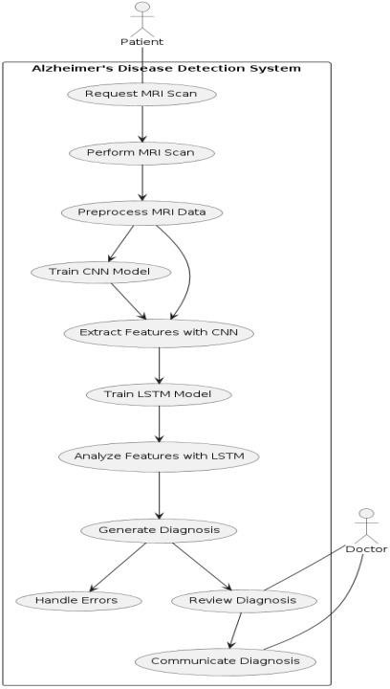

The UML diagram illustrates an Alzheimer's Disease Detection System, starting with a patient's MRI scan request and performance. The system preprocesses the MRI data, trains a CNN model to extract features, and then utilizes an LSTM model for feature analysis. The system generates a diagnosis based on these analyses. The diagnosis is then reviewed by a doctor, communicated to the patient, and any errors are handled.

# CHAPTER 5 ARCHITECTURE DIAGRAM

## System architecture

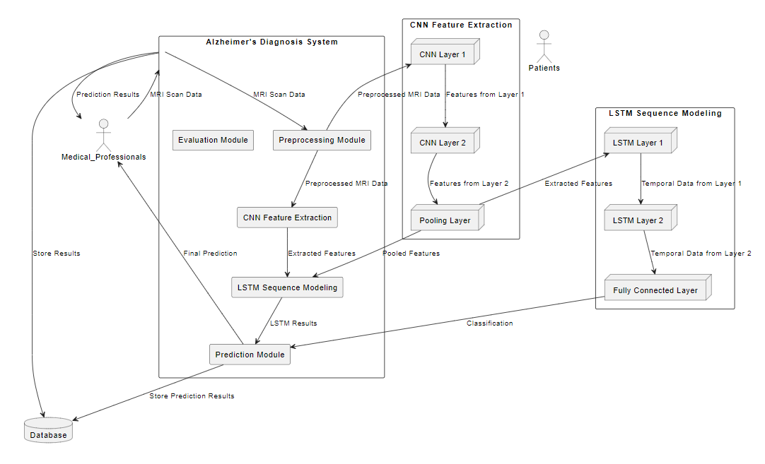

This system architecture diagram illustrates a process for Alzheimer's Disease diagnosis using deep learning. It begins with inputting raw MRI data, which undergoes feature extraction using a 3D convolutional neural network (CNN). The extracted features are processed by an LSTM (Long Short-Term Memory) network to make predictions. Training and evaluation involve adjusting hyperparameters and defining the model. The trained model is then tested for accuracy. Finally, the process includes testing and optimizing the model, clearing gradients, and managing CUDA memory.

# CHAPTER 6

# 6.1 DFD Diagram

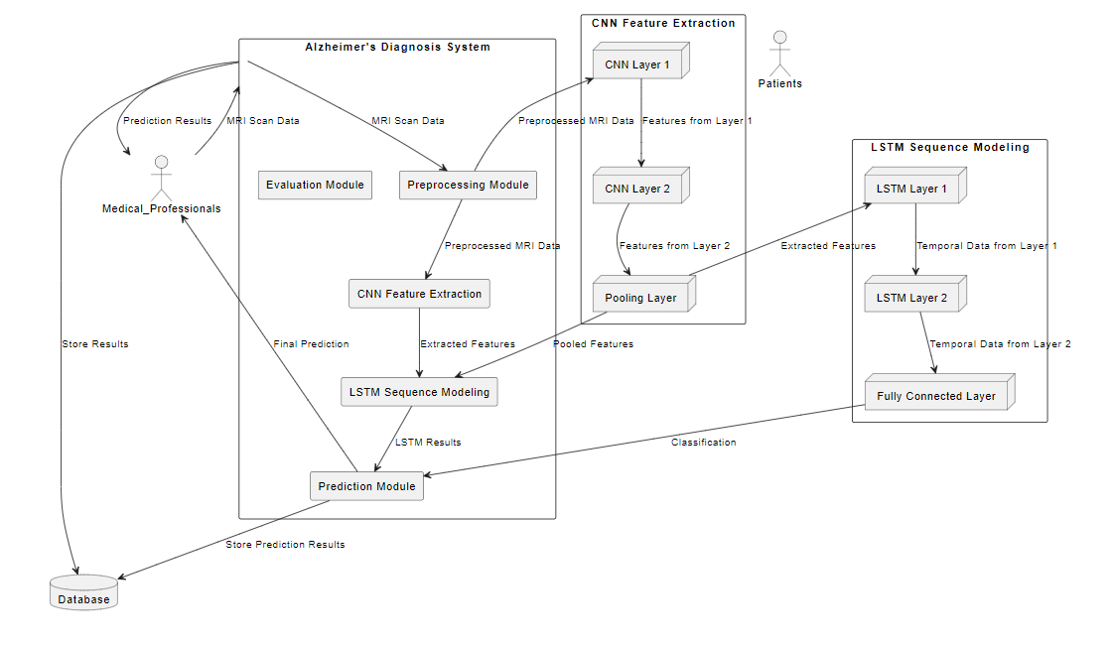

Level 0 DFD (Context Diagram): The Alzheimer’s Diagnosis System receives MRI scan data from clinicians, processes it, and returns predictions, which are stored in a database or shared with clinicians.

Level 1 DFD (Internal Processes): The system preprocesses MRI data, extracts spatial features using CNN, models temporal patterns with LSTM, and provides a final Alzheimer’s diagnosis, evaluated by performance metrics.

Level 2 DFD (Detailed Breakdown): CNN layers extract spatial features, LSTM layers analyze temporal sequences, and a fully connected layer generates the final classification result for Alzheimer’s prediction

# CHAPTER 7

# MS PLANNER

# MS PLANNER SCREENSHOTS

# 

# CHAPTER 8

# CODE

# IMPLEMENTATION

# 

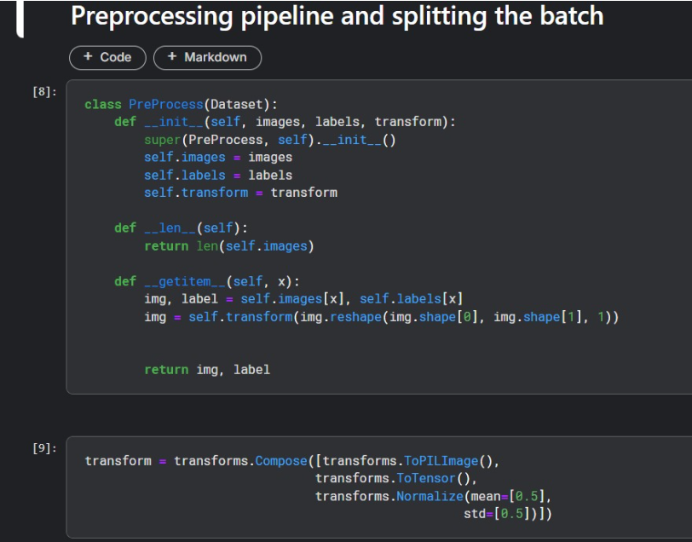

# 

# 

# 

# 

# 

**CHAPTER 9**

**CONCLUSION**

Our team's performance with CNN-LSTM for Alzheimer's disease prediction, in general, is encouraging, though room for improvement exists in areas. The loss on the training set steadily decreased during training and showed a general learning of the model to capture the underlying patterns in the data. However, the periodic fluctuations in the validation loss hint towards some instability, probably reflected as overfitting at some epoch. While training accuracy improves smoothly, the performance on the validation set shows more variability, indicating generalization problems across the validation set.

The model does pretty well on Class 2 in terms of evaluation metrics, with precision at 0.76, recall at 0.72, and F1 at 0.74; but Class 3 is worst, with recall of only 0.51, giving an F1 score of 0.58.

This shows that the model is missing many true positives for this class. Our total accuracy is 0.62, indicating it's about a mid-range performance, but it's the macro average F1 score of 0.33 that really shows there's an imbalance in how the model approaches different classes, with a more strongly performed Class 2 than Class 3. Many of these issues can be handled with regularization methods by applying dropout or weight decay in order to prevent overfitting and stabilize the results in the validation set. Class weighting, data augmentation, or resampling are some other strategies for class imbalance, where the generative ability of the model gets improved. The approach might apply fine-tuning of hyperparameters like learning rate or batch size to avoid overfitting along with the early stopping. Finally, with a focus on enhancing the recall for Class 3, be it through model alteration or additional data, we can enhance the model generally to make better predictions on who might have Alzheimer's disease.

# CHAPTER 10 REFERENCES

* + - [**https://ieeexplore.ieee.org/abstract/document/9521165?casa_token=8l**](https://ieeexplore.ieee.org/abstract/document/9521165?casa_token=8lyvdGTqEPUAAAAA%3AhvcmIjM_dEdgaLn1C_hcHWkhfbPwS783k29-Cqf7dts7UWJF-b5ngikgbthXfg4ZvWFIT-PsNA)[**yvdGTqEPUAAAAA:hvcmIjM_dEdgaLn1C_hcHWkhfbPwS783k29**](https://ieeexplore.ieee.org/abstract/document/9521165?casa_token=8lyvdGTqEPUAAAAA%3AhvcmIjM_dEdgaLn1C_hcHWkhfbPwS783k29-Cqf7dts7UWJF-b5ngikgbthXfg4ZvWFIT-PsNA)

## [-Cqf7dts7UWJF-b5ngikgbthXfg4ZvWFIT-PsNA](https://ieeexplore.ieee.org/abstract/document/9521165?casa_token=8lyvdGTqEPUAAAAA%3AhvcmIjM_dEdgaLn1C_hcHWkhfbPwS783k29-Cqf7dts7UWJF-b5ngikgbthXfg4ZvWFIT-PsNA)

* + - [**https://onlinelibrary.wiley.com/doi/full/10.1155/2008/403896**](https://onlinelibrary.wiley.com/doi/full/10.1155/2008/403896)
    - [**https://ieeexplore.ieee.org/abstract/document/8737996**](https://ieeexplore.ieee.org/abstract/document/8737996)
    - [**https://ieeexplore.ieee.org/abstract/document/8888197?casa_token=b**](https://ieeexplore.ieee.org/abstract/document/8888197?casa_token=bwNZCA6RAUgAAAAA%3AUghnjruUU_7acMDSIEXLGnt5EZdMsvKbZKK5OYyFjziVuWUfgFhxOQLcSMIbgz3fEN_y7BMcog)[**wNZCA6RAUgAAAAA:UghnjruUU_7acMDSIEXLGnt5EZdMsvKb**](https://ieeexplore.ieee.org/abstract/document/8888197?casa_token=bwNZCA6RAUgAAAAA%3AUghnjruUU_7acMDSIEXLGnt5EZdMsvKbZKK5OYyFjziVuWUfgFhxOQLcSMIbgz3fEN_y7BMcog)[**ZKK5OYyFjziVuWUfgFhxOQLcSMIbgz3fEN_y7BMcog**](https://ieeexplore.ieee.org/abstract/document/8888197?casa_token=bwNZCA6RAUgAAAAA%3AUghnjruUU_7acMDSIEXLGnt5EZdMsvKbZKK5OYyFjziVuWUfgFhxOQLcSMIbgz3fEN_y7BMcog)
    - [**https://www.ncbi.nlm.nih.gov/pmc/articles/PMC8249997/**](https://www.ncbi.nlm.nih.gov/pmc/articles/PMC8249997/)