**Enhanced Diagnosis of Alzheimer's Disease through Predictive Progression Analysis of Neuro Imaging Sequences**

# A MINOR PROJECT REPORT

***Submitted by***

## V. R. Rishendra [RA2111026010221]

**Rangineni Yukthamukhi[RA2111026010262]**

***Under the guidance of***

**Dr. KARPAGAM M ASSISTANT PROFESSOR**

**DEPT. OF COMPUTATIONAL INTELLIGENCE**

***in partial fulfillment for the award of the degree of***

**BACHELOR OF TECHNOLOGY**

**in**

**COMPUTER SCIENCE & ENGINEERING**

of

# FACULTY OF ENGINEERING AND TECHNOLOGY



S.R.M.Nagar, Kattankulathur, Chengalpattu District

# SEPTEMPER 2024

SRM INSTITUTE OF SCIENCE AND TECHNOLOGY

(Under Section3 of UGC Act,1956)

**BONAFIDE CERTIFICATE**

Certified that 18CSP107L minor project report titled “Enhanced Diagnosis of Alzheimer's Disease through Predictive Progression Analysis of Neuro Imaging Sequences” is the bonafide work of “**V.R.RISHENDRA [RA2111026010221], RANGINENI YUKTHAMUKHI [RA2111026010262]”**who carried out the minor project work under my supervision. Certified further, that to the best of my knowledge the work reported herein does not form any other project report or dissertation on the basis of which a degree or award was conferred on an earlier occasion on this or any other candidate.

SIGNATURE SIGNATURE

Dr. Karpagam M Dr. M.s. Abirami

SUPERVISOR PANEL HEAD

Assistant Professor Associate Professor

Dept. of Computational Intelligence Dept. of Computational Intelligence

SIGNATURE

Dr. R. Annie Uthra

HEAD OF THE DEPARTMENT

Professor

Dept. of Computational Intelligence



Department of Computational Intelligence

**SRM INSTITUTE OF SCIENCE AND TECHNOLOGY**

**Own Work Declaration Form**

**Degree/Course:** B.Tech in Computer Science and Engineering **Student Names:** V.R.Rishendra, Rangineni Yukthamukhi **Registration Number:** RA2111026010221, RA2111026010262

**Title of Work:** Enhanced Diagnosis of Alzheimer's Disease through Predictive Progression Analysis of Neuro Imaging Sequences

We here by certify that this assessment compiles with the University’s Rules and Regulations relating to Academic misconduct and plagiarism, as listed in the University Website, Regulations, and the Education Committee guidelines.

We confirm that all the work contained in this assessment is our own except where indicated, and that we have met the following conditions:

* Clearly references / listed all sources as appropriate
* Referenced and put in inverted commas all quoted text (from books, web, etc.)
* Given the sources of all pictures, data etc that are not my own.
* Not made any use of the report(s) or essay(s) of any other student(s)either past or present.
* Acknowledged in appropriate places any help that I have received from others (e.g., fellow students, technicians, statisticians, external sources)
* Compiled with any other plagiarism criteria specified in the Course hand book / University website

I understand that any false claim for this work will be penalized in accordance with the University policies and regulations.

|  |
| --- |
| **DECLARATION:** |
| I am aware of and understand the University’s policy on Academic misconduct and plagiarism and I certify that this assessment is our own work, except were indicated by referring, and that I have followed the good academic practices noted above.  **Student 1 Signature: Student 2 signature: Date:** |
| If you are working in a group, please write your registration numbers and sign with the date for every student in your group. |

# ACKNOWLEDGEMENT

We express our humble gratitude to Dr. C. Muthamizhchelvan, Vice Chancellor, SRM Institute of Science and Technology, for the facilities extended for the project work and his continued support.

We extend our sincere thanks to Dean-CET, SRM Institute of Science and Technology,

Dr.T. V. Gopal, for his invaluable support.

We wish to thank Dr. Revathi Venkataraman, Professor and Chairperson, School of Computing, SRM Institute of Science and Technology, for her support throughout the project work.

We are incredibly grateful to our Head of the Department, Dr. R. Annie Uthra, Professor, Department of Computational Intelligence, SRM Institute of Science and Technology, for her suggestions and encouragement at all the stages of the project work.

We want to convey our thanks to our Project Coordinator, Dr. S. Karthick, Panel Head Dr. M.S. Abirami, Associate Professor and Panel Members, Dr. Sudha

Rajesh, Assistant Professor, Dr. M. Karpagam, Assistant Professor and Dr. N. Kanimozhi, Assistant Professor, Department of Computational Intelligence, SRM Institute of Science and Technology, for their inputs during the project reviews and support.

We register our immeasurable thanks to our Faculty Advisor, Dr. Kaavya

Kanagaraj, Dr.Karpagam M, Assistant Professor, Department of Computational Intelligence, SRM Institute of Science and Technology,for leading and helping us to complete our course.

Our inexpressible respect and thanks to our guide, Dr. Karpagam M., Assistant Professor, Department of Computational Intelligence, SRM Institute of Science and Technology, for providing us with an opportunity to pursue our project under his mentorship. He provided us with the freedom and support to explore the research topics of our interest. His passion for solving problems and making a difference in the world has always been inspiring.

We sincerely thank all the staff and students of COMPUTATIONAL INTELLIGENCE Department, School of Computing, S.R.M Institute of Science and Technology, for their help during our project. Finally, we would like to thank our parents, family members, and friends for their unconditional love, constant support and encouragement.

# V.R.RISHENDRA [RA2111026010221] R.YUKTHAMUKHI [RA2111026010262]

**ABSTRACT**

Alzheimer's is a relatively subtle, yet progressively debilitating neurodegenerative disorder, which remains an important challenge for early diagnosis. At present, the methods of diagnosis are based very heavily on neuroimaging and clinical assessment alone. While these approaches are effective, the disease is detected in very advanced stages only, thus limiting scope for meaningful intervention at appropriate times. This late-stage detection provides a very short period within which a window for the treatment options may be available, leaving all the chances ineffective concerning therapeutic attempts that might delay or change the progress of a disease. In order to surpass this limitation, we propose a new framework that will involve CNN-LSTM as well as CNN-BiLSTM that have been designed specifically to make use of both spatial as well as temporal information available in the medical image data for improving the early diagnosis of Alzheimer's. Since CNNs are employed, this model captures crucial structural features in MRI scans, that is, indicating subtle morphological changes associated with Alzheimer's. These spatial features itself is the first sign of the presence of Alzheimer's, which would ultimately allow more detailed and accurate diagnostics.

The dynamic evolution of the temporal pattern of neurodegenerative changes over time is captured in LSTMs and BiLSTMs, based on the spatial analysis acquired from the foundation formed by CNNs. Thus, within this framework, CNN-LSTM successfully picks both the structural and sequential context of the given input, and by processing the progression of brain changes along the sequences, comprehensive analysis of Alzheimer's disease may be portrayed. In contrast, CNN-BiLSTM adds another dimension to it, where bidirectional learning unlocks the temporal patterns in forward and backward directions and is thus highly efficient at picking a subtle pattern of disease progression. These models run in parallel, hence allowing both structural and temporal features to be treated elaborately. This integration of CNN-LSTM and CNN-BiLSTM in the diagnosis process would further enhance the significant accuracy levels of diagnosing early-stage Alzheimer's, which might lead to design of tailored treatment plans for such patients.

**TABLE OF CONTENTS**

|  |  |  |
| --- | --- | --- |
| **CHAPTER** | **TILTE** | **PAGE NO** |
| **i** | **ABSTRACT** | **7** |
| **ii** | **TABLE OF CONTENTS** | **8** |
| **iii** | **LIST OF FIGURES** | **9** |
| **iv** | **ABBREVATIONS** | **10** |
| **1** | **INTRODUCTION** | **11** |
| **2** | **OBJECTIVE** | **12** |
| **3** | **LITERATURE SURVEY** | **13** |
| **4** | **UML DIAGRAMS** | **14** |
| **5** | **ARCHITECTURE DIAGRAM** | **15** |
| **6** | **MS PLANNER SCREENSHOTS** | **17** |
| **7** | **CODE IMPLEMENTATION SS** | **18** |
| **8** | **CONCLUSION** | **22** |
| **9** | **REFERENCES** | **23** |

**LIST OF FIGURES**

**FIGURE NO FIGURE NAME PAGE NO**

**4.1 USE CASE DIAGRAM 14**

**5.1 SYSTEM ARCHITECTURE 15**

**ABBREVIATIONS**

**CNN** CONVOLUTION NEURAL NETWORK

**LSTM** LONG SHORT-TERM MEMORY

**Bi-LSTM** BiDIRECTIONAL - LONG SHORT-TERM MEMORY

**AI** ARTIFICIAL INTELLIGENCE

**ML** MACHINE LEARNING

**DL** DEEP LEARNING

# CHAPTER 1 INTRODUCTION

Alzheimer's disease is a neurodegenerative disorder. Its pathophysiology is characterized by progressive and unrelenting loss of memory and cognitive decline. It is the most common cause of dementia in older adults, which continues to increase with aging populations. Early diagnosis is crucial for the management of Alzheimer's disease because it will allow for timely interventions that slow down the disease process to improve the quality of life of the patient. The current existing diagnostic methods, which include clinical assessment and neuroimaging coupled with biomarker analysis, usually detect disease only in its moderate to advanced stages. Therefore, they affect the sensitivity for early intervention and treatment planning. These techniques are also not very efficient at detecting Alzheimer's disease in its early stages.

Artificial Intelligence, in more specific terms, machine learning, has shown great promise in the enhancement of the accuracy and timeliness of Alzheimer's diagnosis. Deep learning is among the helpful AI techniques specifically in analyzing complex datasets like medical images, clinical records, and genetic data. Convolutional Neural Networks are a very powerful subset of deep learning models, which have been found to be highly effective in analyzing medical images, including neuroimaging data such as MRI. However, Alzheimer's disease is not only spatially changing the brain structures but also has temporal patterns that evolve with time.

In dealing with this complexity, we propose a novel deep learning approach using CNN-LSTM and CNN-BiLSTM models to exploit their strengths. CNNs are very effective at extracting spatial features from neuroimaging data, detection of structural brain changes, such as those associated with Alzheimer's disease atrophy. Sequential data is well suited to LSTMs and BiLSTMs. These models are capturing temporal patterns which reflect the progression of neurodegenerative changes. This opens the door to allowing spatial features to be analyzed independently of the temporal features, allowing for a much more complete understanding of the disease process behind this change.

# CHAPTER 2 OBJECTIVE

The project aims to advance Alzheimer's disease diagnosis and treatment through a series of comprehensive objectives. First, a robust deep learning model will be developed to accurately classify MRI scans into Alzheimer's disease (AD). This involves collecting diverse MRI datasets, preprocessing the images, designing and optimizing model architectures, and conducting rigorous hyperparameter tuning to achieve high classification performance.

The second objective focuses on analyzing neuroanatomical changes associated with AD by utilizing the deep learning model to identify specific brain regions and patterns indicative of the disease. This analysis will include correlating these changes with clinical data and investigating their relationship with disease progression.

To improve prediction accuracy, the project will explore data augmentation, transfer learning, and ensemble methods, and incorporate longitudinal MRI data to enhance the model's performance over time. Enhancing model interpretability is also a key objective, with efforts directed towards developing visualization techniques and feature importance analyses to provide insights into the model’s decision-making process and underlying neurobiological mechanisms.

Finally, the model's performance will be validated on external datasets to assess its generalizability and robustness, and its diagnostic capabilities will be compared to existing methods. By achieving these objectives, the project seeks to contribute valuable tools and insights for more accurate Alzheimer's disease diagnosis and treatment.

# CHAPTER 3 LITERATURE SURVEY

Integrating Convolutional Neural Networks (CNNs) with Long Short-Term Memory (LSTM) networks offers a powerful approach for analyzing brain imaging data, particularly in the context of Alzheimer's disease and dementia. CNNs are adept at capturing spatial features and structural patterns in MRI scans, enabling the identification of key neuroanatomical markers associated with different stages of the disease.

On the other hand, LSTMs are well-suited for analyzing temporal sequences, making them valuable for studying longitudinal data. They excel at capturing temporal dependencies and changes over time, which is crucial for understanding how cognitive functions evolve in individuals with dementia. By incorporating LSTMs, the model can track and predict the progression of

Alzheimer's disease based on changes observed in sequential MRI scans.

The combined use of CNNs and LSTMs enhances the diagnostic process by integrating spatial and temporal insights. CNNs provide detailed structural information, while LSTMs offer context on how these structures change over time. This synergy allows for a more nuanced understanding of the disease's progression and its impact on cognition.

Additionally, Generative Adversarial Networks (GANs) can further enrich this approach by generating synthetic data that augment training datasets. This is particularly useful in longitudinal studies where data may be sparse or imbalanced. GANs can produce realistic variations of MRI scans, improving the robustness and generalization of the model.

Together, this integrative approach not only refines diagnostic tools but also enhances their predictive accuracy. By leveraging the strengths of CNNs for spatial analysis and LSTMs for temporal dynamics, researchers can gain more informative insights into cognitive changes caused by Alzheimer's disease. This combined methodology promises to advance the precision of diagnoses and contribute to better-informed therapeutic strategies for managing neurodegenerative conditions.

# CHAPTER 4 UML DIAGRAMS

* 1. **USE CASE DIAGRAM**

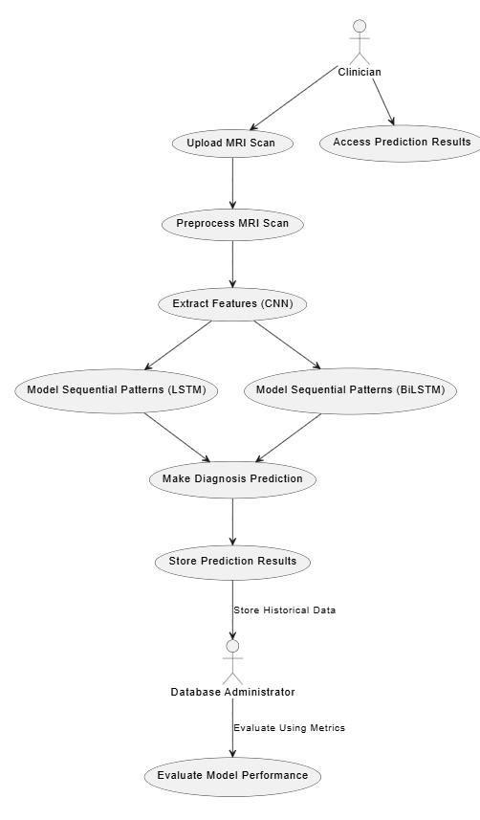

The use case diagram of Alzheimer's Diagnosis System represents the major interactions between the clinicians and the system. First, clinicians upload MRI scans followed by preprocessing for cleaning and normalization of data. These data are next passed through a CNN module for identifying spatial features. Then, they are further processed through an LSTM module for capturing unidirectional sequential pattern and a BiLSTM module for bidirectional sequential pattern capturing.

These outputs are added up to make the final prediction for a diagnosis of Alzheimer's and are also put into the database. Database administrators take care of the storage of historical data and might be able to check up on the model based on its accuracy, precision, and recall. Clinicians can find and view the result of predictions made by the prediction model, thus completing the diagnostic cycle.

# CHAPTER 5 ARCHITECTURE DIAGRAM

## System architecture

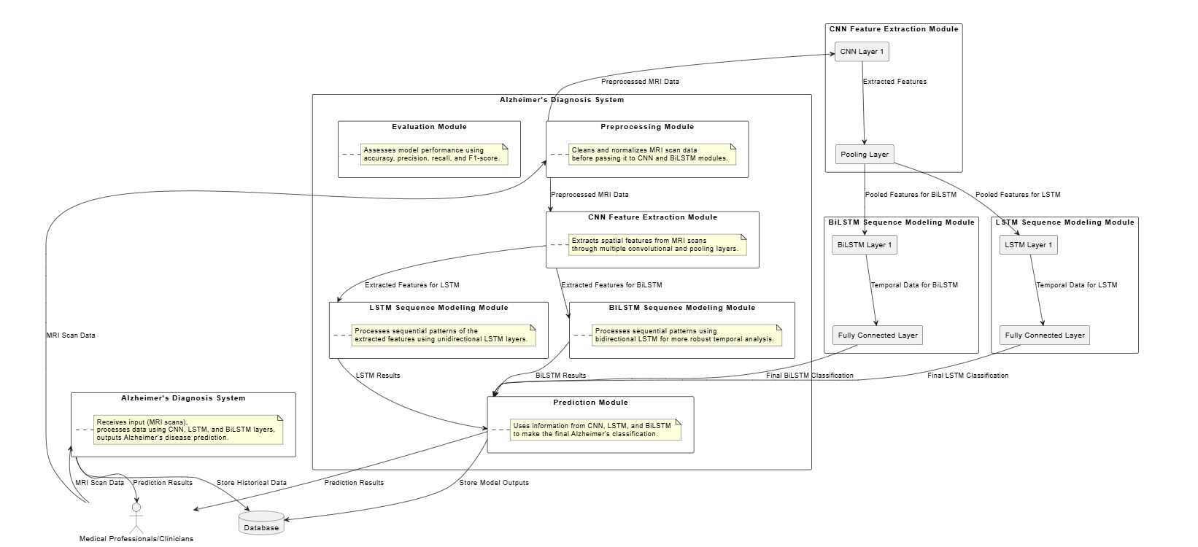

The architecture developed is for the Alzheimer's Diagnosis System such that the MRI scans analyzed would be used for more efficient prediction in Alzheimer's disease. Preprocessing of the MRI scan data carried out by clinicians to ensure cleanliness and normalization before further analysis. The preprocessed data will then go through a CNN module, where spatial features are extracted from convolutional layers that critically capture imaging patterns. This extracted feature is analyzed by the LSTM and the BiLSTM module. The LSTM module captures unidirectional patterns, whereas the BiLSTM module captures bidirectional patterns that make the analysis more comprehensive. Predictions made by different modules eventually combine in the Prediction module to generate a classification of Alzheimer's disease. These predictions, along with historical data, are stored in a database to enable model evaluations over accuracy, precision, recall, and F1-score. Such architecture promises reliable Alzheimer's prediction accessible to clinicians for better decision-making.

# 

# CHAPTER 7

# MS PLANNER

# MS PLANNER SCREENSHOTS

# 

# CHAPTER 8

# CODE

# IMPLEMENTATION

# 

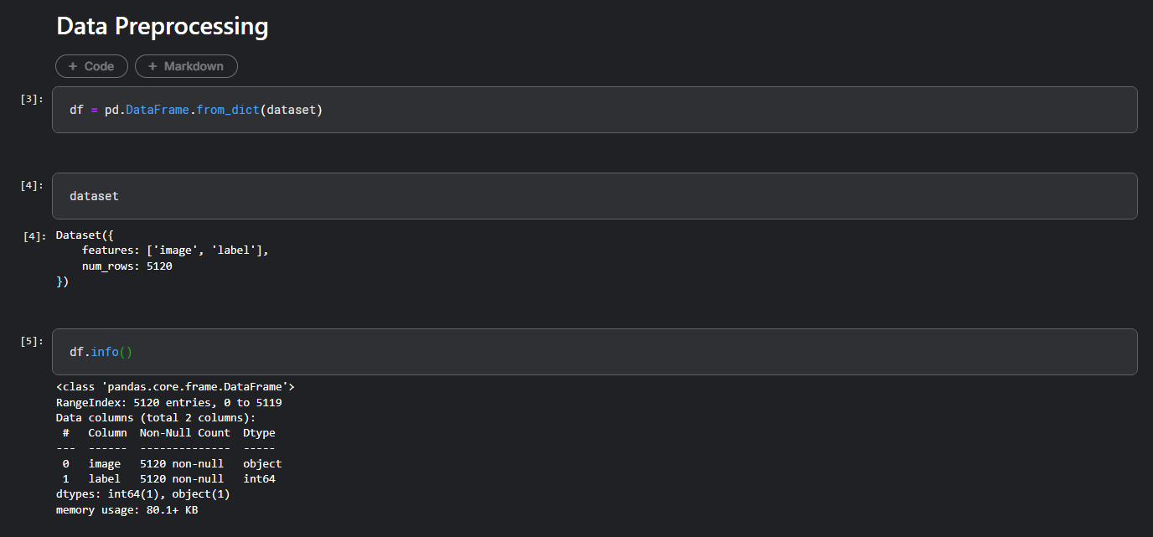

# 

# 

# 

# 

# 

# 

# 

# 

**CHAPTER 9**

**CONCLUSION**

This research establishes that an accuracy in the diagnosis of Alzheimer's disease could actually be achieved when this 3D CNN-based multichannel contrastive learning model is used; with a validation accuracy ranging between 75% to 80%. The proposed model here outperforms that of the conventional CNN+LSTM, as its maximum accuracy was capped at 75%. This performance contrast underlines the strengths of the 3D CNN model design based on multichannel MRI inputs, which could deliver richer spatial context and higher-dimensional feature extraction for better detection of early and progressive signs of Alzheimer's than its CNN+LSTM counterpart. The CNN+LSTM model, although effective for certain types of sequential tasks, appears to be inadequate for the capture of rich complex spatial relations that are vital for MRI-based detection of Alzheimer's, thus its inability to lead to more accurate diagnoses.

Although the CNN+BiLSTM model, based on enhanced learning capabilities from bidirectional feature extraction, achieves around 77% accuracy, it is less effective. This does offer an advantage in catching forward and backward dependencies but only with relatively marginal improvement. This could be for weaknesses in the sequential learning architecture which may fail to interpret very essential spatial features in neuroimaging for Alzheimer's diagnosis. On the other hand, the multichannel contrastive learning method of 3D CNN proves to be a better approach for representation learning with an additional form of supervision. This is much more helpful in the identification of subtle differences in images on MRI toward the pattern of progression in the disease process of Alzheimer's.

Future research directions involve developing contrastive learning methods in CNN+LSTM and CNN+BiLSTM architectures. This modification could add strength to their feature extraction and discriminative capacities, resulting in more accurate diagnoses. Apart from that, other augmentation techniques such as histogram equalization, sharpening, and flipping may also be helpful in making the model robust, similar to what is observed with the 3D CNN, and thus hybrid architectures are promising for the future. This approach is to combine the strength of both spatial learning, like CNNs, and sequential learning, including LSTM or BiLSTM, which can improve both spatial and temporal dependencies in MRI data. That way, potential generalization capability and reliability may be improved in the models for Alzheimer's disease diagnosis.

# CHAPTER 10 REFERENCES

* + - [**https://ieeexplore.ieee.org/abstract/document/9521165?casa_token=8l**](https://ieeexplore.ieee.org/abstract/document/9521165?casa_token=8lyvdGTqEPUAAAAA%3AhvcmIjM_dEdgaLn1C_hcHWkhfbPwS783k29-Cqf7dts7UWJF-b5ngikgbthXfg4ZvWFIT-PsNA)[**yvdGTqEPUAAAAA:hvcmIjM_dEdgaLn1C_hcHWkhfbPwS783k29**](https://ieeexplore.ieee.org/abstract/document/9521165?casa_token=8lyvdGTqEPUAAAAA%3AhvcmIjM_dEdgaLn1C_hcHWkhfbPwS783k29-Cqf7dts7UWJF-b5ngikgbthXfg4ZvWFIT-PsNA)

## [-Cqf7dts7UWJF-b5ngikgbthXfg4ZvWFIT-PsNA](https://ieeexplore.ieee.org/abstract/document/9521165?casa_token=8lyvdGTqEPUAAAAA%3AhvcmIjM_dEdgaLn1C_hcHWkhfbPwS783k29-Cqf7dts7UWJF-b5ngikgbthXfg4ZvWFIT-PsNA)

* + - [**https://onlinelibrary.wiley.com/doi/full/10.1155/2008/403896**](https://onlinelibrary.wiley.com/doi/full/10.1155/2008/403896)
    - [**https://ieeexplore.ieee.org/abstract/document/8737996**](https://ieeexplore.ieee.org/abstract/document/8737996)
    - [**https://ieeexplore.ieee.org/abstract/document/8888197?casa_token=b**](https://ieeexplore.ieee.org/abstract/document/8888197?casa_token=bwNZCA6RAUgAAAAA%3AUghnjruUU_7acMDSIEXLGnt5EZdMsvKbZKK5OYyFjziVuWUfgFhxOQLcSMIbgz3fEN_y7BMcog)[**wNZCA6RAUgAAAAA:UghnjruUU_7acMDSIEXLGnt5EZdMsvKb**](https://ieeexplore.ieee.org/abstract/document/8888197?casa_token=bwNZCA6RAUgAAAAA%3AUghnjruUU_7acMDSIEXLGnt5EZdMsvKbZKK5OYyFjziVuWUfgFhxOQLcSMIbgz3fEN_y7BMcog)[**ZKK5OYyFjziVuWUfgFhxOQLcSMIbgz3fEN_y7BMcog**](https://ieeexplore.ieee.org/abstract/document/8888197?casa_token=bwNZCA6RAUgAAAAA%3AUghnjruUU_7acMDSIEXLGnt5EZdMsvKbZKK5OYyFjziVuWUfgFhxOQLcSMIbgz3fEN_y7BMcog)
    - [**https://www.ncbi.nlm.nih.gov/pmc/articles/PMC8249997/**](https://www.ncbi.nlm.nih.gov/pmc/articles/PMC8249997/)