**Please run the below commands to setup your system with Docker:**

1. Install python 3 and Docker in your system
2. Setup Virtual Environment in your system using ***“pip install virtualenv”***
3. Create virtual environment for running application **“virtualenv --python=python3 assign”**
4. Activate virtual environment **“*assign/Scripts/activate”*  [Windows]**
5. Install required packages using “***pip install –r requirements.txt***”
6. Build docker image using ***“docker build -t web:latest .”***
7. Run Docker image in local setup using

***“docker run -d --name django-docker -e "PORT=8765" -e "DEBUG=1" -p 8007:8765 web:latest”***

1. Open your browser with **“*localhost:8007/api/upload”***
2. ***For stopping docker run below commands:***

* ***docker stop django-docker***
* ***docker rm django-heroku***

1. *Install Postman in your system*

***If Docker is not setup in your system follow the below instructions:***

1. Install python 3 in your system
2. Setup Virtual Environment in your system using ***“pip install virtualenv”***
3. Create virtual environment for running application **“virtualenv --python=python3 assign”**
4. Activate virtual environment **“*assign/Scripts/activate”*  [Windows]**
5. Install required packages using “***pip install –r requirements.txt***”
6. For running server ***“python manage.py runserver”***
7. ***By default it will run on 127.0.0.1:80 or localhost***
8. *Install Postman in your system*

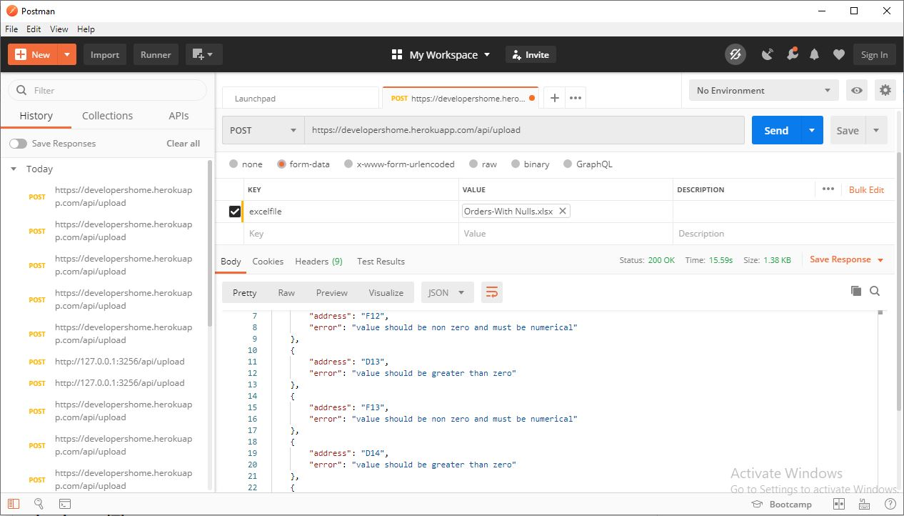

1. Use “***127.0.0.1:8000/api/upload”*** as your api for checking and validating your excel sheet data in web cloud
2. Use ***“excelfile”*** *as a parameter value for post request*
3. *Select* ***“file”*** *from dropdown in* ***“body form”*** *for sending file to server*
4. *You can use* ***“Orders-With Nulls.xlsx”*** present in ***”unit_test”*** folder for your reference if you don’t have any.**
5. *Wait for the response which will state error and address*
6. Create super user using “**python manage.py createsuperuser**” 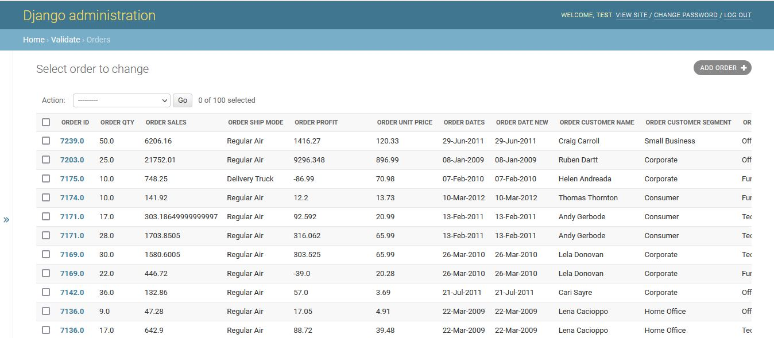
7. Login in admin dashboard for viewing saved data in database for future reference