Assignment : STUDIO SLEEVESUP PRIVATE LIMITED

Github URL : https://github.com/VRS-3999/card-trade-app

Compatibility : Desktop View
Retriving data from Json File : src/utils/CarCatalog.ts

Online Presence : http://164.52.216.51:4000/

Deployed using dockers in E2E Server
Dashboard with filter available (Right now matchs exactly similar subset of letters inputted ):
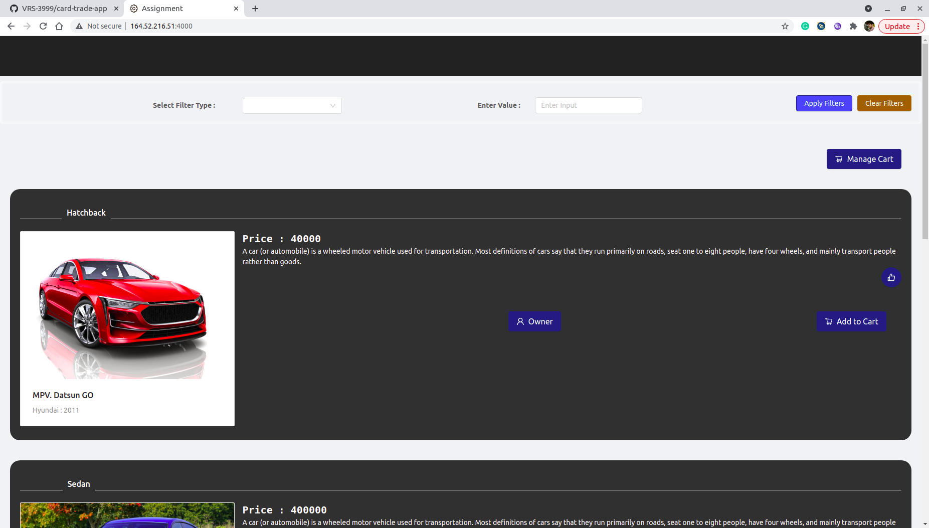

Filter Type:
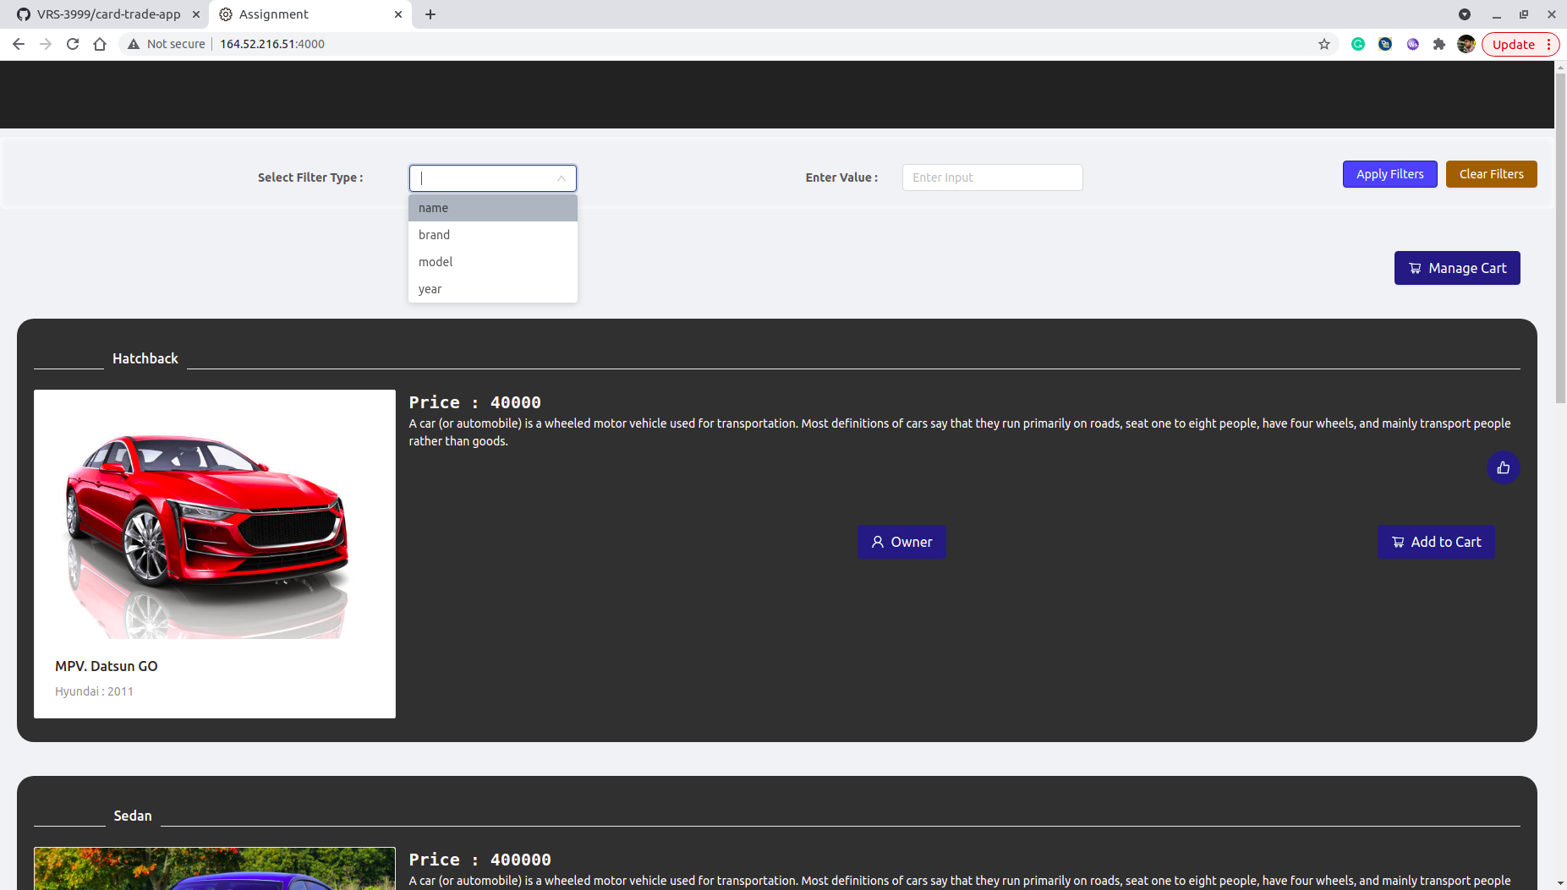
After Filter is Applied:
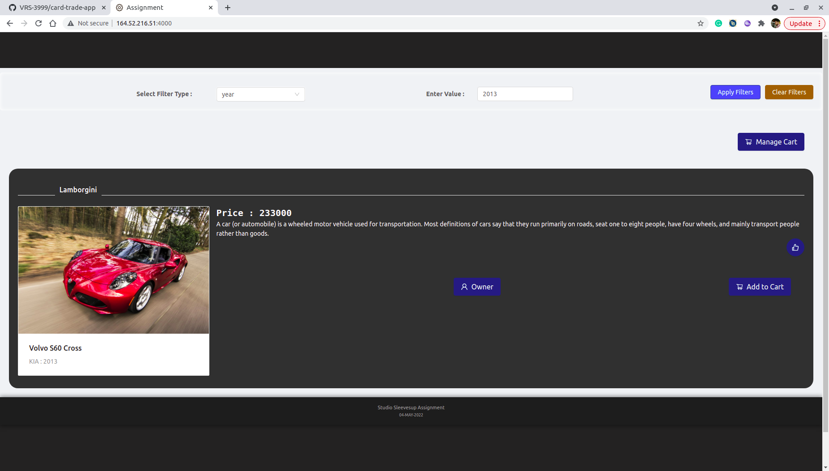

Owner Information
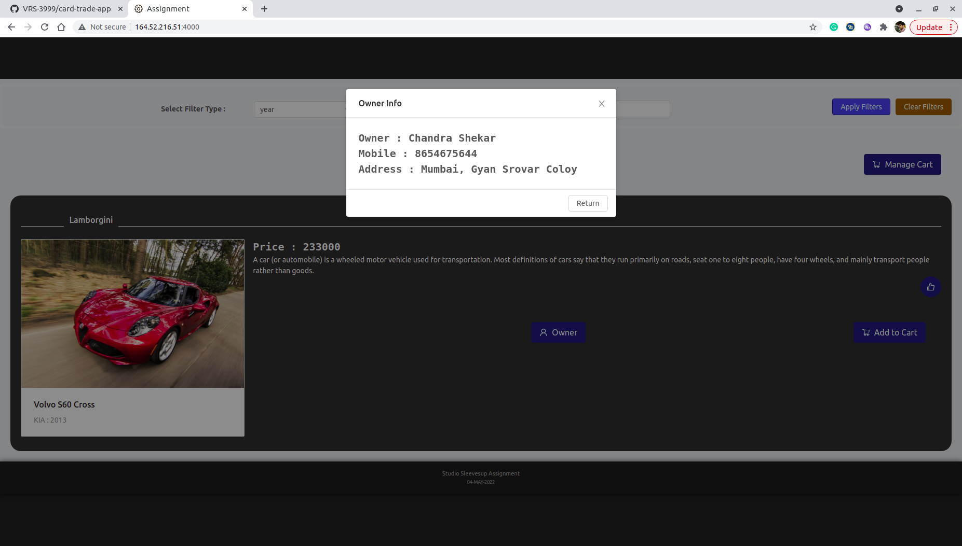

Add To Card (button color will change into green)
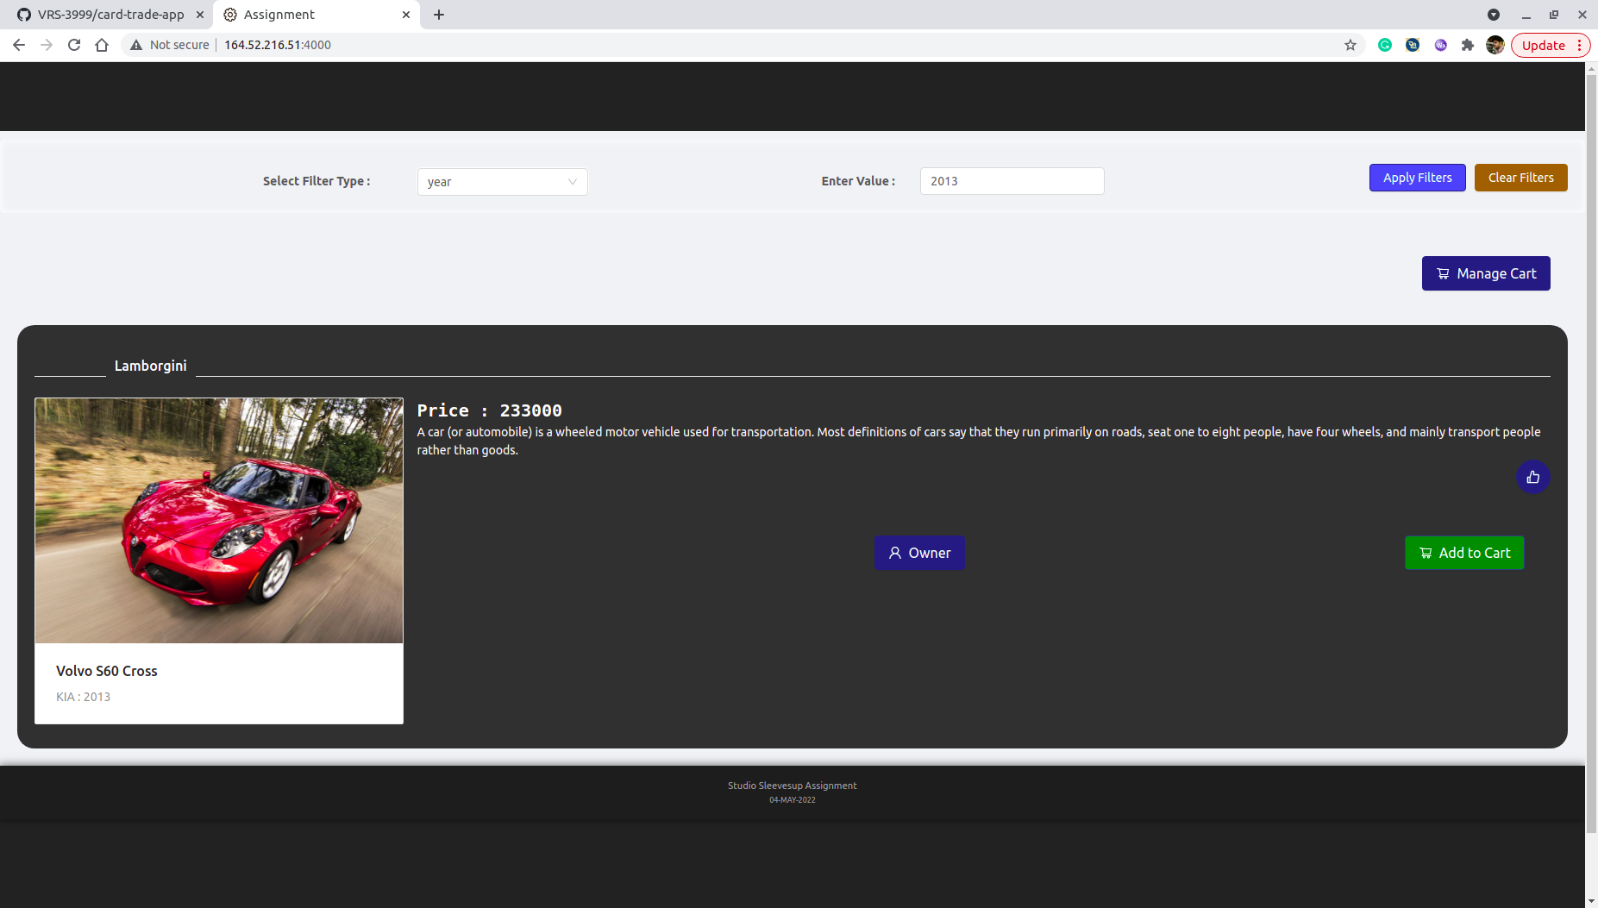

Add to Favourite (Button color will change into green)
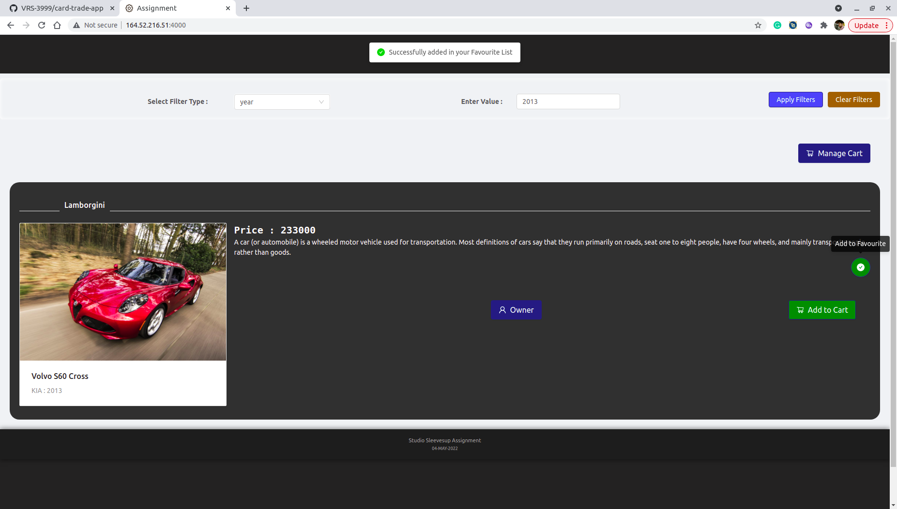

Checkout (Right now only Total Price is calculated) : Click on Manage Cart
