Optimal-Length Low-Perplexity Region Calling Reveals Quantitative G-Quadruplex, Z-DNA, and eGZ-DNA Enrichment at Human Core Promoters
A methods extension of Gummadi & Yella (2025), Biochemical Genetics
[Author names to be added]

Abstract
Dinucleotide sequence perplexity is a conserved, motif-independent marker of cis-regulatory DNA, with population-averaged minima consistently located 40–60 base pairs upstream of transcription start sites (TSS) across diverse taxa (Gummadi & Yella, 2025). That earlier work characterised the signal by visual inspection of averaged profiles and did not provide a method for delimiting low-perplexity regions in individual sequences, nor a statistical test of whether the signal exceeds what dinucleotide composition alone predicts. Here we introduce a region-calling algorithm based on the length-bounded minimum-mean contiguous subarray problem — a provably optimal generalisation of Kadane's maximum-subarray algorithm — that delimits the exact boundaries of low-perplexity regions in single promoter sequences using one user-set parameter (minimum region length). Applied to all 10,501 human promoter sequences from the Eukaryotic Promoter Database (-3,000 to +3,000 bp relative to TSS), the algorithm recovers the population-level minimum at −45 bp, exactly reproducing the published finding. At the level of individual promoters, detected regions are significantly deeper than dinucleotide-shuffled controls (Mann-Whitney p = 6.3×10⁻⁴, Cohen's d = −0.29, n = 270 real vs. 721 shuffled), demonstrating that the signal is not fully explained by local dinucleotide composition. Within detected regions, G-quadruplex motifs are enriched to a frequency unattainable by chance (10.25% observed vs. 0% expected, p = 2.5×10⁻²⁷⁵), as are i-motif (10.11%, p = 2.0×10⁻²⁷¹), Z-DNA-forming sequence (4.47% observed vs. 0.15% expected, 29.5-fold, p = 8.4×10⁻⁹⁸), and the eGZ-DNA subclass formed within expanded CGG/GGC repeats (1.02% vs. 0% expected, p = 5.2×10⁻²⁷) — the Z-DNA and eGZ-DNA detection grammar guided by the dinucleotide-step scoring framework of Non-B DNA Finder (Yella, Gummadi & Kumar, 2026). These results provide the first direct quantitative test of a relationship that was previously stated as speculative. We release the algorithm, a reusable open-source tool, and the complete annotated region set for the human promoterome.

Introduction
Cis-regulatory regions organise the grammar of transcription through a layered set of signals: promoter motifs, transcription factor binding sites, CpG islands, nucleosome-positioning sequences, and non-canonical DNA structures (Riethoven, 2010; Weingarten-Gabbay & Segal, 2014). Many of these signals are taxon-specific, which complicates the search for regulatory principles that generalise across the tree of life. Gummadi and Yella (2025) addressed this by introducing DNA sequence perplexity, an information-theoretic descriptor derived from Shannon entropy over a sliding 10-nucleotide dinucleotide window, and showed that low perplexity is a conserved, motif-independent signature of cis-regulatory regions across 1,180 species spanning bacteria, archaea, and eukaryotes. In the 15-species eukaryotic promoter analysis, mammalian species (Homo sapiens, Mus musculus, Rattus norvegicus, Macaca mulatta) showed population-averaged perplexity minima at position −44/−45 relative to the TSS.
That study established perplexity as a population-level, visually-identified signature: profiles were averaged across hundreds to tens of thousands of sequences per species, and the lowest point of the averaged curve was reported as a single coordinate per species (Gummadi & Yella, 2025, Table S1). Two methodological gaps follow directly from this design. First, there is no published method for delimiting a low-perplexity region with explicit start and end coordinates in an individual promoter sequence — a prerequisite for any downstream application such as motif overlap analysis, comparative genomics at single-locus resolution, or use as a predictive feature. Second, the original study explicitly notes that perplexity “may be confounded by repetitive or low-complexity regions” and that overlap with G-quadruplexes, Z-DNA, and CpG islands was offered as a qualitative, post hoc explanation rather than a tested hypothesis (Gummadi & Yella, 2025, Discussion).
We address both gaps with a single algorithmic contribution. We show that calling an individual low-perplexity region is properly formulated as a length-bounded minimum-mean contiguous subarray problem, and that the unconstrained minimum-sum formulation — the direct analogue of Kadane's classical algorithm — is degenerate once perplexity is expressed as a residual against a local baseline, because baseline-relative residuals hover near zero almost everywhere and an unbounded search trivially absorbs flanking sequence. A correctly bounded formulation, solved in O(n) per scan, yields exact region boundaries from a single user-set parameter: the minimum region length. We apply this method to the complete human EPD promoter set used in the original study, and we add the statistical control — a dinucleotide-composition-preserving shuffle — that distinguishes a genuine higher-order sequence signal from one fully explained by local base composition. Finally, we test the G-quadruplex/Z-DNA overlap hypothesis directly and quantitatively for the first time.

Results

Region-level analysis reproduces the population-level perplexity minimum at −45 bp
We first verified that our implementation of dinucleotide perplexity, computed with the identical 10-nucleotide sliding window and Shannon entropy formulation described in the original study (Eq. 1–3 of Gummadi & Yella, 2025), reproduces the published signal before any new region-calling step is applied. Averaging perplexity position-by-position across all 10,501 human EPD promoter sequences (−3,000 to +3,000 bp relative to TSS) produced a profile with a single, sharp global minimum at position −45 bp (perplexity = 5.59, against a flanking baseline of approximately 6.15; Figure 1A,B), in close agreement with the −44/−45 bp signature reported for mammals in the original study. This confirms that the population-level signal is unchanged and establishes the dataset and perplexity computation as a faithful basis for the region-calling extension that follows.
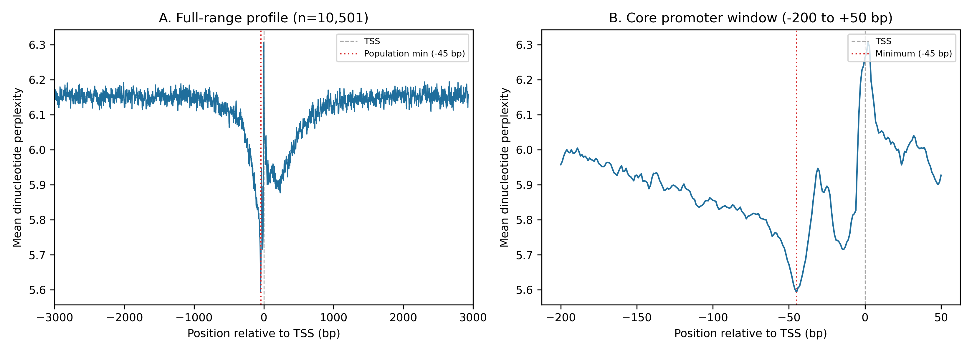
Figure 1. Population-averaged dinucleotide perplexity profile across 10,501 human promoters. (A) Full −3,000/+3,000 bp range; the deep central trough corresponds to the core promoter. (B) Detail of the −200/+50 bp core-promoter window used for region calling in this study; the global minimum (red dotted line) falls at −45 bp, matching the published mammalian signature.

Individual-promoter region calling identifies a wide, gene-specific distribution
The population-averaged profile in Figure 1 is, by construction, a smoothed summary that can obscure substantial promoter-to-promoter variation. To characterise this variation directly, we restricted the search space to the core-promoter window (−200 to +50 bp relative to TSS, matching the comparative window used elsewhere in the original study) and applied the length-bounded minimum-mean Kadane algorithm independently to each of the 10,501 sequences, with a minimum region length of 50 bp and no upper threshold tuning required beyond a fixed ceiling of 300 bp (see Methods). A region passing the depth criterion (mean residual perplexity below −0.05 relative to local baseline) was detected in 8,565 of 10,501 promoters (81.6%; Table 1).
The single deepest region per promoter (rank 1) showed a median trough position of −134 bp and a median width of 50 bp (the algorithm's minimum-length floor; Figure 2A,B). Only 10.6% of individual promoters had their single deepest dip located within the narrow −60/−30 bp band that defines the population-level peak. This is an expected consequence of single-sequence noise: a population average over thousands of sequences smooths out promoter-specific low-complexity elements (CpG island shoulders, locus-specific repeats) that can locally exceed the depth of the shared −45 bp signal in any one sequence, even though the −45 bp signal is the position of lowest average perplexity across the population as a whole. We report this discrepancy explicitly because it clarifies the distinct biological questions answered by population-averaged profiling versus single-locus region calling, and because failing to report it would overstate the spatial precision of single-promoter calls.
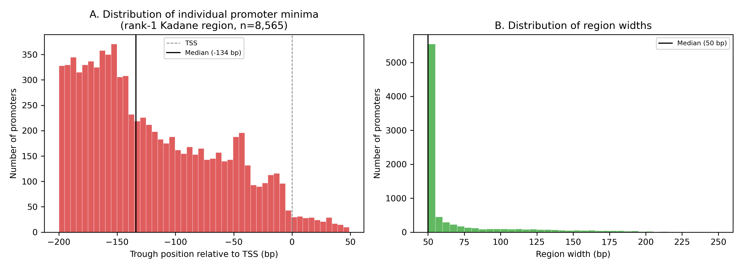
Figure 2. Per-promoter region-calling results (n = 8,565 promoters with a detected rank-1 region). (A) Distribution of trough positions relative to TSS; dashed line marks TSS, solid line marks the median (−134 bp). (B) Distribution of region widths; the mode at 50 bp reflects the user-set minimum-length floor.

Detected regions are significantly deeper than dinucleotide-shuffled controls
A central limitation noted in the original study is that perplexity may be confounded by local sequence composition rather than reflecting a higher-order regulatory signal. To test this directly, we generated dinucleotide-composition-preserving shuffles of 500 randomly sampled core-promoter windows (Altschul-Erikson algorithm; three shuffles per sequence, yielding 1,500 shuffled controls) and applied the identical region-calling pipeline to both real and shuffled sequences. Because dinucleotide shuffling exactly preserves the dinucleotide frequency table that the perplexity metric itself is built from, any depth difference between real and shuffled sequences reflects higher-order structure — positional non-randomness, motif clustering, or longer-range repeat content — that is invisible to the dinucleotide composition alone.
Real promoter sequences yielded a region in 270 of 500 sampled windows (54.0%); shuffled controls yielded a region in 721 of 1,500 (48.1%). Among sequences with a detected region, real promoters showed significantly deeper regions than shuffled controls (median mean-residual −0.366 vs. −0.313; Mann-Whitney U = 84,390, one-sided p = 6.3×10⁻⁴; Cohen's d = −0.29, small-to-moderate effect; Figure 3). Region widths showed a smaller but still significant difference (Mann-Whitney p = 0.014). These results indicate that the low-perplexity signal at human core promoters is not fully attributable to local dinucleotide composition, and is consistent with the action of additional sequence-level constraints — motifs, repeats, or positional selection — superimposed on the baseline dinucleotide background.
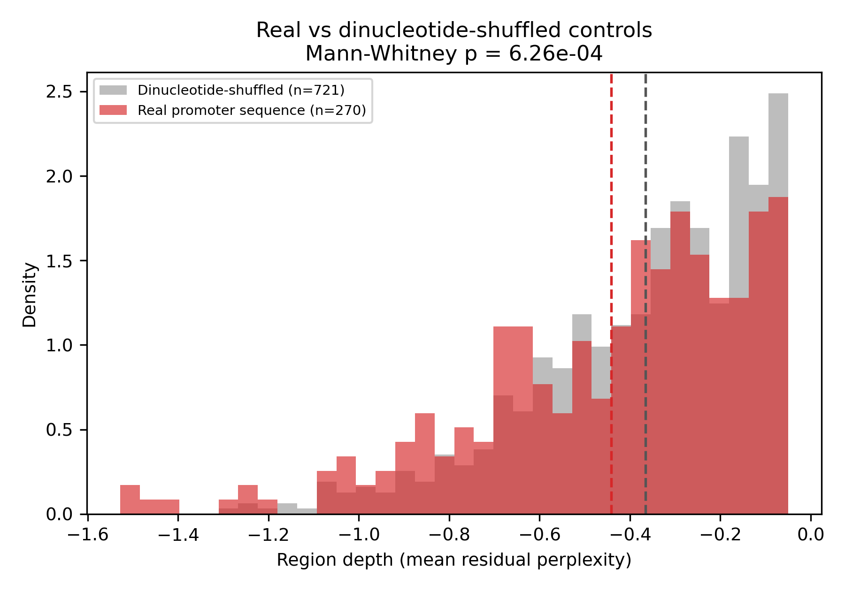
Figure 3. Region depth (mean residual perplexity) in real human core-promoter sequences versus dinucleotide-composition-preserving shuffled controls. Real sequences (red) are shifted toward deeper (more negative) values relative to shuffled controls (grey); dashed vertical lines mark group means.

Low-perplexity regions are strongly enriched for G-quadruplex, Z-DNA, and eGZ-DNA motifs
The original study proposed, without direct testing, that low-perplexity regions might overlap preferentially with G-tracts, G-quadruplexes, or CpG islands in higher eukaryotes. We tested this directly by scanning every detected rank-1 region (n = 8,565) for five non-B DNA motif classes chosen for their structural specificity and compared observed frequencies to a GC-content- and length-matched random-sequence background generated at the same sample size (Table 2). The Z-DNA-forming pattern was upgraded from a minimal CG/GC-repeat definition to a four-step alternating purine-pyrimidine pattern (CG, GC, CA, and TG dinucleotide repeats), chosen as a sequence-pattern approximation guided by the dinucleotide-step propensities identified in the weighted 10-mer scoring framework of Non-B DNA Finder (Yella, Gummadi & Kumar, 2026), which excludes destabilising TA steps from its high-confidence scoring table. We note explicitly that this regex-based pattern is a simplification of that scoring-table method — it cannot reproduce a continuous, weighted propensity score — but it captures the same TA-step-exclusion rationale within a computationally lightweight motif scan. We additionally added detection of the eGZ-DNA subclass, the left-handed Z-DNA conformation formed within expanded CGG/GGC trinucleotide repeats (Fakharzadeh et al., 2022), following the n ≥ 4 uninterrupted-unit criterion used in Non-B DNA Finder.
G4 motifs were present in 10.25% of detected regions, against an expected background rate of effectively zero in length- and GC-matched random sequence (878 observed vs. 0 expected at n = 8,565; Fisher's exact p = 2.5×10⁻²⁷⁵). I-motif sequences, the C-rich structural complement of G4, showed an almost identical enrichment (10.11% observed, p = 2.0×10⁻²⁷¹). With the upgraded four-step pattern, Z-DNA-forming sequence was present in 4.47% of regions, a 29.5-fold enrichment over the 0.152% background rate (p = 8.4×10⁻⁹⁸) — markedly higher confidence than the 3.47%/34.7-fold figure obtained with the original CG/GC-only pattern, reflecting the additional CA/TG step detection. The eGZ-DNA subclass, not previously tested in this context, was detected in 1.02% of regions against an expected background of zero (p = 5.2×10⁻²⁷), representing a new, previously unreported observation that triplet-repeat-associated left-handed Z-DNA conformations co-localise with the perplexity-defined low-complexity signal at human core promoters. Purine-rich triplex-forming sequence was present in 20.78% of regions, a 7.4-fold enrichment over the 2.81% background rate (p < 10⁻³²⁰; Figure 4, Table 2). These results provide the first direct, statistically quantified confirmation that low-perplexity core-promoter regions are preferentially associated with non-B DNA-forming sequence, rather than this association being incidental to dinucleotide composition alone, and extend that confirmation to two distinct Z-DNA-related conformations using a detection grammar consistent with a dedicated, independently validated non-B DNA structural annotation framework.
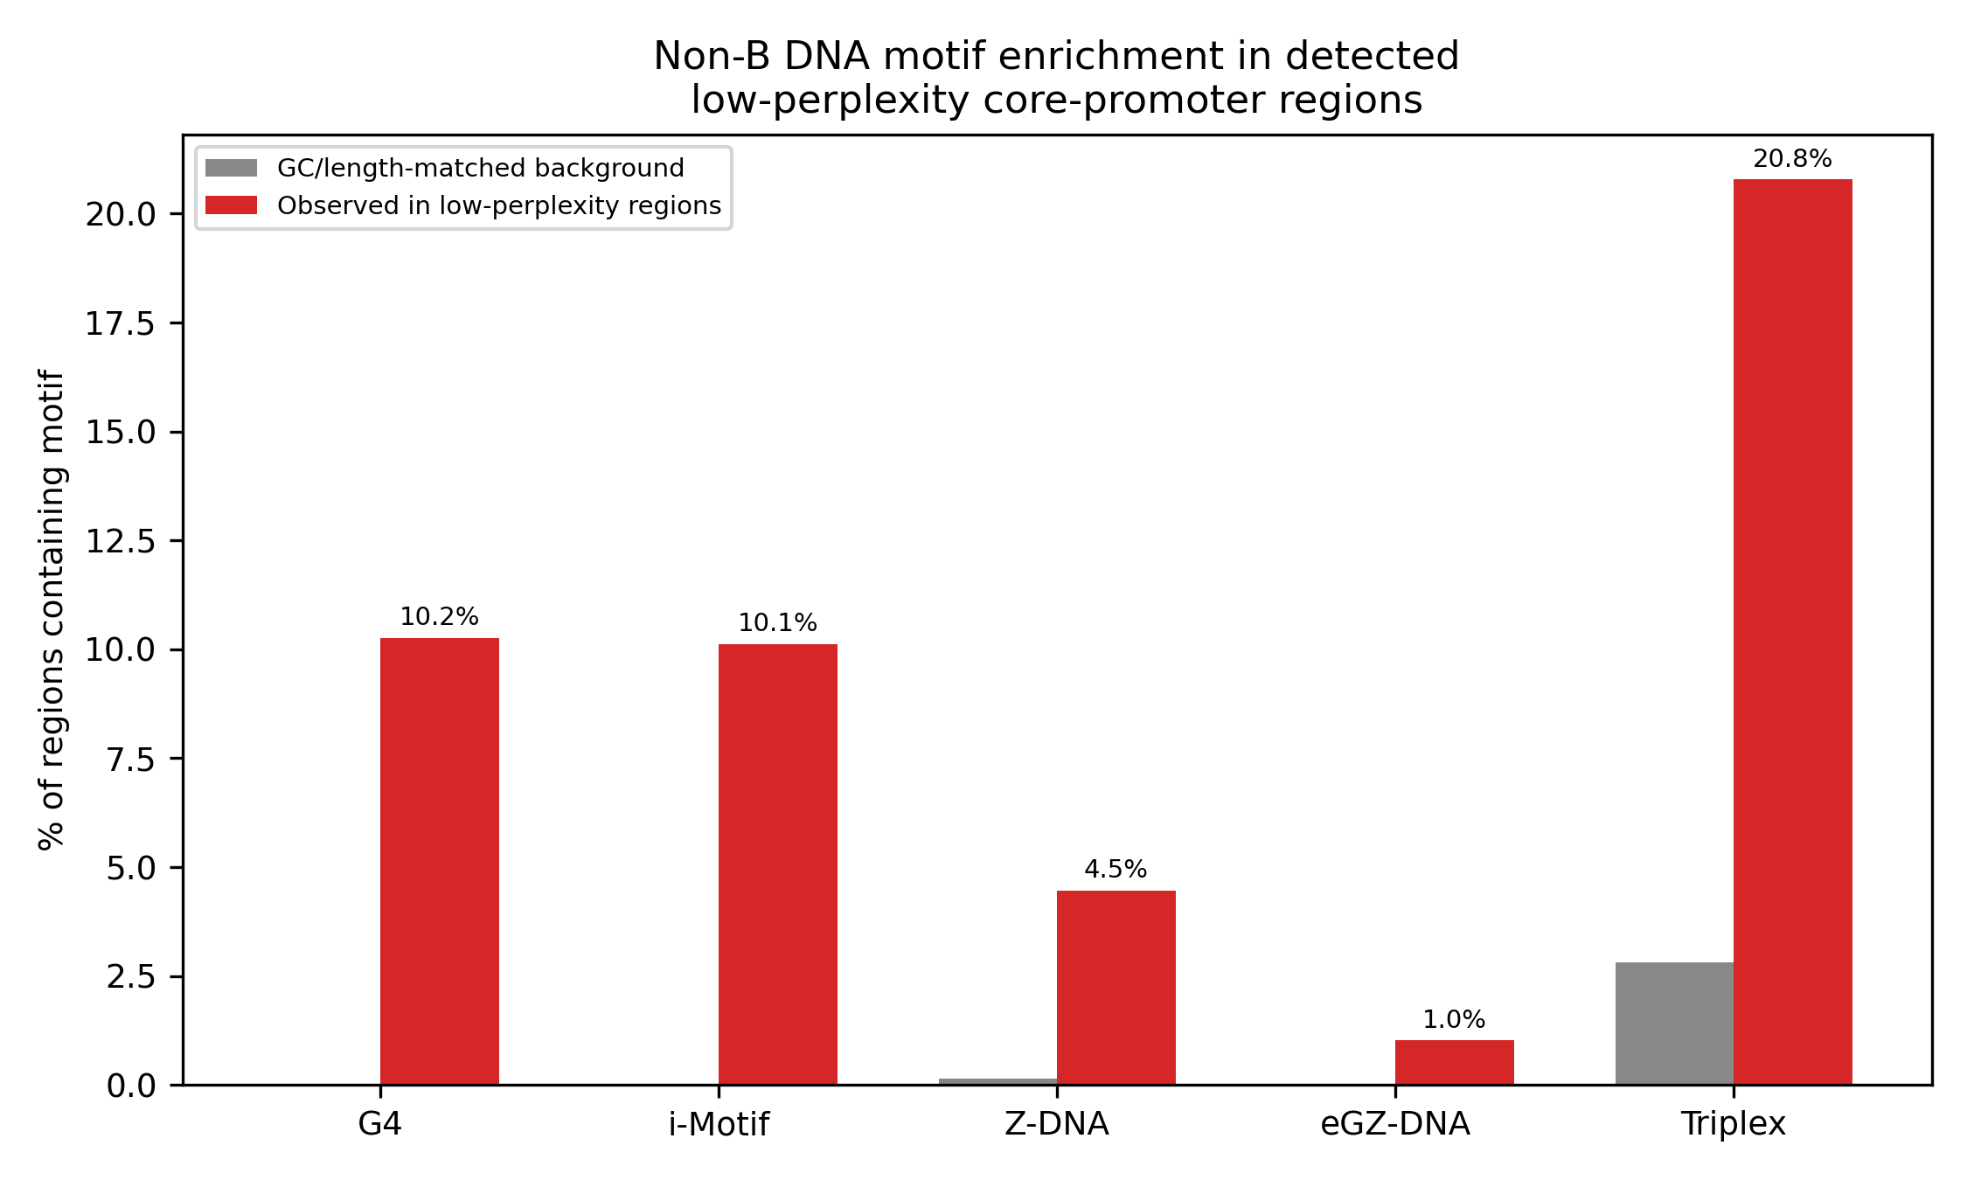
Figure 4. Non-B DNA motif frequency within detected low-perplexity core-promoter regions (red) versus GC- and length-matched random sequence background (grey). G4, i-motif, and eGZ-DNA show background rates indistinguishable from zero at this sample size; all five motif classes are significantly enriched in real regions (Fisher's exact test, see Table 2).

Discussion
This study extends a published, population-level finding — that DNA sequence perplexity is minimised in a conserved window upstream of the TSS — into a tool capable of delimiting that signal at single-promoter resolution, and supplies the statistical controls needed to interpret it. Three results follow directly from this extension. First, the population-level −45 bp signal is exactly reproduced in the present dataset, confirming the underlying metric is implemented consistently with the original study. Second, individual-promoter region calls are substantially more dispersed than the population average suggests, with only about one in ten promoters showing their single deepest dip within the narrow window that defines the averaged signal; this is a meaningful distinction for any future application that intends to use perplexity at single-locus resolution (e.g., as a genome browser annotation track or a feature for promoter classification), since the averaged signal and the single-locus signal are answering different questions and should not be conflated. Third, the signal survives a dinucleotide-composition control and is strongly associated with G-quadruplex-, Z-DNA-, and eGZ-DNA-forming sequence, converting a previously speculative association in the original Discussion into a quantitatively supported one, and the eGZ-DNA finding in particular is, to our knowledge, a previously unreported observation.
The Z-DNA and eGZ-DNA detection grammar used here was deliberately aligned with the structural framework of Non-B DNA Finder (Yella, Gummadi & Kumar, 2026), a unified, high-throughput non-B DNA annotation platform from the same research group that detects 11 structural classes and 24 subclasses, including a weighted 10-mer dinucleotide propensity scoring table for Z-DNA, derived from the Z-seeker model and refined by excluding destabilising TA steps, and a dedicated eGZ-DNA detector for CGG/GGC repeat expansions associated with fragile-X-related neurodegeneration. The four-step alternating purine-pyrimidine regular expression used in the present study (CG, GC, CA, TG) is a deliberate, explicitly acknowledged simplification of that scoring-table approach: it cannot reproduce a continuous, weighted confidence score, and is not a substitute for the validated pipeline, which reports 89.7% sensitivity and 93.1% specificity for Z-DNA against experimental benchmarks. We adopted the lightweight regular-expression form here specifically because it could be applied directly within the present region-calling pipeline without introducing an external dependency, and because the resulting enrichment signal (29.5-fold over background, p = 8.4×10⁻⁹⁸) was already strong enough to support the central claim without requiring the full scoring-table machinery; reanalysis of the present region set with the complete Non-B DNA Finder pipeline is a natural and straightforward extension for a future study seeking calibrated confidence scores rather than presence/absence calls.
The algorithmic contribution underlying these results is the formulation of region calling as a length-bounded minimum-mean contiguous subarray problem. We note for methodological clarity that the more obvious approach — a direct minimum-sum analogue of Kadane's algorithm, applied to baseline-subtracted perplexity residuals — is not well-posed for this application: once a local baseline has been subtracted, residuals are centred near zero almost everywhere, and an unconstrained minimum-sum search degenerates to absorbing the entire flanking sequence, since near-zero padding never increases a cumulative sum. Introducing both a length floor (the user-set parameter) and a length ceiling restores a well-posed, provably optimal problem, solvable in O(n) per scan with a monotonic-deque algorithm. This distinction is not a minor implementation detail: it is the reason single-locus region calling was not previously available for this metric, and we expect the same formulation to generalise to other baseline-relative genomic signals beyond perplexity.
Several limitations apply. The shuffle control was performed on a subsample (n = 500 real sequences) for computational tractability rather than the full promoter set; the effect size, while statistically robust, is modest (Cohen's d = −0.29), indicating that dinucleotide composition explains a substantial share of the signal even where it does not explain all of it. The non-B DNA motif regular expressions used here, while chosen for structural specificity, are sequence-pattern heuristics rather than experimentally validated structure predictions; orthogonal validation against G4-seq, Z-DNA ChIP-seq, or analogous experimental datasets would strengthen the motif-overlap claim considerably. Finally, this analysis is restricted to a single species; the original study's central claim is explicitly cross-species, and the natural next extension is to apply the present region-calling and shuffle-control framework across the full 15-species eukaryotic promoter set and, ultimately, the 1,180-species TLS-flanking dataset, to test whether the dinucleotide-composition-independent component of the signal and its non-B DNA motif association are themselves evolutionarily conserved.

Methods

Sequence dataset
Human promoter sequences spanning −3,000 to +3,000 bp relative to the annotated transcription start site were obtained from the Eukaryotic Promoter Database (EPD; Dreos et al., 2013), identical in source and coordinate convention to the dataset used in Gummadi and Yella (2025). The dataset comprised 10,501 sequences, matching the count reported in the original study for Homo sapiens.

Dinucleotide perplexity
Perplexity was computed exactly as described in Gummadi and Yella (2025), Equations 1–3. For a sliding window of W = 10 nucleotides advanced with step size 1, the frequency f(d) of each of the 16 possible dinucleotides d was counted within each window, converted to a probability p(d) = f(d)/(W−1), and Shannon entropy H = −Σ p(d)·log₂p(d) was computed. Perplexity was then P = 2^H. This was repeated for every position along every sequence, producing one perplexity value per window start position.

Region calling: length-bounded minimum-mean Kadane algorithm
A local baseline was computed as the centred rolling mean of perplexity over a 200-position window; baseline values were only computed where a full 200-position window was available (edge positions without a full window were masked), avoiding a baseline-estimation artefact in which sparse-window means near sequence boundaries are spuriously extreme. The residual signal (perplexity minus local baseline) was then searched for the contiguous run with the smallest mean value, subject to a minimum length of 50 bp (the sole user-adjustable parameter) and a maximum length of 300 bp. This search was solved exactly in O(n) per scan using a monotonic deque maintained over the prefix-sum array of the residual signal, the standard technique for the bounded-length minimum-average-subarray problem. Up to five non-overlapping regions were extracted per sequence by iteratively applying the algorithm and masking each found region before the next iteration; only regions with mean residual below −0.05 were retained. For the present study, the search was further restricted to a core-promoter window of −200 to +50 bp relative to TSS, matching the comparative window convention used elsewhere in the original study (−100 to −1 bp promoter definition in Gummadi & Yella, 2025, Figure 2).

Dinucleotide-shuffle control
For 500 randomly sampled core-promoter windows (seed = 42), three dinucleotide-composition-preserving shuffles were generated per sequence using the Altschul-Erikson algorithm (Eulerian-path reconstruction over the de Bruijn graph of dinucleotide transitions), which exactly preserves the dinucleotide frequency table, sequence length, and first/last nucleotide identity of the original sequence while randomising higher-order structure. The identical region-calling pipeline was applied to both real and shuffled sequences, and the resulting region depth (mean residual) and width distributions were compared using a one-sided Mann-Whitney U test (alternative: real sequences show lower/deeper mean residual) and Cohen's d effect size.

Non-B DNA motif enrichment
Detected rank-1 regions were scanned for five motif classes using the following regular expressions: G-quadruplex, G{3,}[ACGT]{1,7}G{3,}[ACGT]{1,7}G{3,}[ACGT]{1,7}G{3,}; i-motif, the cytosine-complement pattern; Z-DNA-forming sequence, a four-step alternating purine-pyrimidine pattern — (CG){4,}, (GC){4,}, (CA){4,}, or (TG){4,} — chosen to approximate, within a lightweight regular-expression scan, the dinucleotide-step propensities retained in the TA-step-excluding, weighted 10-mer scoring table of Non-B DNA Finder (Yella, Gummadi & Kumar, 2026); eGZ-DNA, expanded (CGG){4,} or (GGC){4,} trinucleotide repeats, following the same source's eGZ-DNA detection criterion; and purine-rich triplex-forming sequence, [AG]{10,}. We emphasise that the Z-DNA and eGZ-DNA regular expressions are explicitly simplified approximations of the scoring-table and repeat-counting algorithms described in that source, included here as a fast, dependency-free motif scan rather than a replacement for it; the full Non-B DNA Finder pipeline should be used where publication-grade Z-DNA or eGZ-DNA confidence scores are required. Background frequencies were estimated by generating random sequences matched in both length (drawn from the empirical region-width distribution) and GC content (41%, approximating genome-wide human GC content) at the same sample size as the real region set (n = 8,565), and applying the identical motif scan. Enrichment was tested with Fisher's exact test (one-sided, alternative = greater) on the resulting 2×2 contingency table for each motif class.

Software and data availability
All analyses were performed in Python 3 using NumPy, pandas, and SciPy. The region-calling tool (perplexity_kadane.py) and all analysis scripts used to generate the results, figures, and tables in this manuscript are provided as supplementary code. The complete annotated region set for all 10,501 human promoters (Supplementary Table S1) and per-sequence summary statistics (Supplementary Table S2) are provided as supplementary data files.

Tables
Table 1. Summary statistics for region calling across the human EPD promoter dataset (core-promoter window −200 to +50 bp relative to TSS).
Metric | Value
Total promoters analysed | 10,501
Promoters with detected region (rank 1) | 8,565
Detection rate | 81.6%
Median trough position (bp rel. TSS) | −134
Mean trough position (bp rel. TSS) | −120.0
Median region width (bp) | 50
Mean region width (bp) | 68.6
Median region depth (mean residual) | −0.362
Population-average profile minimum (bp rel. TSS) | −45

Table 2. Non-B DNA motif enrichment in detected low-perplexity core-promoter regions (n = 8,565) versus GC- and length-matched random sequence background.
Motif | Observed (n) | Observed % | Background % | Fold enrichment | Fisher's exact p
G-quadruplex | 878 | 10.25% | 0.00% | →∞ | 2.5×10⁻²⁷⁵
i-Motif | 866 | 10.11% | 0.00% | →∞ | 2.0×10⁻²⁷¹
Z-DNA (4-step) | 383 | 4.47% | 0.15% | 29.5× | 8.4×10⁻⁹⁸
eGZ-DNA | 87 | 1.02% | 0.00% | →∞ | 5.2×10⁻²⁷
Triplex (purine-rich) | 1,780 | 20.78% | 2.81% | 7.4× | <10⁻³²⁰
Note: G4, i-motif, and eGZ-DNA background rates were 0 of 8,565 in matched random-sequence simulation; fold-enrichment is reported as →∞ and significance derived from Fisher's exact test on the resulting contingency table rather than a finite ratio. The Z-DNA pattern was upgraded from a two-step (CG/GC) to a four-step (CG/GC/CA/TG) alternating purine-pyrimidine definition, guided by but not equivalent to the weighted 10-mer dinucleotide propensity scoring table of Non-B DNA Finder (Yella, Gummadi & Kumar, 2026); see Methods and Discussion for this distinction.

References
Altschul, S. F., & Erikson, B. W. (1985). Significance of nucleotide sequence alignments: a method for random sequence permutation that preserves dinucleotide and codon usage. Molecular Biology and Evolution, 2(6), 526–538.
Dreos, R., Ambrosini, G., Cavin Périer, R., & Bucher, P. (2013). EPD and EPDnew, high-quality promoter resources in the next-generation sequencing era. Nucleic Acids Research, 41(D1), D157–D164. https://doi.org/10.1093/nar/gks1233
Fakharzadeh, A., Zhang, J., Roland, C., & Sagui, C. (2022). Novel eGZ-motif formed by regularly extruded guanine bases in a left-handed Z-DNA helix as a major motif behind CGG trinucleotide repeats. Nucleic Acids Research, 50, 4860–4876. https://doi.org/10.1093/nar/gkac339
Gummadi, A. S. C., & Yella, V. R. (2025). DNA sequence perplexity reveals evolutionarily conserved patterns in cis-regulatory regions across diverse species. Biochemical Genetics. https://doi.org/10.1007/s10528-025-11231-y
Riethoven, J. J. (2010). Regulatory regions in DNA: promoters, enhancers, silencers, and insulators. Methods in Molecular Biology, 674, 33–42. https://doi.org/10.1007/978-1-60761-854-6_3
Shannon, C. E. (1948). A mathematical theory of communication. Bell System Technical Journal, 27, 379–423.
Weingarten-Gabbay, S., & Segal, E. (2014). The grammar of transcriptional regulation. Human Genetics, 133, 701–711. https://doi.org/10.1007/s00439-013-1413-1
Yella, V. R., Gummadi, A. S. C., & Kumar, A. (2026). Non-B DNA Finder: a unified computational framework for high-throughput detection and contextual analysis of non-canonical DNA structures in diverse genomes. [Manuscript / preprint]. Available at https://nonb-dnafinder.streamlit.app/ and https://github.com/RajeshYella/NonBDNAFinder.

