AI Assistant Lab-12.4
V. Rachana
2303A52335
Batch-44
Task 1 – Bubble Sort for Ranking Exam Scores
Scenario
You are working on a college result processing system where a small list of student scores needs to be sorted after every internal assessment.
Task Description
• Implement Bubble Sort in Python to sort a list of student scores.
• Use an AI tool to:
o Insert inline comments explaining key operations such as
comparisons, swaps, and iteration passes
o Identify early-termination conditions when the list becomes sorted
o Provide a brief time complexity analysis
Expected Outcome• A Bubble Sort implementation with:
o AI-generated comments explaining the logic
o Clear explanation of best, average, and worst-case complexity
o Sample input/output showing sorted scores
Prompt Used:Generate a Python program for Bubble Sort to sort student scores. Add inline comments explaining comparisons, swaps, and iteration passes. Include early termination optimization and time complexity analysis.
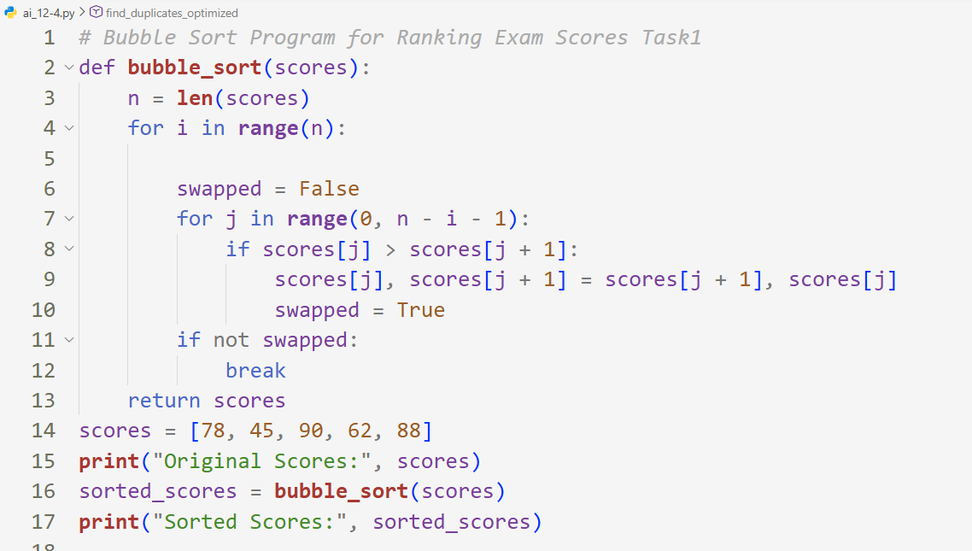
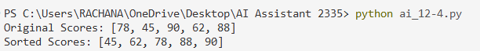
Code Explanation
Bubble Sort compares adjacent elements.
Larger values move toward the end after each pass.
Early termination stops execution if no swaps occur.
Observation
Bubble Sort works well for small datasets but becomes slow for larger lists.
Task 2 – Improving Sorting for Nearly Sorted Attendance Records
AI Prompt Used
Compare Bubble Sort and Insertion Sort for nearly sorted data.
Generate both implementations and explain why Insertion Sort performs better.
Scenario
You are maintaining an attendance system where student roll numbers
are already almost sorted, with only a few late updates.
Task Description
• Start with a Bubble Sort implementation.
• Ask AI to:
o Review the problem and suggest a more suitable sorting algorithm
o Generate an Insertion Sort implementation
o Explain why Insertion Sort performs better on nearly sorted data
• Compare execution behavior on nearly sorted input
Expected Outcome
• Two sorting implementations:
o Bubble Sort
o Insertion Sort
• AI-assisted explanation highlighting efficiency differences for partially sorted datasets
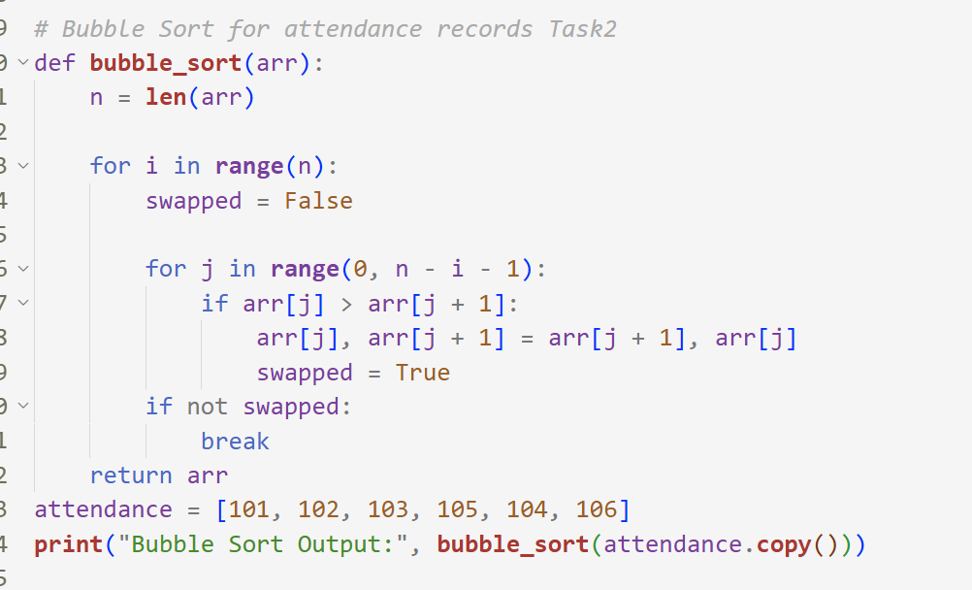
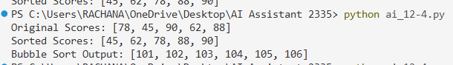
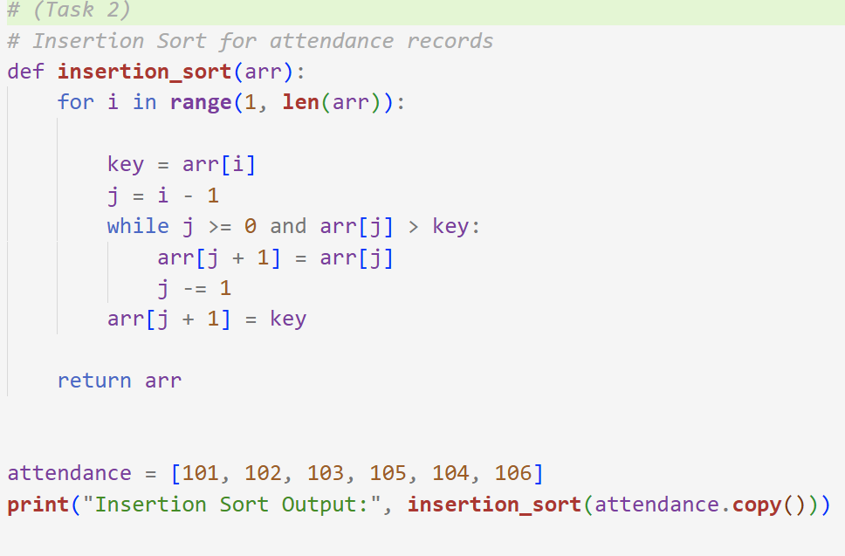
Code Explanation
Bubble Sort compares adjacent roll numbers.
If elements are in the wrong order, they are swapped.
After each pass, the largest element moves to the correct position.
The swapped flag is used for early termination when the list is already sorted.
Observation
- Bubble Sort successfully sorts attendance roll numbers.
- Early termination reduces unnecessary iterations.
- Suitable for small or nearly sorted datasets.
Task 3: Searching Student Records in a
Database
Scenario
You are developing a student information portal where users search for student records by roll number.
Task Description
• Implement:
o Linear Search for unsorted student data
o Binary Search for sorted student data
• Use AI to:
o Add docstrings explaining parameters and return values
o Explain when Binary Search is applicable
o Highlight performance differences between the two searches
Expected Outcome
• Two working search implementations with docstrings
• AI-generated explanation of:
o Time complexity
o Use cases for Linear vs Binary Search
• A short student observation comparing results on sorted vs unsorted lists

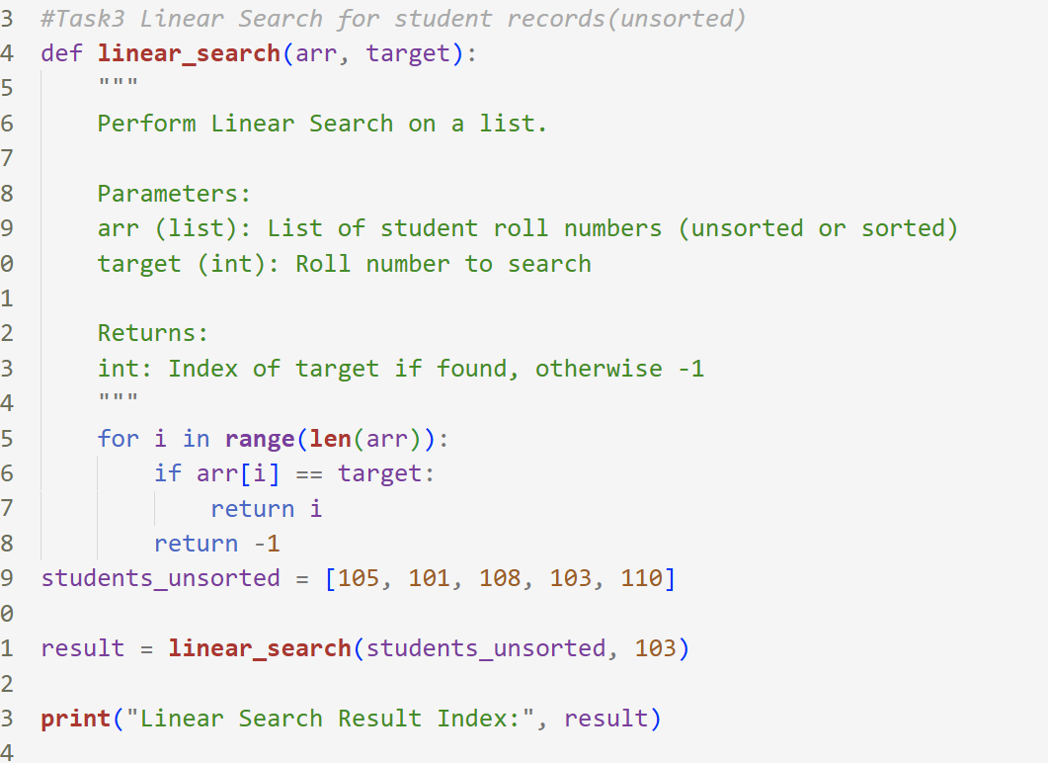
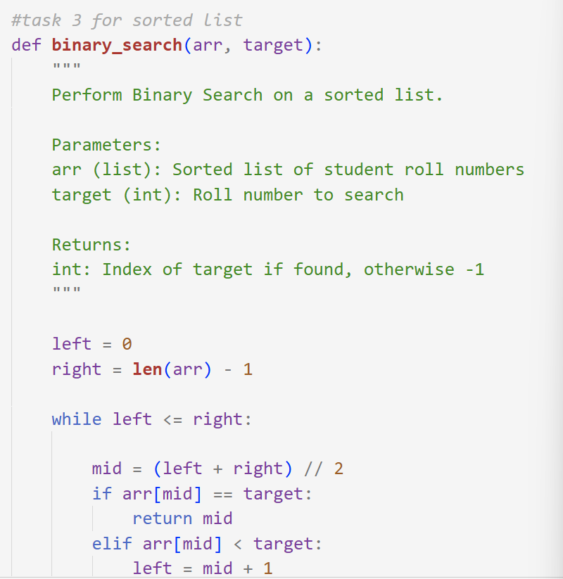
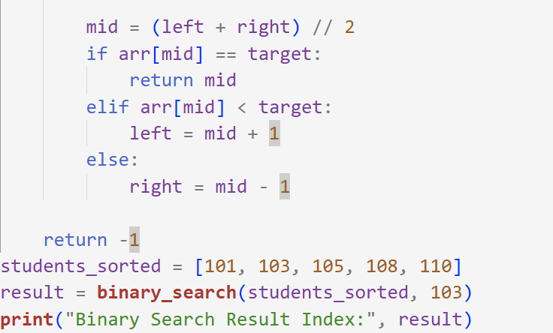
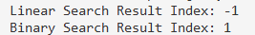

Observation
Binary Search performs much faster on large sorted datasets.
Task 4: Choosing Between Quick Sort and
Merge Sort for Data Processing
Scenario
You are part of a data analytics team that needs to sort large datasets
received from different sources (random order, already sorted, and
reverse sorted).
Task Description
• Provide AI with partially written recursive functions for:
o Quick Sort
o Merge Sort
• Ask AI to:
o Complete the recursive logic
o Add meaningful docstrings
o Explain how recursion works in each algorithm
• Test both algorithms on:
o Random data
o Sorted data
o Reverse-sorted data
Expected Outcome
• Fully functional Quick Sort and Merge Sort implementations
• AI-generated comparison covering:
o Best, average, and worst-case complexities
o Practical scenarios where one algorithm is preferred over
the other
AI Prompt Used
Complete recursive Quick Sort and Merge Sort functions.
Add docstrings and explain recursion.
Compare performance on different datasets.

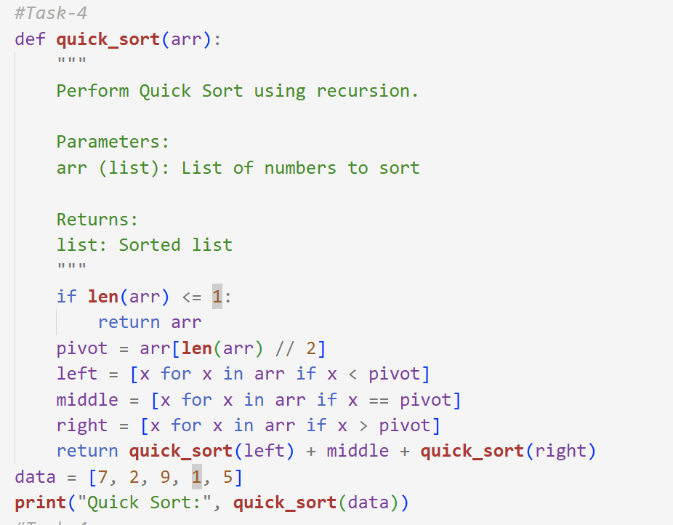
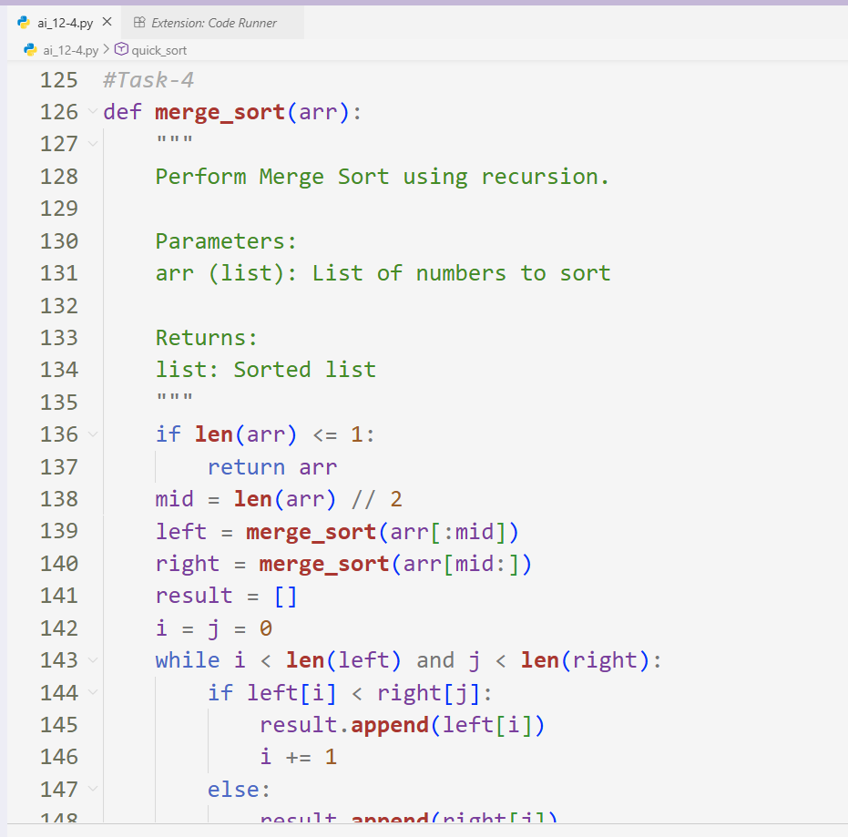
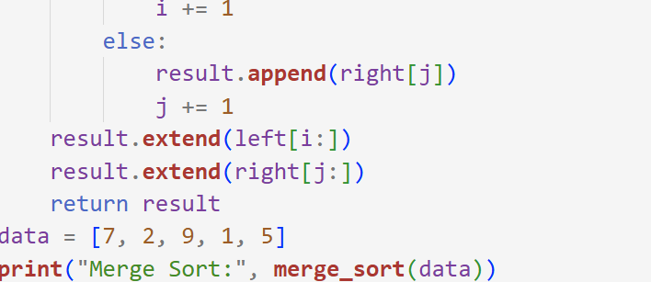
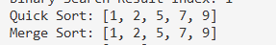
Observation
Quick Sort is faster on average, but Merge Sort is safer for worst-case data.
Task 5: Optimizing a Duplicate Detection
Algorithm
Scenario
You are building a data validation module that must detect duplicate
user IDs in a large dataset before importing it into a system.
Task Description
• Write a naive duplicate detection algorithm using nested loops.
• Use AI to:
o Analyze the time complexity
o Suggest an optimized approach using sets or dictionaries
o Rewrite the algorithm with improved efficiency
• Compare execution behavior conceptually for large input sizes
Expected Outcome
• Two versions of the algorithm:
o Brute-force (O(n²))
o Optimized (O(n))
• AI-assisted explanation showing how and why performance
Improved
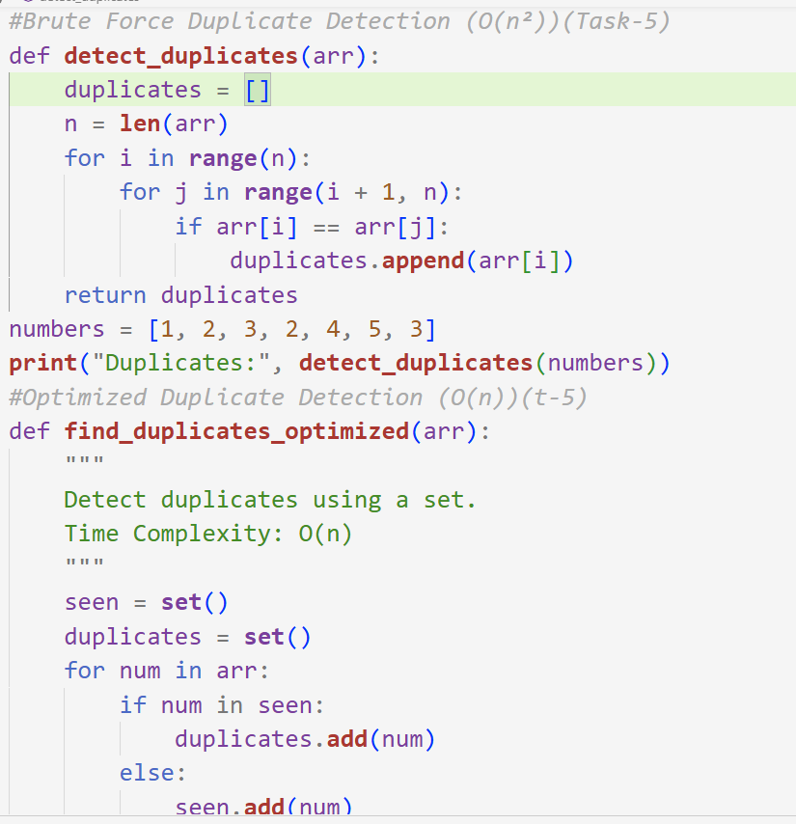
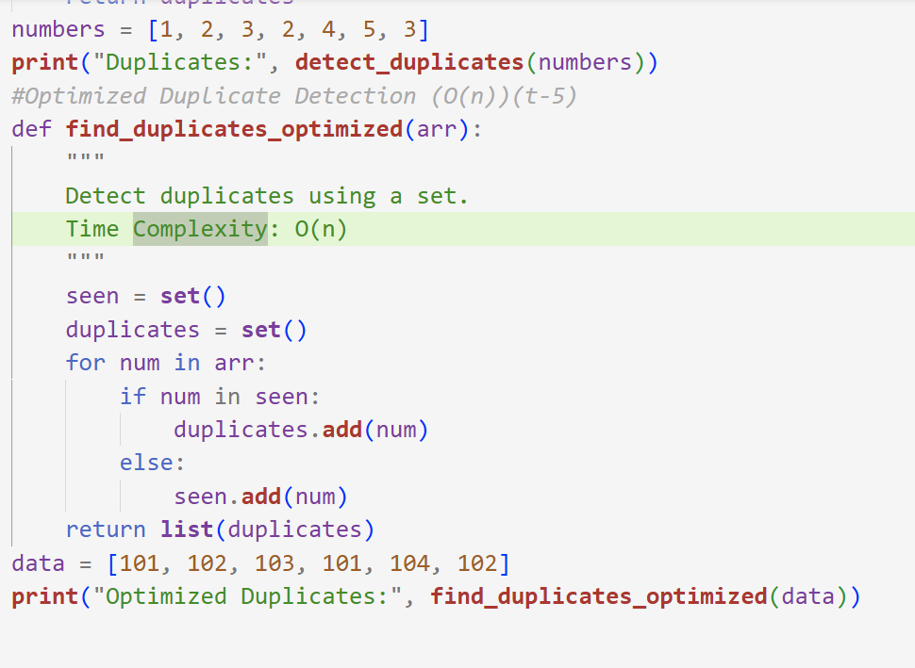
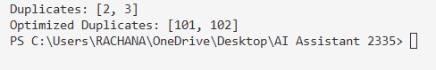
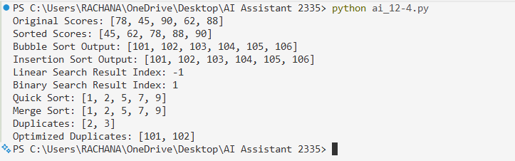
AI Prompt Used
Write brute-force duplicate detection using nested loops.
Suggest optimized set-based approach and compare complexity.
Observation
Optimization reduced time complexity from O(n²) to O(n).

