Architecture:

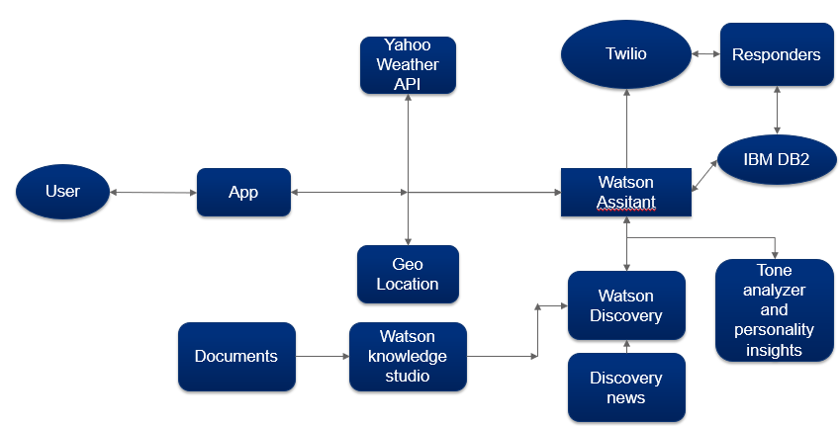

**ROADMAP**:

1. Scaling the Watson discovery service to at least 100,000 documents to get the most relevant answers than Google.
2. Using Google’s Geolocation and Map API to build in a real time map(Costly).
3. Release an android version so that the GPS can improve the accuracy further.
4. Release iOS version
5. Collect data and use IBM Watson Machine Learning and analytics service to further the support during disasters.
6. Introduce Multilingual support to translate languages.
7. Introduce TTS and STT.

We are not stopping with a bot. We are already on course to use state of the art custom neural networks automated using Auto ML (Bayesian Optimization and Reinforcement Learning) to predict the occurrence of a natural disasters based on past data.

For further details on our present and future work, please check out our **technical documentation**.