|  |  |  |  |  |  |  |  |
| --- | --- | --- | --- | --- | --- | --- | --- |
|  | Bicubic interpolation | SRGAN-2 (50 epochs)  train, val | | SRGAN-2 (100 epochs)  train, val | | SRGAN-2 (150 epochs)  train, val | |
| RMSE (wind, m/s) | 1,435 | 1,588 | 1,608 | 1,457 | 1,457 |  |  |
| RMSE (SLP, hPa) | 0,576 | 1,079 | 1,002 | 0,796 | 0,762 |  |  |
| RMSE-95 (m/s) | 1,898 | 2,538 | 2,685 | 2,273 | 2,315 |  |  |
| PSNR | 35,159 | 33,908 | 32,164 | 34,363 | 33,336 |  |  |

(1 January 2010 Low-Interp-High)

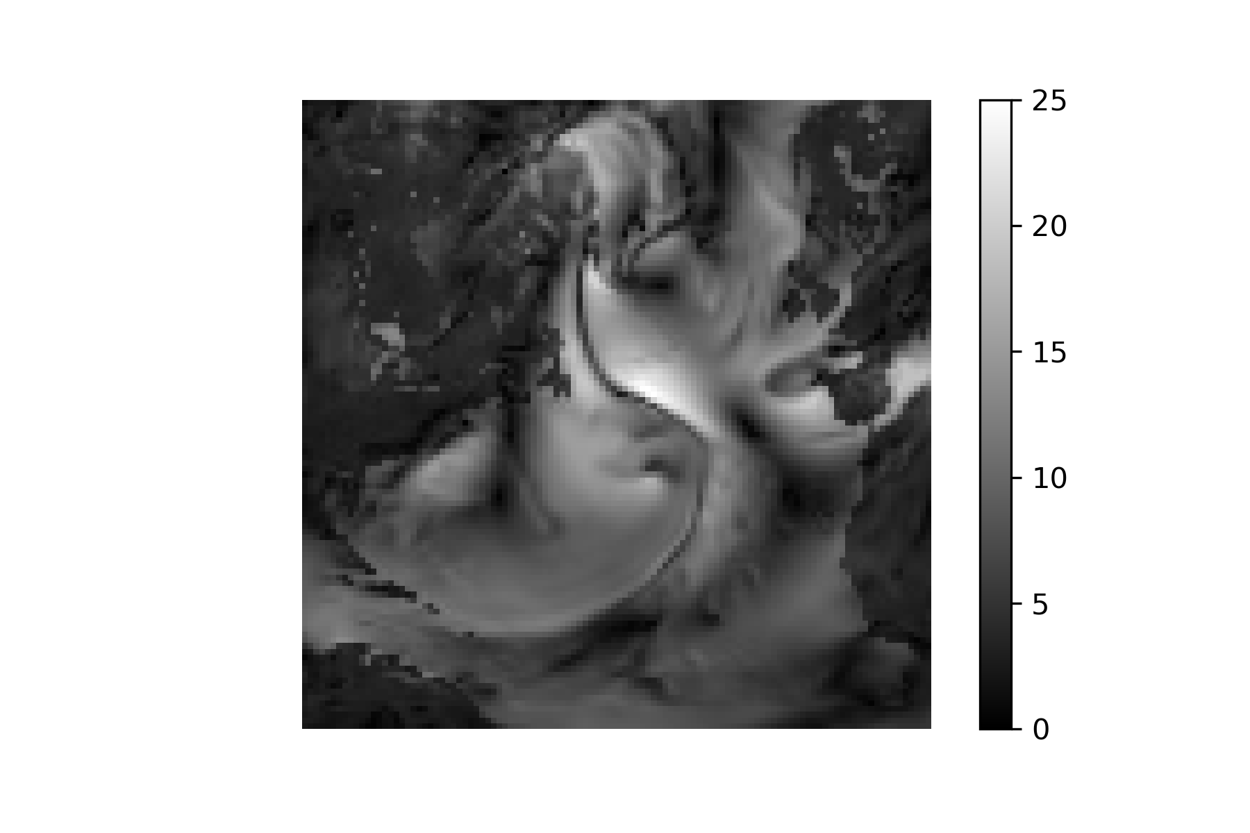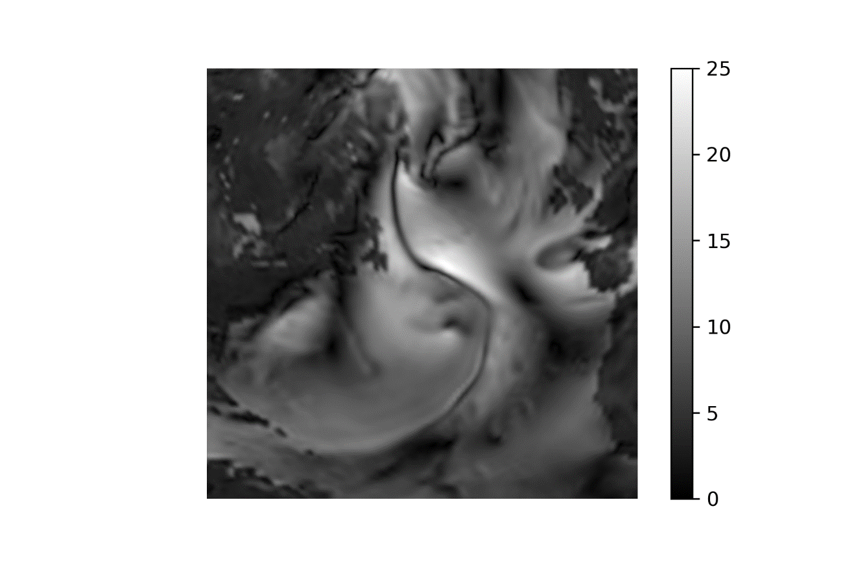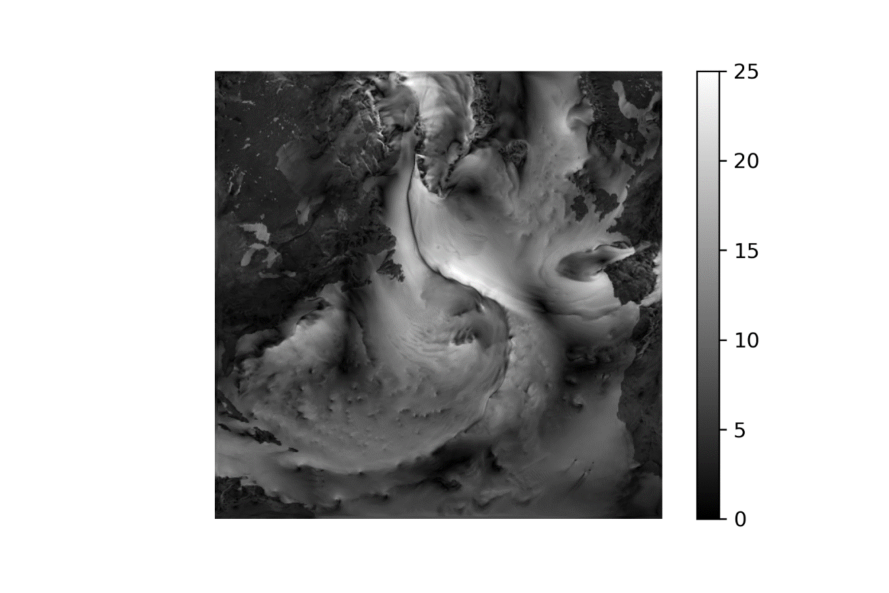

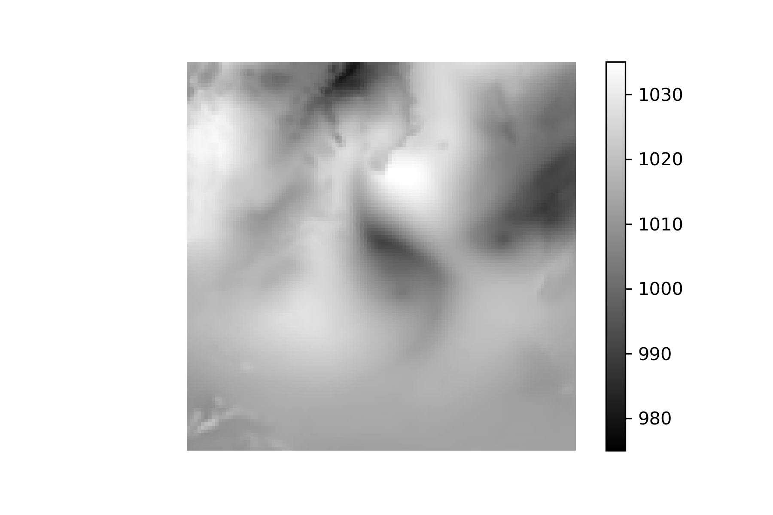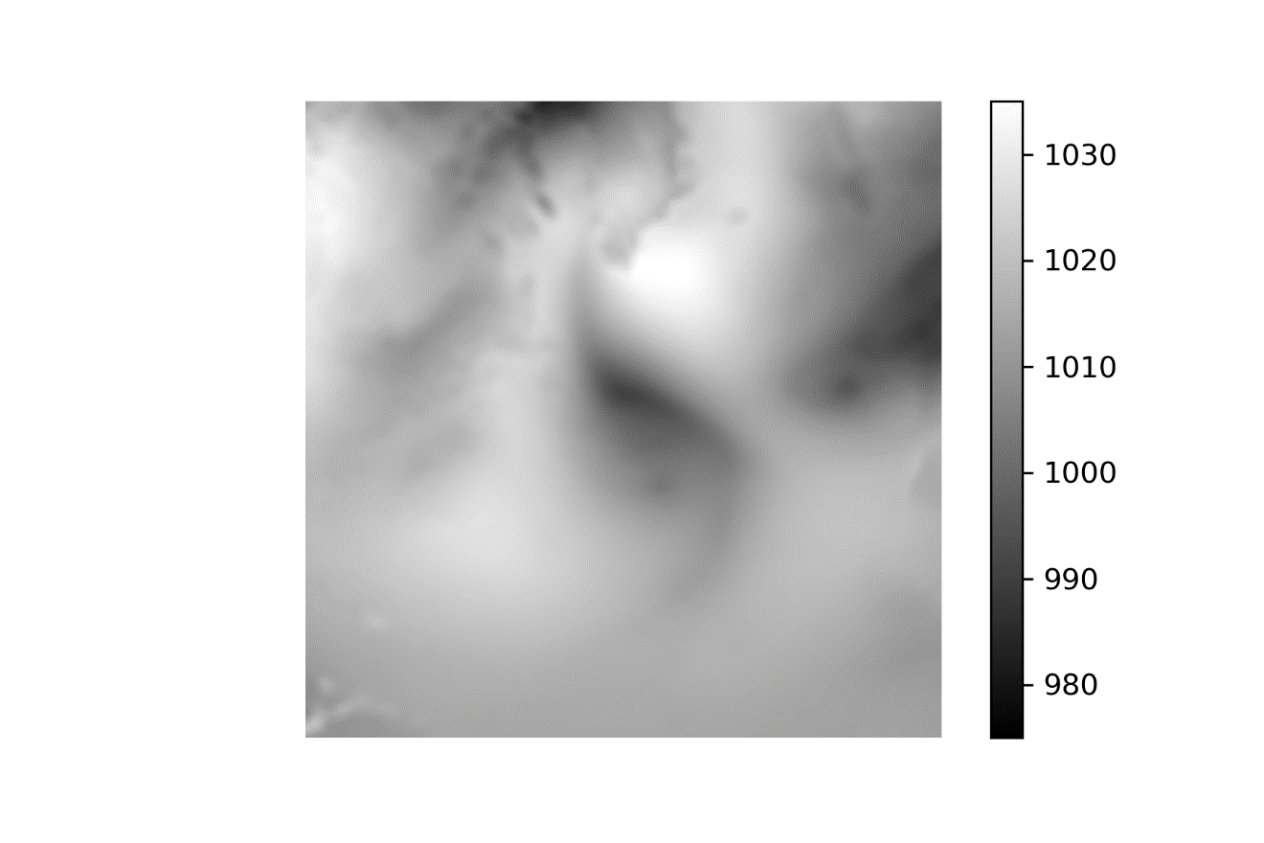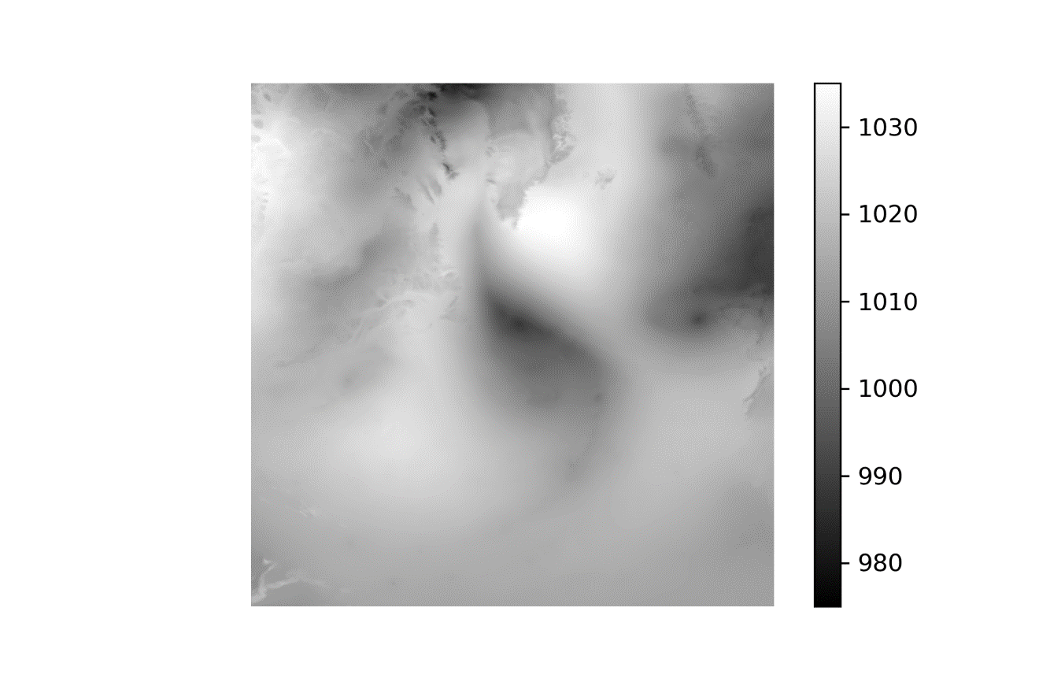

(1 Jul 2010 Low-Interp-High)

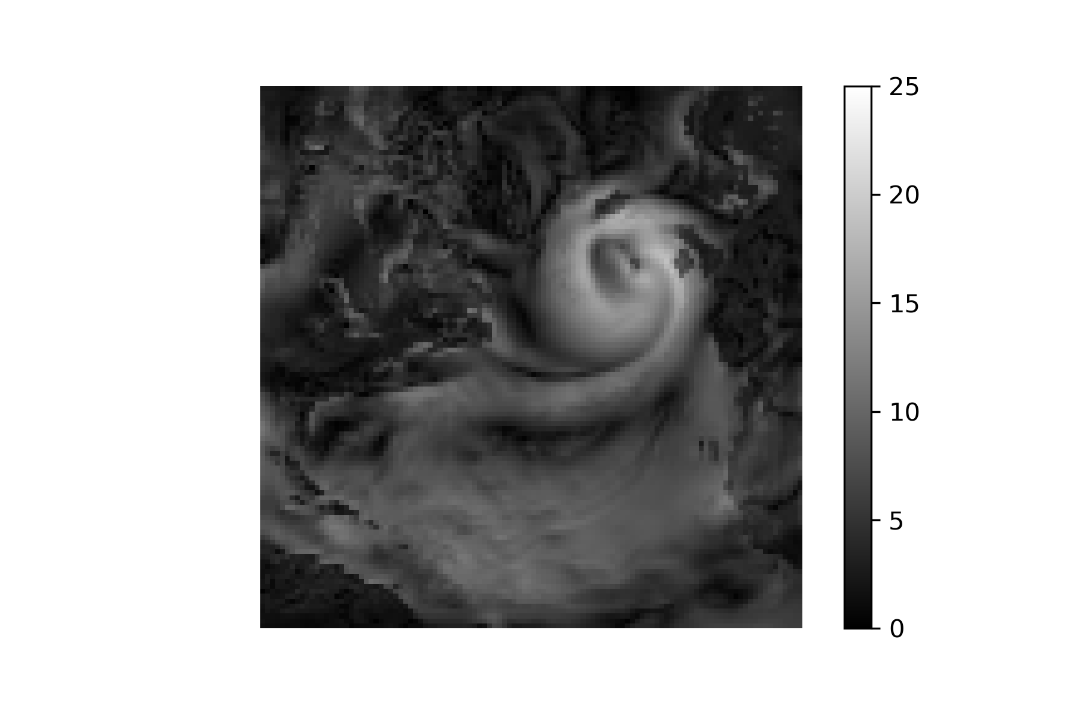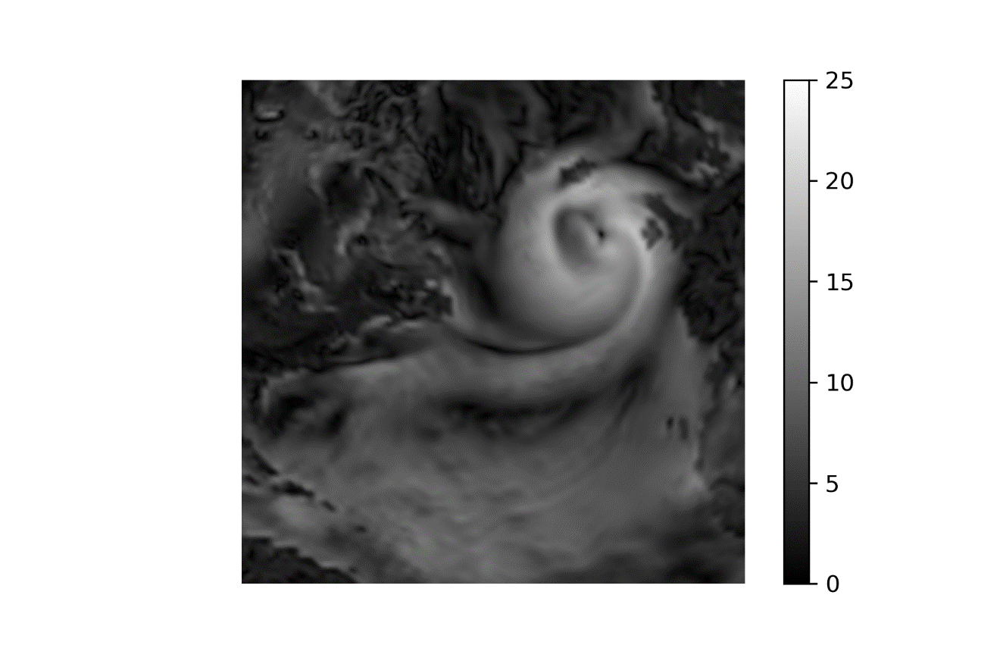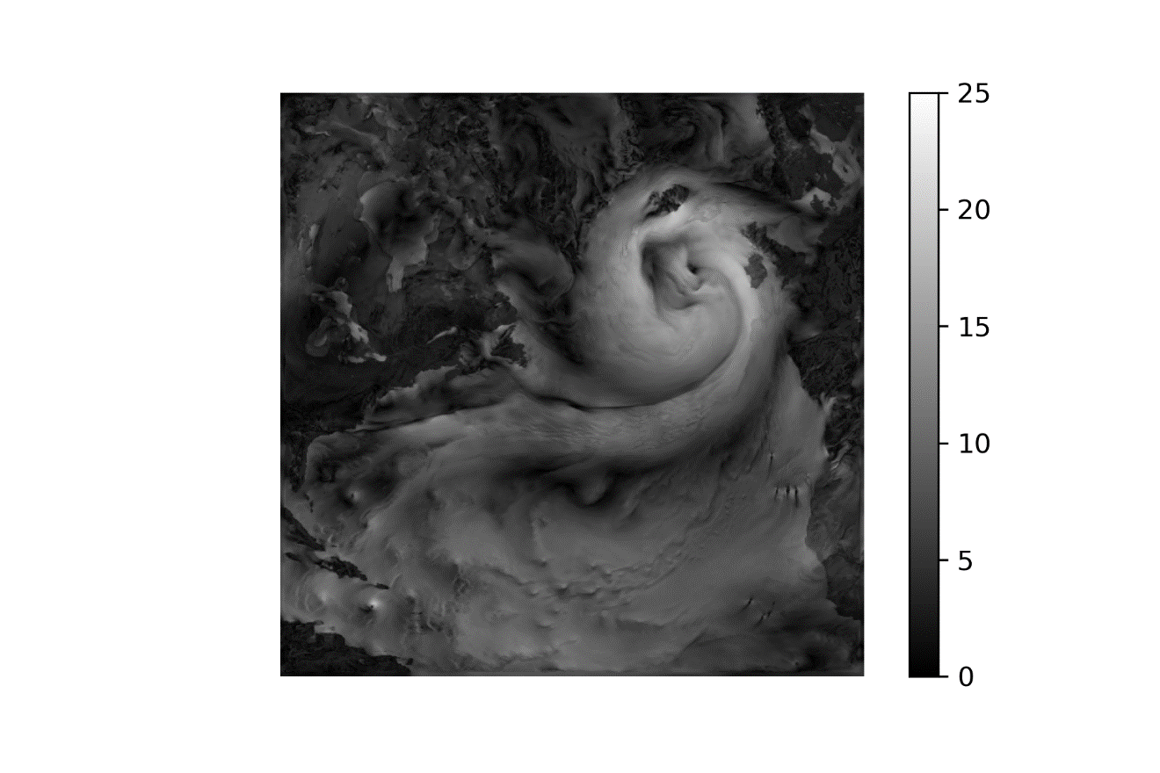

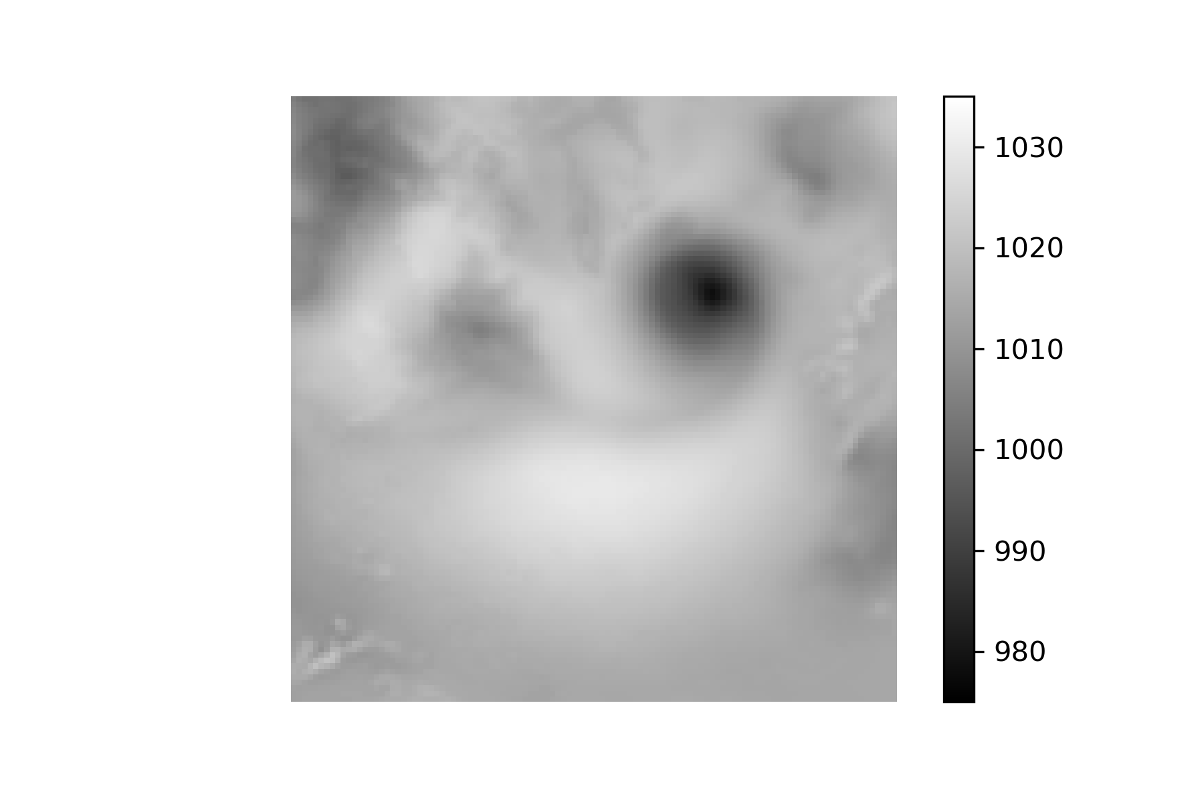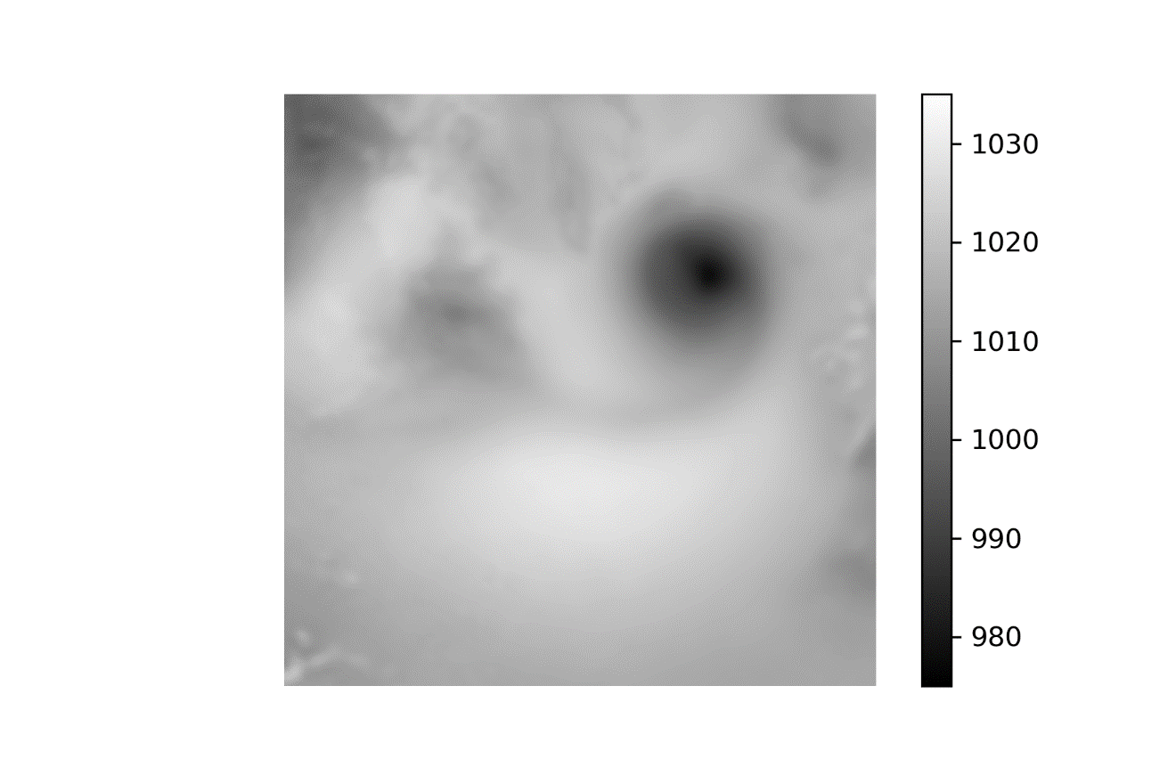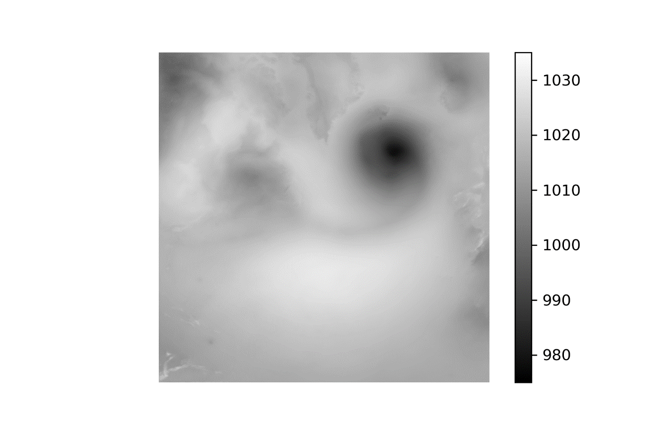

1 Jan 2010 –-50-100-High

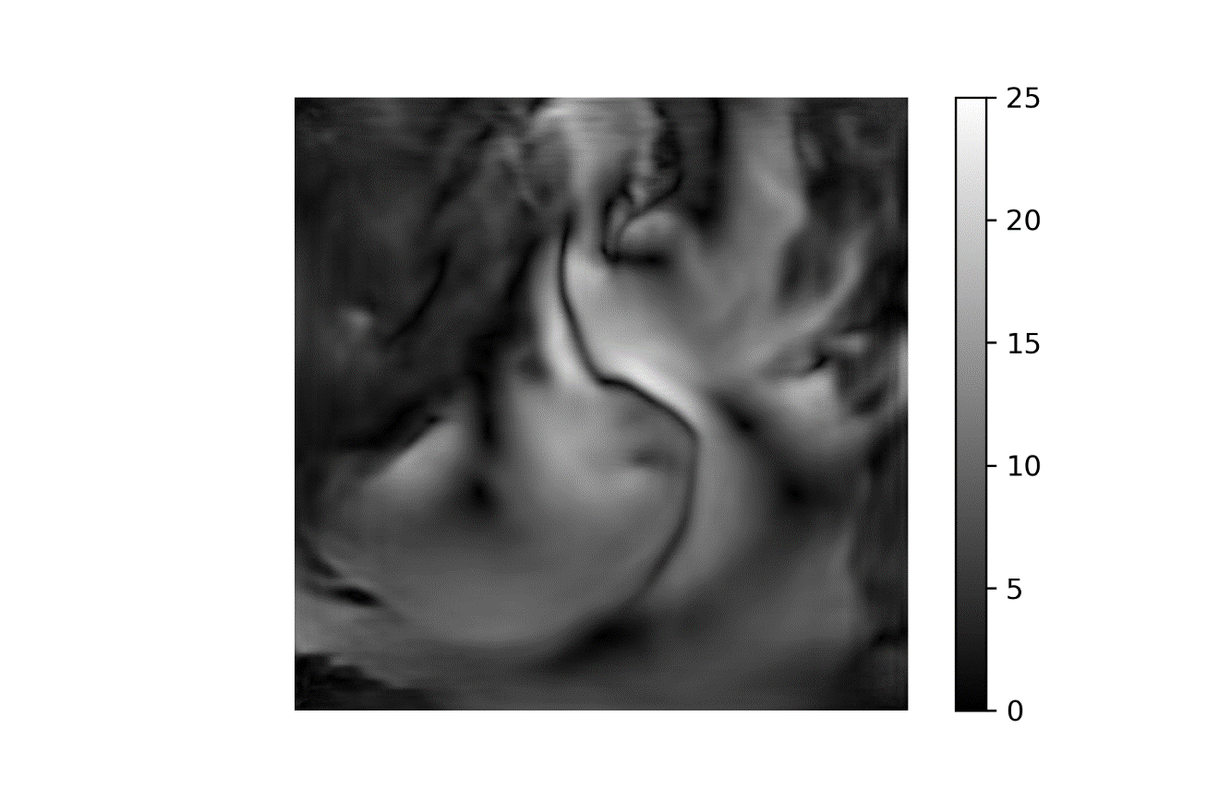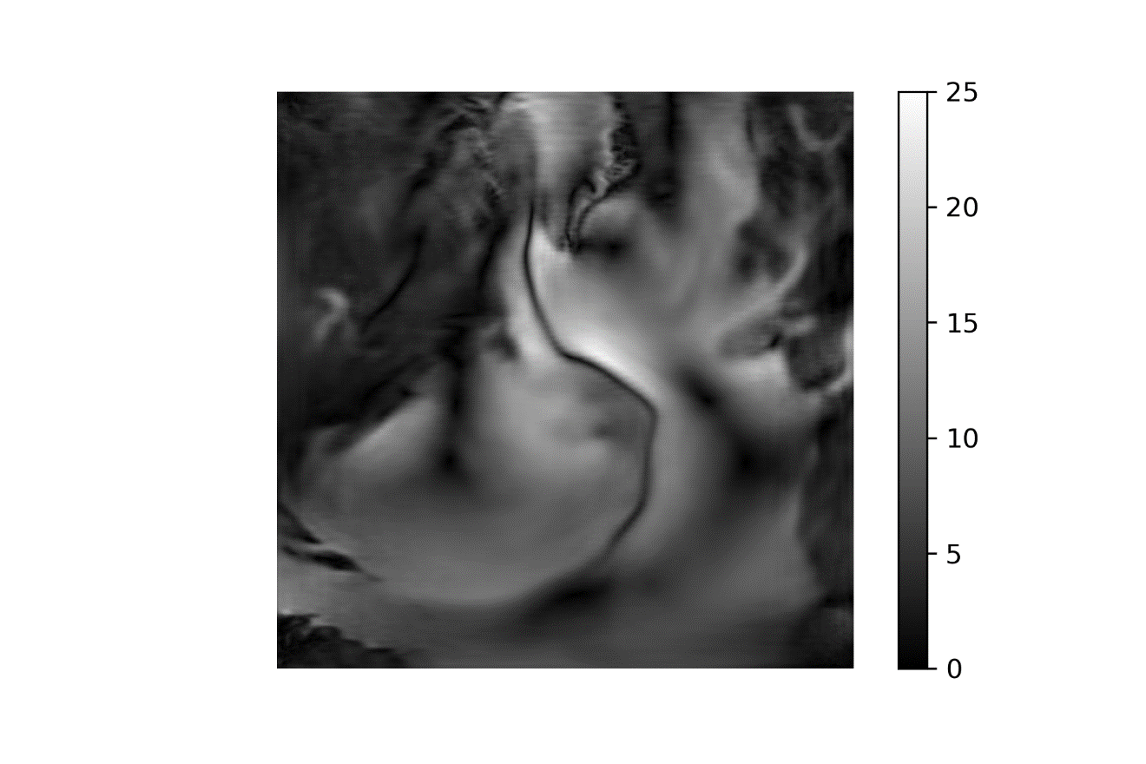

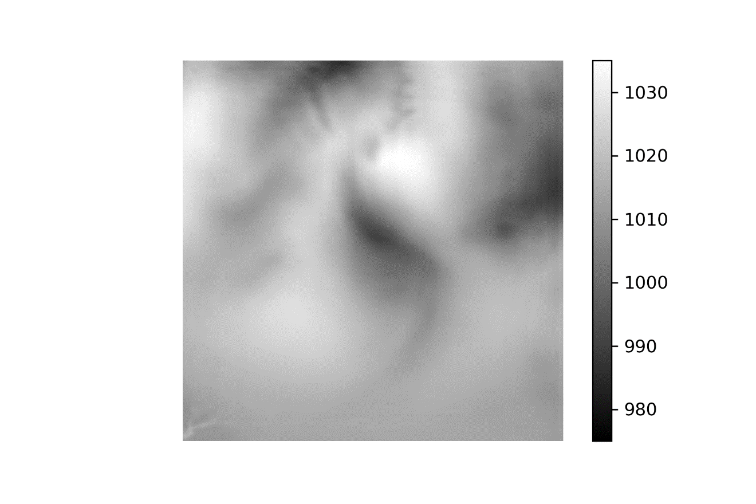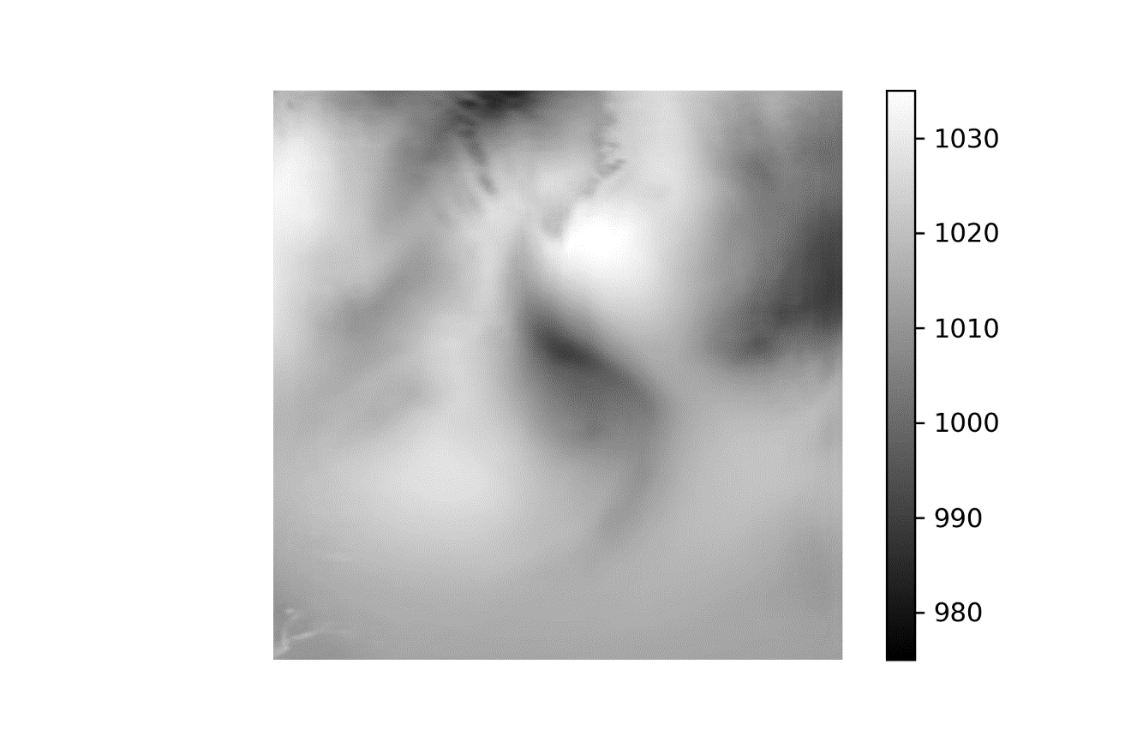

1 Jul 2010 –-50-100-High

