Tutorial 1
<!DOCTYPEhtml>
<htmllang="en">
<head>
<metacharset="UTF-8">
<metahttp-equiv="X-UA-Compatible"content="IE=edge">
<metaname="viewport"content="width=device-width, initial-scale=1.0">
<title>Program-1</title>
<linkrel="stylesheet"href="../Tutorial-1/css/bootstrap.min.css">
<scriptsrc="../Tutorial-1/js/bootstrap.min.js"></script>
<scriptsrc="../Tutorial-1/js/bootstrap.bundle.min.js"></script>
</head>
<body>
<divclass="container">
<br>
<h1>Grid System</h1><br>
<divclass="row">
<divclass="col">
<divclass="p-4 border bg-primary"></div>
</div>
<divclass="col">
<divclass="p-4 border bg-primary"></div>
</div>
</div><br>

<divclass="row">
<divclass="col">
<divclass="p-5 border"style="background-color: yellow;"></div>
</div>
<divclass="col">
<divclass="p-5 border"style="background-color: yellow;"></div>
</div>
<divclass="col">
<divclass="p-5 border"style="background-color: yellow;"></div>
</div>
</div><br>

<divclass="row">
<divclass="col-8">
<divclass="p-5 border bg-success"></div>
</div>
<divclass="col-4">
<divclass="p-5 border"style="background-color: greenyellow;"></div>
</div>
</div><br>

<divclass="row">
<divclass="col">
<divclass="p-5 border"style="background-color: orange;"></div>
</div>
<divclass="col">
<divclass="p-5 border"style="background-color: orange;"></div>
</div>
<divclass="col">
<divclass="p-5 border"style="background-color: orange;"></div>
</div>
<divclass="col">
<divclass="p-5 border"style="background-color: orange;"></div>
</div>
</div><br>

<divclass="row">
<divclass="col">
<divclass="p-3 border"style="background-color: gray;"></div>
</div>
</div>
</div>
</body>
</html>

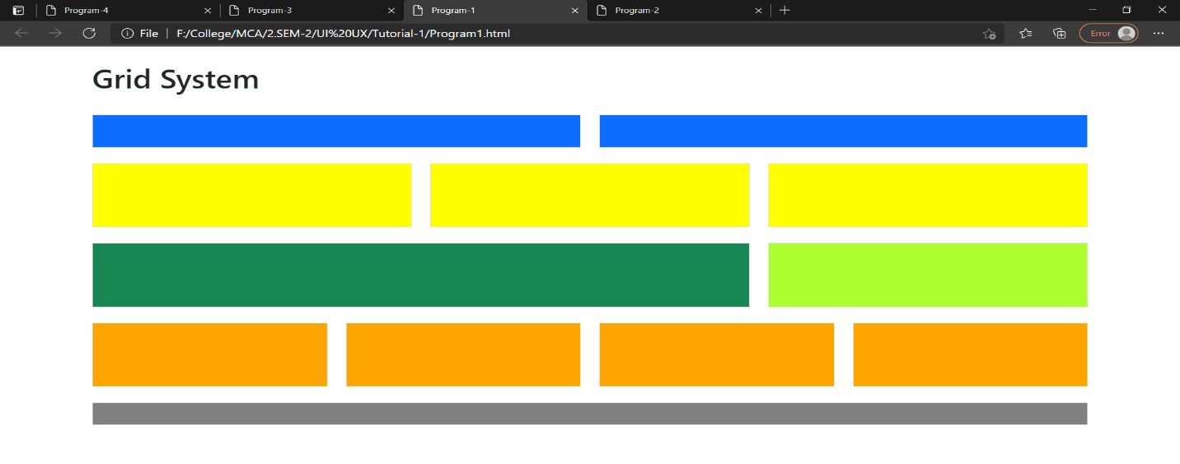
<!DOCTYPEhtml>
<htmllang="en">
<head>
<metacharset="UTF-8">
<metahttp-equiv="X-UA-Compatible"content="IE=edge">
<metaname="viewport"content="width=device-width, initial-scale=1.0">
<title>Program-2</title>
<linkrel="stylesheet"href="../Tutorial-1/css/bootstrap.min.css">
<scriptsrc="../Tutorial-1/js/bootstrap.min.js"></script>
<scriptsrc="../Tutorial-1/js/bootstrap.bundle.min.js"></script>
</head>
<body>
<divclass="container">
<h1>Table Class</h1><br><br>
<tableclass="table table-striped table-hover table-bordered">
<thead>
<td>First Name</td>
<td>Last Name</td>
<td>Email</td>
</thead>
<tbody>
<trclass="border-success">
<td>John</td>
<td>Doe</td>
<td>John@example.com</td>
</tr>
<trclass="border-danger">
<td>Mary</td>
<td>Moe</td>
<td>Mary@example.com</td>
</tr>
<trclass="border-warning">
<td>July</td>
<td>Dooley</td>
<td>July@example.com</td>
</tr>
</tbody>
</table>
</div>
</body>
</html>

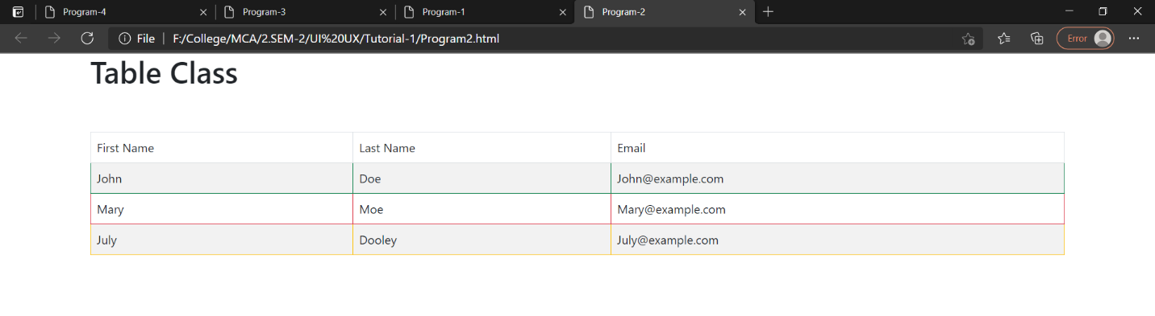

<!DOCTYPEhtml>
<htmllang="en">
<head>
<metacharset="UTF-8">
<metahttp-equiv="X-UA-Compatible"content="IE=edge">
<metaname="viewport"content="width=device-width, initial-scale=1.0">
<title>Program-3</title>
<linkrel="stylesheet"href="../Tutorial-1/css/bootstrap.min.css">
<scriptsrc="../Tutorial-1/js/bootstrap.min.js"></script>
<scriptsrc="../Tutorial-1/js/bootstrap.bundle.min.js"></script>
</head>
<body>
<divclass="container">
<h1>Buttons</h1><br><br>
<divclass="row">
<divclass="col">
<buttonclass="btn btn-danger">Button 1</button>
</div>
</div><br>
<divclass="row">
<divclass="col">
<buttontype="button"class="btn btn-warning btn-lg">Button 2</button>&nbsp;
<buttontype="button"class="btn btn-warning">Button 3</button>&nbsp;
<buttontype="button"class="btn btn-warning btn-sm">Button 4</button>
</div>
</div><br>
<divclass="row">
<divclass="col">
<divclass="d-grid">
<buttontype="button"class="btn btn-secondary btn-block">Button 5</button>
</div>
</div>
</div><br>
<divclass="row">
<divclass="col">
<buttontype="button"class="btn btn-dark disabled">Button 6</button>
</div>
</div>
</div>
</body>
</html>

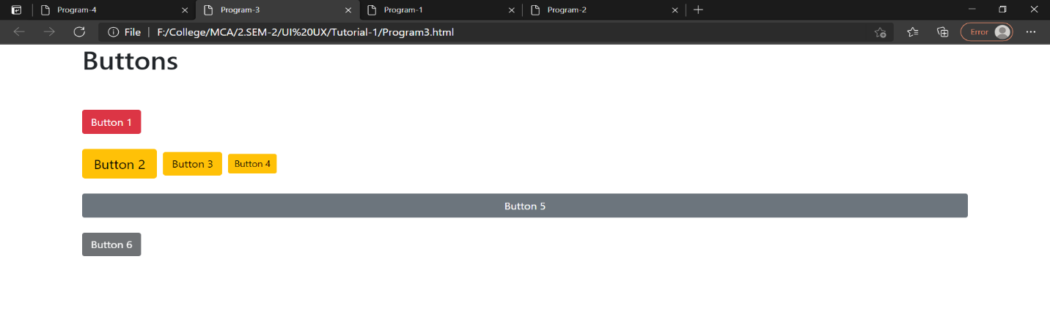
<!DOCTYPEhtml>
<htmllang="en">
<head>
<metacharset="UTF-8">
<metahttp-equiv="X-UA-Compatible"content="IE=edge">
<metaname="viewport"content="width=device-width, initial-scale=1.0">
<title>Program-4</title>
<linkrel="stylesheet"href="../Tutorial-1/css/bootstrap.min.css">
<scriptsrc="../Tutorial-1/js/bootstrap.min.js"></script>
<scriptsrc="../Tutorial-1/js/bootstrap.bundle.min.js"></script>
</head>
<body>
<divclass="container">
<h1>From</h1><br><br>
<divclass="row">
<divclass="col-4">First Name :</div>
</div>
<divclass="row">
<divclass="col-3">
<inputtype="text"class="form-control">
</div>
</div><br>

<divclass="row">
<divclass="col-4">Last Name :</div>
</div>
<divclass="row">
<divclass="col-3">
<inputtype="text"class="form-control">
</div>
</div><br>

<divclass="row">
<divclass="col">
<inputtype="radio"name="r1"> Male
<inputtype="radio"name="r2"> Female
</div>
</div><br>

<divclass="row">
<divclass="col-4">Date Of Birth :</div>
</div>
<divclass="row">
<divclass="col-3">
<inputtype="date"class="form-control">
</div>
</div><br>
<divclass="row">
<divclass="col">
<buttonclass="btn btn-primary">Add</button>
</div>
</div>
</div>
</body>
</html>

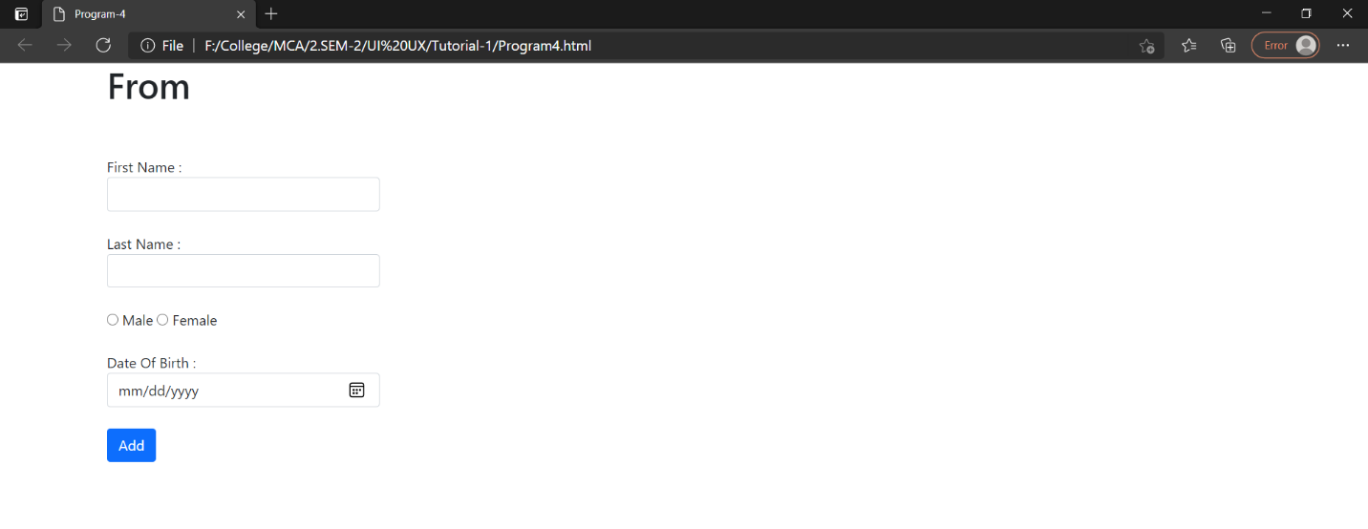
Tutorial 2
1. Write a MongoDB query to display all the documents in the collection restaurants.
db.restaurants.find()
2. Write a MongoDB query to display the fields restaurant_id, name, borough and cuisine for all the documents in the collection restaurant.
db.restaurants.find({},{restaurant_id:1,name:1,borough:1,cuisine:1})
3. Write a MongoDB query to display the fields restaurant_id, name, borough and cuisine, but exclude the field _id for all the documents in the collection restaurant.
db.restaurants.find({},{restaurant_id:1,borough :1,cuisine:1,_id:0})
4. Write a MongoDB query to display the fields restaurant_id, name, borough and zip code, but exclude the field _id for all the documents in the collection restaurant.
db.restaurants.find({},{restaurant_id:1,borough:1,cuisine:1,_id:0,"address.zipcode":1)
5. Write a MongoDB query to display all the restaurant which is in the borough Bronx.
db.restaurants.find({"borough":"Bronx"}).pretty()
6. Write a MongoDB query to display the first 5 restaurant which is in the borough Bronx.
db.restaurants.find({"borough":"Bronx"}).limit(5).pretty()
7. Write a MongoDB query to display the next 5 restaurants after skipping first 5 which are in the borough Bronx
db.restaurants.find({"borough":"Bronx"}).skip(5).limit(5).pretty()
8. Write a MongoDB query to find the restaurants who achieved a score more than 90.
db.restaurants.find({"grades.score":{$gt:90}})
9. Write a MongoDB query to find the restaurants that achieved a score, more than 80 but less than 100
db.restaurants.find({"grades.score":{$gt:80,$lt:100}}).pretty()
10. Write a MongoDB query to find the restaurants which locate in latitude value less than -95.754168.
db.restaurants.find({"address.coord" : {$lt : -95.754168}})

11. Write a MongoDB query to find the restaurants that do not prepare any cuisine of 'American' and their grade score more than 70 and latitude less than -65.754168.
db.restaurants.find({$and:
[
{"cuisine":{$ne:"American"}},
{"grades.score":{$gt:70}},
{"address.coord":{$lt: -65.754168}}
]
}
)
12. Write a MongoDB query to find the restaurants which do not prepare any cuisine of 'American' and achieved a score more than 70 and located in the longitude less than -65.754168.
Note : Do this query without using $and operator.
db.restaurants.find(
{
"cuisine":{$ne:"American"},
"grades.score":{$gt:70},
"address.coord":{$lt:-65.754168}
})
13. Write a MongoDB query to find the restaurants which do not prepare any cuisine of 'American ' and achieved a grade point 'A' not belongs to the borough Brooklyn. The document must be displayed according to the cuisine in descending order.
db.restaurants.find(
{
"cuisine":{$ne:"American"},
"grades.grade":"A",
"borough":{$ne:"Brooklyn"}
}).sort({"cuisine":-1})

14. Write a MongoDB query to find the restaurant Id, name, borough and cuisine for those restaurants which contain 'Wil' as first three letters for its name.
db.restaurants.find({name:/^Wil/},{"restaurantId":1,"name":1,"borough":1,"cuisine":1})
15. Write a MongoDB query to find the restaurant Id, name, borough and cuisine for those restaurants which contain 'ces' as last three letters for its name.
db.restaurants.find({name:/ces$/},{"restaurant Id":1,"name":1,"borough":1,"cuisine":1})
16. Write a MongoDB query to find the restaurant Id, name, borough and cuisine for those restaurants which contain 'Reg' as three letters somewhere in its name.
db.restaurants.find({name:/.*Reg.*/},{"restaurant Id":1,"name":1,"borough":1,"cuisine":1})

17. Write a MongoDB query to find the restaurants which belong to the borough Bronx and prepared either American or Chinese dish
db.restaurants.find({"borough":"Bronx",$or:[{"cuisine":"American"},{"cuisine":"Chinese"}]})
18. Write a MongoDB query to find the restaurant Id, name, borough and cuisine for those restaurants which belong to the borough Staten Island or Queens or Bronxor Brooklyn.
db.restaurants.find(
{"borough" :{$in :["Staten Island","Queens","Bronx","Brooklyn"]}},
{
"restaurant_id" : 1,
"name":1,"borough":1,
"cuisine" :1
}
);

19. Write a MongoDB query to find the restaurant Id, name, borough and cuisine for those restaurants which are not belonging to the borough Staten Island or Queens or Bronxor Brooklyn.
db.restaurants.find(
{"borough" :{$nin :["Staten Island","Queens","Bronx","Brooklyn"]}},
{
"restaurant_id" : 1,
"name":1,"borough":1,
"cuisine" :1
}
);
20. Write a MongoDB query to find the restaurant Id, name, borough and cuisine for those restaurants which prepared dish except 'American' and 'Chinees' or restaurant's name begins with letter 'Wil'.
db.restaurants.find(
{"grades.score" :
{ $not:
{$gt : 10}
}
},
{
"restaurant_id" : 1,
"name":1,"borough":1,
"cuisine" :1
}
);
21. Write a MongoDB query to arrange the name of the restaurants in ascending order along with all the columns
db.restaurants.find(
{$or: [
{name: /^Wil/},
{"$and": [
{"cuisine" : {$ne :"American "}},
{"cuisine" : {$ne :"Chinees"}}
]}
]}
,{"restaurant_id" : 1,"name":1,"borough":1,"cuisine" :1}
);
22. Write a MongoDB query to arrange the name of the restaurants in descending along with all the columns.
db.restaurants.find(
{
"grades.date": ISODate("2014-08-11T00:00:00Z"),
"grades.grade":"A" ,
"grades.score" : 11
},
{"restaurant_id" : 1,"name":1,"grades":1}
);
23. Write a MongoDB query to arrange the name of the cuisine in ascending order and for that same cuisine borough should be in descending order
db.restaurants.find(
{ "grades.1.date": ISODate("2014-08-11T00:00:00Z"),
"grades.1.grade":"A" ,
"grades.1.score" : 9
},
{"restaurant_id" : 1,"name":1,"grades":1}
);
24. Find out how many times each cuisine is offered at various restaurants.

db.restaurants.find(
{
"address.coord.1": {$gt : 42, $lte : 52}
},
{"restaurant_id" : 1,"name":1,"address":1,"coord":1}
);
25. Find out how many times each cuisine is offered at various restaurants in descending order.
db.restaurants.find().sort({"name":1});
26. Which cuisine is highly offered among all restaurants?.
db.restaurants.find().sort(
{"name":-1}
);
27. Find out the top 5 highly offered cuisines among all restaurants?
db.restaurants.find().sort(
{"cuisine":1,"borough" : -1,}
);

Tutorial 3
var event = require('events');

var em = new event.EventEmitter();

em.on("myEvent",(data)=>{
console.log(data);
})

em.on("checkAge",(age)=>{
if(age>18)
{
console.log("eligible");
}
else
{
console.log("Not eligible")
}

})
em.emit('checkAge',22)

em.emit('myEvent',"This is my data");

constexpress = require('express')
varrouter = express.Router();
varMovie = require('./Model/movies')

router.get('/movies',async(req,res)=>{
constiMovie = awaitMovie.find();
res.send(iMovie);
})

// for posting data
router.post('/movies',async(req,res) => {
constiMovie = newMovie({
name:req.body.name,
rating:req.body.rating
})

console.log(iMovie);

awaitiMovie.save((err,msg)=>{
if(err){
res.send(err);
}
else{
res.send(msg);
}
});
})
module.exports = router;

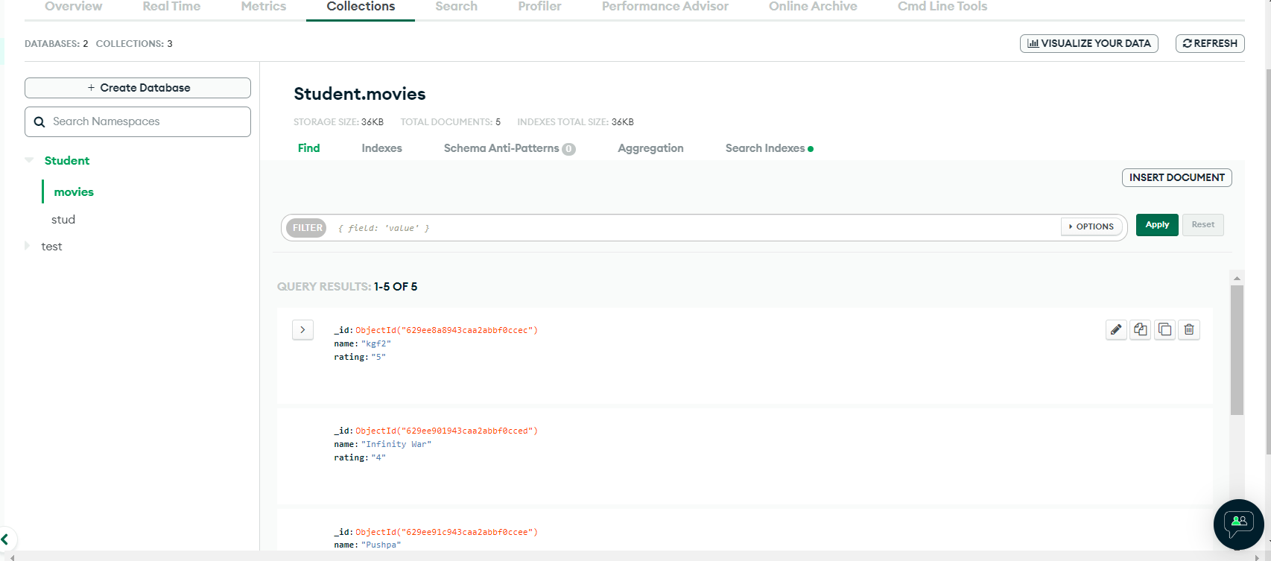

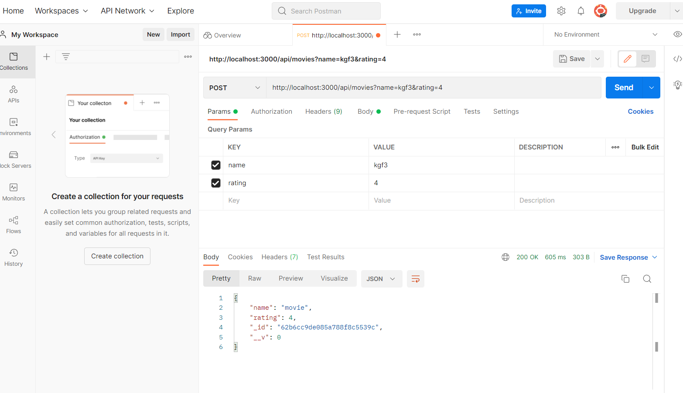
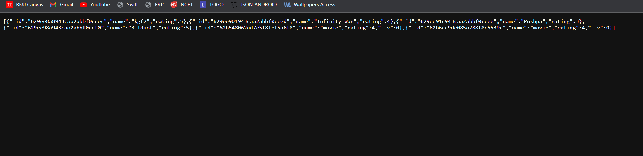

Tutorial 4
varexpress = require('express')
varrouter = express.Router();
varMovie = require('./Model/movie')

router.get("/movies",async(req,res)=>{
constiMovie = await
Movie.find();
res.send(iMovie);
});

//Update Specific Record
router.patch("/movies/:id",async(req,res)=>{
constiMovie = awaitMovie.findOne({_id:req.params.id});
iMovie.name = req.body.name;
iMovie.rating = req.body.rating;

awaitiMovie.save((err,msg)=>{
if(err){
res.status(500).json({
"err":err
})
}else{
res.status(200).json({
"message":msg
})
}
})
})

router.delete("/movies/:id",async(req,res)=>{
awaitMovie.deleteOne({_id:req.params.id},(err,msg)=>{
if(err){
res.status(500).json({
"err":err
})
}else{
res.status(200).json({
"message":msg
})
}
})
})

module.exports = router

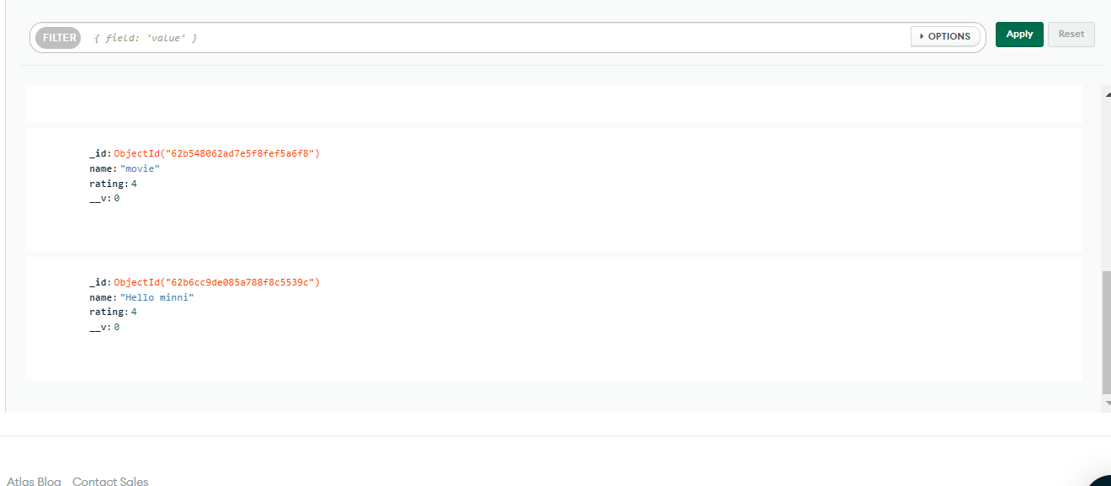

Tutorial 5
varexpress = require('express')
varrouter = express.Router();
varMovie = require('./Model/movie')

router.get("/movies",async(req,res)=>{
constiMovie = await
Movie.find();
res.send(iMovie);
});

//Update Specific Record
router.patch("/movies/:id",async(req,res)=>{
constiMovie = awaitMovie.findOne({_id:req.params.id});
iMovie.name = req.body.name;
iMovie.rating = req.body.rating;

awaitiMovie.save((err,msg)=>{
if(err){
res.status(500).json({
"err":err
})
}else{
res.status(200).json({
"message":msg
})
}
})
})

router.delete("/movies/:id",async(req,res)=>{
awaitMovie.deleteOne({_id:req.params.id},(err,msg)=>{
if(err){
res.status(500).json({
"err":err
})
}else{
res.status(200).json({
"message":msg
})
}
})
})

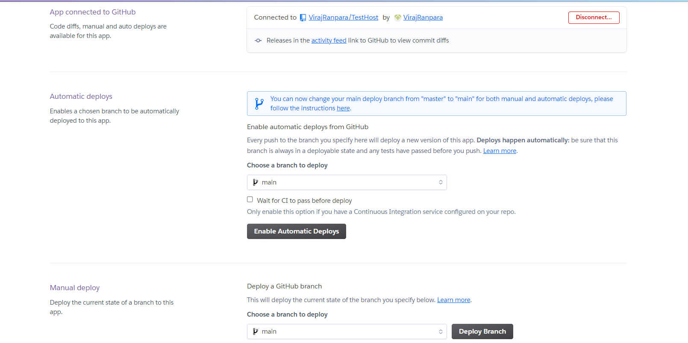

Tutorial 7
<form#login="ngForm"(ngSubmit)="submit(login)">
<divclass="form-group">
<labelfor="exampleInputEmail1">Email address</label>
<inputtype="email"name="Email"#Email="ngModel"[(ngModel)]="email"class="form-control"id="exampleInputEmail1"aria-describedby="emailHelp"placeholder="Enter email">
</div>
<divclass="form-group">
<labelfor="exampleInputPassword1">Password</label>
<inputtype="password"name="Pswd"#Pswd="ngModel"[(ngModel)]="pswd"class="form-control"id="exampleInputPassword1"placeholder="Password">
</div>
<buttontype="submit"class="btn btn-primary">Submit</button>
</form>

<tableclass="table">
<thead>
<th(click)="sort('userId')">UserID</th>
<th(click)="sort('title')">Title</th>
<th(click)="sort('body')">Body</th>
</thead>
<tbody>
<tr*ngFor = "let p of posts | paginate: { itemsPerPage: 10, currentPage: p } | orderBy:Key">
<td>{{p.userId}}</td>
<td>{{p.title}}</td>
<td>{{p.body}}</td>
</tr>
</tbody>
</table>
<pagination-controlsclass="text-center"(pageChange)="p = $event"></pagination-controls>

<divclass="container">
<h1>Photo Details..</h1>
<divclass="row">
<divclass="card-columns">
<divclass="card"*ngFor="let ph of photo | paginate: { itemsPerPage: 6, currentPage: p } ">
<divclass="card-body text-center">
<h5class="card-title">{{ph.title}}</h5>
<imgclass="m-3"[src]="ph.url">
<!-- <p class="card-text">Thumbnail Url: {{p.thumbnailUrl}}</p> -->
</div>
</div>
</div>
</div>
</div>
<pagination-controlsclass="text-center"(pageChange)="p = $event"></pagination-controls>

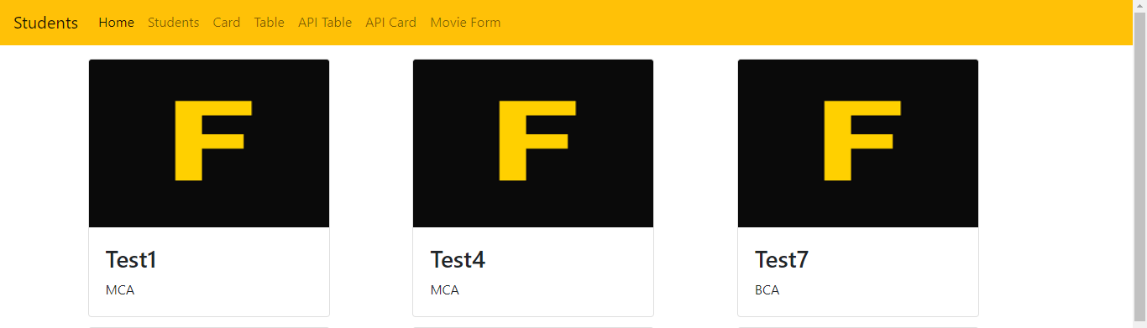
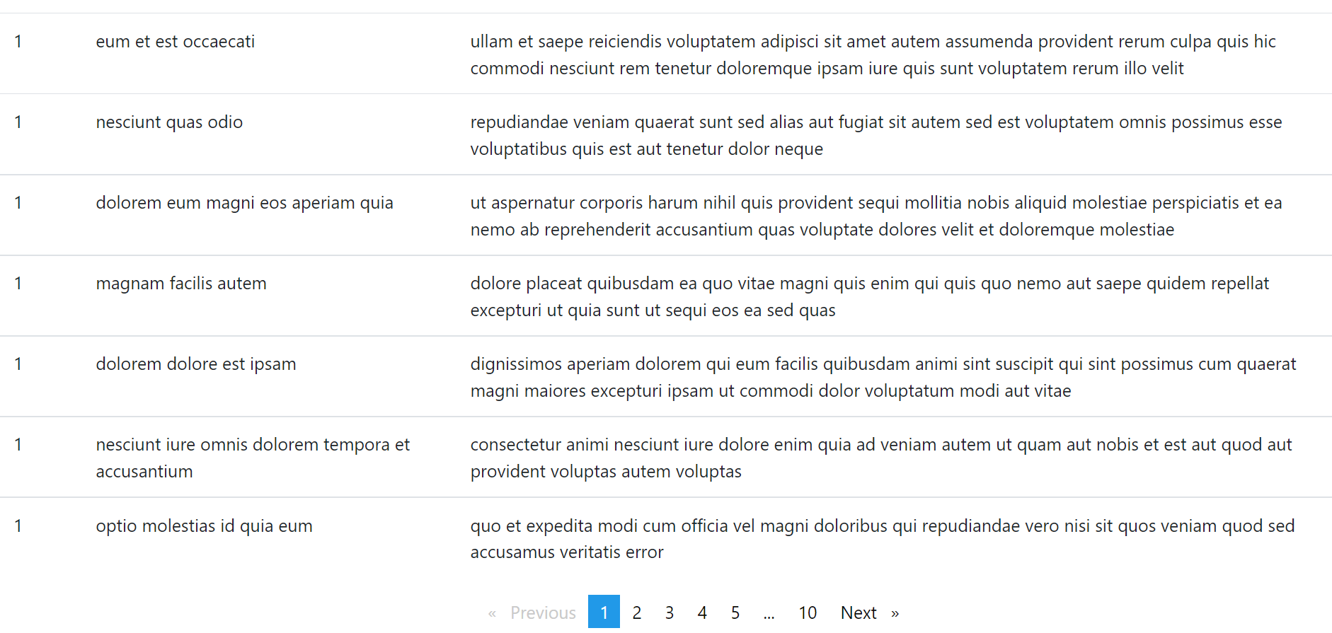
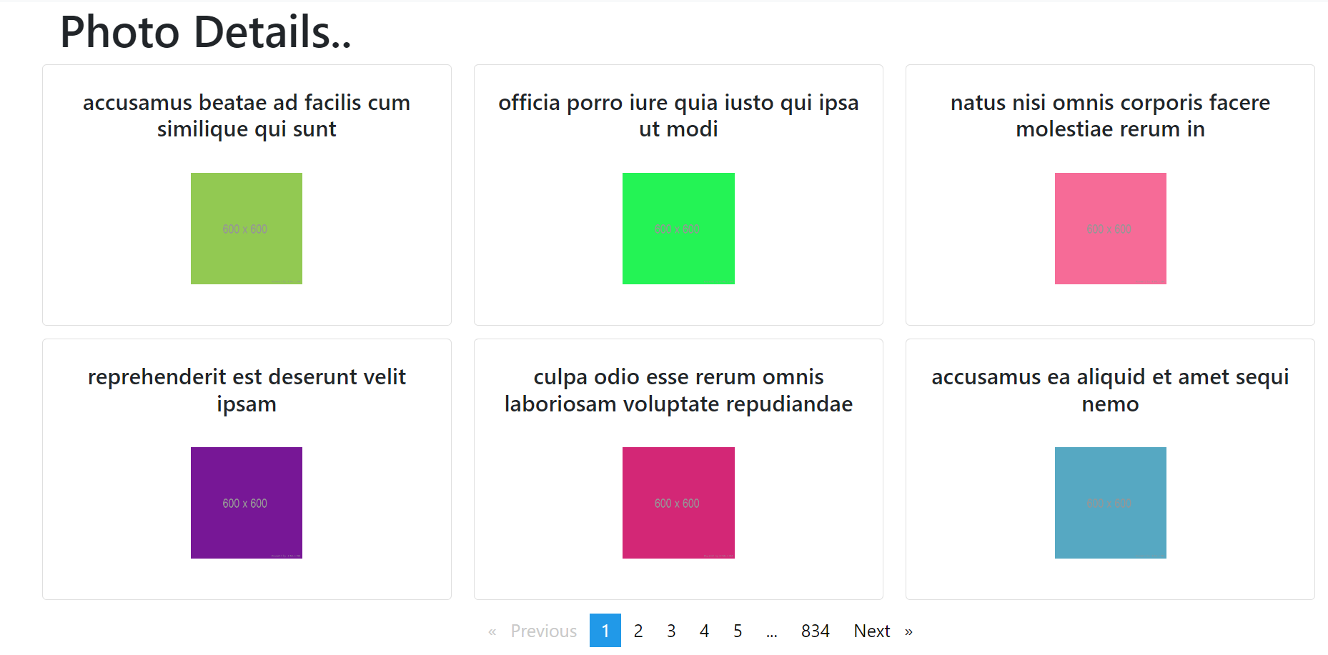
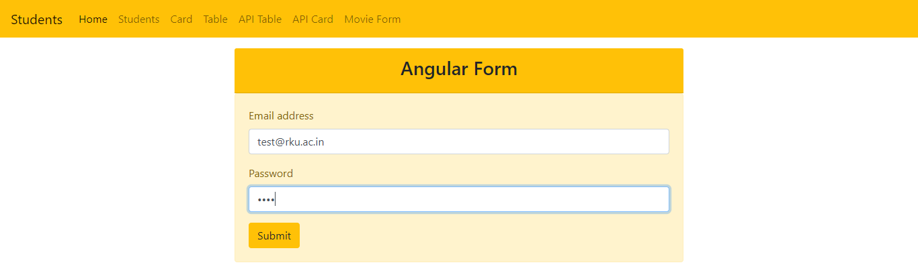

Hands on with Aggregation and Grouping
list the book category
db.books.aggregate({$group:{_id:"$category"}})

find out the total count for each category
db.books.aggregate({$group:{_id:"$category","total_count":{$sum:1}}})

total copies for each category
db.books.aggregate({$group:{_id:"$category","total_count":{$sum:"$copies"}}})

find out those books which are available according to its category
db.books.aggregate([{$match:{status:"A"}},{$group:{_id:"$category"}}])

find out all the books category wise but sort it by category name
db.books.aggregate([{$group:_id:"$category"},{$sort:{_id:1}}])

find out total likes of books cat. wise and sort by cat. name db.books.aggregate([{$group:{_id:"$category","total_likes":{$sum:"$likes"}}},{$sort:{_id:1}}])

find out total likes where likes greater than 100 of books cat. wise and sort by cat. name
db.books.aggregate([{$group:{_id:"$category","total_likes":{$sum:"$likes"}}},{$match:{total_likes:{$gt:100}}},{$sort:{total_likes:1}}])

find out highest likes where likes greater than 100 of books cat. wise and sort by cat. name
db.books.aggregate([{$group:{_id:"$category","total_likes":{$sum:"$likes"}}},{$match:{total_likes:{$gt:100}}},{$sort:{total_likes:1}},{$limit:1}])

find out second highest likes where likes greater than 100 of books cat. wise and sort by cat. name
db.books.aggregate([{$group:{_id:"$category","total_likes":{$sum:"$likes"}}},{$match:{total_likes:{$gt:100}}},{$sort:{total_likes:1}},{$skip:1},{$limit:1}])

Hands on With Querying using Regex Expression
- find the documents whose description starts with "M".

- find the documents whose description end with "n"

3. find the documents whose description contains "line" word"
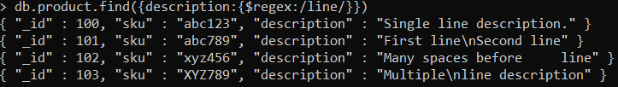

4. find the documents whose description contains second character "i".

5. find the documents where "sku" fields contains "xyz", ignore the case sensitivity.

6. find the documents where any line from the description starts with 'S..

Practice with CRUD
1. Create a Database named "Stocks"
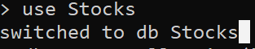

2. Create an empty collection named "inventory"
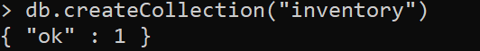

3. Insert below records in the inventory collection all together.
db.inventory.insertMany([
{ item: "journal", qty: 25, size: { h: 14, w: 21, uom: "cm" }, status: "A" },
{ item: "notebook", qty: 50, size: { h: 8.5, w: 11, uom: "in" }, status: "A" },
{ item: "paper", qty: 100, size: { h: 8.5, w: 11, uom: "in" }, status: "D" },
{ item: "planner", qty: 75, size: { h: 22.85, w: 30, uom: "cm" }, status: "D" },
{ item: "postcard", qty: 45, size: { h: 10, w: 15.25, uom: "cm" }, status: "A" }
]);

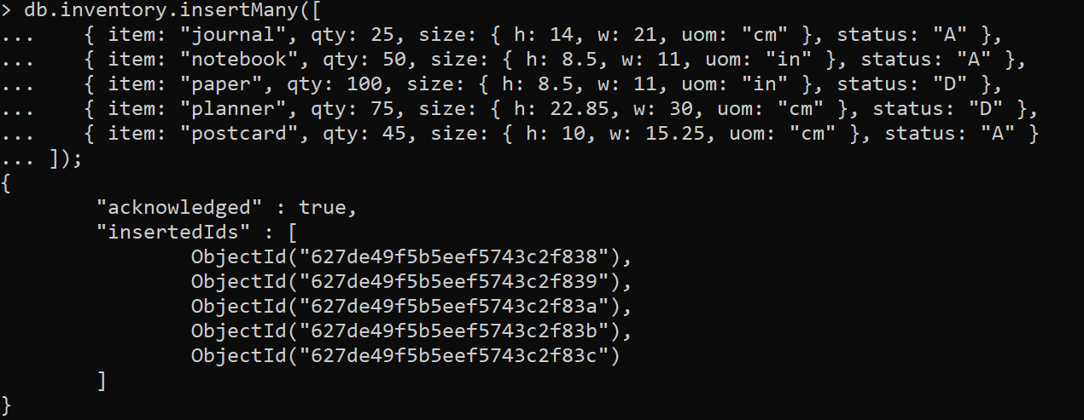

4. Select all documents from inventory collection
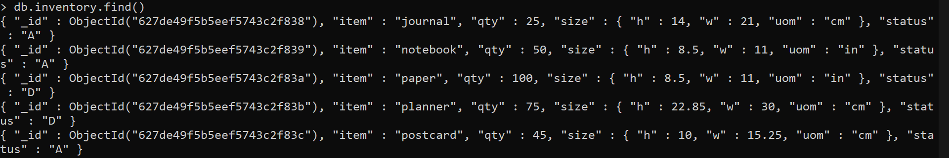
5. selects from the inventory collection all documents where the status equals "D"
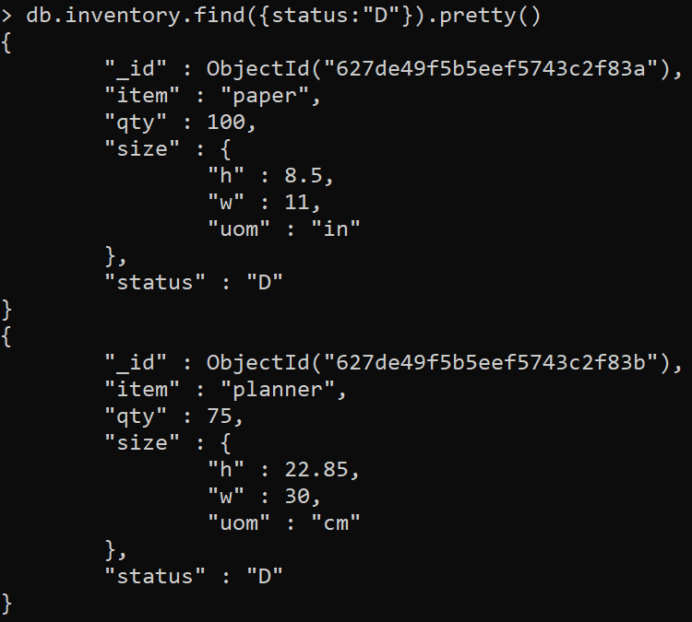

6. Retrieves all documents from the inventory collection where status equals either "A" or "D".

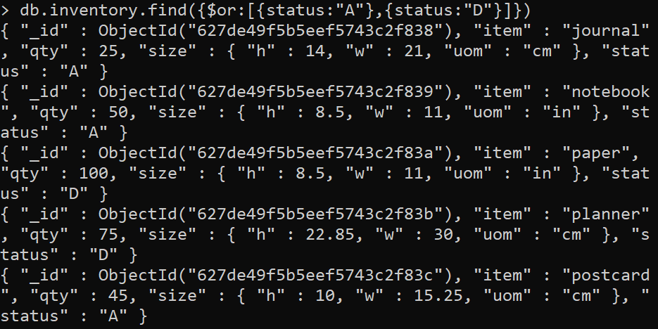

7. Retrieve documents in the inventory collection where the status equals "A" and qty is less than ($lt (Links to an external site.)Links to an external site.) 30

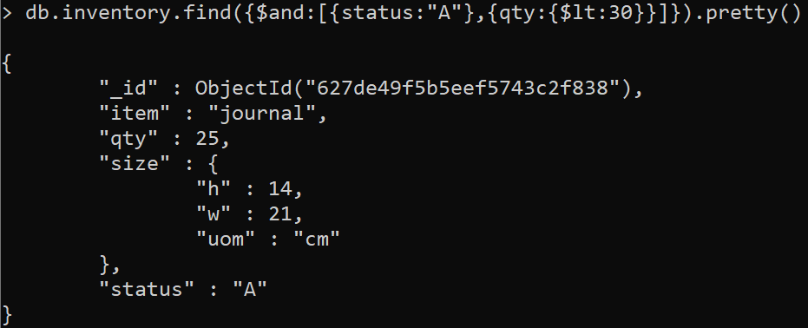

8. Retrieve all documents in the collection where the status equals "A" or qty is less than ($lt (Links to an external site.)Links to an external site.) 30

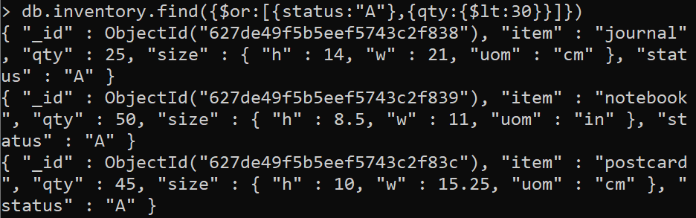

9. Update qty to 25 where item is notebook

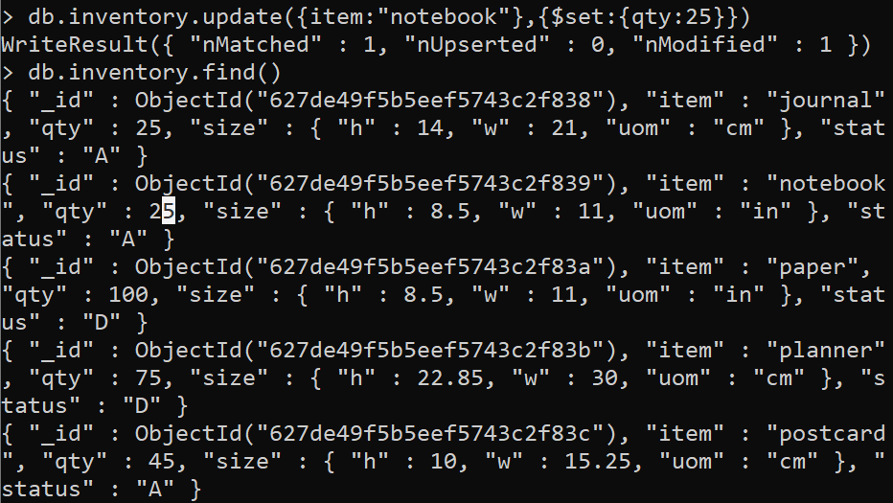

10. Update all status to 'B' where status is 'D'
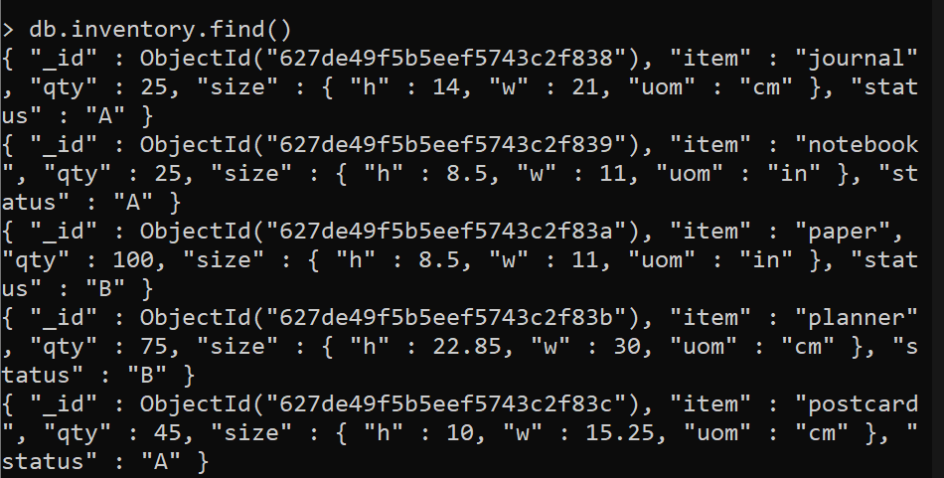

11. Write a query to demonstrate usage of upsert.

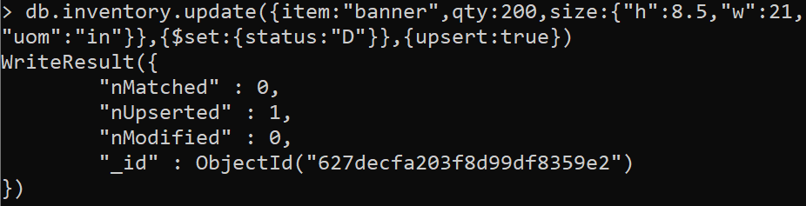

12. Delete the document where qty is 100

13. Delete all the documents from inventory collection.

14. Rename the collection.

15. Delete the database.
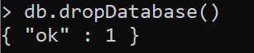

Hands on with Aggregation and match

list the book category
db.books.aggregate({$group:{_id:"$category"}})

find out the total count for each category
db.books.aggregate({$group:{_id:"$category","total_count":{$sum:1}}})

total copies for each cayegory
db.books.aggregate({$group:{_id:"$category","total_count":{$sum:"$copies"}}})

find out those books which are available according to its category
db.books.aggregate([{$match:{status:"A"}},{$group:{_id:"$category"}}])

find out all the books category wise but sort it by category name
db.books.aggregate([{$group:_id:"$category"},{$sort:{_id:1}}])

find out total likes of books cat. wise and sort by cat. name
db.books.aggregate([{$group:{_id:"$category","total_likes":{$sum:"$likes"}}},{$sort:{_id:1}}])

find out total likes where likes greate than 100 of books cat. wise and sort by cat. name
db.books.aggregate([{$group:{_id:"$category","total_likes":{$sum:"$likes"}}},{$match:{total_likes:{$gt:100}}},{$sort:{total_likes:1}}])

find out highest likes where likes greate than 100 of books cat. wise and sort by cat. name
db.books.aggregate([{$group:{_id:"$category","total_likes":{$sum:"$likes"}}},{$match:{total_likes:{$gt:100}}},{$sort:{total_likes:1}},{$limit:1}])

find out second highest likes where likes greate than 100 of books cat. wise and sort by cat. name
db.books.aggregate([{$group:{_id:"$category","total_likes":{$sum:"$likes"}}},{$match:{total_likes:{$gt:100}}},{$sort:{total_likes:1}},{$skip:1},{$limit:1}])

