Selection and Placement of Sales Personnel

Introduction

Selection systems for sales personnel range from simple one-step systems consisting of nothing more than an informal personal interview to complex multistep systems incorporating diverse mechanisms designed to gather information about applicants for sales job.

"A selection system is a set of successive 'screens' at any of which an applicant may be dropped from further consideration".

Companies using multistep selection systems differ as to the number of steps and their order of inclusion. Each company designs its selection system to fit its own information needs and to meet its own budgetary limitations. As applicants survive succeeding steps in the system, the additional increments of information enable increasingly accurate estimates of success and failure probabilities.

Selection of proper sales people is very important to avoid disappointments, both to the employer and employee. Effective sales managers make every effort to get the best sales people available to them. Having wrong personnel costs a great deal to any organisation as neither the employer nor the employee is satisfied. An organisation's turnover rate shows the effectiveness of its selection process. It is a risk both to the company and the sales person. The company looses because the sales person does not fit into the required job and the sales person looses by choosing a wrong career and losing time which cannot be recovered. Unlike other jobs success in selling does not depend on a intellectual ability alone. There are many emotional demands on the salesman also. His personality, ability, experience, temperament and aptitude are also important in tackling situations that many a times are very disappointing. Like management, selection is also both an art and a science. It is an art as it requires experience and science because a set of systematic procedures are followed.

The process of selection of sales personnel differs from company to company depending upon the requirements. The applicant goes through various stages and the chances of selection get better as more and more stages are cleared. It is important for the company to find the suitable candidate, how he would be an asset to the company as well as fit well so that his requirements are also met.

Preliminary Interview

The initial screening is usually undertaken by the receptionist in the employment office. This interview is essentially a sorting process in which perspective applicants are given the necessary information about the nature of the jobs in the organisation. The necessary information then is elicited from the candidates relating to their education, experience, skill, salary demanded, the reasons for leaving the present job, their job interest, physical appearance, age and facility of speech. If a candidate meets with the requirements of the organisation he may be selected for further action. If not, he is eliminated at this preliminary stage.

Formal Application Blank

An application blank is a brief history sheet of an employee's background and can be useful for future reference in case of need.

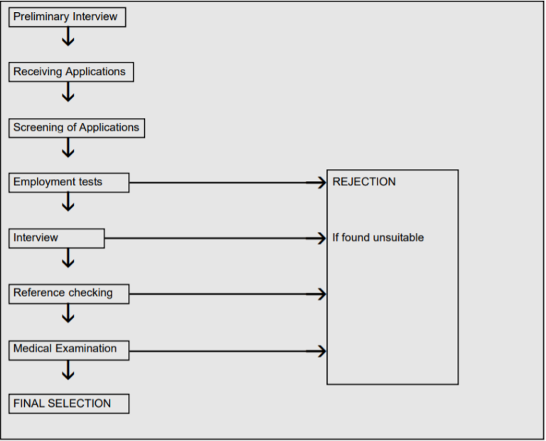

An application blank is a traditional, widely accepted device for getting information from a prospective applicant which will enable the management to make a proper selection.

The blank provides preliminary information and helps in interview by indicating the areas of interest and discussion. It is a useful device for collecting historical data from the candidate as well as storing information for later reference.

Ideally each company should prepare its own formal application form as per its information requirements. But to save the time and cost o

f preparing its own application form it can follow a standard application form. Categories of information used in standard application forms on usual terms are: 1. Personal (a) name (b) address (c) sex (d) date of birth and age (e) marital status (f) children/dependents. 2. Education (a) schooling : primary/secondary (b) higher education: institutions (c) qualifications (d) specified training, e.g., apprenticeships, sales (e) membership of professional bodies. 3. Employment History (a) number of jobs held (b) name of companies worked for (c) duration and dates of employment (d) positions, duties and responsibility. 4. Other Interests (a) sports (b) hobbies (c) membership of societies/clubs.

Interview

An interview can be defined as an attempt at gathering information from the candidate concerning his suitability for the job under consideration. No method other than interview is quite as satisfactory in judging an individuals' ability in oral communication, personal appearance and attitude towards selling and personal impact on others which are most important for the person involved in selling.

Interview Decisions

The following important decisions have to be taken by the management regarding interviews:

Who: The usual practice is to interview several persons and evaluate each applicant. In large sales organisation, district or branch sales manager handles the interview while in small organisations the responsibility lies with the top personnel of sales and marketing department.

Where: Similarly the place of interviewing also depends upon the size and degree of decentralisation in the organisation. In large and highly decentralised organisations the responsibility lies with district/branch/regional level sales department while in centralised organisations it lies with top personnel of sales and marketing department.

When: A short interview is generally used at the initial stage of screening process as preliminary interview, while a detailed/depth interview is used at a later stage in the selection process.

Interviewing Techniques

Mainly four kinds of interviewing techniques are used in a sales organisation. These are:

Non-Directed/Non-Structured Interview: This kind of interview does not follow a standard format of questions, instead it involves a relaxed discussion. Some personnel experts say that a non-directive technique yields maximum insight into an individual's attitude and interests. This method is perhaps the best way of probing an individual's personality in depth. The main drawback is that administering the interview and interpreting the results demands specialised instructions.

Patterned/Structured Interview: In this method the interviewers are given a prepared list of questions or a specific outline of questions designed to elicit a basic core of information.

McMurray explains why the patterned interview is likely to improve the judgement of the interviewers: First, the interviewer works from definite job specifications, he knows what qualities each job requires. Second, he has a plan, he knows what questions to ask. Third, he has been trained in the techniques of conducting an interview. Fourth, prior to interview, he has checked with outside sources and already knows a great deal about the applicant. Fifth, the interviewer himself has been carefully selected to assure that he has adequate intelligence and is emotionally well adjusted.

Interaction (Stress) Interview: It is a highly complex technique. In this the interviewer assumes a hostile role towards the applicant. He deliberately puts him on the defensive by trying to annoy, embarrass and frustrate him. The interaction interview simulates the stresses the applicant would meet in actual selling and how he would react to them.

Rating Scales: In this method results are obtained from comparable ratings of the same individual by different interviewers. The rating scales of the interview are so constructed that interviewers' ratings are channeled into a limited choice of responses. For instance, in evaluating the attitude of the candidate an interviewer is forced to choose from one of these answers: negative and complaining, pessimistic, positive and healthy, strong loyalty.

Employment test refers to a procedure, technique, or measurement instrument for ascertaining characteristics such as aptitudes, capacities, intelligence, knowledge, skills, or personality.

Reference Check

Sometimes applicants are asked to name as references those people on whom they can rely to speak about them.

The main purpose of reference checks as a selection tool is to verify the facts such as dates of employment, earnings, sales volume, absenteeism and nature of the past selling job. This typical procedure is to check the references by personal visit, telephone or letter.

Psychological Testing

"Tests are the most misused, the least understood, yet the most valuable sources of information about the applicants".

A psychological test can be defined both in a broad as well as narrow manner. Broadly, it has been defined as a "Systematic approach for comparing the behaviour of two or more persons". In narrow sense, "It is a sample of an aspect of an individual's behaviour, performance or attitude".

Thus, we may define it as a systematic procedure for sampling human behaviour.

Psychological testing is gaining greater importance as a selection tool of sales personnel because of sales management becoming more formalised and rising cost of selection and training.

The major purpose of testing is to identify the various aspects of a persons' behaviour such as intelligence, achievements, interests, aptitude, personality traits, etc.

Different Types of Psychological Tests

Psychological tests are divided into four categories on the basis of human behaviour. But mostly, the three categories: Aptitude Test, Personality Test and Achievement Test are used in selection procedure of sales personnel.

Aptitude or Ability Test: These are used to measure the talent/ability of a candidate to learn the job or skill. They detect peculiarities or defects in a person's sensory or intellectual capacity. They focus attention on a particular type of talent, e.g., learning, reasoning or a mechanical bend of mind. Such tests may be of the following types:

Mental or Intelligence Test: They measure the overall intellectual activity or the intelligence quotient (IQ) of the candidate. They also determine the candidate's word fluency, memory, inductive reasoning, speed of perception and spatial visualisation.

Psychomotor or Skill Test: These tests measure a person's ability to do a specific job. They are administered to determine mental dexterity or mental ability and similar attributes involving muscular movement, control and coordination.

Personality Tests: These tests try to find out an individual's value system, his emotional reactions and maturity and his characteristic mood. Their major motive is to measure the basic make up or characteristics of individuals which are non-intellectual in nature.

These tests can be categorised into the following types.

(i) Objective Test: They measure neurotic tendencies, self-sufficiency, dominance-submission and self-confidence. These are scored objectively.

(ii) Project Tests: In this the candidate is asked to project his own interpretation into certain standard stimulus situations which reflects his own values, motives and personality.

(iii) Situation Test: This reveals the ability of a candidate to undergo stress and his demonstration of ingenuity under pressure. In short, we can say that it is a measure of applicant's reaction when he is placed in a particular situation.

Achievement Tests (Proficiency Tests): Achievement tests seek to determine how much the individual knows about a subject. They determine the admission feasibility of the candidate and measure what he is capable of doing.

1. Tests for measuring job knowledge: They are administered to determine degree of their qualification and feasibility to perform the job.

2. Work sample tests: They demand the administration of the actual job as a test.

Interest Test: It is assumed in the use of interest tests that a relationship exists between test and motivation. Hence, if two persons have equal ability, the one with a greater interest in a particular job is more successful. These tests aim at finding out the types of work in which the candidate is interested.

However, these are not used much in the selection procedure of sales personnel as significant variation has been found in the interest test scores of successful and unsuccessful sales persons.

Physical Examination

Sales persons' job requires unusual stamina, strength or tolerance of hard working conditions. The presence or absence of these qualities in the candidate is revealed by physical examination. The major purpose of physical examination in the selection procedure of sales persons is that:

1. It gives a clear indication whether candidate is physically able to perform the sales person's job in the company.

2. It prevents selection of people who suffer from some contagious diseases.

3. It discovers the existing disabilities of the candidate and a record of the same is maintained so that the question of company's responsibilities would be settled in the event of a workman's compensation claim.

Rating of Interviewee

Having studied all the factors related to selection process, these should now be rated on the placement summary. The various facts should be compared with the requirements of the main profile and a score noted in the appropriate box. He should be rated 1 for a perfect match, 2 for an average match, 3 for below average and 4 for totally unsatisfactory. Comments should be made in the appropriate column to explain apparent discrepancies. Overall comments can be made in the space provided.

The scores should not be totalled or averaged in arriving at the final recommendation, as the weighing of the various factors will vary. What the manager must do is to consider each candidate as a mixture of factors and by identifying strong and weak points, come to a recommendation and score the man on the four-category scale. Category 1 men will normally be offered jobs immediately. Category 2 are not qualified in all respects and failing the appearance of anyone better, are worth employing. Only in dire circumstances, when it is imperative that someone be employed, should category 3 men be taken on. Category 4 staff should never be employed however desperate the manager might feel, for they can only create worse problems rather than solving them.

Two further considerations that the manager must take into account in arriving at his decision Notes are the compatibility of the man with his future colleagues and superiors and the future management needs of the company.

How well a man fits into a team can often determine his success. It is usually fatal to put a dynamic, aggressive, ambitious twenty six year old into a sales force consisting of security minded senior citizens hanging on for their pensions. It is likewise dangerous to have a man who is over-compatible with his superior. This often comes about by "mirror-image" selection, a common fault of many inexperienced managers. Because a candidate happens to have a similar background to the manager, that is, comes from the same part of the country, went to the same school, shares an interest in water-polo and the like, it may be tempting to assume that he possesses similar business abilities but if a manager is prone to such temptations, it is better for him to ask a colleague to take over the interviewing.

Employment Offer

An employment offer is extended to the candidate who successfully passes through all the preceding steps.

Placement of Sales Personnel

Once, an offer of employment has been extended and accepted the final stage in procurement function is concluded, and the process of placement of the individual on the new job and orienting him to the organisation. Placement may be defined as "the determination of the job to which an accepted candidate is to be assigned and his assignment to the job. It is a matching of what the supervisor has reason to think he can do with the job demands (job requirements), it is a matching of what he imposes (in strained working conditions) and what he offers in the form of payroll, companionship with others, promotional possibilities, etc."

Probation

After selection, the employee is generally put on a probation period, ranging from one to two years, after which his employment may be regularised, provided that during this period, his work has been found to be satisfactory. Only in very rare cases is the employee, once placed, asked to quit and even then, it is only when there is something very serious against him or he is found guilty of continued negligence in the performance of his duties. The new employee is placed as a probationer until the trial period is over.

Future

Every company must look at its future management requirements as well as its need for career salesman. Usually, these two demands will have to be met by different types of staff. Therefore, two different man profiles may be necessary when looking to fill similar sales positions. Those men with management potential should certainly score higher in leadership, self-reliance and ability to accept responsibility categories than the career sales staff. Unless different standards are adopted, too many men of high potential may be employed who will quickly become frustrated and leave. If men who can be only career salesman are taken on, there will be no potential management pool for the future. The relationship between the two categories will depend upon the spans of control, the number of management levels and the life span of management in each job.

Keywords

Achievement Tests (Proficiency Tests): Achievement tests seek to determine how much the individual knows about a subject. They determine the admission feasibility of the candidate and measure what he is capable of doing.

Aptitude or Ability Test: These are used to measure the talent/ability of a candidate to learn the job or skill. They detect peculiarities or defects in a person's sensory or intellectual capacity. They focus attention on a particular type of talent, e.g., learning, reasoning or a mechanical bend of mind.

Mechanical Aptitude Test: These measure the capacity of a person to learn a particular type of mechanical work as they measure a person's visual-motor coordination or integration.

Mental or Intelligence Test: They measure the overall intellectual activity or the intelligence quotient (IQ) of the candidate. They also determine the candidate's word fluency, memory, inductive reasoning, speed of perception and spatial visualisation.   
Non-Directed/Non-Structured Interview: This kind of interview does not follow a standard format of questions, instead it involves a relaxed discussion. Some personnel experts say that a non-directive technique yields maximum insight into an individual's attitude and interests.

Objective Test: They measure neurotic tendencies, self-sufficiency, dominance-submission and self-confidence. These are scored objectively.

Patterned/Structured Interview: In this method the interviewers are given a prepared list of questions or a specific outline of questions designed to elicit a basic core of information.

Personality Tests: These tests try to find out an individual's value system, his emotional reactions and maturity and his characteristic mood. Their major motive is to measure the basic make up or characteristics of individuals which are non-intellectual in nature.

Situation Test: This reveals the ability of a candidate to undergo stress and his demonstration of ingenuity under pressure. In short, we can say that it is a measure of applicant's reaction when he is placed in a particular situation.