**Name:** Vineel Sai

**Reg No:** 498

**IIIT Kalyani, Assignment 5 8085 Micro controller**

**PROB.1** FIVE NUMBERS ARE STORED IN CONSECUTIVE MEMORY LOCATIONS STARTING FROM 9000H. SORT THE NUMBER IN ASCENDING ORDER.

4200 0E 05 MVI C, 5

4202 0D DCR C

4203 21 00 08C LOOP1: LXI H, 8C00H

4206 71 MOV M, C

4207 21 00 090 LXI H, 9000H

420A 7E LOOP2: MOV A, M

420B 23 INX H

420C BE CMP M

420D DA 15 42 JC SKIP

4210 56 MOV D, M

4211 77 MOV M, A

4212 2B DCX H

4213 72 MOV M, D

4214 23 INX H

4215 0D SKIP: DCR C

4216 C2 0A 042 JNZ LOOP2

4219 21 00 08C LXI H, 8C00H

421C 4E MOV C, M

421D 0D DCR C

421E C2 03 042 JNZ LOOP1

4221 76 HLT

**INPUT OUTPUT**

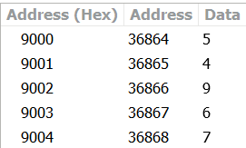 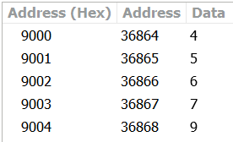

**PROB.2** FIVE NUMBERS ARE STORED IN CONSECUTIVE MEMORY LOCATIONS STARTINGFROM 9000H. SORT THE NUMBER IN DESCENDING ORDER.

4200 0E 05 MVI C, 5

4202 0D DCR C

4203 21 00 08C LOOP1: LXI H, 8C00H

4206 71 MOV M, C

4207 21 00 090 LXI H, 9000H

420A 7E LOOP2: MOV A, M

420B 23 INX H

420C BE CMP M

420D D2 15 42 JNC SKIP

4210 56 MOV D, M

4211 77 MOV M, A

4212 2B DCX H

4213 72 MOV M, D

4214 23 INX H

4215 0D SKIP: DCR C

4216 C2 0A 042 JNZ LOOP2

4219 21 00 08C LXI H, 8C00H

421C 4E MOV C, M

421D 0D DCR C

421E C2 03 042 JNZ LOOP1

4221 76 HLT

**INPUT OUTPUT**

 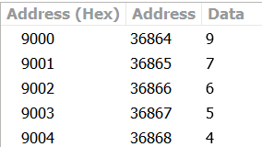

**PROB.3** A SET OF EIGHT READINGS IS STORED IN MEMORY LOCATIONS STARTING FROM 8C50H.WRITE AN ALP TO CHECK WHETHER A BYTE 40H EXISTS IN THE SET AND ALSO STORE THE NUMBER OF TIMES 40H OCCURS IN 9550H.

4200 0E 08 MVI C, 8

4202 06 28 MVI B, 40

4204 21 50 8C LXI H, 8C50H

4207 16 00 MVI D, 0

4209 7E LOOP: MOV A, M

420A B8 CMP B

420B C2 0F 042 JNZ SKIP

420E 14 INR D

420F 23 SKIP: INX H

4210 0D DCR C

4211 D2 09 042 JNC LOOP

4214 7A MOV A, D

4215 32 50 95 STA 9550H

4218 76 HLT

**INPUT OUTPUT**

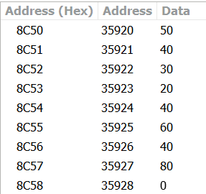 

**PROB.4** GENERATE THE FIRST 10 ELEMENTS OF THE FIBONACCI SERIES.

4200 06 00 MVI B, 0

4202 0E 08 MVI C, 8

4204 16 01 MVI D, 1

4206 21 00 08C LXI H, 8C00H

4209 70 MOV M, B

420A 23 INX H

420B 72 MOV M, D

420C 78 LOOP: MOV A, B

420D 82 ADD D

420E 42 MOV B, D

420F 57 MOV D, A

4210 23 INX H

4211 77 MOV M, A

4212 0D DCR C

4213 C2 0C 042 JNZ LOOP

4216 76 HLT

**OUTPUT**

