**Name:** Vineel Sai

**Reg No:** 498

**IIIT Kalyani, Assignment 3 8051 Micro controller**

**PROB.1** STORE THE HIGHER NIBBLE OF R7 IN TO BOTH NIBBLES OF R6

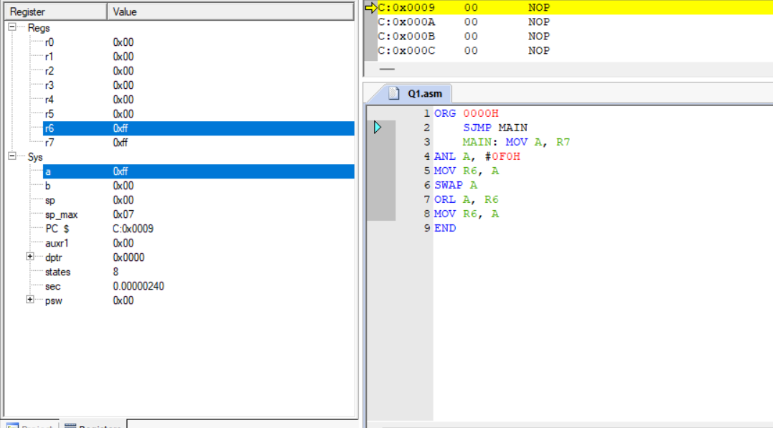

**PROB.2** GIVEN A BLOCK OF DATA BYTES FROM 100H TO 200H. FIND OUT HOW MANY BYTES FROM THIS BLOCK ARE GREATER THAN THE NUMBER IN R2 AND LESS THAN THENUMBER IN R3. STORE THE COUNT IN R4.

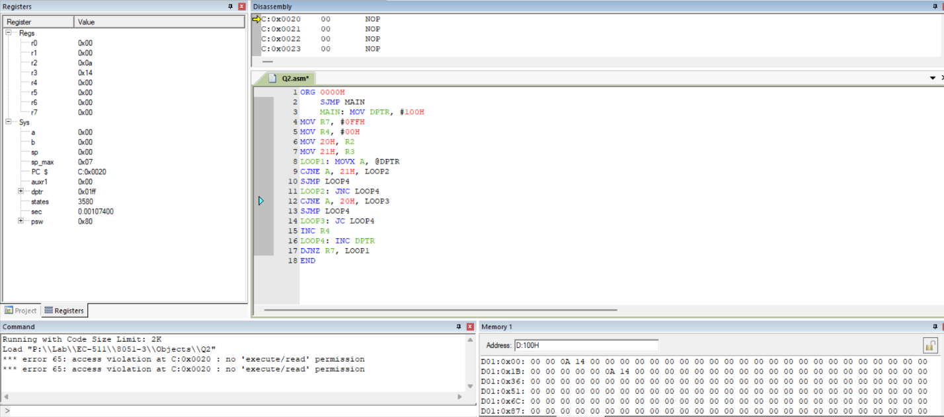

**PROB.3** MULTIPLY 0ECH BY 25H USING REPEATED ADDITION AND STORE THE RESULT IN R5.

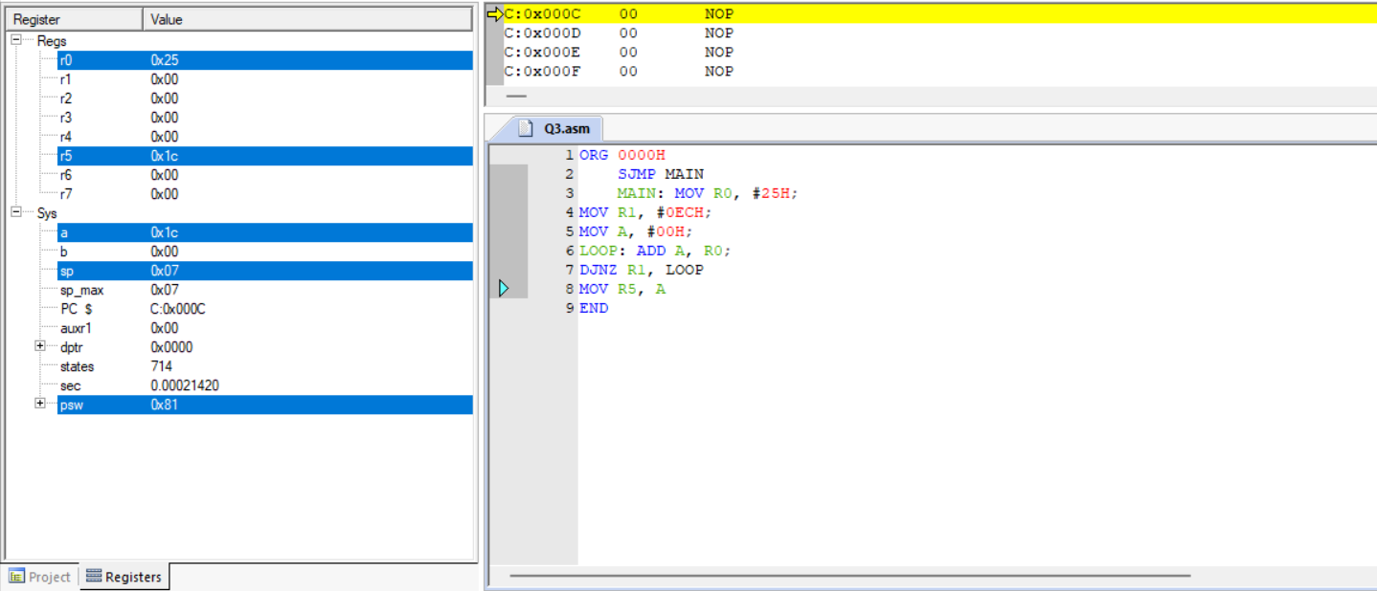

**PROB.4** LOAD THE ACCUMULATOR WITH THE VALUE 55H. COMPLEMENT A700 TIMES.

