**Name:** Vineel Sai

**Reg No:** 498

**IIIT Kalyani, Assignment 6 8085 Micro controller**

**PROB.1** A SET OF 10 BYTES ARE STORED AT MEMORY LOCATIONS STARTING FROM

8C50.WRITE AN ALP TO CHECK EACH BYTE AND SAVE THE NO. OF BYTES THAT ARE

HIGHER THAN 3C AND LOWER THAN 64 IN MEMORY LOCATIONS STARTING FROM

9060H ONWARDS.

4200 21 50 8C LXI H, 8C50H

4203 4E MOV C, M

4204 11 60 90 LXI D, 9060H

4207 23 LOOP: INX H

4208 7E MOV A, M

4209 FE 3C CPI 3CH

420B DA 15 42 JC SKIP

420E FE 64 CPI 64H

4210 D2 15 42 JNC SKIP

4213 12 STAX D

4214 13 INX D

4215 0D SKIP: DCR C

4216 C2 07 042 JNZ LOOP

4219 76 HLT

**INPUT OUTPUT**

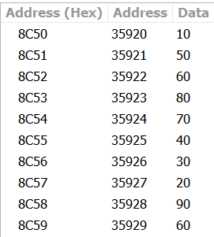 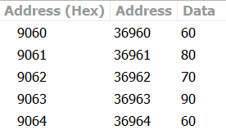

**PROB.2** ADDITION OF TWO NUMBERS GIVEN THROUGH PORTS. RESULT WILL ALSO BE STORED IN SOME PORT ADDRESS.

4200 DB 00 IN 000H

4202 67 MOV H, A

4203 DB 01 IN 001H

4205 84 ADD H

4206 D3 02 OUT 002H

4208 76 HLT

**OUTPUT**

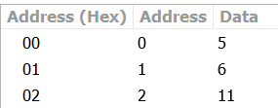

**PROB.3** SUBTRACTION OF TWO NUMBERS GIVEN THROUGH PORTS. RESULT WILL ALSO BE STORED IN SOME PORT ADDRESS.

4200 DB 00 IN 000H

4202 67 MOV H, A

4203 DB 01 IN 001H

4205 94 SUB H

4206 D3 02 OUT 002H

4208 76 HLT

**OUTPUT**

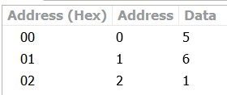

**PROB.4** MULTIPLICATION OF TWO NUMBERS GIVEN THROUGH PORTS. RESULT WILL ALSO BE STORED IN SOME PORT ADDRESS.

4200 DB 00 IN 000H

4202 4E MOV C, M

4203 DB 01 IN 001H

4205 06 00 MVI B, 00H

4207 04 LOOP: INR B

4208 91 SUB C

4209 D2 07 042 JNC LOOP

420C 05 DCR B

420D 78 MOV A, B

420E D3 02 OUT 002H

4210 76 HLT

**OUTPUT**

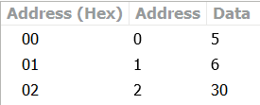

**PROB.5** DIVISION OF TWO NUMBERS GIVEN THROUGH PORTS. RESULT WILL ALSO BE STORED IN SOME PORT ADDRESS.

4200 DB 00 IN 000H

4202 4E MOV C, M

4203 DB 01 IN 001H

4205 06 00 MVI B, 00H

4207 04 LOOP: INR B

4208 91 SUB C

4209 D2 07 042 JNC LOOP

420C 05 DCR B

420D 78 MOV A, B

420E D3 02 OUT 002H

4210 76 HLT