**Name:** Vineel Sai

**Reg No:** 498

**IIIT Kalyani, Exam 2 8051 Micro controller**

**PROB:** WRITE A PROGRAM TO DETERMINE IF THE CONTENT OF R0 IS FFH. IF SO, MOVE FFH TO R5.

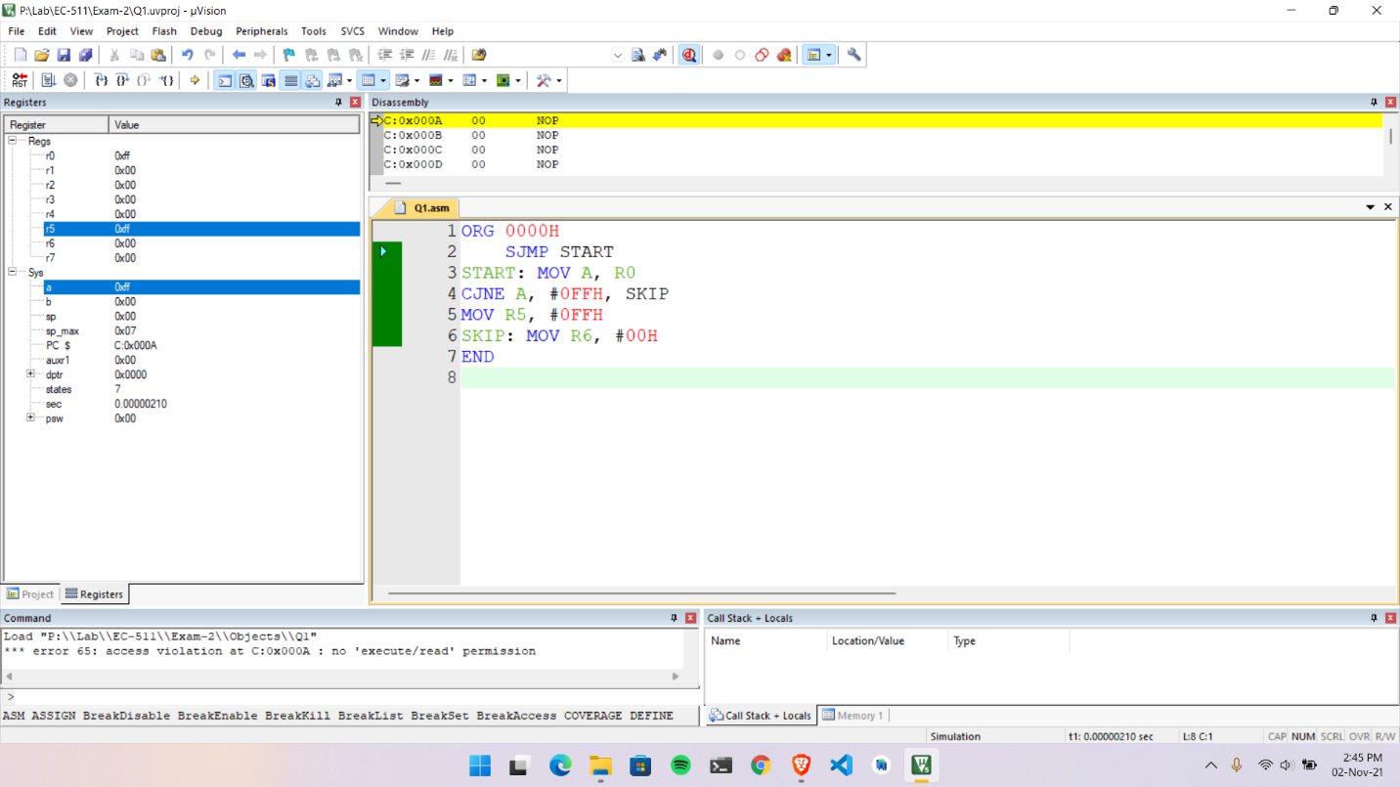

ORG 0000H

SJMP START

START: MOV A, R0

CJNE A, #0FFH, SKIP

MOV R5, #0FFH

SKIP: MOV R6, #00H

END