# Ágreiningur - Conflict

Dæmi um tvær útgáfur af sama skjali

1. Verkefnið opnað í Git Bash
2. Status kannaður
3. Staðan uppfærð
4. Staðan skráð
5. Status kannaður – OK en er skrefi á undan master á GitHub
6. Verkefnið sent á GitHub ! en það er ekki hægt sjá „error“ skilaboð
7. Til að leysa áreksturinn þarf að sækja (pull) GitHub master   
   (master|MERGING)
8. Skoða ágreining – git diff
9. <<<<<<< HEAD – local textinn
10. ===== textinn af Github >>>>>>> 510e2cf01
11. Annar hvor textinn er hreinsaður út ásamt HEAD og >>>>>>>  
     í *Sublime text editor*
12. Staðan uppfærð
13. Staðan könnuð
14. Staðan skráð (master) erum búinn að leysa ágreining!
15. Verkefnið sent á GitHUb - OK

Notandi@Notandi-THINK MINGW64 ~

1 $ cd /c/Users/Notandi/Desktop/Git/github_verkefni

Notandi@Notandi-THINK MINGW64 ~/Desktop/Git/github_verkefni (master)

2 $ git status

On branch master

Your branch is up-to-date with 'origin/master'.

Changes not staged for commit:

(use "git add <file>..." to update what will be committed)

(use "git checkout -- <file>..." to discard changes in working directory)

modified: README.md

Untracked files:

(use "git add <file>..." to include in what will be committed)

Github_greinar-samruni.docx

no changes added to commit (use "git add" and/or "git commit -a")

Notandi@Notandi-THINK MINGW64 ~/Desktop/Git/github_verkefni (master)

3 $ git add .

Notandi@Notandi-THINK MINGW64 ~/Desktop/Git/github_verkefni (master)

4 $ git commit -m 'greinar v1'

[master 235d2dd] greinar v1

2 files changed, 12 insertions(+), 25 deletions(-)

create mode 100644 Github_greinar-samruni.docx

rewrite README.md (88%)

Notandi@Notandi-THINK MINGW64 ~/Desktop/Git/github_verkefni (master)

5 $ git status

On branch master

Your branch is ahead of 'origin/master' by 1 commit.

(use "git push" to publish your local commits)

nothing to commit, working directory clean

Notandi@Notandi-THINK MINGW64 ~/Desktop/Git/github_verkefni (master)

6 $ git push

To https://github.com/VSH24/github_verkefni.git

! [rejected] master -> master (fetch first)

error: failed to push some refs to 'https://github.com/VSH24/github_verkefni.git '

hint: Updates were rejected because the remote contains work that you do

hint: not have locally. This is usually caused by another repository pushing

hint: to the same ref. You may want to first integrate the remote changes

hint: (e.g., 'git pull ...') before pushing again.

hint: See the 'Note about fast-forwards' in 'git push --help' for details.

Notandi@Notandi-THINK MINGW64 ~/Desktop/Git/github_verkefni (master)

7 $ git pull

remote: Counting objects: 14, done.

remote: Compressing objects: 100% (11/11), done.

remote: Total 14 (delta 7), reused 8 (delta 3), pack-reused 0

Unpacking objects: 100% (14/14), done.

From https://github.com/VSH24/github_verkefni

e5befb3..510e2cf master -> origin/master

warning: Cannot merge binary files: Github_greinar-samruni.docx (HEAD vs. 510e2c f01eafc8bd0ed0a73cac8dbb510ef7ff9a)

Auto-merging README.md

CONFLICT (content): Merge conflict in README.md

Auto-merging Github_greinar-samruni.docx

CONFLICT (add/add): Merge conflict in Github_greinar-samruni.docx

Automatic merge failed; fix conflicts and then commit the result.

Notandi@Notandi-THINK MINGW64 ~/Desktop/Git/github_verkefni (master|MERGING)

8 $ git diff

**diff --cc Github_greinar-samruni.docx**

**index c027a7f,3eb0e5c..0000000**

**--- a/Github_greinar-samruni.docx**

**+++ b/Github_greinar-samruni.docx**

**diff --cc README.md**

**index 60be06b,e92334c..0000000**

**--- a/README.md**

**+++ b/README.md**

@@@ -7,6 -7,7 +7,13 @@@

</li>

<li>Goggaðu (<i>e. fork</i>) í þessa geymslu (<i>e. Repository</i>) yfir á þi nn GitHub reikning.</li>

<li>Í skjalinu <i> "github_verkefni-glosur.docx </i> er hægt að sjá vinnuferl ið við að stofna þessa geymslu</li>

9 <<<<<<<< HEAD – *local* textinn

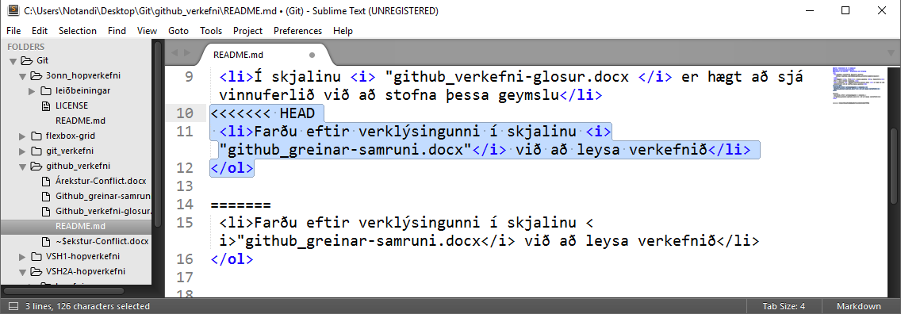

10 ====== textinn af GitHub

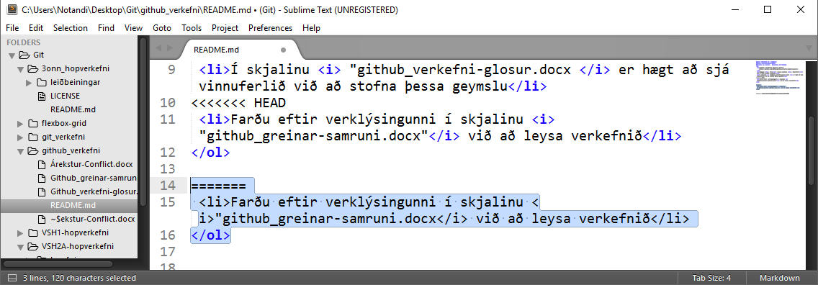

11 Annar hvor textinn er hreinsaður út ásamt HEAD og >>>>>>> 510e2cf01

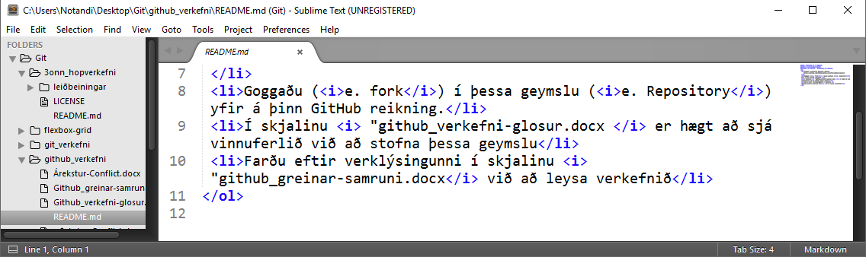

Notandi@Notandi-THINK MINGW64 ~/Desktop/Git/github_verkefni (master|MERGING)

11 $ git add .

Notandi@Notandi-THINK MINGW64 ~/Desktop/Git/github_verkefni (master|MERGING)

12 $ git status

On branch master

Your branch and 'origin/master' have diverged,

and have 1 and 4 different commits each, respectively.

(use "git pull" to merge the remote branch into yours)

All conflicts fixed but you are still merging.

(use "git commit" to conclude merge)

Changes to be committed:

modified: README.md

Notandi@Notandi-THINK MINGW64 ~/Desktop/Git/github_verkefni (master|MERGING)

13 $ git commit -m 'readmí OK'

[master c68bec3] readmí OK

Notandi@Notandi-THINK MINGW64 ~/Desktop/Git/github_verkefni (master)

14 $ git status

On branch master

Your branch is ahead of 'origin/master' by 2 commits.

(use "git push" to publish your local commits)

nothing to commit, working directory clean

Notandi@Notandi-THINK MINGW64 ~/Desktop/Git/github_verkefni (master)

15 $ git push

Counting objects: 7, done.

Delta compression using up to 2 threads.

Compressing objects: 100% (7/7), done.

Writing objects: 100% (7/7), 97.99 KiB | 0 bytes/s, done.

Total 7 (delta 4), reused 0 (delta 0)

remote: Resolving deltas: 100% (4/4), completed with 2 local objects.

To https://github.com/VSH24/github_verkefni.git

510e2cf..c68bec3 master -> master

Notandi@Notandi-THINK MINGW64 ~/Desktop/Git/github_verkefni (master)

$