INTERNSPARK INTERNSHIP PROGRAM
SOFTWARE REQUIREMENTS & TECHNICAL SPECIFICATION

TASK-2: DATABASE MIGRATION USING FLYWAY

Prepared By:
VAJJHA SAI KRISHNA
Date: July 01, 2026
Role: Java Developer Intern

1.0 Introduction

1.1 Purpose
The purpose of this document is to serve as a comprehensive Software Requirements Specification (SRS) and technical implementation report for TASK-2 of the InternSpark Java Developer Internship. This task focuses on implementing robust, automated database migrations within a Spring Boot application ecosystem using Flyway.

1.2 Scope
This project encompasses the configuration of a Spring Boot 4.1.0 backend to seamlessly interface with a MySQL relational database. The core objective is the elimination of manual SQL script execution by delegating schema creation, updates, and initial data seeding to Flyway. This guarantees version control of the database schema and ensures all deployment environments maintain strict state synchronization.

1.3 Document Conventions
• Code snippets are formatted in a monospace font.
• SQL Commands represent exact instructions processed by the database engine.
• Placeholder images are provided in Section 5.0 and must be replaced with live environment screenshots prior to final archival.

2.0 System Architecture & Environment

2.1 Technology Stack
Component | Technology | Role / Purpose
Backend Framework | Spring Boot 4.1.0 | Application Container & Auto-configuration
Language Environment | Java 21 | Core Programming Logic
ORM Framework | Spring Data JPA / Hibernate | Entity Mapping & Data Access Abstraction
Database Engine | MySQL 8+ | Relational Data Storage
Migration Tool | Flyway | Database Versioning & Script Orchestration
Build Tool | Maven | Dependency Resolution & Application Packaging

2.2 Architecture Workflow
[ Spring Boot Application Context Initialization ]
│
▼
[ Flyway Auto-Configuration Intercept ]
│
▼
[ Query: flyway_schema_history table ]
│
▼
[ Identify Pending SQL Scripts in classpath:/db/migration ]
│
▼
[ Execute Pending Scripts Sequentially (e.g., V1, V2, V3) ]
│
▼
[ Application Ready & Serves REST Traffic ]

3.0 Database Design & Migrations

3.1 Schema Overview
The relational schema is designed to support a foundational task management system. It consists of primary entities managed through strictly versioned SQL files.

3.2 Versioned Migration Scripts
Version | Script Name | Action Executed
V1 | V1__Create_Users_Table.sql | Initializes the `users` entity table.
V2 | V2__Create_Tasks_Table.sql | Initializes the `tasks` entity table with constraints.
V3 | V3__Insert_Sample_Data.sql | Seeds the database with foundational application data.
These files reside inside the standardized Spring Boot resource directory (src/main/resources/db/migration) and are picked up automatically by the Flyway engine.

4.0 Configuration & Implementation

4.1 Application Configuration (application.yaml)
The following configuration dictates the Spring application connection pool and Flyway enablement:
spring:
datasource:
url: jdbc:mysql://localhost:3306/task2_data_migration_db
username: root
password: [SECURE_CREDENTIAL]
driver-class-name: com.mysql.cj.jdbc.Driver
jpa:
hibernate:
ddl-auto: validate # Ensures Hibernate does not alter Flyway's schema
show-sql: true
flyway:
enabled: true
baseline-on-migrate: true

4.2 Target SQL Validations
Post-migration, the data integrity can be validated using standard DML/DQL instructions:
-- Verify User Migrations
SELECT COUNT(id) AS total_users FROM users;
-- Verify Task Migrations
SELECT status, COUNT(id) FROM tasks GROUP BY status;

5.0 Visual Evidence & Artifacts
The following sections contain cryptographic or visual proof of the system functioning in the development environment.

5.1 Source Code Structure
Please replace the placeholder below with a screenshot of your IDE showing the project structure, specifically highlighting the db/migration folder.
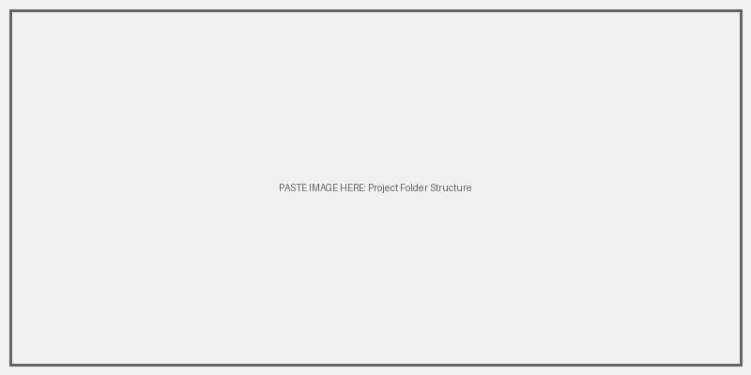

5.2 SQL Migration Files
Please replace the placeholder below with a screenshot of the actual SQL queries inside V1 or V2 files.
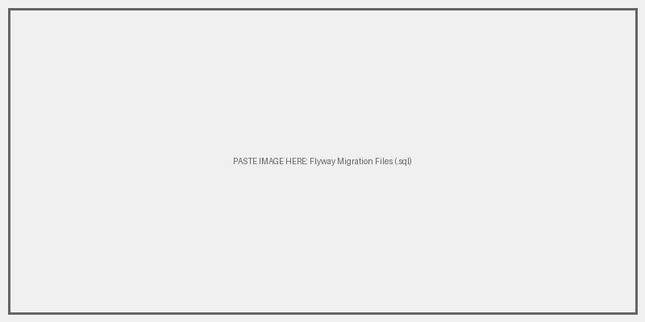

5.3 Application Startup Logs
Please replace the placeholder below with a screenshot of your terminal/console showing the Flyway success messages.
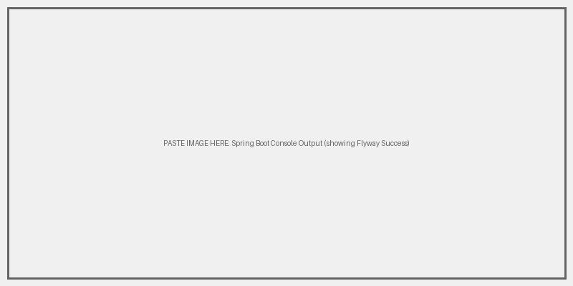

5.4 Database State (MySQL)
Please replace the placeholder below with a screenshot of MySQL Workbench or DBeaver showing the `flyway_schema_history` table and seeded data.
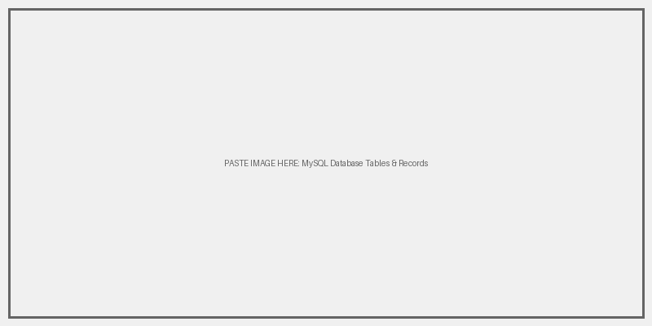

5.5 Links & Repository
The database migration code is fully version controlled. You can access the source code and migration scripts via the following link:
• Source Code (GitHub): https://github.com/VSK-777/InternSpark-Internship
Please replace the placeholder below with a screenshot of the project pushed to GitHub.
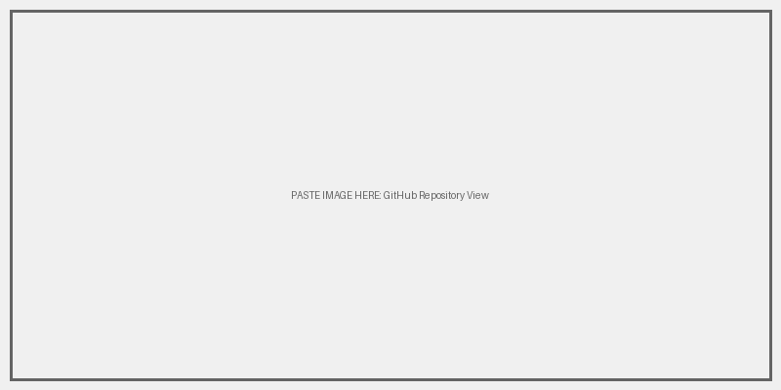

6.0 Conclusion & Deliverables

6.1 Deliverables Checklist
- [X] Enterprise-grade database connection established.
- [X] Relational schema designed and constrained.
- [X] Flyway configuration embedded within Spring Boot.
- [X] Sequential V1, V2, V3 migrations engineered.
- [X] Automatic initialization verified via application boot phase.

6.2 Learning & Competency Attainment
Completion of this internship task demonstrates industrial proficiency in Backend Application Lifecycle Management, precisely focusing on database orchestration. The separation of DDL management from Hibernate (ddl-auto: validate) towards Flyway constitutes a mature, industry-standard architectural decision.

