INTERNSPARK INTERNSHIP PROGRAM
DOCUMENTATION

TASK-1: FULL STACK EMPLOYEE CRUD APPLICATION

Prepared By:
VAJJHA SAI KRISHNA
Date: July 01, 2026
Role: Java Developer Intern

1.0 Introduction

1.1 Purpose
The purpose of this document is to serve as a comprehensive Software Requirements Specification (SRS) and technical implementation report for TASK-1 of the InternSpark Java Developer Internship. This task focuses on developing a complete Full Stack Employee Management System.

1.2 Scope
This project encompasses a React-based frontend client, a Spring Boot 4.1.0 RESTful API backend, and a MySQL relational database. The system provides full Create, Read, Update, and Delete (CRUD) capabilities, ensuring secure, decoupled communication via JSON over HTTP.

1.3 Document Conventions
• Code snippets are formatted in a monospace font.
• Placeholder images are provided in Section 5.0 and must be replaced with live environment screenshots prior to final archival.

2.0 System Architecture & Environment

2.1 Technology Stack
Component | Technology | Role / Purpose
Frontend Client | React, Vite, CSS | User Interface & State Management
Backend Framework | Spring Boot 4.1.0 | REST API & Business Logic
ORM Framework | Spring Data JPA | Entity Mapping & Data Access
Database Engine | MySQL 9.x | Persistent Relational Storage

2.2 Architecture Workflow
[ React Frontend UI (Port 5173) ]
│
│ (JSON / HTTP Requests)
▼
[ Spring Boot REST Controllers (Port 8080) ]
│
│ (Service Layer Validation)
▼
[ Spring Data JPA Repositories ]
│
│ (Hibernate / JDBC)
▼
[ MySQL Database (employee_db) ]

3.0 API Documentation

3.1 REST Endpoints
HTTP Method | Endpoint URL | Action
GET | /api/employees | Retrieve all employee records
POST | /api/employees | Create a new employee record
PUT | /api/employees/{id} | Update an existing employee record
DELETE | /api/employees/{id} | Delete an employee record

4.0 Configuration & Implementation

4.1 Frontend API Integration
The frontend isolates server communication within a dedicated service file. Environment variables inject the appropriate base URL.
const API_BASE_URL = import.meta.env.VITE_API_BASE_URL || 'http://localhost:8080';
export const getEmployees = async () => {
const res = await fetch(`${API_BASE_URL}/api/employees`);
return res.json();
};

4.2 Backend Security & Exception Handling
The Spring Boot server masks internal stack traces from the client using @ControllerAdvice, providing standardized JSON error payloads.
@ExceptionHandler(Exception.class)
public ResponseEntity<ErrorResponse> handleGlobalException(Exception ex) {
return ResponseEntity.status(HttpStatus.INTERNAL_SERVER_ERROR)
.body(new ErrorResponse("An internal server error occurred."));
}

5.0 Visual Evidence & Artifacts
The following sections contain cryptographic or visual proof of the system functioning in the development environment.

5.1 React Frontend Interface
Please replace the placeholder below with a screenshot of the Employee Dashboard UI in your browser.
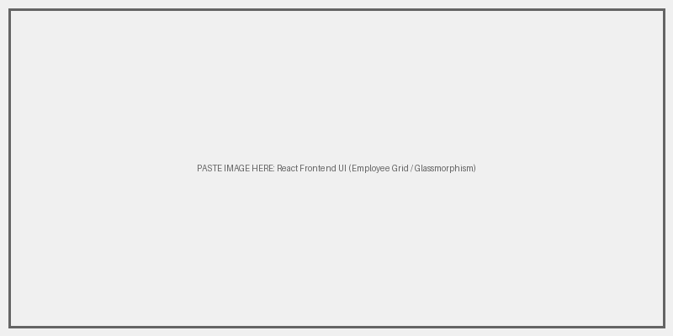

5.2 Spring Boot Backend Architecture
Please replace the placeholder below with a screenshot of your Java IDE showing the Controller/Service/Repository structure.
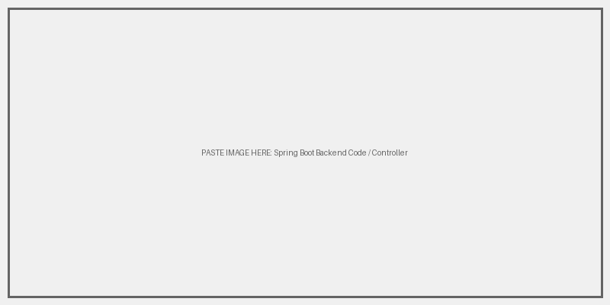

5.3 Database State (MySQL)
Please replace the placeholder below with a screenshot of MySQL Workbench showing the employee records.
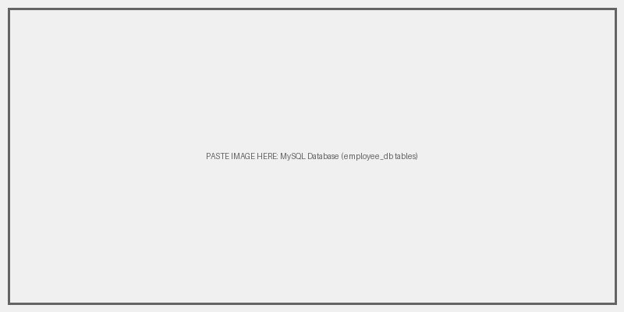

5.4 API Testing
Please replace the placeholder below with a screenshot showing a successful API call (via Postman, Swagger, or Chrome Network Tab).
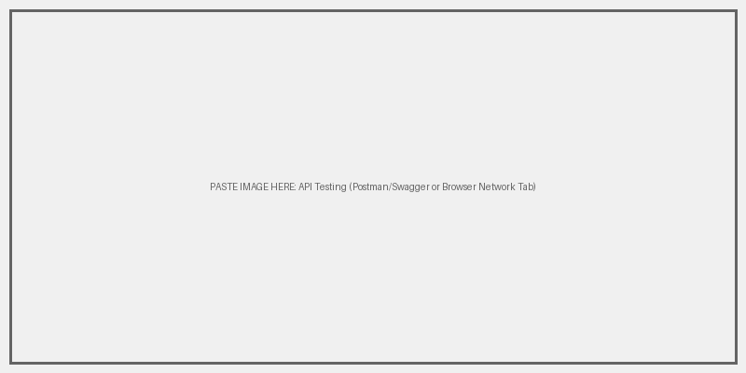

5.5 Links & Repository
The project is fully version controlled and deployed to cloud infrastructure. You can access the live environments and source code via the following links:
• Live Frontend Demo (Vercel): https://intern-spark-internship.vercel.app/
• Live API Backend (Render): https://employee-api-fqt8.onrender.com/api/employees
• Source Code (GitHub): https://github.com/VSK-777/InternSpark-Internship
Please replace the placeholder below with a screenshot of the project pushed to GitHub.
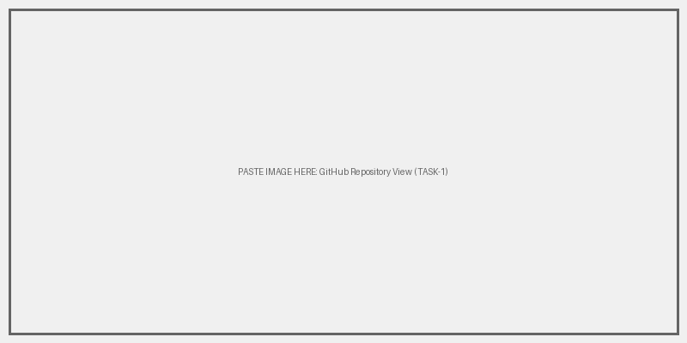

6.0 Conclusion & Deliverables

6.1 Deliverables Checklist
- [X] Highly responsive, aesthetic React UI implemented.
- [X] Secure Spring Boot RESTful API constructed.
- [X] MySQL database securely integrated via Spring Data JPA.
- [X] Global Exception Handling configured to prevent stack trace leaks.
- [X] Full end-to-end CRUD capabilities validated.

6.2 Learning & Competency Attainment
Completion of this internship task demonstrates industrial proficiency in Full Stack Application Lifecycle Management, precisely focusing on decoupled architectural design. The separation of concerns between a React presentation layer and a Java enterprise backend constitutes a mature, industry-standard architectural decision.

