Title

Author

Date

# Heading 1

## Heading 2

### Heading 3

#### Heading 4

##### Heading 5

This is an R Markdown document. Markdoswn is a simple formatting syntax for authoring HTML, PDF, and MS Word documents. For more details on using R Markdown see <http://rmarkdown.rstudio.com>.

When you click the **Knit** button a document will be generated that includes both content as well as the output of any embedded R code chunks within the document. You can embed an R code chunk like this:

summary(cars)

## speed dist   
## Min. : 4.0 Min. : 2.00   
## 1st Qu.:12.0 1st Qu.: 26.00   
## Median :15.0 Median : 36.00   
## Mean :15.4 Mean : 42.98   
## 3rd Qu.:19.0 3rd Qu.: 56.00   
## Max. :25.0 Max. :120.00

You can also embed plots, for example:

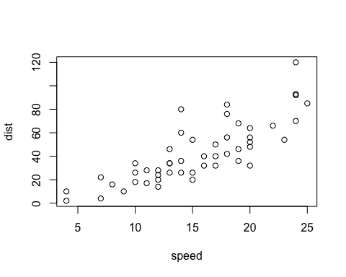

Figure 1. This is a figure caption.

Note that the echo = FALSE parameter was added to the code chunk to prevent printing of the R code that generated the plot.

A Pander generated table:

|  |  |  |  |
| --- | --- | --- | --- |
|  | var | m | s |
| **Ozone** | Ozone | 42.1293103448276 | 32.987884514434 |
| **Solar.R** | Solar.R | 185.931506849315 | 90.0584222283817 |
| **Wind** | Wind | 9.95751633986928 | 3.5230013522126 |
| **Temp** | Temp | 77.8823529411765 | 9.46526974097146 |
| **Month** | Month | 6.99346405228758 | 1.41652248401231 |
| **Day** | Day | 15.8039215686275 | 8.86452036842542 |

Table 1. Descriptive statistics for airquality

Bibliography style reference:

Jackson et al., (2012). XXXXX. XXX HAEJhfSDf jkshdf sdfkn asdf asdf akjsdf a,sdbf ,aksbdf nabsdf,mnbasd,fmnba sdf