Ex. No. 1 | Working with Widgets and Layouts
Date of Exercise | 09.08.2026
GitHub Code Link (Keep as public) | https://github.com/vsrajhavel/FlutterLaboratory
Aim
To design and develop a Flutter application that displays a list of fruit items using Row, Column, Container, Card and ListView widgets, and to create reusable custom widgets to organize the user interface effectively.
Description
Flutter is a UI framework used to build applications for multiple platforms from a single codebase. In Flutter, the user interface is constructed using widgets. Widgets describe the structure, layout, styling and behaviour of the application.
This experiment implements a simple fruit-list application named “Fresh Fruits”. The home screen contains an application bar, a welcome section, a heading and a scrollable list of fruit items. Each fruit is displayed in a card with an emoji, name, short description and price.
The following widgets are used in this experiment:
• Row: Arranges its child widgets horizontally.
• Column: Arranges its child widgets vertically.
• Container: Provides layout space, padding, dimensions, background colour and decoration.
• Card: Groups related information in an elevated visual panel.
• ListView.builder: Builds a scrollable list of items efficiently from the fruit data.
• Expanded: Allows the list to occupy the remaining available vertical space.
A Fruit class is used as a simple data model to store each fruit’s name, emoji, description and price. FruitCard is a reusable custom StatelessWidget. The same FruitCard layout is reused for every fruit by passing a different Fruit object to it. This reduces code duplication and makes the interface easier to maintain.
The application is executed in Google Chrome using Flutter Web. The ListView can be scrolled to view all the fruit entries.

Program
File: lib/main.dart
import 'package:flutter/material.dart';

void main() {
runApp(const MyApp());
}

// Main application widget
class MyApp extends StatelessWidget {
const MyApp({super.key});

@override
Widget build(BuildContext context) {
return MaterialApp(
debugShowCheckedModeBanner: false,
title: 'Fresh Fruits',
theme: ThemeData(
colorSchemeSeed: Colors.green,
useMaterial3: true,
),
home: const FruitHomePage(),
);
}
}

// Fruit data model
class Fruit {
final String name;
final String emoji;
final String description;
final String price;

const Fruit({
required this.name,
required this.emoji,
required this.description,
required this.price,
});
}

// Main home page
class FruitHomePage extends StatelessWidget {
const FruitHomePage({super.key});

// List of fruit items
static const List<Fruit> fruits = [
Fruit(
name: 'Apple',
emoji: '🍎',
description: 'Fresh and juicy red apples',
price: '₹120 / kg',
),
Fruit(
name: 'Banana',
emoji: '🍌',
description: 'Sweet and ripe bananas',
price: '₹60 / dozen',
),
Fruit(
name: 'Orange',
emoji: '🍊',
description: 'Rich in Vitamin C',
price: '₹80 / kg',
),
Fruit(
name: 'Strawberry',
emoji: '🍓',
description: 'Fresh and delicious strawberries',
price: '₹200 / box',
),
Fruit(
name: 'Grapes',
emoji: '🍇',
description: 'Sweet seedless grapes',
price: '₹100 / kg',
),
Fruit(
name: 'Watermelon',
emoji: '🍉',
description: 'Refreshing summer fruit',
price: '₹40 / kg',
),
];

@override
Widget build(BuildContext context) {
return Scaffold(
appBar: AppBar(
title: const Text(
'Fresh Fruits 🍃',
style: TextStyle(fontWeight: FontWeight.bold),
),
backgroundColor: Colors.green,
foregroundColor: Colors.white,
),

// Column arranges the header and list vertically
body: Column(
crossAxisAlignment: CrossAxisAlignment.start,
children: [
// Welcome section using Container
Container(
width: double.infinity,
padding: const EdgeInsets.all(20),
color: Colors.green.shade50,
child: const Column(
crossAxisAlignment: CrossAxisAlignment.start,
children: [
Text(
'Welcome!',
style: TextStyle(
fontSize: 25,
fontWeight: FontWeight.bold,
),
),
SizedBox(height: 5),
Text(
'Choose your favourite fresh fruits.',
style: TextStyle(fontSize: 15),
),
],
),
),

// Section heading
const Padding(
padding: EdgeInsets.fromLTRB(16, 20, 16, 10),
child: Text(
'Available Fruits',
style: TextStyle(
fontSize: 21,
fontWeight: FontWeight.bold,
),
),
),

// ListView displays all fruit cards
Expanded(
child: ListView.builder(
padding: const EdgeInsets.symmetric(horizontal: 12),
itemCount: fruits.length,
itemBuilder: (context, index) {
return FruitCard(fruit: fruits[index]);
},
),
),
],
),
);
}
}

// Reusable custom widget for displaying a fruit
class FruitCard extends StatelessWidget {
final Fruit fruit;

const FruitCard({
super.key,
required this.fruit,
});

@override
Widget build(BuildContext context) {
return Card(
elevation: 3,
margin: const EdgeInsets.symmetric(vertical: 7),
child: Padding(
padding: const EdgeInsets.all(14),

// Row arranges fruit details horizontally
child: Row(
children: [
// Container displays the fruit emoji
Container(
width: 65,
height: 65,
alignment: Alignment.center,
decoration: BoxDecoration(
color: Colors.green.shade50,
borderRadius: BorderRadius.circular(12),
),
child: Text(
fruit.emoji,
style: const TextStyle(fontSize: 35),
),
),

const SizedBox(width: 15),

// Column arranges fruit details vertically
Expanded(
child: Column(
crossAxisAlignment: CrossAxisAlignment.start,
children: [
Text(
fruit.name,
style: const TextStyle(
fontSize: 18,
fontWeight: FontWeight.bold,
),
),
const SizedBox(height: 5),
Text(
fruit.description,
style: TextStyle(
fontSize: 13,
color: Colors.grey.shade600,
),
),
const SizedBox(height: 5),
Text(
fruit.price,
style: const TextStyle(
fontSize: 15,
color: Colors.green,
fontWeight: FontWeight.bold,
),
),
],
),
),

const Icon(
Icons.arrow_forward_ios,
size: 17,
color: Colors.grey,
),
],
),
),
);
}
}

Output Screenshots
The following screenshot shows the Fresh Fruits application running successfully in Google Chrome. The screen displays the application bar, welcome section and fruit cards. The list can be scrolled to view the remaining fruits.
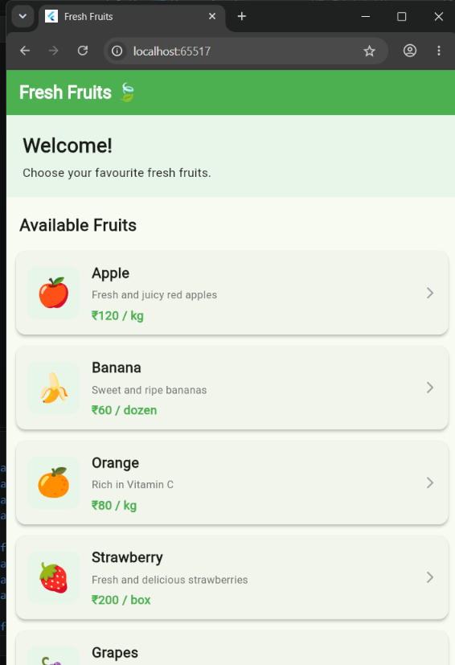
Result
Thus, the Flutter application “Fresh Fruits” was successfully designed and executed. The application displays fruit items using Row, Column, Container, Card and ListView widgets. A reusable custom widget named FruitCard was implemented to display each fruit consistently. The application was run successfully in Google Chrome using Flutter Web.

