Ex. No. 2 | Adaptive and Responsive UI Design
Date of Exercise | 31 October 2026
GitHub Code Link (Keep as public) | https://github.com/vsrajhavel/FlutterLaboratory
Aim
To design and implement a responsive Flutter application for an E-Commerce Product Catalog by creating reusable custom product widgets and applying responsive layout techniques so that the user interface adapts to different screen sizes.
Description
Responsive UI design is the process of arranging and resizing interface elements so that an application remains usable on devices with different screen dimensions. In Flutter, responsive layouts can be created by checking the available space and choosing suitable layout properties.
This experiment implements an e-commerce product catalog named “ShopEase”. The screen contains an application bar, a search field, a promotional welcome banner, a product section and a grid of product cards. Each product card displays an emoji representing the product, its name, category, price, rating and an Add to Cart button.
The main widgets and techniques used are:
• LayoutBuilder: Reads the maximum width available to the page so that the layout can respond to the screen size.
• Responsive breakpoints: Uses two columns below 600 pixels, three columns from 600 to below 900 pixels, and four columns at 900 pixels or above.
• GridView.builder: Creates the product cards in a scrollable grid using the selected number of columns.
• ProductCard: A reusable custom StatelessWidget that displays the details of one product.
• Product model: Stores each product’s name, category, emoji, price, rating and background colour.
• ConstrainedBox: Limits the content width to 1200 pixels on wide screens.
• Expanded and Flexible: Allocate available space and help prevent content overflow.
• setState(): Updates the cart count when the Add to Cart button is pressed.
The LayoutBuilder checks the available width and selects the grid configuration. For widths below 600 pixels, two product columns are displayed. For widths from 600 to below 900 pixels, three columns are displayed. For widths of 900 pixels or more, four columns are displayed. The product card aspect ratio is also adjusted for these width ranges.
The application is tested in Google Chrome at both desktop and narrow/mobile-sized browser widths. This demonstrates that the same Flutter application can adapt its product grid to different available screen sizes.

Program
File: lib/main.dart
import 'package:flutter/material.dart';

void main() {
runApp(const ShopEaseApp());
}

// MAIN APPLICATION
class ShopEaseApp extends StatelessWidget {
const ShopEaseApp({super.key});

@override
Widget build(BuildContext context) {
return MaterialApp(
debugShowCheckedModeBanner: false,
title: 'ShopEase',
theme: ThemeData(
colorSchemeSeed: Colors.deepPurple,
useMaterial3: true,
),
home: const ProductHomePage(),
);
}
}

// PRODUCT DATA MODEL
class Product {
final String name;
final String category;
final String emoji;
final double price;
final double rating;
final Color color;

const Product({
required this.name,
required this.category,
required this.emoji,
required this.price,
required this.rating,
required this.color,
});
}

// MAIN PRODUCT PAGE
class ProductHomePage extends StatefulWidget {
const ProductHomePage({super.key});

@override
State<ProductHomePage> createState() => _ProductHomePageState();
}

class _ProductHomePageState extends State<ProductHomePage> {
// PRODUCT LIST
final List<Product> products = const [
Product(
name: 'Wireless Headphones',
category: 'Electronics',
emoji: '🎧',
price: 1499,
rating: 4.8,
color: Color(0xFFEDE7F6),
),
Product(
name: 'Smart Watch',
category: 'Electronics',
emoji: '⌚',
price: 2499,
rating: 4.6,
color: Color(0xFFE3F2FD),
),
Product(
name: 'Running Shoes',
category: 'Fashion',
emoji: '👟',
price: 1999,
rating: 4.5,
color: Color(0xFFFFF3E0),
),
Product(
name: 'Backpack',
category: 'Accessories',
emoji: '🎒',
price: 999,
rating: 4.4,
color: Color(0xFFE8F5E9),
),
Product(
name: 'Camera',
category: 'Electronics',
emoji: '📷',
price: 5999,
rating: 4.9,
color: Color(0xFFFCE4EC),
),
Product(
name: 'Sunglasses',
category: 'Fashion',
emoji: '🕶️',
price: 799,
rating: 4.3,
color: Color(0xFFFFF9C4),
),
Product(
name: 'Smartphone',
category: 'Electronics',
emoji: '📱',
price: 12999,
rating: 4.7,
color: Color(0xFFE0F7FA),
),
Product(
name: 'Wrist Watch',
category: 'Accessories',
emoji: '⌚',
price: 1799,
rating: 4.5,
color: Color(0xFFF3E5F5),
),
];

int cartCount = 0;

@override
Widget build(BuildContext context) {
return Scaffold(
backgroundColor: const Color(0xFFF7F7FB),

// APP BAR
appBar: AppBar(
backgroundColor: Colors.deepPurple,
foregroundColor: Colors.white,
title: const Text(
'ShopEase',
style: TextStyle(fontWeight: FontWeight.bold),
),
actions: [
Padding(
padding: const EdgeInsets.only(right: 20),
child: Row(
children: [
const Icon(Icons.shopping_cart_outlined),
const SizedBox(width: 5),
Text('$cartCount'),
],
),
),
],
),

// RESPONSIVE BODY
body: LayoutBuilder(
builder: (context, constraints) {
final width = constraints.maxWidth;

// RESPONSIVE BREAKPOINTS
int columns;

if (width < 600) {
columns = 2;
} else if (width < 900) {
columns = 3;
} else {
columns = 4;
}

// DIFFERENT CARD SIZES
double cardRatio;

if (width < 600) {
cardRatio = 0.62;
} else if (width < 900) {
cardRatio = 0.72;
} else {
cardRatio = 0.78;
}

return Center(
child: ConstrainedBox(
constraints: const BoxConstraints(
maxWidth: 1200,
),
child: Column(
crossAxisAlignment: CrossAxisAlignment.start,
children: [
// SEARCH BAR
Padding(
padding: const EdgeInsets.all(16),
child: TextField(
decoration: InputDecoration(
hintText: 'Search products...',
prefixIcon: const Icon(Icons.search),
filled: true,
fillColor: Colors.white,
border: OutlineInputBorder(
borderRadius: BorderRadius.circular(15),
borderSide: BorderSide.none,
),
),
),
),

// WELCOME BANNER
Container(
width: double.infinity,
margin: const EdgeInsets.symmetric(
horizontal: 16,
),
padding: const EdgeInsets.all(18),
decoration: BoxDecoration(
color: Colors.deepPurple.shade50,
borderRadius: BorderRadius.circular(15),
),
child: Column(
crossAxisAlignment: CrossAxisAlignment.start,
children: [
Text(
'Discover Amazing Products!',
style: TextStyle(
fontSize: width < 600 ? 18 : 23,
fontWeight: FontWeight.bold,
color: Colors.deepPurple,
),
),
const SizedBox(height: 5),
const Text(
'Find the best products at great prices.',
),
],
),
),

// SECTION TITLE
const Padding(
padding: EdgeInsets.fromLTRB(16, 20, 16, 12),
child: Text(
'Popular Products',
style: TextStyle(
fontSize: 21,
fontWeight: FontWeight.bold,
),
),
),

// RESPONSIVE PRODUCT GRID
Expanded(
child: GridView.builder(
padding: const EdgeInsets.symmetric(
horizontal: 16,
vertical: 5,
),
itemCount: products.length,
gridDelegate:
SliverGridDelegateWithFixedCrossAxisCount(
crossAxisCount: columns,
crossAxisSpacing: 14,
mainAxisSpacing: 14,
childAspectRatio: cardRatio,
),
itemBuilder: (context, index) {
return ProductCard(
product: products[index],
onAddToCart: () {
setState(() {
cartCount++;
});

ScaffoldMessenger.of(context).showSnackBar(
SnackBar(
content: Text(
'${products[index].name} added to cart!',
),
duration: const Duration(seconds: 1),
),
);
},
);
},
),
),
],
),
),
);
},
),
);
}
}

// REUSABLE CUSTOM PRODUCT WIDGET
class ProductCard extends StatelessWidget {
final Product product;
final VoidCallback onAddToCart;

const ProductCard({
super.key,
required this.product,
required this.onAddToCart,
});

@override
Widget build(BuildContext context) {
return Card(
color: Colors.white,
elevation: 3,
clipBehavior: Clip.antiAlias,
shape: RoundedRectangleBorder(
borderRadius: BorderRadius.circular(15),
),
child: Padding(
padding: const EdgeInsets.all(10),
child: Column(
crossAxisAlignment: CrossAxisAlignment.start,
children: [
// PRODUCT IMAGE AREA
Expanded(
child: Container(
width: double.infinity,
decoration: BoxDecoration(
color: product.color,
borderRadius: BorderRadius.circular(12),
),
child: Center(
child: Text(
product.emoji,
style: const TextStyle(fontSize: 55),
),
),
),
),

const SizedBox(height: 10),

// PRODUCT NAME
Text(
product.name,
maxLines: 1,
overflow: TextOverflow.ellipsis,
style: const TextStyle(
fontSize: 15,
fontWeight: FontWeight.bold,
),
),

const SizedBox(height: 3),

// PRODUCT CATEGORY
Text(
product.category,
style: TextStyle(
color: Colors.grey.shade600,
fontSize: 12,
),
),

const SizedBox(height: 5),

// PRICE AND RATING
Row(
mainAxisAlignment: MainAxisAlignment.spaceBetween,
children: [
Flexible(
child: Text(
'₹${product.price.toStringAsFixed(0)}',
overflow: TextOverflow.ellipsis,
style: const TextStyle(
color: Colors.deepPurple,
fontSize: 14,
fontWeight: FontWeight.bold,
),
),
),
const SizedBox(width: 3),
const Icon(
Icons.star,
color: Colors.amber,
size: 15,
),
Text(
product.rating.toString(),
style: const TextStyle(fontSize: 12),
),
],
),

const SizedBox(height: 8),

// ADD TO CART BUTTON
SizedBox(
width: double.infinity,
height: 35,
child: ElevatedButton(
onPressed: onAddToCart,
style: ElevatedButton.styleFrom(
backgroundColor: Colors.deepPurple,
foregroundColor: Colors.white,
padding: EdgeInsets.zero,
shape: RoundedRectangleBorder(
borderRadius: BorderRadius.circular(8),
),
),
child: const Text(
'Add to Cart',
style: TextStyle(fontSize: 12),
),
),
),
],
),
),
);
}
}

Output Screenshots
The screenshots below show the ShopEase application running in Google Chrome at two different browser widths. The desktop-sized view displays four product columns, while the narrow/mobile-sized view displays two product columns. This demonstrates the responsive grid behaviour implemented using LayoutBuilder and GridView.builder.
Figure 1: Desktop / wide-screen layout
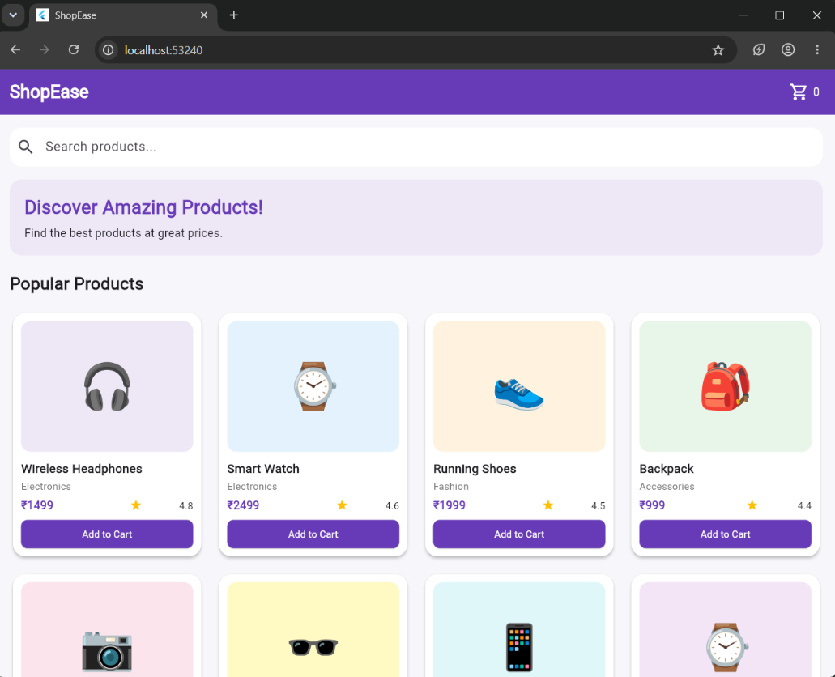
Figure 2: Narrow / mobile-sized layout
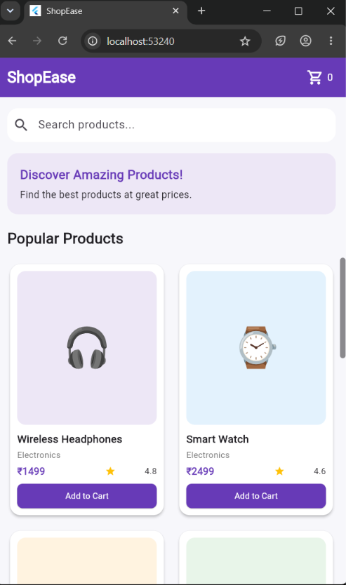
Result
Thus, the ShopEase E-Commerce Product Catalog application was successfully designed and implemented using Flutter. Reusable custom product widgets were created to display product information. Responsive layout techniques using LayoutBuilder, screen-width breakpoints and GridView.builder were implemented to adapt the product grid to different screen sizes. The application was tested successfully in Google Chrome using both desktop-sized and narrow/mobile-sized layouts.

