Ex. No. 7 | Data Persistence Using Google Cloud Firestore
Date of Exercise | 01 November 2026
Github Code Link(Keep as public) | https://github.com/vsrajhavel/FlutterLaboratory

Aim
To design and develop a Flutter application that stores and retrieves student information using Google Cloud Firestore, demonstrating cloud-based data persistence through Create and Read operations.
Description
Cloud Firestore is a NoSQL cloud database provided by Firebase. It stores data as documents organized into collections and synchronizes changes in real time. In this experiment, a Flutter application named StudentHub Cloud is developed to register student details and retrieve the stored records from a Firestore collection named 'students'. The application collects the student's name, register number, department and email address. When the Save Student button is pressed, the add() method of the Cloud Firestore collection reference creates a new document containing these fields and a server timestamp. A StreamBuilder listens to the collection's snapshots() stream and displays the student records in the application. This stream-based approach updates the displayed list when Firestore data changes. Firebase is initialized in the main() function using Firebase.initializeApp() and the platform-specific configuration generated by the FlutterFire CLI. The application was executed in Google Chrome, and the saved student document was verified in the Firebase Console.
Program

import 'package:flutter/material.dart';
import 'package:firebase_core/firebase_core.dart';
import 'package:cloud_firestore/cloud_firestore.dart';
import 'firebase_options.dart';

void main() async {
WidgetsFlutterBinding.ensureInitialized();

await Firebase.initializeApp(
options: DefaultFirebaseOptions.currentPlatform,
);

runApp(const MyApp());
}

class MyApp extends StatelessWidget {
const MyApp({super.key});

@override
Widget build(BuildContext context) {
return MaterialApp(
debugShowCheckedModeBanner: false,
title: 'StudentHub Cloud',
theme: ThemeData(
primarySwatch: Colors.indigo,
useMaterial3: true,
),
home: const StudentPage(),
);
}
}

class StudentPage extends StatefulWidget {
const StudentPage({super.key});

@override
State<StudentPage> createState() => _StudentPageState();
}

class _StudentPageState extends State<StudentPage> {
final nameController = TextEditingController();
final registerController = TextEditingController();
final departmentController = TextEditingController();
final emailController = TextEditingController();

final CollectionReference students =
FirebaseFirestore.instance.collection('students');

Future<void> addStudent() async {
if (nameController.text.isEmpty ||
registerController.text.isEmpty ||
departmentController.text.isEmpty ||
emailController.text.isEmpty) {
ScaffoldMessenger.of(context).showSnackBar(
const SnackBar(content: Text('Please fill all fields')),
);
return;
}

await students.add({
'name': nameController.text.trim(),
'registerNumber': registerController.text.trim(),
'department': departmentController.text.trim(),
'email': emailController.text.trim(),
'createdAt': FieldValue.serverTimestamp(),
});

nameController.clear();
registerController.clear();
departmentController.clear();
emailController.clear();

ScaffoldMessenger.of(context).showSnackBar(
const SnackBar(content: Text('Student saved successfully!')),
);
}

@override
void dispose() {
nameController.dispose();
registerController.dispose();
departmentController.dispose();
emailController.dispose();
super.dispose();
}

@override
Widget build(BuildContext context) {
return Scaffold(
appBar: AppBar(
title: const Text('StudentHub Cloud'),
backgroundColor: Colors.indigo,
foregroundColor: Colors.white,
),
body: Padding(
padding: const EdgeInsets.all(20),
child: Column(
children: [
TextField(
controller: nameController,
decoration: const InputDecoration(
labelText: 'Student Name',
border: OutlineInputBorder(),
),
),
const SizedBox(height: 12),

TextField(
controller: registerController,
decoration: const InputDecoration(
labelText: 'Register Number',
border: OutlineInputBorder(),
),
),
const SizedBox(height: 12),

TextField(
controller: departmentController,
decoration: const InputDecoration(
labelText: 'Department',
border: OutlineInputBorder(),
),
),
const SizedBox(height: 12),

TextField(
controller: emailController,
decoration: const InputDecoration(
labelText: 'Email',
border: OutlineInputBorder(),
),
),
const SizedBox(height: 15),

ElevatedButton.icon(
onPressed: addStudent,
icon: const Icon(Icons.cloud_upload),
label: const Text('Save Student'),
),

const Divider(height: 30),

const Text(
'Registered Students',
style: TextStyle(
fontSize: 20,
fontWeight: FontWeight.bold,
),
),

Expanded(
child: StreamBuilder<QuerySnapshot>(
stream: students
.orderBy('createdAt', descending: true)
.snapshots(),
builder: (context, snapshot) {
if (snapshot.hasError) {
return Text('Error: ${snapshot.error}');
}

if (snapshot.connectionState ==
ConnectionState.waiting) {
return const CircularProgressIndicator();
}

final studentList = snapshot.data!.docs;

if (studentList.isEmpty) {
return const Center(
child: Text('No students registered yet'),
);
}

return ListView.builder(
itemCount: studentList.length,
itemBuilder: (context, index) {
final data = studentList[index].data()
as Map<String, dynamic>;

return Card(
child: ListTile(
leading: const CircleAvatar(
child: Icon(Icons.person),
),
title: Text(data['name']),
subtitle: Text(
'Register No: ${data['registerNumber']}\n'
'Department: ${data['department']}\n'
'Email: ${data['email']}',
),
isThreeLine: true,
),
);
},
);
},
),
),
],
),
),
);
}
}
Output Screenshots
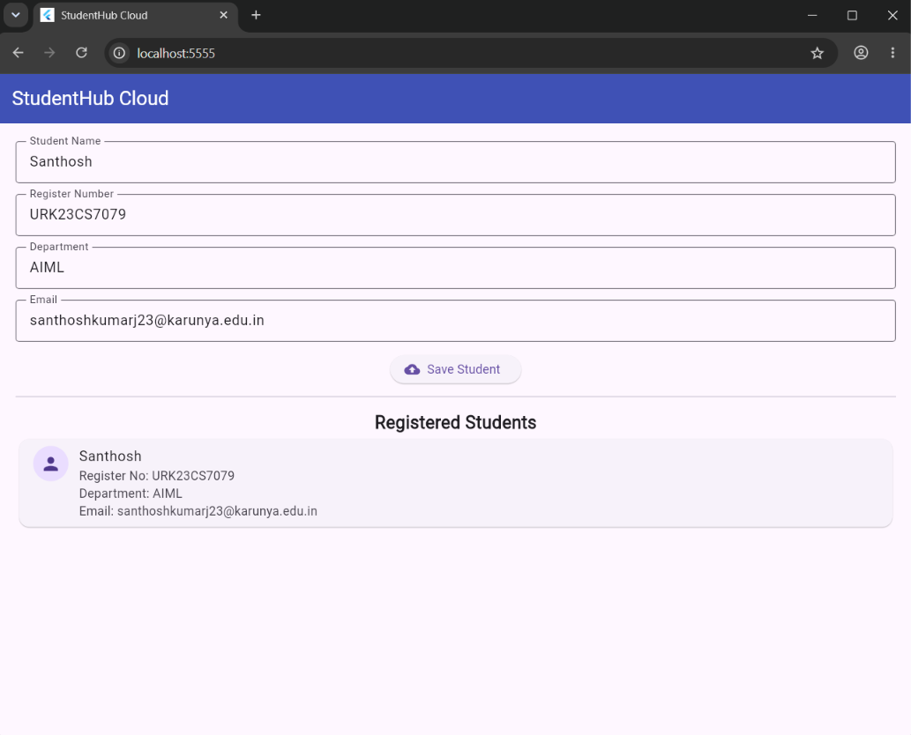
Figure 1: StudentHub Cloud application displaying the student registration form and retrieved student record.
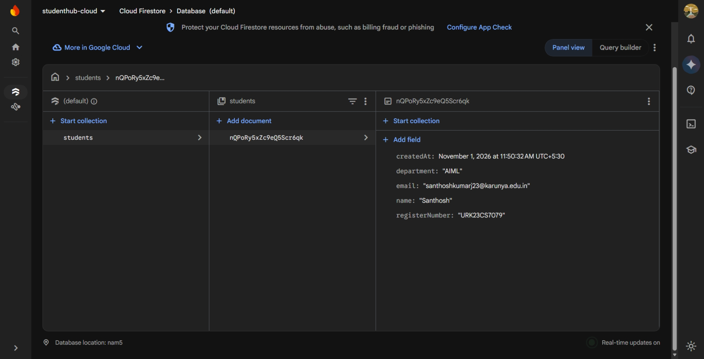
Figure 2: Student record stored successfully in the 'students' collection of Google Cloud Firestore.
// Output of the program
Result
Thus, the StudentHub Cloud Flutter application was successfully developed and connected to Google Cloud Firestore. The application performed Create and Read operations by storing student details in the 'students' collection and retrieving them using a real-time snapshots() stream. The saved student document was verified in the Firebase Console.

