
IS 602
Spreadsheet Modelling for Decision-Making
G2-Group 6
Akshaya Vijayakumar Sivakami
Carina Faith Peh Xin Yi
Cher In Teo
Serene Cheng
Xiong Yu

Contents
Introduction 3
Module 1 Demographic Projection 3
1.1 Mortality & Fertility Rates 4
1.2 Demographic Projection 4
1.3 Conclusion 4
Module 2 Hospital Demand and Admission Forecasting 5
2.1 Projected Bed Occupancy Rate (BOR) 5
2.2 Sensitivity Analysis 6
2.3 Trade-Off Analysis: BOR vs. Annual Bed Expansion Rate 6
2.4. Conclusion 6
Module 3 Government Healthcare Costs Projection 7
3.1 Projected Government Healthcare Budget 7
3.2 Government Healthcare Costs 8
3.3 Sensitivity Analysis 8
3.4 Conclusion 9
Module 4 Financing and Subsidy Sustainability 9
4.1 Household Data and Income Assumptions 9
4.2 Financing Gap Analysis 10
4.3 Household Out-of-Pocket (OOP) Burden 10
4.4 Trade-Off Analysis Subsidy rate vs Fiscal Sustainability 11
4.5 Interactive Household Out-of-Pocket Burden Estimator 11
Summary 12
Appendix 13
References 14

Introduction
Singapore is facing an unprecedented demographic shift. The country is set to become "super-aged" in 2026, with over 21% of residents aged 65 and above — rising to 1 in 4 by 2030 (Ministry of Health [MOH}, 2026a). The economic and societal consequences are far-reaching. An ageing population strains economic growth, labour supply, and social security systems.
Specific to healthcare, the rise in chronic age-related illnesses such as cancer, diabetes, and dementia is expected to drive demand sharply upward. According to WHO, life expectancy for Singapore had increased from 78.6 years in 2001 to 83.9 in 2021 but healthy life expectancy had only increased from 69.4 years to 73.7 years (World Health Organization, 2023).
Driven by both ageing population and disease prevalence (MOH, 2023), government healthcare expenditure has been on an upward trend. Government budget allocation for healthcare is projected to reach SGD 30 billion in 2030 (MOH, 2025a).
Against this backdrop, this report presents a spreadsheet modelling approach to assess the long-term sustainability of Singapore's public healthcare system through to 2035. The model is structured across four interconnecting modules: demographic projection (Module 1); hospital admission and bed occupancy forecasts (Module 2); healthcare expenditure estimation (Module 3); and financing sustainability assessment (Module 4). Through scenario-based analysis of key policy levers, the model provides data-driven insights into the system's long-term viability.

Module 1 Demographic Projection
This module projects Singapore's resident population structure from 2026 to 2035 using historical data, incorporating mortality/survival rates and age-specific fertility rates. Elderly age bands (e.g., 65-69 to 90+) are segmented to reflect rising healthcare utilization intensity, serving as the primary demand driver for hospital modelling and enabling sensitivity analyses.
Assumptions:
- Population refers to resident population (Singapore citizens and permanent residents), as they are the primary users of subsidies.
- Population change is driven by natural change (births and deaths).
- Male to female ratio is held constant at 50% for projection period. This assumption is for simplicity; the global average is closer to 1.05 males for every 1 female
- Each year, 20% of each age group transitions to the next age band. Since an age band covers 5 years, approximately (or 20%) of the people in that group are in their final year of that band (e.g., age 4 in the 0–4 group) and will move to the next band (age 5 in the 5–9 group) in the next time step.
- Fertility is modelled for women aged between 15 to 49 (consistent with the dataset).

Mortality & Fertility Rates
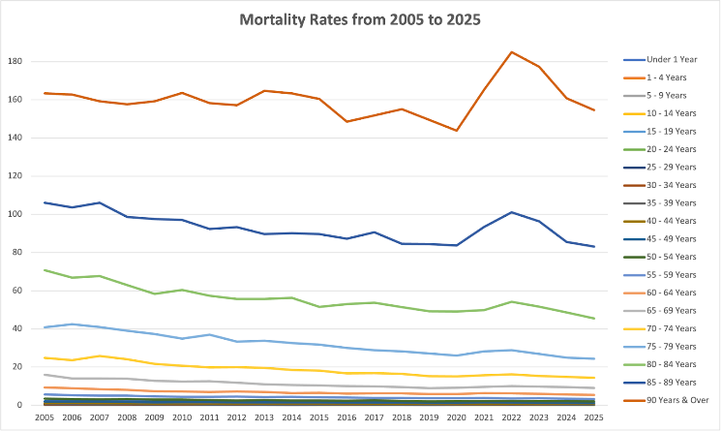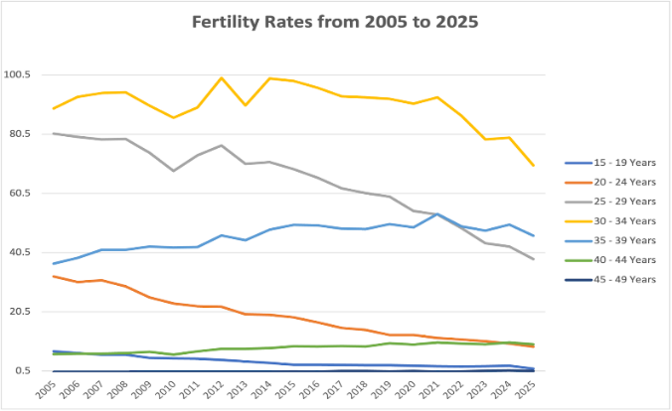
Figure 1 Mortality Rates Figure 2 Fertility Rates
Age-specific mortality rates have remained relatively stable across the 20-year period so a 5-year average (2021–2025) was applied across all age cohorts for projections up to 2035.
Fertility rates, particularly in the peak fertility age cohorts (25–29 and 30–34), showed a significant and consistent downward trend. The Excel GROWTH() function is used to project these rates through 2035, reflecting an exponential decay model that better represents this accelerating decline compared to a simple linear average.

1.2 Demographic Projection
2025 serves as the base year for the projection, with the following methodology applied across each age band:
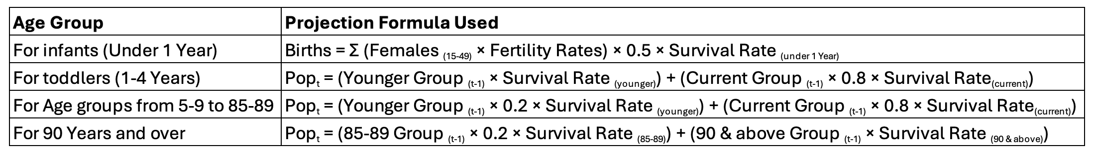

1.3 Conclusion
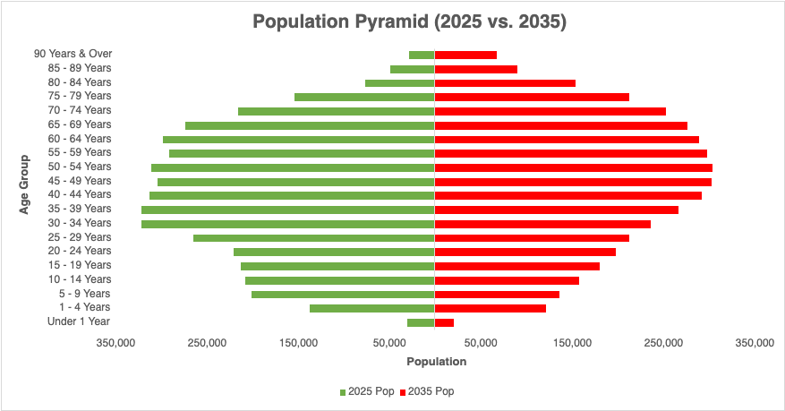
Figure 3 Population Projection
The "bulge" is moving upward. By 2035 (red), the population is no longer a pyramid but an inverted vase. The elderly age cohorts (65 to 90+) are expanding drastically, indicating exponential increase in hospital bed demand and chronic disease management costs.

Module 2 Hospital Demand and Admission Forecasting
This module evaluates whether Singapore’s public acute hospital bed capacity can meet projected admission demand from 2025 to 2035. The analysis uses the demographic projection from Module 1, official age-specific admission rates, average length of stay (ALOS), and Ministry of Health (MOH) bed expansion policies to forecast Bed Occupancy Rate (BOR) and conduct trade-off analysis between bed supply and occupancy risk.

2.1 Projected Bed Occupancy Rate (BOR)
The analysis evaluates whether existing and planned bed capacity is sufficient to meet projected hospital admission demand, incorporating age-specific population, admission rate (AR), average length of stay (ALOS), and the bed expansion rate for 2031–2035.
$${\text{AR}}_{adj}={\text{AR}}_{linear,t}⋅{\left(1-r\right)}^{t-2024}, where \text{t}=\text{year}, r=Govt Policy Factor(e.g., Healthier SG)$$
Age-specific admission rates are forecasted using a linear trend based on 2006–2024 historical data. It adjusts the forecast using a policy reduction factor to reflect programmes such as Healthier SG, but this adjustment is applied only to age groups aged 40 and above, since the programme is not assumed to affect those below age 40. Total admissions are finally computed by applying the adjusted age-specific admission rate to the projected population of each age group and summing across all age groups.
$${\text{BedDays}}_{t}={\text{Admissions}}_{t}⋅\text{ALOS }, Where t=year, ALOS=average length of stay$$
$${\text{Beds}}_{t}={\text{Beds}}_{t-1}⋅\left(1+Δ\right), where Δ=annual bed expansion rate$$
$${\text{BOR}}_{t}=\frac{{\text{BedDays}}_{t}}{{\text{Beds}}_{t}×365}$$
The annual expansion rate Δ was calculated using a Compound Annual Growth Rate (CAGR) formula based on the MOH’s announced target of 13,000 additional beds by 2030 [5] (MOH, 2025b).
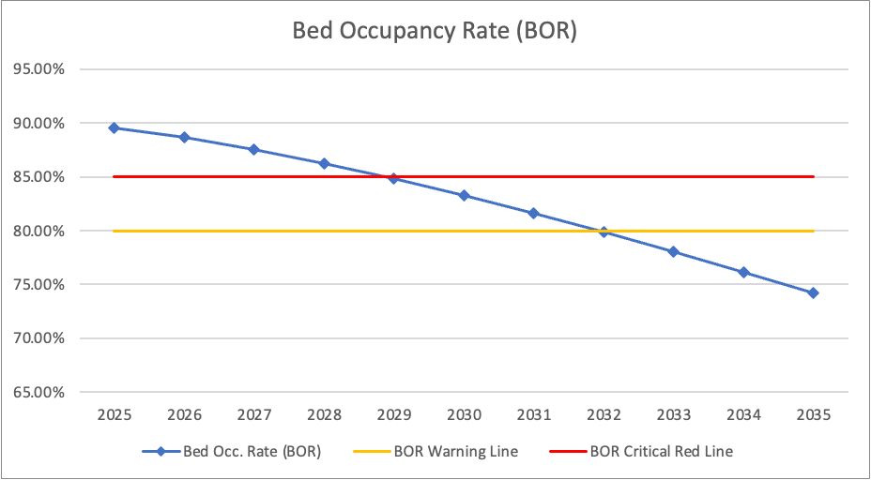
Figure 4 Projected BOR vs Capacity Thresholds (2025–2035)
A sustained BOR rate below 85% is generally recommended for optimal patient care [6] (MOH, 2022), with 80% serving as an early warning threshold.

2.2 Sensitivity Analysis
Sensitivity analysis is performed to assess how different key parameters affect the projected 2035 Bed Occupancy Rate (BOR) to identify primary drivers of capacity pressure.
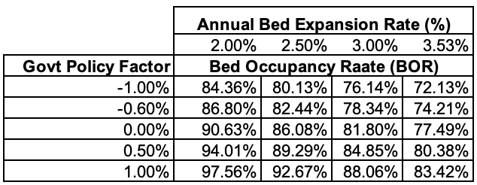
The Annual Bed Expansion Rate has the greatest impact on hospital capacity pressure. Reducing it from 3.53% to 2.00% will increase BOR from 74.21% to 86.80% (+12.59%), breaching the 85% optimal threshold.
Government initiatives such as Healthier SG also demonstrate a strong positive impact. At 3.53% Annual Bed Expansion Rate, an increase in efficiency from -0.6% to 0% increases BOR by about 3.3%.

2.3 Trade-Off Analysis: BOR vs. Annual Bed Expansion Rate
A trade-off analysis is conducted to determine the minimum annual bed expansion rate needed to keep BOR below 85% in 2035.
As shown below, an annual bed expansion rate of at least 2.30% is required to maintain BOR under the 85% threshold.
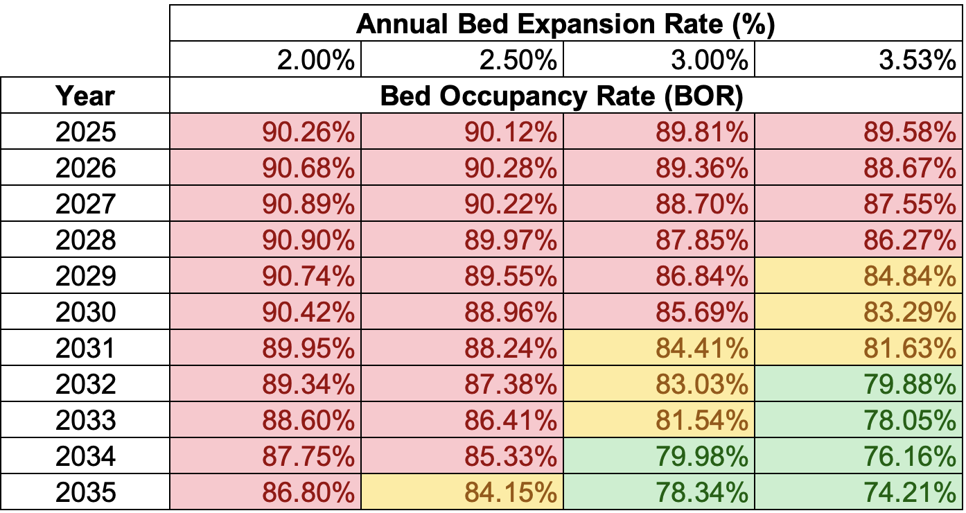
Figure 5 Trade Off Analysis

2.4. Conclusion
- At an annual bed expansion rate of 3.53%, there will be sufficient capacity in 2035 as BOR is projected to be 74.21%.
- The minimum annual bed expansion rate required to maintain the optimal threshold of < 85% is < 2.3%, effectively balancing capacity and cost.
- Reducing ALOS or improving the effectiveness of health intervention programmes (e.g., Healthier SG) significantly reduces BOR pressure.

Module 3 Government Healthcare Costs Projection
This module aims to project government operating expenditure related to hospital admissions based on the demographic projection from Module 1 and projected bed demand from Module 2. Published data on government expenditure on healthcare and healthcare Consumer Price Index (CPI) are used in the forecasting analyses.
MOH’s operating expenditure is used for the daily running costs of the public healthcare system, of which key components are medical subsidies, manpower, supplies and consumables, utilities and maintenance amongst others (MOH, 2024a).
Assumptions:
- 40% of the published Operating Expenditure on Health is directly related to variable operating costs related to public hospitals admissions.
- Analyses on healthcare operating expenditure is solely on costs related to public hospitals inpatient admissions and excludes other healthcare expenditure related to polyclinics, daycare et cetera.

3.1 Projected Government Healthcare Budget
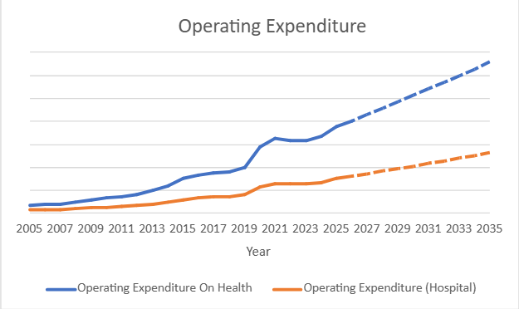
Figure 6 Operating Expenditure (S$ millions)
There was a structural shift for Operating Expenditure from years 2020 onwards due to COVID-19 measures undertaken by MOH that have been integrated into regular operations. The opening of Woodlands Hospital (from late 2023) also contributed to the increase in operating expenditure.
Linear forecasting was used to estimate future expenditure, using reference years 2023 to 2025 (post-COVID 19).
Projected operating expenditure for 2026 is in line with MOH’s recent announcement for 2026 of SGD 20.04 billion (MOH, 2026b).

3.2 Government Healthcare Costs
Medical inflation rate was derived from historical Healthcare Consumer Price Index (HCPI) data for years 2015 to 2025. Linear forecasting was used to calculate medical inflation rates thereafter.
Current Year Medical Inflation Rate = Current Year HCPI – Previous Year HCPI
Current Year HCPI
With 2025 as a base year:
Cost Per Admission (CPA) = Operating Expenditure * 40%
Bed Demand Days
For years 2026 to 2035:
Annual Healthcare Costs = CPA * Bed Demand Days * Medical Inflation Rate

3.3 Sensitivity Analysis
One-variable sensitivity testing was applied using inflation rates versus healthcare costs, using 2025 as a base year and variable inflation rates from 1% to 8%.
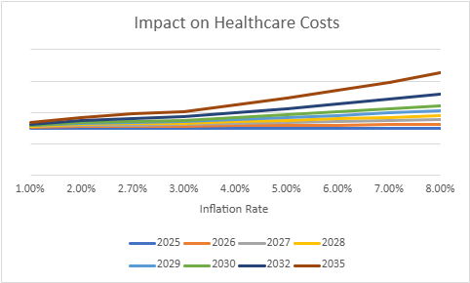
Figure 7 One-Way Sensitivity Test
Two-variable sensitivity testing was applied with the inclusion of an elderly cost multiplier ranging from 1.0 to 2.5.
Elderly patients receive more subsidies through the Pioneer Generation (born before 1949) and Merdeka Generation (born 1950-1959) schemes as well as via employment income-based means testing.
The elderly population can be further segmented into 3 main categories, ‘Young-Old’, ‘Medium-Old’ and ‘Oldest-Old’ (Singapore Department of Statistics, 2020). As multimorbidity increases with age (Fortin et al., 2012), older sub-groups are likely to incur higher hospitalisation costs.
The elderly cost multiplier, applied to hospital expenditure, can be used to more accurately reflect the cost burden of the elderly population over time.

3.4 Conclusion
One-way sensitivity analysis shows inflation rate is a highly sensitive driver of healthcare costs which rise sharply and non-linearly as inflation increases. Adding the elderly cost multiplier captures the compounding cost burden of an ageing population, as older cohorts incur higher hospitalisation costs due to multimorbidity and attract greater subsidies.
Healthcare costs are highly sensitive to both variables, tripling from the best-case scenario (low inflation, low multiplier) to the worst-case scenario (high inflation, high multiplier). Even holding inflation constant at 2.7%, costs are projected by 30% from S$7.5 billion to S$9.8 billion.

Module 4 Financing and Subsidy Sustainability
This module evaluates whether Singapore’s government can sustainably finance its projected public healthcare expenditure through 2035 and assess the financial burden placed on households if it cannot. Building on the total healthcare expenditure from Module 3, this module projects the government’s healthcare budget, identifies financing gap and estimates household out-of-pocket burden across low, base and high scenarios.

4.1 Household Data and Income Assumptions
Number of Resident Households
A projection growth rate of 1.6 % was applied using reference years 2020 to 2025 as they are more reflective of Singapore’s current demographic trajectory, characterised by a declining total fertility rate of 0.97 in 2024. Resident households are projected to reach approximately 1,730,000 by 2035.
Average Household Size
Average household size declined from 3.70 persons in 2000 to 3.06 persons in 2025. A linear decline of 0.026 persons per year was applied based on the full 25-year historical trend. Household size is projected to reach approximately 2.80 persons by 2035.
Median Household Employment Income
Median monthly household income grew from $4,000 in 2000 to $12,027 in 2025, and is projected to reach approximately $19,038 by 2035, applying a nominal Compound Annual Growth Rate (CAGR) of 4.7% derived from the 2015–2025 trend to avoid distortion from COVID-19-related income fluctuations between 2020 to 2022.

4.2 Financing Gap Analysis
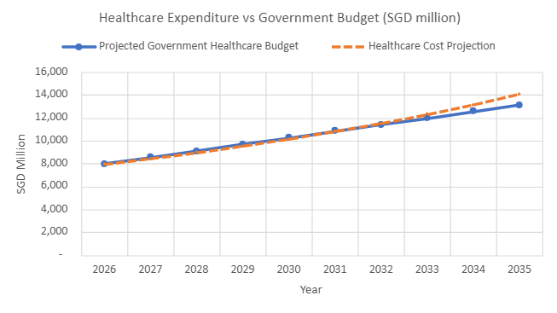
Figure 8 Financing Gap
From 2026 to 2032, the government budget maintains a surplus over projected healthcare costs. However, the two lines converge around 2033, after which costs exceed the budget — generating a deficit of SGD 183.8 million in 2033 that widens to SGD 749.9 million (5.7% of the projected budget) by 2035.

4.3 Household Out-of-Pocket (OOP) Burden
Out-of-pocket (OOP) expenditure per household is estimated by applying a weighted average subsidy rate of 65% (derived from MOH's B2/C Ward subsidy schedule for Singapore Citizens) to total projected healthcare expenditure, divided by the number of resident households. B2/C wards are used as the representative ward class, accounting for at least 65% of public hospital beds.
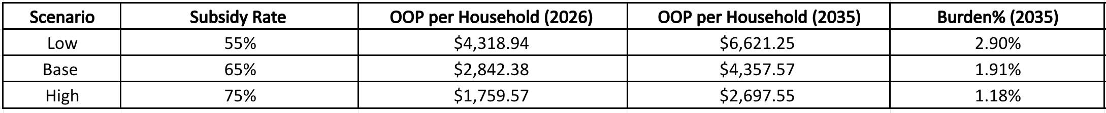
Low scenario = government grows slowly + lower subsidies -> bigger household burden, smaller financing gap
Base scenario = most realistic projection based on historical data → your main model output
High scenario = government spending grows fast + higher subsidies → smaller household burden, larger financing gap

Under the base scenario, OOP expenditure per household increases from $2,842.38 in 2026 to $4,357.57 by 2035, remaining stable at approximately 1.91% of median annual household income as household income kept pace with medical inflation.
Across all scenarios, household burden stays well below 3% of annual income, suggesting public healthcare remains broadly affordable through to 2035 even with less subsidies.
However, it is important to note that this metric captures inpatient public hospital costs only. Broader household healthcare spending data indicates Singaporeans spend approximately 6.7% of monthly expenditure on direct medical costs and an additional 8.3% on insurance premiums [10] (Lim, 2025), suggesting total healthcare financial burden is significantly higher than what the model captures.

4.4 Trade-Off Analysis Subsidy rate vs Fiscal Sustainability
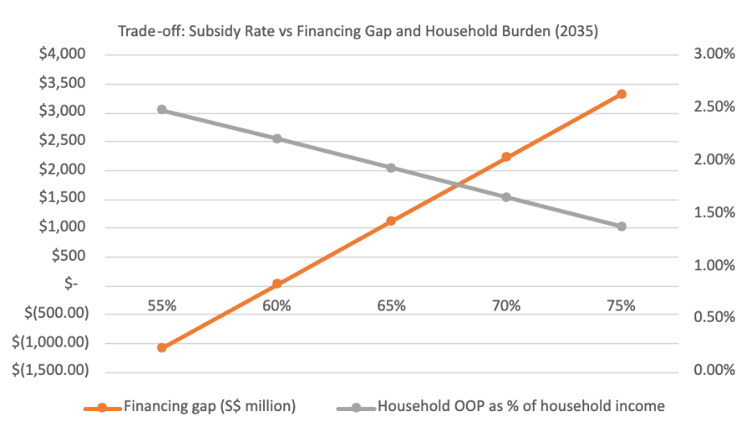
Figure 9 Trade Off Analysis
Figure 9 shows the trade-off between fiscal sustainability and household affordability as the subsidy rate varies from 55% to 75% in 2035.
Increasing the subsidy rate reduces household OOP burden from 2.48% to 1.38% of annual income, but at a rising fiscal cost. At 55%, the government maintains a surplus of SGD 1,188 million. As the subsidy rate rises beyond approximately 60%, the financing gap turns negative, meaning hospital costs exceed the projected budget.
The two lines intersect at approximately 68% subsidy rate, beyond which the financing gap widens faster than household burden falls, indicating diminishing returns on additional subsidies. This points to 65%–68% as the optimal subsidy range, balancing fiscal sustainability with household affordability.

4.5 Interactive Household Out-of-Pocket Burden Estimator
To complement the scenario-level analysis, an interactive estimator was developed to allow users to project their personal out-of-pocket (OOP) healthcare burden from 2025 to 2035 based on their specific household profile.
Users input two parameters: ward type (B2/C or B2+) and monthly per capita household income (PCHI) bracket from which the applicable MOH subsidy rate is automatically derived. The estimator then projects the annual OOP cost per admission and benchmarks it against projected median household income, classifying the financial burden as Low (<5%), Moderate (5–10%), or High (>10%) of annual income.

Summary
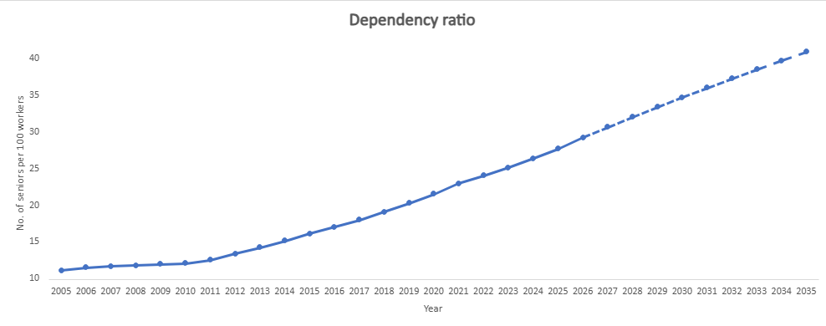
Figure 10 Dependency Ratio
The old-age dependency ratio is projected to rise steadily from approximately 11 elderly persons per 100 working-age persons in 2005 to 41 per 100 by 2035, driven by declining birth rates and rapid growth in the elderly population, placing increasing strain on healthcare resources and fiscal pressure.
Rapid growth of not just the elderly population but the old-oldest and the declining birth rate which reached a record low of 0.87 in 2025 (Yong, 2026) are irreversible demographic trends.
Unable to stop the ageing population and with past pro-natalist campaigns failing to yield results, Singapore has pivoted to preventive health and intervention programmes such as Grow Well Sg, Healthier SG and Age Well SG across every life stage.
Expanding hospital infrastructure buffers rising demand but is constrained by land and manpower scarcity. Digital transformation to enhance clinical efficiency is a more sustainable long-term strategy which MOH has already begun to pursue (MOH, 2024b).
CPF and Medisave changes were announced in the 2025 Budget to allow Singapore the cost of burden with its citizens, whilst managing long-term healthcare affordability (Central Provident Fund, 2025).
Overall. Singapore's healthcare system appears sustainable through 2035 under base case assumptions but a combination of high inflation, lower bed expansion rates and increase elderly cost multiplier effect could simultaneously stress all four dimensions of the model.
Limitations
Low granularity in empirical data of hospital admissions rate by age disallowed useful insights based on age cohorts but was partially mitigated with the elderly cost multiplier.
Government healthcare budget projection is based on historical data and does not account for future policy shifts or occurrence of pandemic events.
A lack of access to detailed data on public hospital income and expenditure necessitated the assumption to use 40% of total operating expenditure for cost per admission projection.
Household healthcare burden is likely underestimated by use of inpatient costs as a proxy for total healthcare affordability and is a larger percentage of total income for low-income households.

Appendix
Data Sources
Click on data description to be directed to the source
Data Description | Purpose
Singapore Population by Age Group | To analyze population growth trends and project future population by age group through 2035. Base population will be used to forecast hospital demand
Hospital Admission Rate By Sex And Age, Annually-HAR | Obtain baseline age-specific admission rates.
MOH Bed Expansion Plan | Acute hospital beds in 2024. Annual bed expansion rate.
Beds In Inpatient Facilities | Used to forecast future acute hospital beds.
Waiting Times for Admissions | ALOS: Average length of stay
Hospital Bed Occupancy Rate | BOR thresholds
Annual Government Healthcare Expenditure | Used to forecast future expenditure
MOH Healthcare Consumer Price Index | Used to calculate healthcare inflation rate
Median household Income | Latest median monthly income figure
Household employment Income | To calculate key household income trends (KHIT)
Number of households in Singapore | Total number of residents households
Subsidies for Acute Inpatient Care at Public Healthcare Institutions | % subsidy for public hospital patients by ward class

References
[1] Ministry of Health. (2026a, March 16). Age Well SG.
https://www.moh.gov.sg/ageing-well/ageing-in-the-community/
[2] World Health Organization. (2023). Singapore
https://data.who.int/countries/702
[3] Ministry of Health. (2023, October 23). Disease Burden.
https://www.moh.gov.sg/others/resources-and-statistics/disease-burden/
[4] Ministry of Health. (2025a, March 7). Speech by Mr Ong Ye Kung, Minister for Health, at the Ministry of Health Committee of Supply Debate 2025.
https://www.moh.gov.sg/newsroom/speech-by-mr-ong-ye-kung--minister-for-health--at-the-ministry-of-health-committee-of-supply-debate-2025--on-friday-7-march-2025/
[5] Ministry of Health. (2025b, March 7). Expanding Healthcare Capacity and Transforming the Healthcare Workforce.
https://www.moh.gov.sg/newsroom/expanding-healthcare-capacity-and-transforming-the-healthcare-workforce/
[6] Ministry of Health. (2022, March 10). Hospital bed occupancy rate.
https://www.moh.gov.sg/newsroom/hospital-bed-occupancy-rate/
[7] Ministry of Health. (2024a, April 2). Statistics on government expenditure on public healthcare, subsidised medical care for citizens, PRs and foreigners, and healthcare spend by government and individuals.
https://www.moh.gov.sg/newsroom/statistics-on-government-expenditure-on-public-healthcare--subsidised-medical-care-for-citizens--prs-and-foreigners--and-healthcare-spend-by-government-and-individuals/
[8] Ministry of Health. (2026b, March 4). Operating Expenditure for the Ministry of Health.
https://www.moh.gov.sg/newsroom/operating-expenditure-for-the-ministry-of-health/
[9] Singapore Department of Statistics. (2020, March). Recommendations on definition and classification of age.
https://assets.app.optical.gov.sg/singstat/production/published/assets/fab914bb-0775-4604-b3ab-f43402727b2d.pdf
[10] Fortin, M., Stewart, M., Poitras, M.-E., Almirall, J., & Maddocks, H. (2012). A systematic review of prevalence studies on multimorbidity: Toward a more uniform methodology. Epidemiologic Reviews, 35(1), 75–83. https://doi.org/10.1093/epirev/mxs004
[11] Lim, A. (2025, March 21). 7 Healthcare cost statistics in Singapore (2025). SmartWealth Singapore.
https://smartwealth.sg/healthcare-cost-statistics-singapore/
[12] Yong, G. (2026, February 26). Singapore's total fertility rate sinks to new low of 0.87. The Straits Times.
https://www.straitstimes.com/singapore/politics/spores-total-fertility-rate-sinks-to-new-low-of-0-87
[13] Ministry of Health. (2024b, October 10). Transforming Healthcare Through Technology.
https://www.moh.gov.sg/newsroom/transforming-healthcare-through-technology/
[14] Central Provident Fund Board. (2025, March 18). CPF changes announced in Budget and COS 2025 and what it means for you.
https://www.cpf.gov.sg/member/infohub/educational-resources/cpf-changes-announced-in-budget-and-cos-2025-and-what-it-means-for-you

