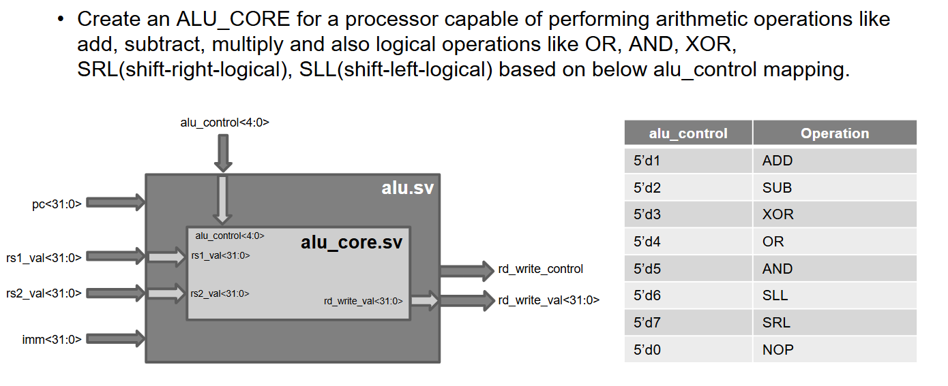

include "processor_defines.sv"

module alu_core(

input logic [31:0] rs1_val,

input logic [31:0] rs2_val,

input logic [4:0] alu_control,

output logic [31:0] rd_write_val

);

// Edit the code here begin ---------------------------------------------------

always @(*) begin

case (alu_control)

5'd1: rd_write_val = rs1_val + rs2_val;

5'd2: rd_write_val = rs1_val - rs2_val;

5'd3: rd_write_val = rs1_val ^ rs2_val;

5'd4: rd_write_val = rs1_val | rs2_val;

5'd5: rd_write_val = rs1_val & rs2_val;

5'd6: rd_write_val = rs1_val << rs2_val;

5'd7: rd_write_val = rs1_val >> rs2_val;

default rd_write_val = 32'b0;

endcase

end

// Edit the code here end -----------------------------------------------------

/*

Following section is necessary for dumping waveforms. This is needed for debug and simulations

*/

`ifndef SUBMODULE_DISABLE_WAVES_ALU_CORE

initial begin

$dumpfile("./sim_build/alu_core.vcd");

$dumpvars(0, alu_core);

end

`endif

Endmodule

