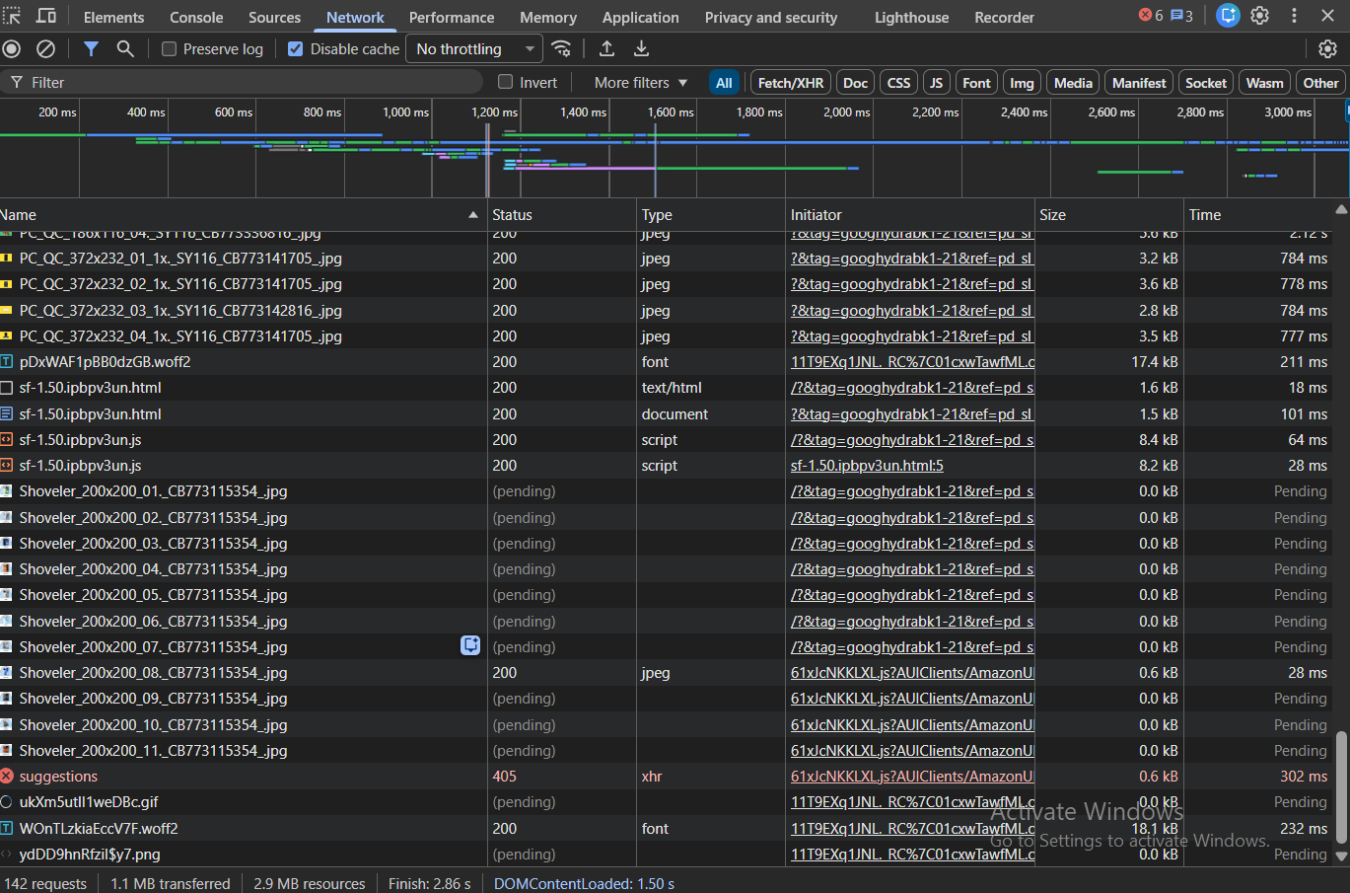
- Total Requests & Transfer Size: How many total requests were made? What was the total transferred size (e.g., 2.5 MB)?
Ans: Total requests: 142
Transfer Size: 1.1 MB
- Largest Resource: What was the single largest resource (by size)? What type was it (image, JavaScript, font)?
Ans: Largest resource was a JavaScript (script) file of 70.6 kB
- Slowest Resource: Find the resource with the longest Time (hover to see Waiting (TTFB), Content Download). Why do you think it was slow? (Hint: Look at its type and initiator).
Ans:
The resource was slow due to a high server response time (TTFB), caused by backend processing and third-party ad/tracking logic rather than large file size.
- Analysis: Identify one potential optimization. (e.g., "The hero image is a 1.2MB PNG; it could be compressed to WebP.")
Ans: Multiple JPEG product images were loaded late and showed high total load times. These images caused layout shifts, contributing to a high CLS value (0.25). Therefore, we could serve product images in WebP/AVIF format and explicitly define image dimensions (width & height) in HTML. This helps because WebP/AVIF significantly reduces image file size compared to JPEG and also reduces Cumulative Layout Shift (CLS) and improves visual stability.

Part 2: The Performance Panel (The "User Experience" Audit)
Goal: Analyze how the page performs during a realistic user interaction.
In the Performance tab, start recording, then perform this sequence: scroll, click a navigation link, wait for the page to load, and stop the recording.
Answer these questions:
- Main Thread Work: In the flame chart, find a long yellow (JavaScript) or purple (Rendering/Layout) block. What was happening at that time? (Click on it for details).
- Visual Metrics: What was the approximate Total Blocking Time (TBT)? Was there a Layout Shift (a red bar in the Experience section)? Describe what caused it.
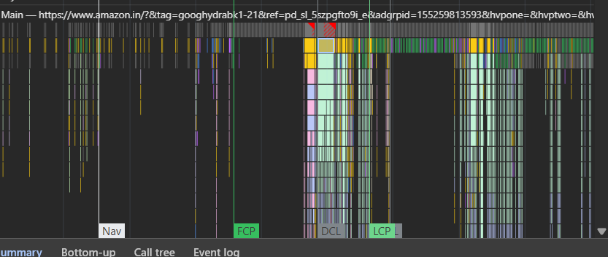
- Summary: In your own words, did the page feel janky or smooth during your interaction? Does the performance recording support your feeling?

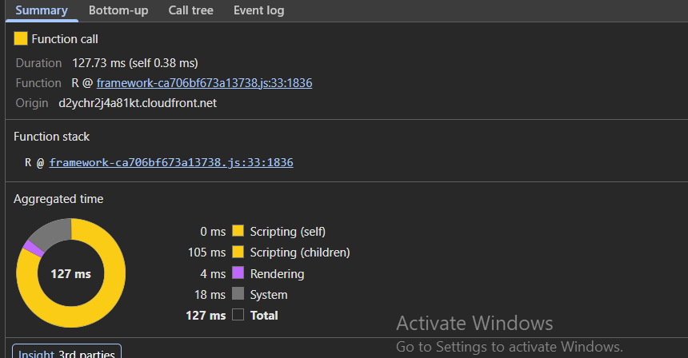
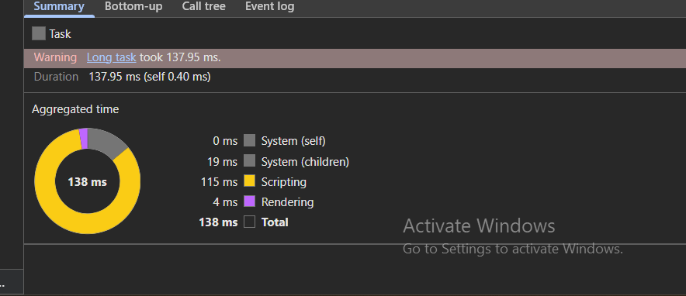
- Page loading function call was happening.
- Yes there was a layout shift. In the Performance flame chart, a long JavaScript task of about 138 ms was observed on the main thread. The task consisted mainly of JavaScript execution (115 ms), which blocked the main thread and delayed user interaction. Since the task exceeded the 50 ms threshold, it contributed significantly to Total Blocking Time (TBT).
- The page was smooth during my user interaction as can be seen by the smaller duration of Total Blocking Time.

Part 3: The Memory Panel (The "Efficiency" Audit)
Goal: Check for potential memory leaks or heavy memory usage.
In the Memory tab, take a Heap snapshot and note its size. Perform a repetitive action (e.g., open/close a modal, scroll an infinite list, filter products), take a second snapshot, then use the Comparison view to compare them.
Answer these questions:
- Memory Delta: Did the total memory increase between snapshots? By how much?
- Object Analysis: Look at the "# New" and "# Deleted" columns. Are a significant number of new objects being created but not cleaned up? List the top 2 "Constructor" types that increased the most.
- Conclusion: Based on this quick test, does the page seem to manage memory well during your repeated action, or is there a suspicion of a leak?
Ans: a. The size of the snapshots was 37.9 MB. The total memory did not increase.
b. No significant issue observed. Although new objects were created, a comparable number were also deleted, so memory usage remained stable. This indicates that objects are being properly cleaned up. Top 2 Constructor types with the largest increase
- (number) {# New: 203, # Deleted: 10 and Net increase (Δ): +193}
- $l{ # New: 60, # Deleted: 0 and Net increase (Δ): +60}
- While some objects such as numbers and internal JavaScript objects were created during interaction, the overall memory remained stable, suggesting normal runtime behaviour rather than a memory leak.
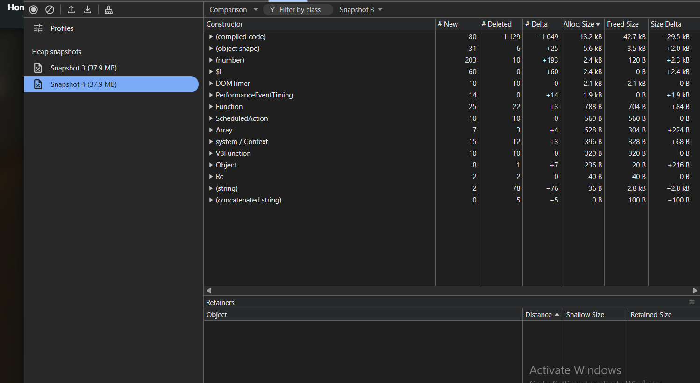

Part 4: The Lighthouse Panel (The "Automated Quality" Audit)

Goal: Use Lighthouse to generate an automated report on the website's performance, accessibility, SEO, and best practices.

In the Lighthouse tab, set the device to Desktop, check all categories (Performance, Accessibility, Best Practices, SEO), and click "Analyze page load." Screenshot the full report.

Answer these questions:

- Overall Scores: What were the performance, accessibility, best practices, and SEO scores (out of 100)?
- Core Web Vitals: What were the specific metrics for Largest Contentful Paint (LCP), First Input Delay (FID), and Cumulative Layout Shift (CLS)? Does the page pass these Core Web Vitals?
- Top Opportunity: What is the #1 most impactful performance opportunity Lighthouse suggests? (e.g., "Remove unused JavaScript").
- Cross-Verification: Does Lighthouse's report confirm or contradict any of your findings from the Network or Performance panels? Give one example.

Answer:
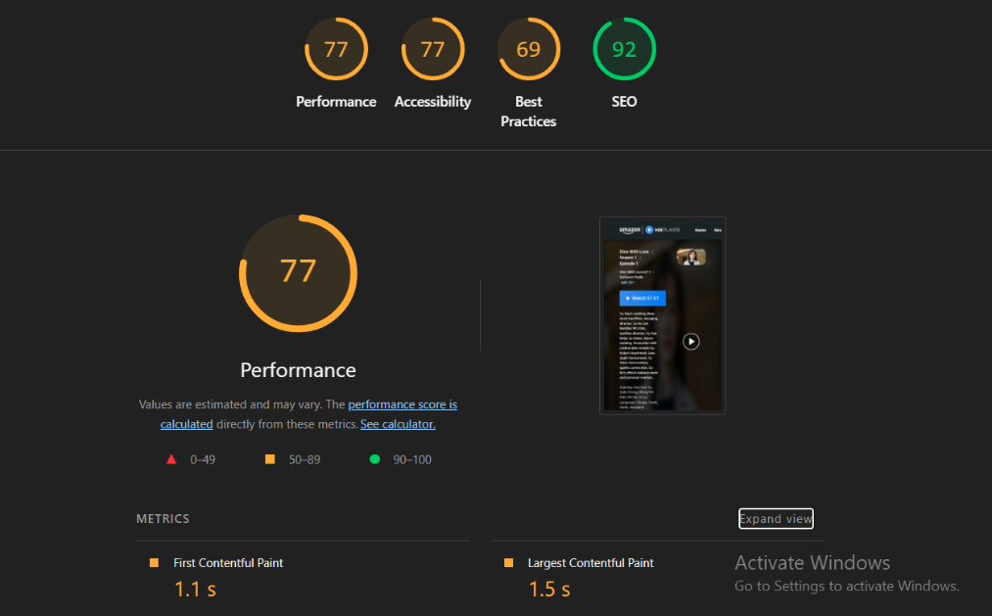

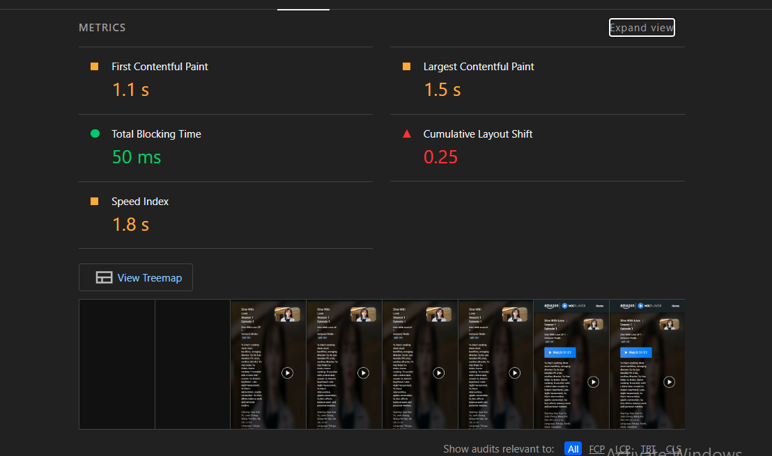
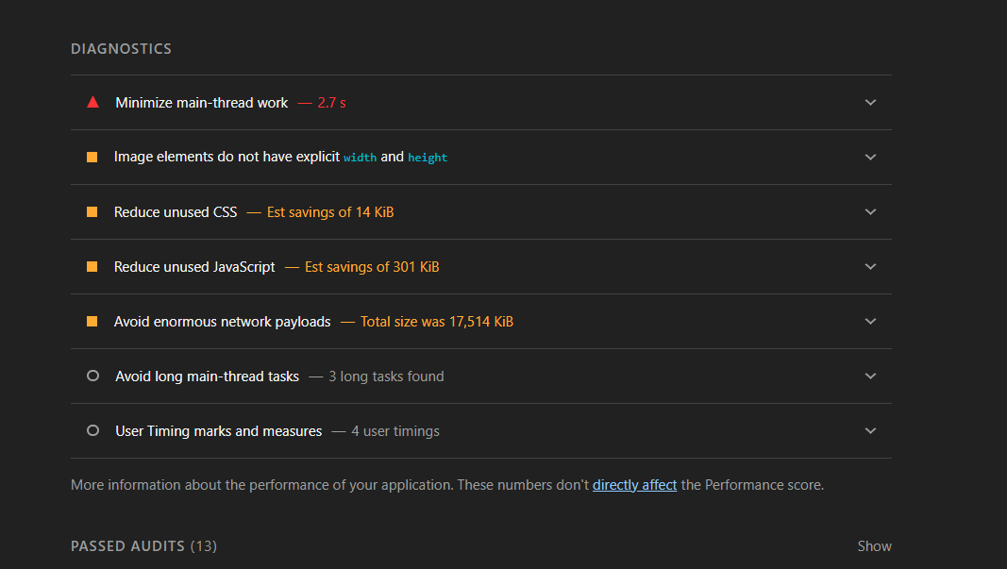
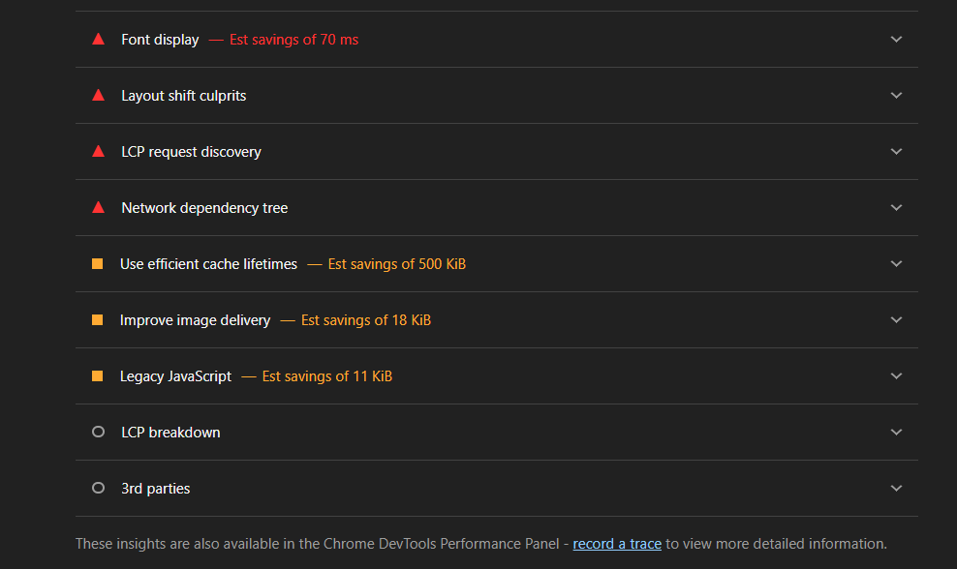
- Performance: 77
Accessibility: 77
Best Practices: 69
SEO: 92
- Largest Contentful Paint: 1.5 s
Cumulative Layout Shift: 0.25
First Contentful Paint: 1.1 s (First Input Delay)
Although LCP and FID/FCP are within acceptable limits, the page fails Core Web Vitals due to a high CLS value of 0.25.
- Top suggestion: Consider setting font-display to swap or optional to ensure text is consistently visible. swap can be further optimized to mitigate layout shifts with font metric overrides.
- Yes, it confirms the findings.
It confirms the findings. In the Performance panel, long JavaScript tasks (approximately 138 ms) were observed on the main thread, which increased Total Blocking Time (TBT). Lighthouse also reported JavaScript execution time as a performance concern and highlighted script-related work affecting responsiveness. Additionally, the Network panel showed many third-party and ad-related requests. Lighthouse’s high CLS (0.25) aligns with layout shifts observed during page load, likely caused by dynamically loaded images and ads.

Website: Amazon

