Emotions

_________________

GRU

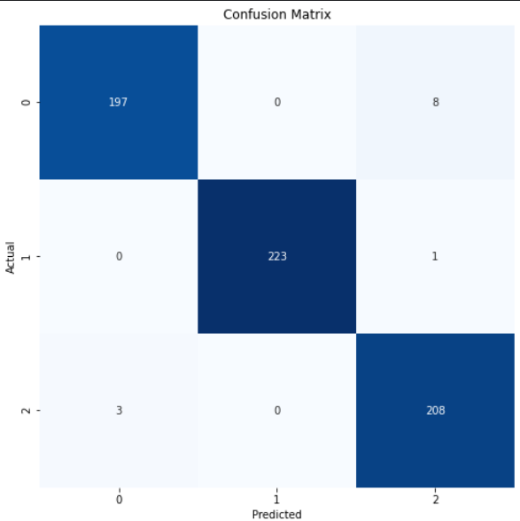

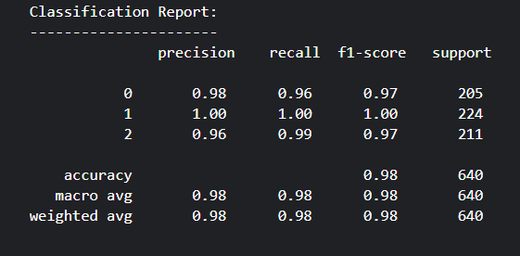

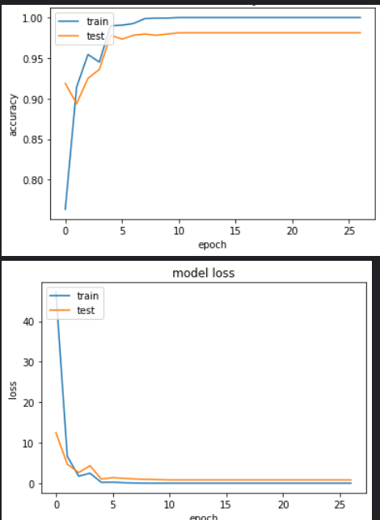

loss: 8.9904e-11 - accuracy: 1.0000 - val_loss: 0.8092 - val_accuracy: 0.9812

SimpleRNN

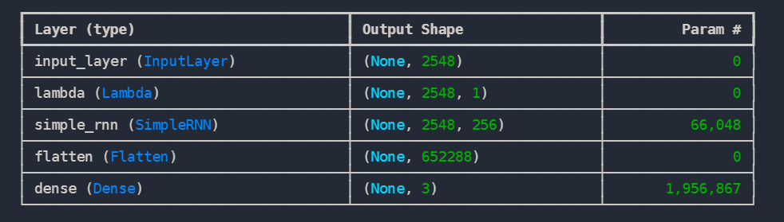

accuracy: 0.9928 - loss: 0.3675 - val_accuracy: 0.9264 - val_loss: 12.6107

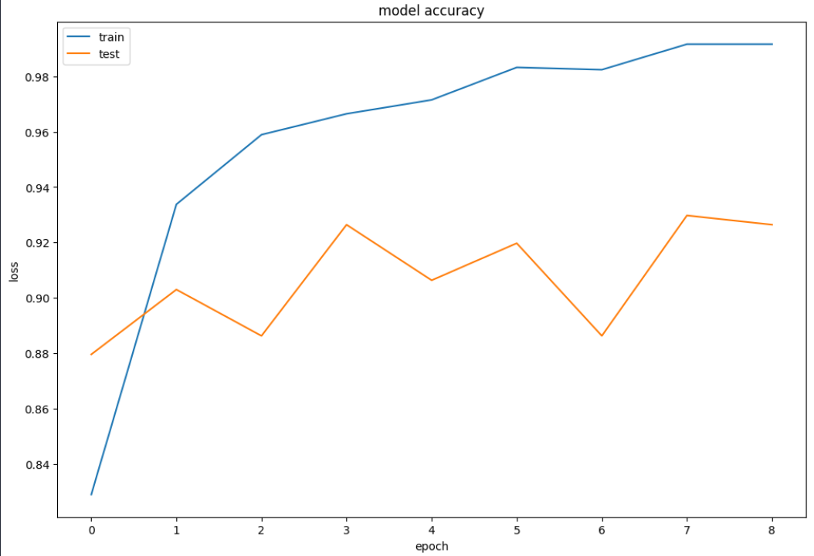

LSTM

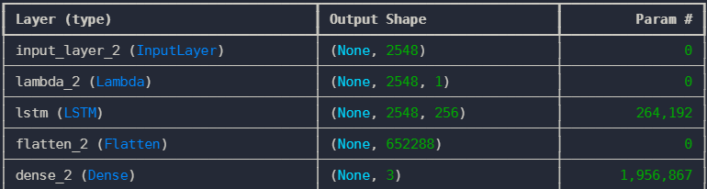

accuracy: 0.9902 - loss: 0.1651 - val_accuracy: 0.9599 - val_loss: 1.6691

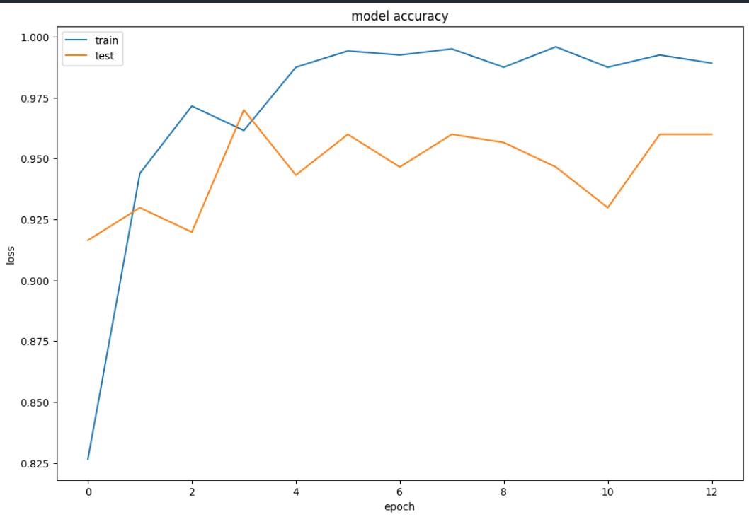

CNN

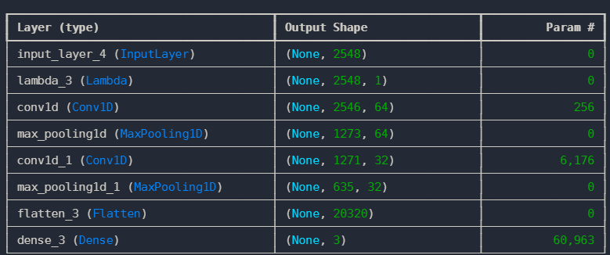

accuracy: 0.5086 - loss: 1344728203264.0000 - val_accuracy: 0.5485 - val_loss: 6095375433728.0000

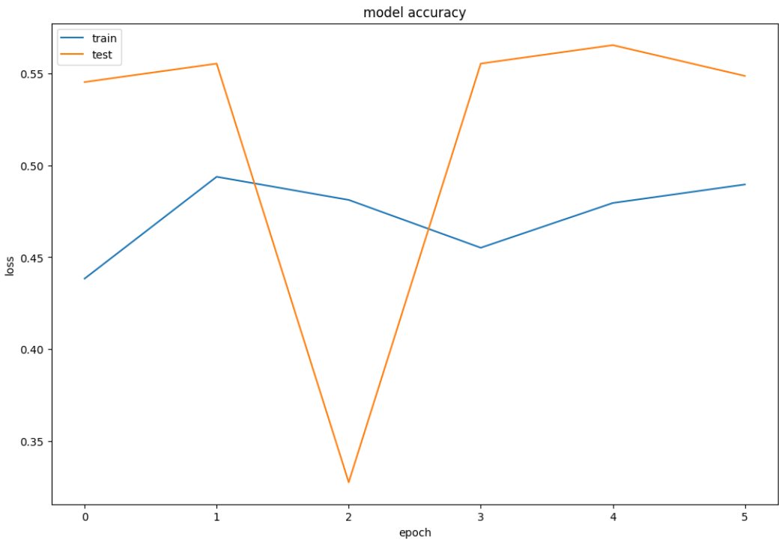

SVM

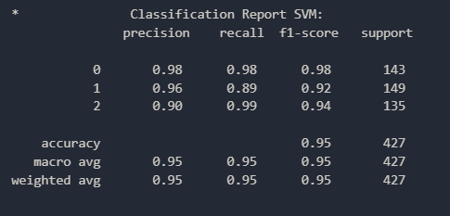

Logistic regression

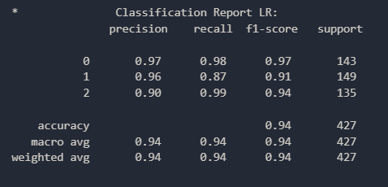

Random Forest

