Content Brief Set — Home Fitness for Beginners
Keyword research + SERP analysis + content briefs for a 3-article content cluster ·
Kavi VS · July 2026
Process: seed keywords expanded via Google autocomplete, related searches, and “People also ask”; SERP reviewed manually for the top 5–6 ranking pages per primary keyword to identify format, depth, and content gaps. Volume/competition are directional (see Keyword Tracker) and should be verified with Google Keyword Planner before publishing. The three briefs below are built as an interlinked cluster — a beginner's likely path is Workout → Schedule → Equipment.
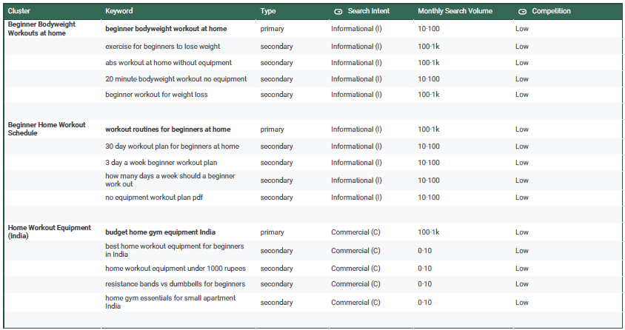
Content Brief 1: Beginner Bodyweight Workouts at Home
Target keyword: beginner bodyweight workout at home
Secondary keywords:
- exercise for beginners to lose weight
- abs workout at home without equipment
- 20 minute bodyweight workout no equipment
- beginner workout for weight loss
Search intent: Informational
Title tag:
Beginner Bodyweight Workout at Home: No Equipment (49 chars)
Meta description:
A simple bodyweight workout for complete beginners — no equipment, 20 minutes, with modifications for every exercise at home. Start today. (139 chars)
Content gap:
Top-ranking pages (Peloton, Healthline, Planet Fitness, Nerd Fitness) assume some fitness vocabulary already — terms like “progressive overload” or “circuit” go unexplained. Write for someone who has never worked out: plain-language cues, “what if I can't do a full push-up yet” style troubleshooting for every move, and a printable checklist.
Outline:
H2: Why Bodyweight Training Works for Complete Beginners
H2: What You Need Before You Start
H2: The 20-Minute Beginner Routine
H3: Warm-up (3 min)
H3: Main circuit (14 min) — each move with a beginner modification
H3: Cooldown (3 min)
H2: How Often Should You Do This Workout?
H2: What to Do Next
Internal linking plan
- Link out to “Beginner Workout Schedule for Home” (Brief 2) under “How Often Should You Do This Workout” — natural next step
- Link out to “Best Home Workout Equipment for Beginners in India” (Brief 3) under “What to Do Next” — for readers ready to add resistance
FAQ’s:
- Common Beginner Mistakes (and Easy Fixes)
- What to Do Next?
Content Brief 2: Beginner Workout Schedule for Home
Target keyword: workout routines for beginners at home
Secondary keywords:
- 30 day workout plan for beginners at home
- 3 day a week beginner workout plan
- how many days a week should a beginner work out
- no equipment workout plan pdf

Search intent: Informational (some navigational — readers looking for a downloadable plan)
Title tag:
Beginner Workout Schedule for Home: A Realistic Weekly Plan (58 chars)
Meta description:
How many days a week beginners should train, how long each session should be, and a sample weekly schedule you can actually stick to. (135 chars)
Content gap:
Competitors (Zing Coach, SetForSet, BetterMe, NASM) converge on generic “3–4 days a week” advice without addressing why beginners actually quit — schedule guilt and missed days. Add a genuinely minimal 2-day-a-week on-ramp and an explicit “what to do if you miss a day” section, which none of the top results cover directly.
Outline:
H2: How Many Days a Week Should a Beginner Work Out?
H2: Sample Weekly Schedule (2-Day and 3-Day Options)
H2: How Long Should Each Session Be?
H2: What to Do If You Miss a Day
H2: When to Add a 4th Day
Internal linking plan
- Link back to “Beginner Bodyweight Workout at Home” (Brief 1) for the actual session content behind each scheduled day
- Link forward to “Best Home Workout Equipment for Beginners in India” (Brief 3) when introducing the 4th-day progression
Content Brief 3: Best Home Workout Equipment for Beginners in India
Target keyword: budget home gym equipment India
Secondary keywords:
- best home workout equipment for beginners in India
- home workout equipment under 1000 rupees
- resistance bands vs dumbbells for beginners
- home gym essentials for small apartment India
Search intent: Commercial investigation
Title tag:
Best Home Workout Equipment for Beginners in India (Budget Guide) (67 chars)
Meta description:
The only home workout equipment every beginner needs in India — what to buy first, what to skip, and real options under ₹1,000. (127 chars)
Content gap:
Existing India-focused guides (Fitactus, Jerai Fitness, Adify) are strong but start budgets at ₹15,000+ for a “real” setup. There's a genuine gap for someone who wants to test the habit before spending — a true under-₹1,000 / household-items-first tier is nearly absent from current results.
Outline:
H2: Do You Need Equipment at All? (Start with Bodyweight First)
H2: The Under-₹1,000 Starter Tier
H3: Resistance band, workout mat
H2: The ₹1,000–₹5,000 Tier
H3: Adjustable dumbbells, skipping rope
H2: What to Skip as a Beginner (treadmills, smart mirrors, multi-gyms)
H2: Where to Buy (Decathlon, Amazon India, local sports shops)
Internal linking plan
- Open by linking back to “Beginner Bodyweight Workout at Home” (Brief 1) — equipment is optional, not required, to start
- Link back to “Beginner Workout Schedule for Home” (Brief 2) when discussing when to add a 4th equipment-based day

Why this is a cluster, not three separate posts
Each brief links to the other two along the beginner's natural path: start with bodyweight (Brief 1), build a habit with a schedule (Brief 2), then add equipment once the habit sticks (Brief 3).

