Computer Graphics Coursework – Self Assessment Document

Name: Varun Chandru Amarnani ID number: 22476814

Complete the self-assessment grid below by writing a short explanation of how you have satisfied the requirement and how it has implemented in your code.

Learning outcome | Mark | Weighted mark
1. Use appropriate mathematical tools (40%) |  | 0
2. Develop a 3D graphics application (30%) |  | 0
3. Write shader code (30%) |  | 0
 | Total | 0

Your mark for each Learning Outcome (LO) is the highest mark achieved based on the criteria specified in the self-assessment grid. Note that you will need to have satisfied all criteria at the lower mark bands to be awarded marks in the higher mark bands, e.g., to get a mark in the 70 - 80 band for a learning outcome you will have needed to have satisfied all criteria in the 40 – 50 and 50 – 60 mark bands.

Learning Outcomes:

LO1 Select and use appropriate mathematical tools for constructing and manipulating geometry in 3D space.
LO2 Develop an interactive 3D graphics application using an industry-standard API.
LO3 Write shader code for the programmable pipeline on modern graphics hardware using an industry standard shader language.

Self-assessment Grid

Mark | Criterion | Comments (state how and where you have achieved the criterion)
42, 45, 48 | LO1: Basic use of vector and matrix objects
42, 45, 48 | LO2: Application compiles and runs without alterations to the source code of CMake file. | 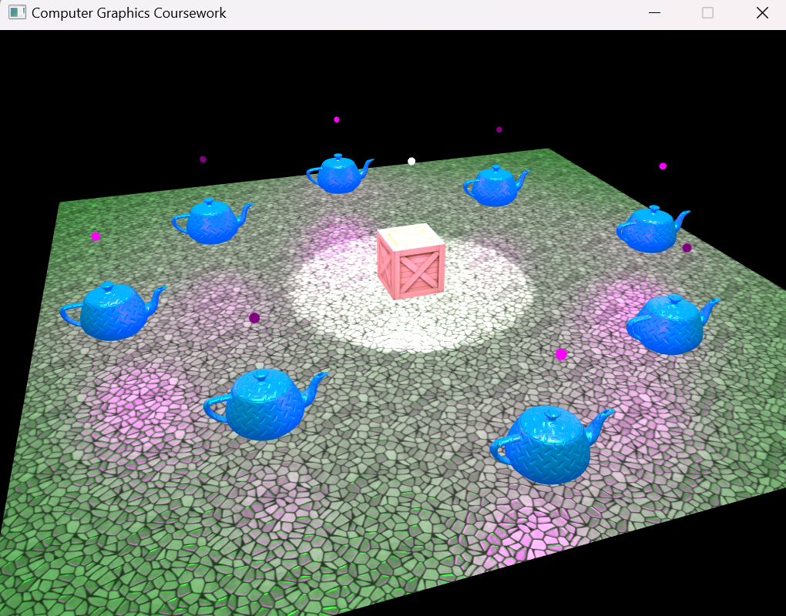
42, 45, 48 | LO3: Implementation of shaders to apply appropriate textures to objects.
52, 55, 58 | LO1: Basic use of translation, rotation and scaling transformations. | In the math class(maths.cpp) in them I have created functions for translation, rotation and scaling using the glm library(glm::mat4), by doing this I can calculate any translation, rotation or scaling matrix for any object in the coursework.cpp file. For example in coursework.cpp in lines 179-182 I use these functions to give the teapots a position, rotation, scale and angle.  It is also used in the render loop on lines 261-264 to calculate the model matrix
52, 55, 58 | LO1: Implementation of glm library functions for calculating view and projection matrices. | To calculate the view and projection matrices I made use of the lookat and perspective function from the glm library. In camera.cpp on line 15 I use the lookat function to calculate the view matrix, this gets given the inputs of the eye which are the coordinates for the camera position, the inputs for target which are the coordinates of the target point the camera is pointing at and the input of worldUp which is a vector pointing straight up.  Then on line 18 I use the perspective function to calculate the perpective projection matrix, this takes the input of  near – distance from (0,0,0) to the near clipping plane  far – distance from (0,0,0) to the far clipping plane  fov – field of view angle between top and bottom clipping planes.  aspect – the width to height aspect ratio of the window
52, 55, 58 | LO2: 3D virtual world has been created using instances of a single object type. | In coursework.cpp from lines 103 to 139 we can see that I create multiple objects of the same type which is a teapot. From the start I first declared the model for the teapot which is the constructor for it, this loads the vertex and texture coordinates from an .obj file and creates the relevant buffers. I then proceeded to add the teapots to the objects vector and assign their positions by making an array, the rotation, scale and angle for all of them and the finally in the render loop on line 273 draw the model of the teapot.
52, 55, 58 | LO3: Use of shaders to apply dynamic lighting from point light sources | In coursework.cpp from lines 144 to 175 you can see that I have added many point light sources, each of them with their position, colour and attenuation. I also declared a model constructor to pass a spere object as the light source.  In light.cpp I created a function to add points lights more easily in the main file, however for the light to be able to bounce and reflect from objects we need to add lighting properties to the objects,  From lines 101 to 104 I define the lighting properties for the teapot, starting with:  ka - which is the ambient reflection, light that scatter on all surfaces on screen.  kd – that is diffuse reflection which reflects light of a rough surface  ks and Ns – Specular reflection which depends on the position of the light source.  The sum of these 3 properties gives the colour intensity of a fragment on a surface.  This is also the reason why the teapot have many textures because each of them reflects the light in a certain way.  All of this lighting calculation are done by the shaders in the fragments shader and vertex shader.
62, 65, 68 | LO1: Implementation of students own functions for calculating view and projection matrices.
62, 65, 68 | LO2: 3D world created using multiple object types.
62, 65, 68 | LO2: Users can navigate the virtual world using keyboard and mouse inputs.
62, 65, 68 | LO3: Use of shaders to apply dynamic lighting from different types of light sources.
72 75, 78 | LO1: Implementation of students own functions to replace glm functions (e.g., glm::length(), glm::dot(), glm::cross() etc.).
72 75, 78 | LO1: Implementation of quaternions to calculate rotation matrix.
72 75, 78 | LO2: Interactive dynamic aspects of the virtual word and controllable by the user (e.g., position of objects, location and function of light sources etc.).
72 75, 78 | LO3: Appropriate implementation of normal and specular maps.
85, 90, 100 | LO1: Use of quaternions to calculate view matrix.
85, 90, 100 | LO1: Use of SLERP to smooth out changes in camera direction.
85, 90, 100 | LO2: Implementation of a third person camera with the ability to switch between first and third period view.
85, 90, 100 | LO2: The position of the camera or character obeys the constraints of the physical space (e.g., can’t pass through objects, can’t hover in midair etc.).
85, 90, 100 | LO3: Use of shaders to apply parameter driven effects within the scene, e.g., light properties controlled using camera/character position.

