R crash course goals

## Goals

Things to be able to do:

### 1) read in your data

batdat = read.csv("bat_data.csv")  
#or   
#batdat = read.csv("Users/klangwig/Dropbox/teaching/bat_data.csv")

### 2) load and install packages

#install.packages("ggplot2") #install a package (or use GUI system)  
  
library(ggplot2) #load a package before use

## Warning: package 'ggplot2' was built under R version 3.4.4

### 3) get help

?"unique"

### 4) examine your data

unique(batdat$species)  
str(batdat)  
head(batdat)  
tail(batdat)  
dim(batdat)  
names(batdat)  
nrow(batdat)  
ncol(batdat)

### 5) do a calculation with your data

log(batdat$gdL)  
log10(batdat$gdL)  
3+3  
batdat$temp + 10

### 6) make a new column

batdat$log.loads = log10(batdat$gdL) #make a new column that is the log of this column

### 7) subset data - using subset(), or square brackets []

#using subset  
MYSE.dat = subset(batdat, species=="MYSE") #a factor/character, so need == and quotes  
dim(MYSE.dat) #what are the dimensions of the new data frame?

## [1] 12 12

warm.temps = subset(batdat, temp>6) #a number, so no quotes  
dim(warm.temps)

## [1] 258 12

#same thing using square brackets (say "where")  
MYSE.dat = batdat[batdat$species=="MYSE",]  
dim(MYSE.dat)

## [1] 12 12

warm.temps = batdat[batdat$temp>6,]

### 8) use aggregate or table to summarize some data

bat.summary = aggregate(log.loads~species, FUN=mean, data = batdat) #aggregate data using the mean to give fungal loads by species  
bat.summary

## species log.loads  
## 1 EPFU -3.642464  
## 2 MYLU -3.026398  
## 3 MYSE -3.688292  
## 4 PESU -2.039707  
## 5 SUBSTRATE -4.110905

### 9) make a histogram of a column in your data

hist(batdat$log.loads)

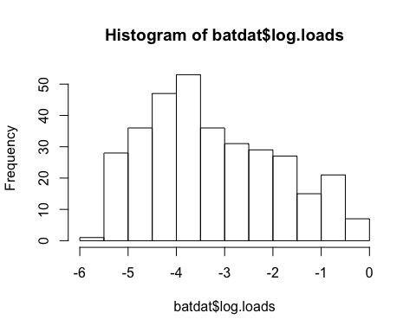

### 10) write out a dataframe

write.csv(bat.summary, "bat.summary.csv",row.names = F)

### 11) save script, close R **without saving workspace**

### 12) re-open R, repeat the same thing by re-running your script after clearing your workspace

### Helpful links:

<https://greggilbertlab.sites.ucsc.edu/teaching/rtransition/>

<https://www.statmethods.net/>