Quantitative Methods in Ecology and Evolution
Final Project Draft
Rough, rough draft
Ben Stalheim
Abstract

Introduction
Birds are experiencing global declines (Inger et al. 2015, Rosenberg et al. 2019, Dupont and Dobson 2025, Johnston et al. 2025), with a net loss of nearly 3 billion individuals in North America since 1970 (Rosenberg et al. 2019). These losses largely stem from a combination of habitat degradation (Wilcove et al. 1998, Jetz et al. 2007, Loss et al. 2015), climate change (Şekercioğlu et al. 2012, Pearce‐Higgins et al. 2015), and human-induced mortality (window collisions, cat predation, roadkill, turbines, etc.). In eastern North America, the decline of disturbance-mediated systems, such as grasslands, shrublands, and savannas, has had a significant negative impact on species adapted to these more open environments (Askins 1993). In these areas, particularly in the southeastern United States, fire historically was the predominant force creating and maintaining open conditions that birds rely on (Frost 1998, Engstrom et al. 2005). But decades of fire suppression and widespread land conversion have sharply reduced the extent of natural open spaces, including longleaf pine (Pinus palustris) savannas, which now occupy less than 5% of their historic range in the Southeast (Oswalt and Guldin 2021). As these environments have disappeared, many species now occur in alternative landscapes that only partially replicate their preferred conditions (Bulluck and Buehler 2006). Birds specialized for these disturbance-maintained systems (termed disturbance-dependent species), are now among the most imperiled in the region (Brawn et al. 2001, Hunter et al. 2001). Given the widespread loss of disturbance-mediated environments and the species that depend on them, shifts in bird community composition are likely increasing. Therefore, it is crucial to document bird communities and their changes, especially in these threatened ecosystems.
Community dynamics can be quantified through local colonization, extinction, and turnover rates, which provide insight into the processes shaping bird assemblages (Nichols et al. 1998, Willrich et al. 2016, Toledo-Lima and Pichorim 2020). These community-level vital rates can reveal how communities respond to disturbance or to newly available environments (Whitcomb et al. 1977, Hobson and Schieck 1999). Turnover often accelerates following disturbance events (Hobson and Schieck 1999), and unfavorable conditions such as drought can also drive shifts in community composition (Toledo-Lima and Pichorim 2020). Persistent changes in species composition may indicate environmental instability (Vallejos et al. 2020). Local extinctions can also signal declining habitat suitability (Gates and Donald 2000, Boulinier et al. 2001), whereas high colonization rates may reflect newly created or restored habitat (Lindenmayer et al. 2016). Because avian communities often shift as vegetation advances through successional stages (Hobson and Schieck 1999), ecosystems undergoing dynamic shifts in plant structure typically exhibit corresponding changes in bird assemblages (Di Cecco and Hurlbert 2022). Measures of colonization, extinction, and turnover therefore not only illuminate processes shaping avian communities but also serve as key indicators of ecosystem stability and resilience (Dornelas et al. 2014).
The aim of this study is to evaluate how community dynamics like turnover, alpha diversity, and gamma diversity change over time in disturbance-mediated environments. I will compare these dynamics on reclaimed mining lands to two nearby open canopy pine ecosystems: an early-successional longleaf pine forest and a mature longleaf pine forest. I predict that reclaimed mining sites will exhibit elevated turnover compared to non-mining areas. I also predict that disturbance age (i.e., years since a disturbance event) will have a positive effect on turnover, with the strongest effects occurring at the Mission Mine.
I predict that gamma and alpha diversity will be lower at the Mission Mine compared to both non-mining ecosystems. Similar to turnover, I predict that disturbance age will have a negative effect on alpha diversity at all sampling locations, but the strongest effects will be at the Mission Mine.
Methods
Study Area
This study took place in the southeastern coastal plain of Georgia, USA, in Charlton, Brantley, Folkston, and Wayne counties. Climate in this region is influenced by topical maritime air. Therefore, spring, fall, and summer are hot and wet with mean monthly temperatures of 22 – 26°C and mean monthly rainfall of 100 – 130 mm from May – September (Climatology 1987). We monitored bird species at 27 survey points within three locations: the Mission Mine (n = 9), Sansavilla Wildlife Management Area (Sansavilla WMA, n = 10), and Okefenokee National Wildlife Refuge (Okefenokee NWR, n= 8) (Figure 1). These areas are flat with predominantly sandy soils, and low basal area of loblolly (Pinus taeda) and longleaf (Pinus palustris) pine trees.
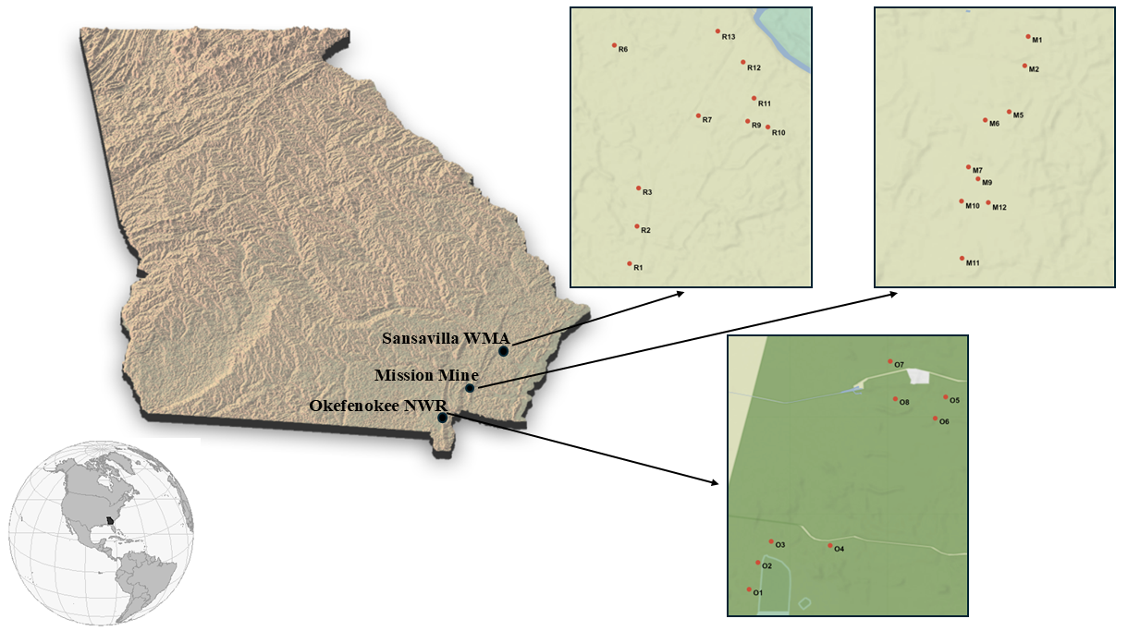
Figure 1: Map of study area. This study took place in Georgia, USA at three sampling locations: Sansavilla WMA, Mission Mine, and Okefenokee NWR. A total of 27 survey points across these three sampling locations were monitored using acoustic detectors.
The Mission Mine is an active heavy mineral surface mine with ongoing reclamation (CITE). Reclaimed areas are restored with their original topsoil and then replanted with loblolly pine seedlings (CITE). Herbicides targeting grasses and hardwoods are applied to promote growth of pines (CITE). But after planting, no management practices occur. Land is not reclaimed synchronously, and therefore a mosaic of differently-aged pine stands form (CITE). When surveys began in 2023, sites within the Mine ranged from 1-year post reclamation to 5-years (see TABLE). Because no fire or other management occurs within the reclaimed areas, time since disturbance advances linearly with year. We assigned the year land was reclaimed as year 0.
The Sansavilla WMA protects tracts of young longleaf pine forest that were restored in 2015. Managed by Georgia Department of Natural Resources, fire is used to maintain open canopy conditions and thin understory vegetation. Tracts are not managed with identical fire regimes, but typically prescribed burns occur every 2 -3 years. A complete fire history during our survey was provided by department staff.
The Okefenokee NWR harbors some of the oldest longleaf pine forest in North America (CITE). Known as one of the largest peat-producing wetlands in the world, the Okefenokee swamp is surrounded by stands of longleaf pine that are > 60 years old. These mature longleaf pine stands are vitally important for many species associated with open canopy pine conditions (CITE). Management practices focus heavily on maintaining conditions for a few endangered and threatened species, notably Red-cockaded Woodpecker (), Gopher Tortoise (), and Indigo Snake () (CITE). Prescribed fire is used to clear undergrowth and maintain open canopy conditions (CITE). Burning occurs at 2 or 3 year intervals within the upland environment. A complete fire history during our survey period was provided by staff (see TABLE).
Acoustic Sampling and Recording Sites
We collected data from 2023 – 2026 at the Mission Mine and Sansavilla WMA, and from 2024 – 2026 at Okefenokee NWR. We used Wildlife Acoustics Song Meter Mini and Mini 2 (Wildlife Acoustics Inc., Maynard, MA, USA) autonomous recording units (ARUs) to survey bird species. Every ARU was calibrated and programmed to record 16-bit WAV audio daily for 67 minutes with +18 dB gain and at a sampling rate of 44.1 kHz. Recordings were taken in the morning and evening to match peak bird activity (Robbins 1981) and ensure coverage of crepuscular and nocturnal species (Figure 2). Our recording schedule used high daily temporal resolution, which improves detection probability and diversity estimates (Metcalf et al. 2022). Surveys were conducted from March – September; however, for this study we only analyzed data collected between June 1 and June 30. All ARUs were randomly established at survey points within our three locations. However, units were constrained to environments within our area of inference (i.e., newly-reclaimed land at Mission Mine, recently-restored longleaf pine at Sansavilla, and mature longleaf pine at Okefenokee). To reduce spatial autocorrelation and assume independence among survey points, we implemented a 225m buffer around each ARU (i.e., 450m distance between units) (Digby et al. 2013, Thomas et al. 2020, Winiarska et al. 2025, Clapp et al. 2026).
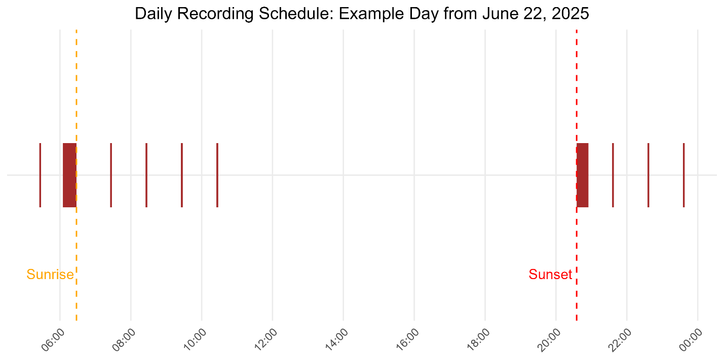
Figure 2: Schedule used to record bird species using ARUs. To maximize the number of detectable species, we surveyed during dawn and dusk to capture diurnal and crepuscular species.
Acoustic Data Processing and Target Species
Acoustic data were processed using BirdNET v2.4, a deep neural network machine-learning algorithm that annotates recordings of bird vocalizations (Kahl et al. 2021). BirdNET was activated in a Python environment on a high-performance computer to efficiently process the large quantity of data. Geographic coordinates were input to allow BirdNET to filter species outputs using eBird data (Sullivan et al. 2009). We inspected the species list BirdNET used to confirm all local breeding birds were available for the model to detect. Then, following steps outlined in previous studies (Wood and Kahl 2024, Scanferla et al. 2025), we manually reviewed 180 randomly selected BirdNET segments for each species. We reviewed a total of 72 bird species.
Disturbance History
Disturbance histories for each survey point were categorized as years since a disturbance event. With year 0 indicating a disturbance event occurred the same year monitoring took place. At the Mission Mine, disturbances were caused by mining and reclamation, with year 0 indicating complete reclamation of the site (i.e., all seedlings planted). We viewed Sentinel-2 imagery to determine when each point was reclaimed. At Sansavilla WMA and Okefenokee NWR, disturbances were caused by fire. For these locations, year 0 indicated a burn was conducted the same year monitoring occurred. We used fire history data from staff at both locations to assign disturbance histories to our survey points.
Environmental Variables
We accessed weather data surrounding our study locations using the riem package in R (Salmon and Elchison 2016). This package provided temperature, wind, relative humidity, and other environmental variables using weather stations from nearby airports. Airports nearest to each survey site were used as indices for weather around the survey point. We averaged temperature, wind, relative humidity, and other measurements across the day from 0500 to 1100. Daily averages for each measurement were then applied to all detections for each day at associated survey points.
Mean temperature throughout our study averaged 22.17°C during June. There was little variation in mean daily temperature across the three study locations. Wind speed averaged 0.74 m/s during our study. Average daily wind speeds were higher at the Mission Mine (1.19) and Okefenokee NWR (1.13 m/s) than Sansavilla WMA (0.28 m/s). Relative humidity was continually high during our study, with a mean daily percentage of 92. The Mission Mine (95.1%) and Okefenokee NWR (94.9%) averaged slightly higher relative humidity than Sansavilla WMA (89.8%).
Gamma and Alpha Diversity
We tested our hypothesis that gamma diversity differed across sampling locations by using generalized linear models with a Conway-Mawell Poisson distribution and logit-link function. Gamma diversity measures annual species richness at a broader level by pooling all survey points and measuring species across sampling locations. We fit models using ecosystem-type (i.e., sampling location) as a fixed effect and accounted for variation in sampling year by including year as a fixed effect in a separate model. We compared both models against a null model.
We tested our hypothesis that alpha diversity differed across sampling locations and with disturbance age by using generalized linear mixed effects models with a Conway-Maxwell Poisson distribution and logit-link function. Alpha diversity measures species richness at a finer scale, and measures species detected at each survey point over a sampling period. We fit models using ecosystem-type (i.e., sampling location) and disturbance age as fixed effects with all their combinations. Survey point was included as a random effect in all models to account for repeated sampling. We compared all models against a null model.
Community Level Turnover
We tested our hypothesis that bird communities at reclaimed mining lands experience higher turnover rates compared to mature and young longleaf pine forest by measuring beta diversity using the Jaccard dissimilarity index. This index ranges from 0 to 1, with 0 indicating no change and 1, a completely dissimilar community (CITE). We used the betapart (CITE) package in R to calculate total dissimilarity, turnover, and nestedness for every transition year at survey points (CITE). Although these measurements typically compare differences in communities separated by space, they also can be applied to compare how communities change over time (i.e., temporal beta diversity)(CITE). The Jaccard dissimilarity index works on presence/absence data; therefore, we turned our raw detection data into simples 1s and 0s to match this format.
We calculated a Jaccard dissimilarity value for each survey point during every transition year (i.e., 2023 – 2024 or 2024 – 2025). For each transition year, we calculated total turnover, replacement, and nestedness. Replacement measures species actively replacing those in a community. Nestedness measures species loss or gain, without a replacement. While total turnover sums both of these values across the whole community, effectively comparing how much the community changed in one year at each survey point. We were most interested in total turnover and modeled all of our turnover data using this statistic.
We used generalized linear mixed models with a beta distribution and logit-link function to model turnover in bird communities. We used two main predictors: location (i.e., ecosystem-type) and disturbance age (i.e., years since a disturbance event). We fit models using each as sole predictors and also additive, interactive, and null models. We used AIC model selection to identify our top models.
Results
We detected 46 species over three years of acoustic surveys. We used observed species richness values because species accumulation curves showed 30 days to be long enough to detect the acoustic community (FIGURE). Community richness estimates using unmarked::occuComm() were also nearly identical to observed values. The top model included only ecosystem-type as a fixed effect. There was support for an additive model including year as a fixed effect with ecosystem-type, but this model did not improve overall fit and included an extra parameter. Gamma diversity was lowest at the Mission Mine (28 ± 1.08) and significantly differed from the Okefenokee NWR (33 ± 1.44, p = 0.013) and Sansavilla WMA (35.7 ± 1.22, p < 0.0001)). There was no significant difference in mean gamma diversity between the Okefenokee NWR and Sansavilla WMA (p = 0.339).
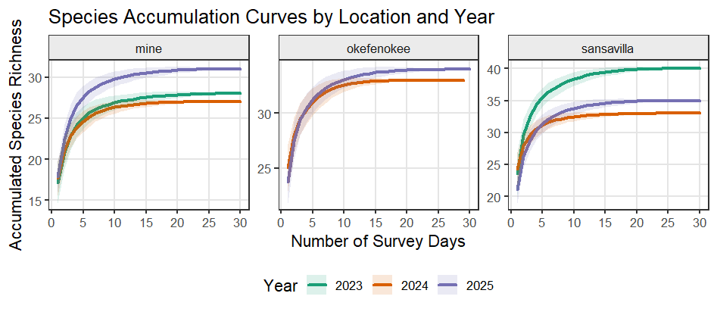

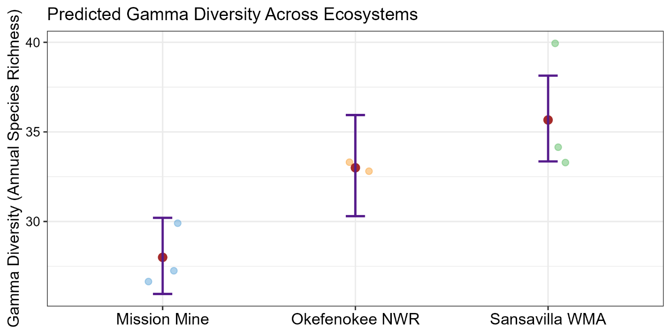

Alpha diversity varied across sampling locations (FIGURE). The top model included only ecosystem-type as a fixed effect. Alpha diversity was significantly lower at the Mission Mine (20 ± 0.615) compared to the Sansavilla WMA (25.9 ± 0.707, p < 0.0001) and Okefenokee NWR (27.2 ± 0.928, p < 0.0001). Meanwhile, we detected no difference in alpha diversity between the Sansavilla WMA and Okefenokee NWR (p = 0.484). An interactive model of ecosystem-type and disturbance age was within 2 ΔAIC of the top model, suggesting a possible influence of disturbance age on alpha diversity. The effect of disturbance age varied across sampling locations (FIGURE). The Mission Mine showed a slight positive trend (β = 0.028 ± 0.017), while Okefenokee (β = −0.015 ± 0.041) and Sansavilla (β = −0.023 ± 0.016) showed negative trends. However, all of these estimates overlapped zero. Pairwise slope comparisons of disturbance age revealed no significant differences among locations. However, Sansavilla and the Mine had marginally significant differences in their slopes (p = 0.072). Mean alpha diversity was still significantly different between the Mission Mine and other sampling locations (p < 0.0002 for both) while accounting for disturbance age in this model.
Turnover differed among ecosystem types (FIGURE). We fit a candidate model set including ecosystem type, disturbance age, their additive combination, their interaction, and an intercept-only null model, all with survey point as a random effect. The ecosystem-type model and the additive model received the most support by AIC (ΔAIC < 2 from one another), while all other models ranked lower. We selected the more parsimonious ecosystem-type model because this model fits better with prior hypotheses. Mean turnover at Okefenokee (0.192 ± 0.024 SE) was significantly lower than at Mission Mine (0.296 ± 0.018 SE, p = 0.003) and Sansavilla WMA (0.280 ± 0.017 SE, p = 0.012). Turnover at Sansavilla did not significantly differ from the Mission Mine (p = 0.785). When modeled in isolation, disturbance age was positively associated with turnover (β = 0.064 ± 0.027, p = 0.017), though this effect was weakened after accounting for ecosystem type in the interactive model (β = 0.084 ± 0.053, p = 0.113). Although turnover tended to increase with disturbance age at Mission Mine (β = 0.084 ± 0.053) and Sansavilla (β = 0.043 ± 0.055), slopes did not differ significantly among ecosystem types (all pairwise contrasts p > 0.84), and all confidence intervals overlapped zero.
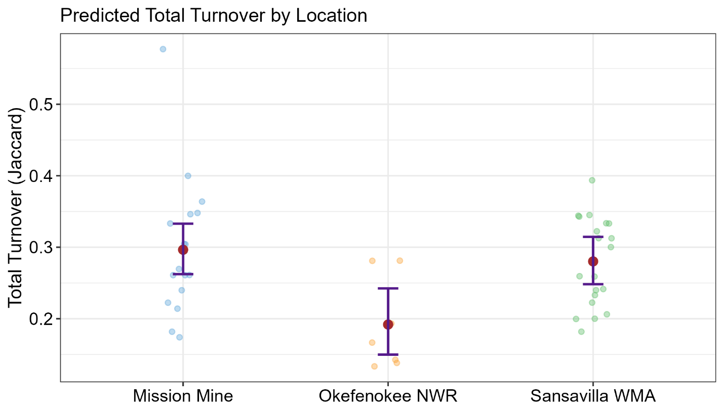

Discussion

Bibliography

