|  |  |  |
| --- | --- | --- |
| Vocational School of Coding and Innovations | | |
| **Theme:** **Game with words** | | |
| **Galaxy Team:**  Vasil Stanchev  Emil Ribarev  Martin Atanasov  Krasiyana Kamburova |  |  |

Table of content

1. Authors 3

2. Purpose 4

3. Diagram 5

4. Main steps in the implementation of the project 6

5. Elements 7

5.1. The human brain 7

5.2. Developer-Oriented 7

5.3. Developer Environment 7

5.4. Architecture and Code 7

5.5. DevOps Tools 7

6. The Code 9

6.1. doShowMenu() 9

6.2. runQuiz() 10

# Authors

|  |  |  |  |
| --- | --- | --- | --- |
| • | Vasil Stanchev | <VTStanchev18@codingburgas.bg> | Class IXA |
| • | Emil Ribarev | <eiribarev@codingburgas.bg> | Class IXV |
| • | Martin Atanasov | <mvatanasov18@codingburgas.bg> | Class IXV |
| • | Krasiyana Kamburova | <KSKamburova18@codingburgas.bg> | Class IXB |

# Purpose

The application is developed for educational and entertaining purposes and develops the following skills:

* + Semantic skills (Semantic skills refers to the ability to understand meaning in different types of words, phrases, narratives, signs and symbols.)
  + Phonological skills (Phonological awareness lets kids recognize and work with the sounds of spoken language.)
  + Vocabulary improvement
  + Understanding of vocabulary

Sometimes it can be very difficult for children to learn the vocabulary, but thanks to this application their work will be easier because they will learn it while having fun.

# Diagram

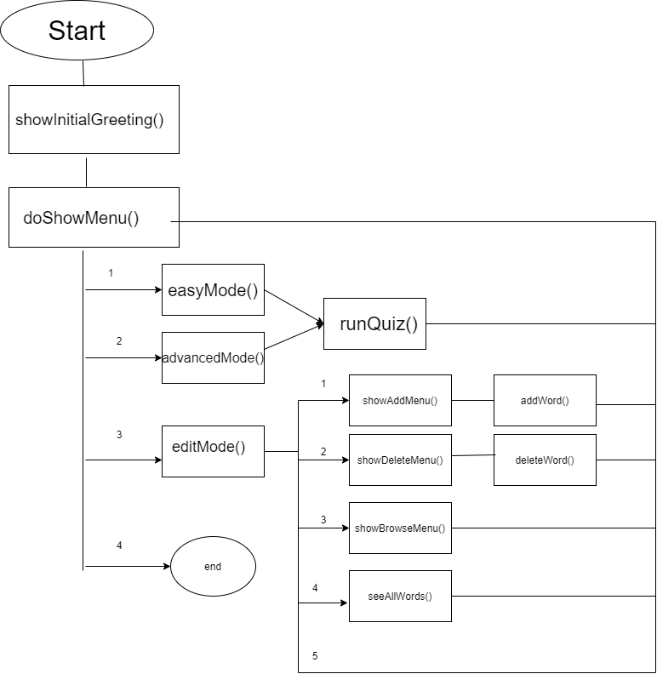

# Main steps in the implementation of the project

* Defining the main idea
* Defining the purpose of the project
* Implementing the project by writing code

The application is written entirely in C++.

# Elements

The structure of the application is as easy to use as possible. The information is consistent with the selected objectives. The main principles for building an application are:

## The human brain

The human brain has difficulty trying to consume too much information. Reducing the cognitive load on developers is beneficial because it means that they can focus their energy on solving the problem at hand, instead of maintaining a complex model of the entire application, and its future features, in their minds as they solve specific problems.

## Developer-Oriented

The biggest hurdle to rapid development is often not your development process, but how much time you spend focusing on the business logic of the function you are working on.

## Developer Environment

An example of an easy-to-work-with development environment:

* + A developer clones a GitHub repo
  + He or she runs a couple of commands from a makefile
  + Tests run
  + The application comes up and is accessible
  + Code changes are apparent in the running application

## Architecture and Code

## DevOps Tools

Beyond making your app easy to understand and easy to work with, one of the ways to improve productivity on an engineering team is to reduce the time developers spend on their own infrastructure. Developers who don’t have environments that are easy-to-work-with from the start must invariably spend time making the environment easy-to-work-with-for-them.

# The Code

## doShowMenu()

This is the main menu function of our program. It is responsible for calling the main functions of the different modules.

It takes as argument a vector of type string.

It returns true if the main menu should be shown again and false otherwise.

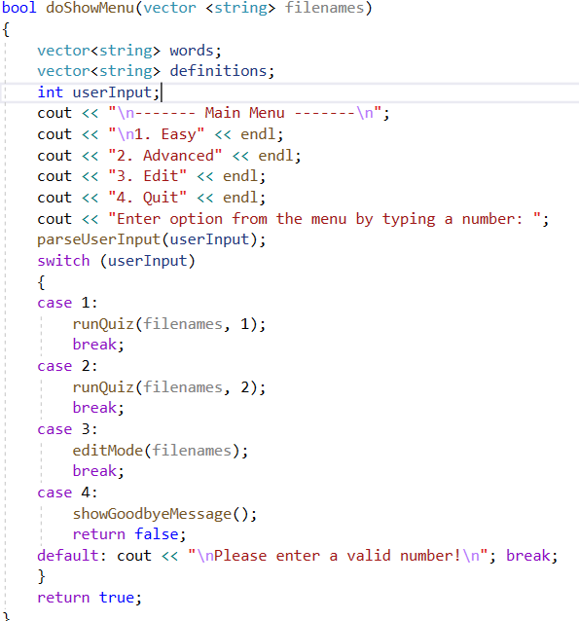

## runQuiz()

 It is responsible displaying the words and definitions for the game.

It takes as argument a vector of type string and an integer.

It returns void so it does not return anything.

