

**QtRptDesigner**

Version 2.1.0

Programmer*: Aleksey Osipov*

*Web-site:* [*http://www.aliks-os.tk*](http://www.aliks-os.tk)

Email*:* [*aliks-os@ukr.net*](mailto:aliks-os@ukr.net)

*Web-site:* [*http://www.qtrpt.tk*](http://www.qtrpt.tk)

*Address in Facebook* [*https://www.facebook.com/qtrpt*](https://www.facebook.com/qtrpt)

QtRptDesigner attended for preparation XML files, which will be used and processed by QtRPT engine for building reports. XML file contains information about of different items and their properties, and how this items should get data from data source, etc. QtRPT engine allows to process script embedded into the report. By script, the user can defined, how the fields must be processed depends of some condition.

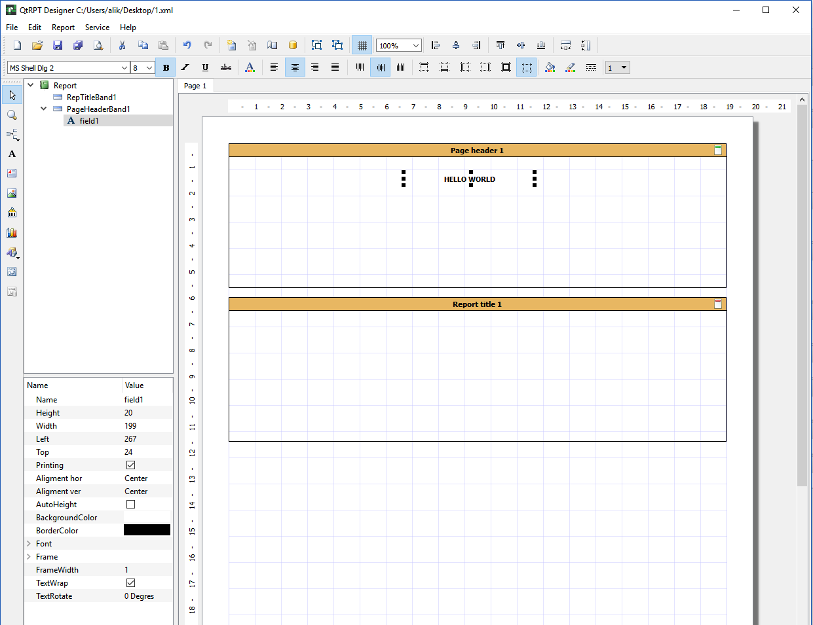

**Interface of the Designer**

For convenience, the buttons are grouped into a logical group and each is located on a separate panel. In addition, in the designer all elements are presented in the form of a tree, which allows you to clearly see the hierarchy of the report.

**Edit Panel**



Contains the following buttons

|  |  |
| --- | --- |
|  | New report |
|  | Open |
|  | Save |
|  | Save as |
|  | Preview |
|  | Cut |
|  | Copy |
|  | Paste |
|  | Undo |
|  | Redo |
|  | New report page |
|  | Delete page of the report |
|  | Page setting |
|  | Data source ***(Not needed for Codiac users)*** |
|  | Group selected items |
|  | Ungroup |
|  | Show grid |
|  | Align by left edge all selected items |
|  | Align by center all selected items |
|  | Align by right edge all selected items |
|  | Align by top edge all selected items |
|  | Align by center (vertical) edge all selected items |
|  | Align by bottom edge all selected items |
|  | Set same width on selected items |
|  | Set same height on selected items |

**Formatting Panel**



|  |  |
| --- | --- |
|  | Font selection |
|  | Bold |
|  | Italic |
|  | Underline |
|  | Strikeout |
|  | Font color |
|  | Align left |
|  | Align center |
|  | Align right |
|  | Justify |
|  | Align top |
|  | Align V center |
|  | Align bottom |
|  | Top border |
|  | Bottom border |
|  | Left border |
|  | Right border |
|  | Set all borders |
|  | Remove all borders |
|  | Background color |
|  | Border color |
|  | Border style |
|  | Border thickness |

**Items Panel элементов**

|  |  |
| --- | --- |
|  | Select tool |
|  | Magnifying glass |
|  | Add band |
|  | Add field |
|  | Add rich text |
|  | Add image |
|  | Add barcode |
|  | Add chart |
|  | Add draw |
|  | Add cross table ***(Not needed for Codiac users)*** |

**Bands**

Band is area where the user’s fields can be placed. The band can be a following type:

|  |  |
| --- | --- |
| **Band type** | **Purpose of the band** |
| Report Title | This band is printed only once at the start of the report and only on the first page |
| Page Header | This band is printed at the top on each page |
| Data Grouping Header | This band is used when you need to group data that are placed on the Master Data band and show Header for each group |
| Master Header | This band is printed before Master Data band |
| Master Data | This band is intended for printing of some data set. The band printing is repeated depends of records count |
| Master Footer | This band is printed after Master Data band |
| Data Grouping Footer | This band is used when you need to group data that are placed on the Master Data band and show Footer for each group |
| Page Footer | This band is printed at the bottom on each page |
| Report Summary | This band is printed only once at the end of the report and only on the last page |

To make report more flexible, you can put more than one Master Data Band and corresponded bands (Master Header, Master Footer and Grouping Bands). Each Master Data Band has own data source.

***Note for Codiac Users***: You should enter the *alias* for data source of the band

**Report structure and field’s property**

|  |  |
| --- | --- |
|  | At left from report you can see the report structure and set of property. When some field or band is selected, the appropriate properties are shown. From the list of properties, you can change any property, as well as by pressing appropriate button on the panel |

**Page settings**

|  |  |
| --- | --- |
|  | You can set parameters for each page of the report. Set a size and orientation, margins and background images (watermark). |

**Working with the Fields**

The purpose of the field (element) is display information. The field should be placed on the band only. There are several types of the fields. Before placing field on the report, it should, contains at least one band. To place field on the band, click on selected field on the Panel of Elements, then click on band. The field will be placed. On selecting, the field’s properties will be shown in the list at the right. You can change the property of the field in the list or by clicking appropriate button on the panel.

**Fields moving and resizing**

The field can be moved or resized by mouse or by keyboard. When you use the keyboard, press **Ctrl + Arrow** key to move the field or **Shift + Arrow** to resize the field. You can select the several fields, to do it, please click on the first field, then press and hold on Ctrl key. While the Ctrl is pressed, click on the other fields that you want to select. Then you can use appropriate combination of keys (Ctrl + Arrow) or (Shift + Arrow) to move or resize the selected fields simultaneously.

**Field’s Alignment**

Several selected fields can be aligning to the one of edge. To do it, select the several fields and click on the appropriate button. All fields will be aligned to edge of the first selected field.

**Data of the field**

If the text in the should be static – just enter the text. If the text should be taken from any data source of third party application, you should enter the alias in the following form

[AliasOfTheField] – the square brackets indicate that it is alias. In the field you can some build-in functions. To add function or take a look at the full list of function, double click on the field, then click on “Add function” button. The angle brackets indicate that it is a “function”.

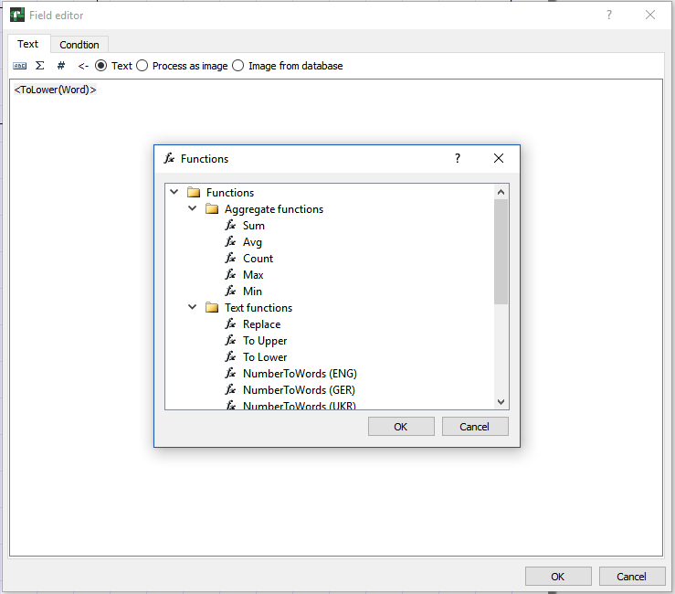

You can mix using aliases and build-in functions. For example:

<ToLower([companyName])> - This means that will be taken string from alias “companyName” and all cases will be set to lower.

The price is <NumberToWords(‘ENG’, [price])> dollars - This means that will be take value from alias “price” and digital value will be written as a string. For example, if the price is 100, then the result of processing will be as “The price is one hundred dollars”.

You can also use some system variables:

* Date
* Time
* Page
* TotalPages
* LineNo
* LineCount

During the report generations, the appropriate value will be inserted into the field. For example,

The page <Page> of <TotalPages> - Will generate: “The page 1 of 3”.

**Data group property**

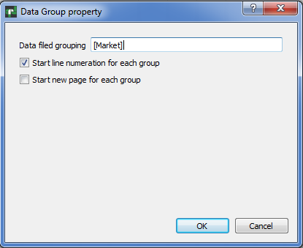

***Note for Codiac Users***: In the “Data field grouping”, you should enter the *alias* of the field.

**Barcode property**

***Please note*: that since version 1.4.5, to use barcode feature, you need to have built QtZint library. The source files are in folder Zint-2.4.4. After building, place (QtZint.dll, QtZint.so file) library into the folder where your application able to find it.**

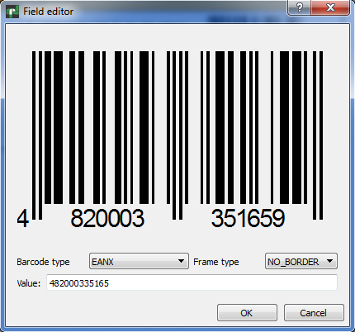

**Field highlighting**

You can highlight the field depends of value. You should switch to “Condition” tab, click on “Highlight” and enter some condition, for example

[Condition] < 0, so when alias Condition will have value below zero, the font color will be blue and background color will be yellow in our example. You can set font Bold, Italic, underline or Strikeout.

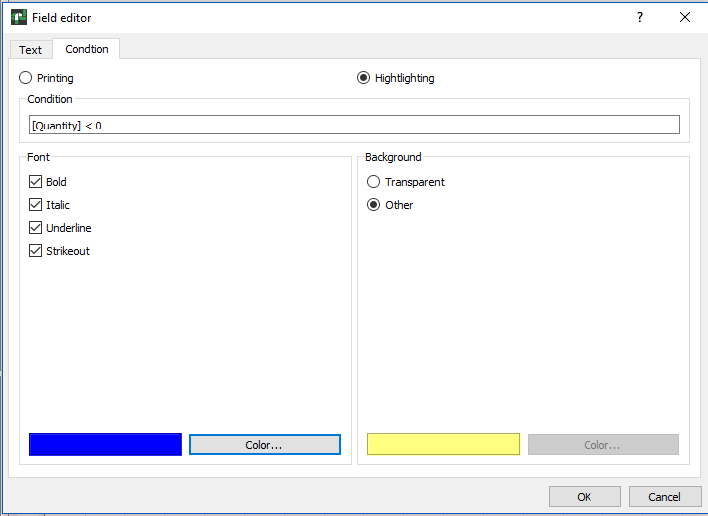

**Rich Text field editor**

To edit the field “Rich text”, double click on the chosen container. The dialog box in which you can bring the text will open, change its property. You may change font’s property such as Bold, Italic, Underline, change color of the text. This field also supports system varibales and work with external data. However, this field doesn’t works with conditions.

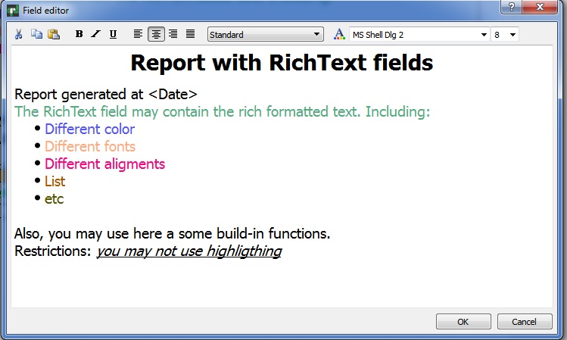

**Charts**

The QtRptDesigner allows to work with a different type of charts, the examples below.

|  |  |
| --- | --- |
|  |  |
|  |  |

To edit the properties of the chart, you should double click on the chart. Will be open the dialog with various fields to setup the properties of the chart. The chart can be static, i.e. value stay un-changed or dynamic, i.e. the values for diagram will get from data source.

***Note for Codiac Users***: For dynamic chart, you should enter the *alias* for data source of the chart (series).

For Stacked bar chart you should setup data source for each series. You can setup various font, font color, background color, captions, etc.

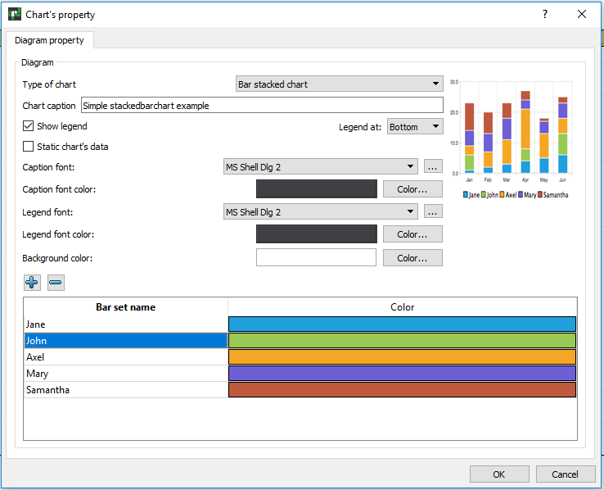

**Plugins**

The QtRptDesigner functionality can be enhanced via plugin technology. Some plugins can be automatically launched on QtRptDesigner start, some can be run via Main Menu -> Service -> Plugins -> Name of Plugin. Possible to define should plugin execute some function before report preview or not.

**How to create custom plugin**

To create custom plugin, you must inherit the CustomInterface like in the code below

#pragma once

#include <QObject>

#include <QtPlugin>

#include "CustomInterface.h"

class SessionPlugin : public QObject, CustomInterface

{

Q_OBJECT

Q_PLUGIN_METADATA(IID "qtrpt.project.CustomInterface")

Q_INTERFACES(CustomInterface)

Q_CLASSINFO("PluginName", "Plugin Name")

Q_CLASSINFO("AddToMenu", "false")

Q_CLASSINFO("RunOnLoading", "true")

Q_CLASSINFO("ShowReport", "true")

public:

explicit SessionPlugin(QObject *parent = 0);

bool *execute*(QSharedPointer<QDomDocument> xmlDoc) override;

void *saveData*(QSharedPointer<QDomDocument> xmlDoc) override;

void *showReport*(QSharedPointer<QDomDocument> xmlDoc) override;

void *clear*(QSharedPointer<QDomDocument> xmlDoc) override;

};

The following CLASSINFO parameters affect on behavior of plugin

* PluginName – Just name of plugin
* AddToMenu – Define, will or not this plugin added to Menu of plugins
* RunOnLoad – Define, will or not this plugin running on start of designer
* ShowReport – Defin, will or not the plugins function “***showReport***” executes before preview of report in the designer

Description of public functions:

* execute – This function is calling when user select the name of plugin in Menu
* saveData – This function is calling before report saving
* showReport – This function is calling before report showing
* clear – This function is calling when the new report is created

***Plugins. Notes for Codiac users***

For Codiac user there are three plugins. First plugin, allow to connect and carry out verification of user’s credential at the start of the QtRptDesigner. You should enter your login, password and indicate address and port of the Codiac service. If user successful pass verification, the QtRptDesigner will be run and user will be able to send request to Codiac server and get data from it.

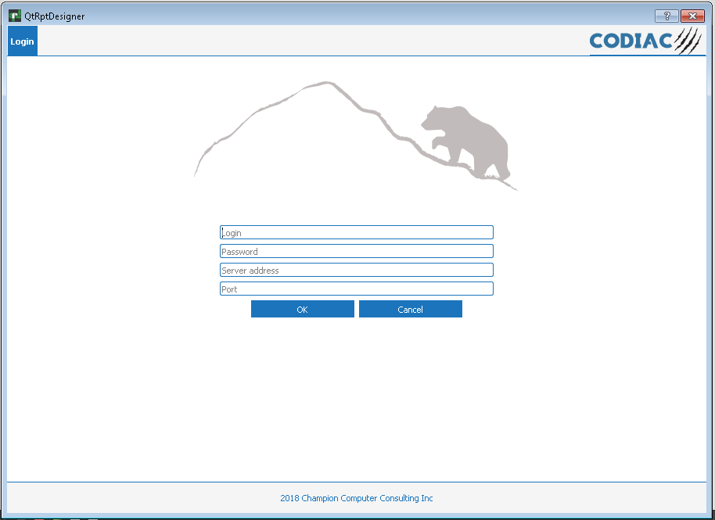

The second plugin allow edit the input parameters that will be sent to Codiac server.



You can add, edit input aliases names and their values. This plugin is available from Plugin menu.

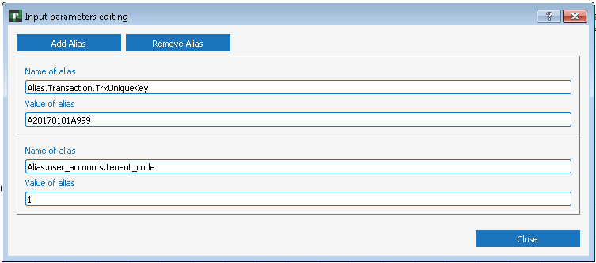

Each Input Alias contains two fields: Name of alias and Value of alias. To add pair, please “Add Alias” button, and enter Name and Value of Alias. To remove alias, pleas click at any field of the pair, then click at “Remove Alias” button. After editing of the Input aliases, the report (XML file) should be saved.

The third plugin “Template directory”, allows view the list of templates in the Codiac service, load them into QtRptDesigner, delete from service, update template in service after editing and add new one.

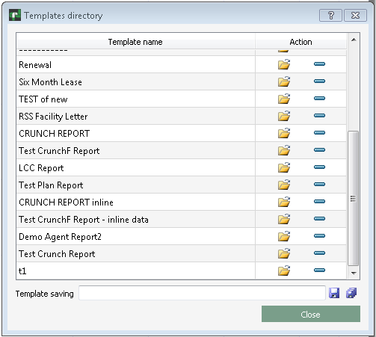

To load selected template, double click on the row or click on the appropriate icon. The selected template will be load into QtRptDesigner.

To delete selected template, click on icon “minus”.

To save existing template, click on “Save” icon. If you want rename template, change the name in input field “Temlate saving” and press “Save”. To save template under new name you should press “Save as” button.