1) . Java Lambda Expressions
import java.io.*;
import java.util.*;
interface PerformOperation {
boolean check(int a);
}
class MyMath {
public static boolean checker(PerformOperation p, int num) {
return p.check(num);
}
PerformOperation isOdd(){
return n->n%2!=0;
}
PerformOperation isPrime(){
return n->{
if (n<2){
return false;
}
for (int i = 2;i<=Math.sqrt(n);i++){
if(n%i==0){
return false;
}
}
return true;
};
}
PerformOperation isPalindrome(){
return n->{
int original =n;
int reverse=0;
while(n>0){
reverse = reverse*10+n%10;
n /=10;
}
return original == reverse;
};
}
}
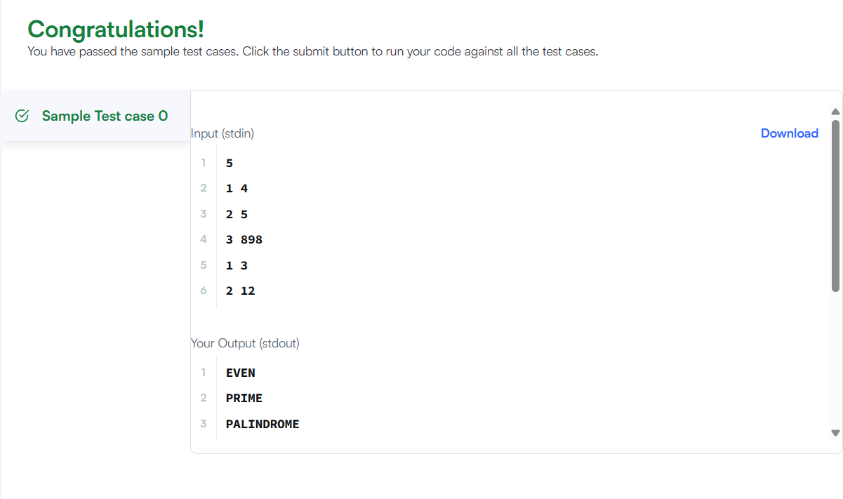

2) Java Comparator
import java.util.*;
class Checker implements Comparator<Player>{
public int compare(Player a, Player b){
if(a.score != b.score){
return b.score - a.score;}
return a.name.compareTo(b.name);
}
}
class Player{
String name;
int score;
Player(String name, int score){
this.name = name;
this.score = score;
}
}
