SMART OUTPASS
AI-POWERED DIGITAL OUTPASS AND CONSENT-BASED LIVE TRACKING SYSTEM

A Project Report submitted in partial fulfillment of the requirements for the degree of

BACHELOR OF COMPUTER SCIENCE
(ARTIFICIAL INTELLIGENCE & DATA SCIENCE)

To the
PERIYAR UNIVERSITY, SALEM – 11

By
S.MADHUMITHA
Register No: C24UG141AID022

VIVEKANANDHA ARTS AND SCIENCE COLLEGE FOR WOMEN
[An ISO 9001:2015 Certified Institution]
(Affiliated to Periyar University, Salem; Recognized under Sections 2(f) and 12(B) of the UGC Act, 1956)
Veerachipalayam (PO), Sankari (TK), Salem (DT) – 637303
OCTOBER – 2026
PERIYAR UNIVERSITY
Name of the College | Vivekanandha Arts and Science College for Women, Sankari.
Programme | Bachelor of Computer Science (Artificial Intelligence & Data Science)
Name of the Student | S.Madhumitha
Register Number | C24UG141AID022
Title of the Project Work | SMART OUTPASS
Name of the Internal Guide | P.KALAISELVI.,
Qualification | MCA., M.Phil.,NET.,
Place | Veerachipalayam
Date
Signature of the Internal Guide

CERTIFICATE

CERTIFICATE

This is to certify that the project work entitled “SMARTOUTPASS – AI-POWERED DIGITAL OUTPASS AND CONSENT-BASED LIVE TRACKING SYSTEM” submitted in partial fulfillment of the requirements for the degree of Bachelor of Computer Science (Artificial Intelligence & Data Science) to Periyar University, Salem, is a record of bonafide work carried out by S. Madhumitha (Register No. C24UG141AID022) under my supervision and guidance.
The work presented in this report is based on the Smart Outpass project developed as an academic system for digital outpass requests, approval, gate verification, trip tracking, notifications, and administrative reporting.

Head of the Department |  | Internal Guide
Date of Viva-Voce:

Internal Examiner |  | External Examiner

DECLARATION

DECLARATION

I hereby declare that the project work entitled “SMARTOUTPASS – AI-POWERED DIGITAL OUTPASS AND CONSENT-BASED LIVE TRACKING SYSTEM” submitted to Periyar University, Salem, in partial fulfillment of the requirements for the award of the degree of Bachelor of Computer Science (Artificial Intelligence & Data Science), is a report of the work carried out by me under the supervision of P.KALAISELVI., MCA., M.Phil.,NET., Assistant Professor, Department of Artificial Intelligence & Data Science, Vivekanandha Arts and Science College for Women during the period of study 2024– 2027.
I further declare that this report has been prepared for academic submission and that any project limitations or functions requiring deployment configuration are described accordingly.
Signature of the Candidate
S.Madhumitha
Register No: C24UG141AID022

I certify that the declaration made above by the candidate is true.

Signature of the Guide
P.KALAISELVI., MCA., M.Phil.,NET.,

Assistant Professor,

ACKNOWLEDGEMENT

ACKNOWLEDGEMENT
I express my sincere gratitude to the Almighty for the strength and perseverance that enabled me to complete this project work.
At the outset I would like to thank Vidhya Rathna, Rastriya Rathna, Hind Rathna, Bharat Excellence Prof. Dr. M. KARUNANITHI, B.Pharm., M.S., Ph.D., D.Litt., Chairman & Secretary and Tmt. K. KRISHNAVENI KARUNANITHI, M.A., Managing Director, Vivekanandha Educational Institutions, who gave me an opportunity to undergo this project work successfully in this esteemed institution.
I extend my grateful thanks to Dr. S. ARTHANAREESWARAN, M.D., (General Medicine), Joint Managing Director, and Dr. K. SREERAGHANITHI ARTHANAREESWARAN, M.S. (Ophthalmology), Joint Secretary, Vivekanandha Educational Institutions, for their valuable suggestions in fulfilling this project.
I extend my grateful thanks to Dr. K. KRUPANITHI, M.D., (Emergency Medicine), Vice Chairman, and Dr. K. B. NIVETHANA KRUPANITHI, M.B.B.S., M.S., (OG), Executive Director, Vivekanandha Educational Institutions, for their encouragement.
I express my deep sense of gratitude to Dr. V. PADMANABHAN, M.Com., M.Com (CA), MBA., Ph.D., NET, Principal, Vivekanandha Arts and Science College for Women (Sankari), for the valuable advice and suggestions to accomplish this task successfully.
I place on record my profound gratitude to Prof. Mrs. S. VISHALATCHI, M.C.A., M.Phil., UGC-NET, Head of the Department of Artificial Intelligence and Data Science, for giving me the opportunity to complete this project successfully and for her valuable guidance and timely advice. I also thank her for the excellent guidance and the time and attention she spent on this work.
I express my deep gratitude to my project guide, P.KALAISELVI., MCA., M.Phil.,NET., Assistant Professor, for her guidance, constructive suggestions, and careful review during the development and documentation of this work.
I also thank the faculty members, friends, and family who offered their assistance and encouragement. Finally, I acknowledge the open-source technologies and documentation that supported the implementation of Smart Outpass.
S.Madhumitha

TABLE OF CONTENTS
CHAPTER NO | TITLE | PAGE NO
 | CERTIFICATE
 | DECLARATION
 | ACKNOWLEDGEMENT
 | SYNOPSIS
1 | CHAPTER 1 – INTRODUCTION
 | 1.1 Background of the Project
 | 1.2 Problem Statement
 | 1.3 Objectives
 | 1.4 Scope
 | 1.5 Existing and Proposed Systems
 | 1.6 Feasibility Study
2 | CHAPTER 2 – SYSTEM ANALYSIS AND REQUIREMENTS
 | 2.1 Stakeholders and Roles
 | 2.2 Functional Requirements
 | 2.3 Non-Functional Requirements
 | 2.4 Hardware and Software Requirements
3 | CHAPTER 3 – SYSTEM DESIGN
 | 3.1 Architecture Overview
 | 3.2 System Workflow
 | 3.3 Trip State Model
 | 3.4 Database Design
 | 3.5 Security and Privacy Design
 | 3.6 Data Flow Summary
4 | CHAPTER 4 – IMPLEMENTATION
 | 4.1 Server Implementation
 | 4.2 Web Application
 | 4.3 Mobile Application
 | 4.4 QR Gate Verification
 | 4.5 Consent and Location Processing
 | 4.6 AI-Assisted Delay Risk
 | 4.7 Notifications and Scheduled Jobs
5 | CHAPTER 5 – TESTING AND EVALUATION
 | 5.1 Testing Objectives
 | 5.2 Test Scenarios
 | 5.3 Test Environment and Evidence
 | 5.4 Evaluation and Limitations
6 | CHAPTER 6 – CONCLUSION AND FUTURE ENHANCEMENTS
 | 6.1 Conclusion
 | 6.2 Future Enhancements
 | 6.3 Additional Future Enhancements
 | 6.3.1 Tamil and Other Language Support
 | 6.3.2 Privacy Controls and DPDP Act Alignment
 | 6.3.3 Scheduled Report Emails
 | 6.3.4 Administrator Two-Factor Login and Multi-Server Sessions
 | 6.3.5 Play Store and App Store Releases
 | BIBLIOGRAPHY
 | APPENDIX A – USER GUIDE
 | APPENDIX A – USER GUIDE
 | APPENDIX B – ABBREVIATIONS
 | APPENDIX C – DATA FLOW DIAGRAMS
C | C.1 DFD Level 0 – Context Diagram
C | C.2 DFD Level 1 – Main Processes and Data Stores
 | SOURCE CODE
 | SCREENSHOTS

SYNOPSIS
College outpass administration commonly involves request forms, manual approval, paper passes, and gate registers. These separate activities can make it difficult to follow a request from submission through approval, departure, return, and closure. SmartOutpass is a digital system designed to coordinate these stages through a web application, a mobile application, and a central API.
Students can submit an outpass request with its reason, destination, departure time, and expected return time. Staff with appropriate roles reviews requests. The system creates a signed QR pass for an approved trip, which security staff can scan to record the exit and later the entry. The QR workflow enforces one exit and one entry for a trip.
The project includes consent-based location sharing during an active trip. Location updates are accepted only when the trip is active, consent is in force, and the update falls within the trip window. A geofence engine can identify arrival at a destination and return to campus. Parents and staff can receive configured notifications. Background jobs monitor overdue trips, loss of location signal, pass expiry, automatic completion, and retention of old location records.
An explainable delay-risk component estimates the likelihood and size of a late return from trip and historical features. Staff can use the score and contributing reasons as decision support. Administrative functions include user and campus-data management, audit records, reports, and operational settings.
The server is implemented with Node.js and Express, with MariaDB persistence, JWT authentication, role-based access control, Socket.IO updates, and scheduled jobs. The web client uses React and Vite; the mobile client uses React Native and Expo. This report describes the system requirements, architecture, implementation, database design, workflow, testing approach, limitations, and future enhancements. The project is an academic software system; actual deployment requires correct environment configuration, database migration, operational review, and device-level validation.
Educational institutions need a reliable process for recording student requests to leave campus and for coordinating approval and gate checks. In a paper-based process, a student may submit a form, wait for a staff member to review it, carry a physical pass, and have a guard record the departure and return separately. Information may be distributed across forms, registers, phone calls, and messages.
SmartOutpass brings these activities into a shared digital workflow. It provides role-specific access for students, wardens, faculty, security staff, parents, and administrators. The system records request and trip events so that authorized users can follow the status of an outpass.

INTRODUCTION

The problem

Most colleges still run outpasses on paper slips and gate registers. Approvals wait for a warden to be found, guards cannot verify a slip is genuine, and nobody knows whether a student has actually returned until someone checks the register. Parents learn about delays last.

The solution

SmartOutpass is a web and mobile system that replaces the paper outpass end to end. Students apply from their phone, wardens approve in one tap, and security scans a signed QR code at the gate. With the student's consent, the app shares their location only for that trip and tells parents when they leave, arrive and return.

Key features

• Digital requests and approval: one-time trips or recurring daily passes (internship, tuition, sports), approved once with remarks or in bulk.

• AI delay-risk score: each request gets a 0–100 score with reasons, learned from past trips, so wardens can spot likely late returns.

• QR gate verification: a signed, time-limited QR records EXIT on the first scan and ENTRY on the second; reused, expired or wrong-day codes are rejected and logged.

• Consent-based live tracking: off by default, opted into per trip, revocable at any time, and limited to the trip window.

• Automatic alerts: parents and wardens hear "departed", "reached home" and "reached college"; overdue trips escalate from student (+15 min) to warden (+30) to parents and security (+60).

• Administration: CSV bulk import, self-registration with approval, campus and hostel geofences, reports with CSV/PDF export, and an audit log of every action.
Security and privacy
Every rule is enforced on the server, not just in the app. Each role sees only its own data, and parents see a student only after the college verifies the link. Location is shared only with explicit consent, for one trip, and is deleted after 30 days. Passwords are hashed, logins are rate-limited, and every approval, scan and consent change is written to an audit log.

SYSTEM REQUIREMENTS

Technology
Layer | Built with
SERVER | Node.js, Express, JWT login, Socket.IO for real-time updates, scheduled jobs
DATABASE | MariaDB
WEB APP | React, Tailwind CSS, Leaflet maps, Recharts
AI MODULE | Built-in logistic-regression model;

1.2 PROBLEM STATEMENT
A disconnected or manual outpass process can make it difficult to verify whether a request was approved, whether the student exited through the gate, or whether the student returned. Manual records can also delay communication with parents and staff. A tracking feature without explicit consent and clear time limits would create privacy concerns. The project therefore addresses workflow coordination while applying role restrictions and trip-scoped consent to location sharing.
1.3 OBJECTIVES
The primary objective is to design and implement a digital outpass platform that records the request, review, gate, and trip lifecycle in one system.
The specific objectives are to provide authenticated role-based access; enable students to submit and view requests; allow authorized staff to review requests; create signed QR passes for approved trips; record exit and entry scans; provide explicit, revocable consent for trip location sharing; evaluate geofence events; notify permitted users about relevant trip events; provide delay-risk information as decision support; and support administrative reports and audit records.
1.4 SCOPE
The project scope covers a Node.js API, a React web client, and a React Native mobile client. It includes outpass request management, approval, QR gate verification, trip status management, consent records, location pings, geofences, notifications, scheduled monitoring jobs, AI-assisted delay-risk estimates, and administrative functions.
The solution does not replace institutional policy, emergency services, or human review. Push delivery and SMS depend on external service configuration. Background location behavior depends on operating-system permissions and a suitable mobile build. Production deployment requires institution-specific user data, secure infrastructure, backups, and operational policies.
1.5 EXISTING AND PROPOSED SYSTEMS
In a typical existing process, paper forms and registers are used to record requests and gate events, while updates may be communicated through individual phone calls or messages. This can result in duplicated entry and limited visibility across roles.
The proposed system maintains a shared record of the outpass lifecycle. Request status, approval details, trip events, gate scans, consent, and notifications are associated with application records. Users see only the information permitted by their role and relationship to the student.
1.6 FEASIBILITY STUDY
Technical feasibility: The project uses available development frameworks and database technology. Node.js, Express, MariaDB, React, and Expo support the API, browser interface, persistence, and mobile features. Camera, location, and push capabilities require device permissions and deployment configuration.
Economic feasibility: The software stack is based primarily on open-source tools. Costs for a production service would depend on hosting, domain, messaging, monitoring, and maintenance requirements.
Operational feasibility: Role-specific screens and a defined request-to-return workflow are intended to support students, staff, security personnel, and parents. Institution-specific procedures and training would be needed before operational use.
Schedule feasibility: The system is divided into API, web, mobile, database, and reporting modules. This modular structure supports staged development and academic demonstration.

CHAPTER 2 – SYSTEM ANALYSIS AND REQUIREMENTS
2.1 STAKEHOLDERS AND ROLES
Student: creates an outpass request, reviews its status, views the approved QR pass, and grants or revokes location consent for an eligible trip.
Warden and faculty: review requests according to assigned permissions, make approval decisions, and monitor relevant trip and overdue information.
Security staff: verify a QR pass at the gate and record the exit or entry event.
Parent: views permitted information for a verified linked student, including selected notifications and trip location only while sharing is active and authorized.
Administrator: manages users, campus configuration, settings, audit information, and reports.
2.2 FUNCTIONAL REQUIREMENTS
Authentication and authorization: the system authenticates users and enforces role-based access on protected API routes. Access tokens and rotating refresh tokens support session management.
Outpass requests: a student can submit reason, category, destination, departure time, expected return time, and supporting details. The request moves through statuses such as pending, approved, rejected, cancelled, active, overdue, completed, or expired.
Review: authorized staff can inspect pending requests and record a decision and remarks. The system records the reviewer and review time.
QR gate processing: an approved trip has a signed QR token. A valid first scan records exit; a subsequent valid scan records entry. Invalid, expired, reused, or out-of-window scans are rejected and recorded.
Trip tracking: location submissions are accepted only for a qualifying trip when the student has granted consent and the trip is in its permitted time window. Consent may be revoked.
Notifications: relevant events can be delivered in-app and, when configured, through push or SMS channels. Parent notifications are restricted to an allow-list of event types.
Monitoring and reports: scheduled jobs monitor overdue trips, missing location signals, pass expiry, automatic completion, and location-ping retention. Administrative reports provide summary and export functions.
2.3 NON-FUNCTIONAL REQUIREMENTS
Security: passwords are stored as bcrypt hashes; protected endpoints use authentication and authorization; inputs are validated; and database queries use parameters.
Privacy: location sharing is explicit, trip-scoped, and revocable. Parent location access is limited to verified relationships and active consent. Location retention is controlled by a scheduled cleanup policy.
Reliability: persistent records and conditional database updates support consistent trip and gate state transitions. Unique constraints prevent duplicate trip events.
Usability: web and mobile clients present functions according to user role and provide status-oriented navigation.
Maintainability: API routes, services, jobs, database migrations, and client modules are separated by responsibility.
Performance: database indexes support common lookups such as request status, trip status, user role, and location history by trip and time. Actual capacity must be measured under the intended deployment load.
2.4 HARDWARE AND SOFTWARE REQUIREMENTS
Development hardware: a computer capable of running Node.js, a MariaDB server, a modern browser, and Android development tools if a mobile emulator is required. A camera-equipped smartphone is useful for QR and location validation.
Server software: Node.js 20 or later, MariaDB 10.6 or later (or compatible MySQL), and npm dependencies listed in the server package manifest.
Web software: React 18, Vite, React Router, TanStack Query, Axios, Leaflet, and supporting UI libraries.
Mobile software: React Native with Expo, Expo Camera, Expo Location, Expo Notifications, secure storage, and map libraries.
Network and configuration: the API must be reachable from browser and mobile clients. Database credentials, signing secrets, CORS origins, and optional notification-provider credentials are supplied through environment configuration.

CHAPTER 3 – SYSTEM DESIGN
3.1 ARCHITECTURE OVERVIEW
SmartOutpass follows a client-server architecture. The React web application and React Native mobile application communicate with the Express API over HTTP. The API validates requests, applies authentication and role checks, runs business services, and persists records in MariaDB. Socket.IO provides real-time event delivery to connected clients. Scheduled jobs perform periodic monitoring and maintenance.
The architecture separates presentation, API routing, domain services, database access, and background work. External push and SMS providers are optional integrations and are enabled through server configuration.
3.2 SYSTEM WORKFLOW
The student submits an outpass request. The API validates the input, stores the request, calculates delay-risk information, and makes the request available to authorized reviewers. A reviewer approves or rejects it. Approval creates an associated trip and QR token.
At the gate, security scans the QR code. The server validates the token, trip status, and time window, then records the exit. If consent is granted, eligible location updates can be sent during the trip. The geofence engine evaluates pings for destination and campus events. On the return journey, security scans the same pass to record entry and complete the trip. Monitoring jobs handle overdue and other time-based conditions.
3.3 TRIP STATE MODEL
The request and trip records represent related but distinct parts of the workflow. A request can be pending review, approved, rejected, cancelled, active, overdue, completed, or expired. An approved trip waits for gate exit; exit makes it active. A scheduled check can mark an active trip overdue after its expected return threshold. Entry or an eligible automatic-completion rule closes the trip and ends tracking consent.
Gate transitions are guarded by conditional database updates so concurrent scans cannot both claim the same transition. Event uniqueness also prevents repeated geofence events from being emitted for the same trip and event type.
3.4 DATABASE DESIGN
The relational database stores accounts and the records required to coordinate requests and trips. The users table contains account identity, role, and profile associations. Departments and hostels store institutional groupings; parent_student_links stores parent relationships and verification state.
The outpass_requests table stores the reason, destination, schedule, review status, and risk information. The trips table stores QR identity, gate timestamps, lifecycle status, escalation level, and monitoring timestamps. Gate events are recorded in gate_logs. Trip milestones are stored in trip_events.
tracking_consents records consent scope, grant and revocation times, and request context. location_pings stores trip-linked coordinates and measurement metadata. geofences stores campus, destination, or custom boundary definitions. notifications stores delivery channel and state. audit_logs captures selected administrative and security events. ai_trip_samples stores historical model-training examples.
Foreign keys maintain relationships between users, requests, trips, and events. Indexes support common status, role, and time-based queries. Database migration files define and evolve the schema.
3.5 SECURITY AND PRIVACY DESIGN
Access tokens are used to protect API routes. Refresh tokens are stored as hashes and rotate when refreshed; reuse of an old token can revoke the associated token family. Passwords are not stored in plaintext.
Role checks restrict operations to appropriate users. Student and parent access is scoped to the relevant student or verified relationship. Location endpoints additionally require an active trip and active consent. Revocation stops further eligible tracking. Auditing records selected security and administrative actions.
QR tokens are signed with a dedicated secret and contain the trip identity and expiration. The server verifies signature, trip association, status, and time window before recording a gate event. External secrets and database credentials are provided through environment variables rather than source code.
3.6 DATA FLOW SUMMARY
Input: credentials, request details, staff decisions, QR scans, consent actions, location measurements, and administrative changes.
Processing: validation, authentication, role and relationship checks, risk estimation, state-transition checks, geofence evaluation, notification routing, and scheduled monitoring.
Storage: MariaDB records requests, trips, users, consent, location, events, audit data, and notification status.
Output: status views, QR passes, gate results, notifications, maps, reports, and risk explanations.

CHAPTER 4 – IMPLEMENTATION
4.1 SERVER IMPLEMENTATION
The server is a Node.js application built with Express. Routes expose authentication, users, outpass requests, trips, gate operations, geofences, dashboards, reports, administration, and AI-related endpoints. Middleware handles authentication, validation, and errors. Services implement trip, tracking, gate, notification, geofence, and AI operations.
MariaDB access uses the mysql2 library. SQL values are parameterized. Migrations apply versioned schema changes, and separate scripts support seeding, schema generation, model retraining, and trip simulation. The application can expose interactive API documentation through its API documentation route.
4.2 WEB APPLICATION
The web client is implemented with React and Vite. React Router organizes application pages, while TanStack Query supports API data fetching and cache updates. The interface includes role-specific workflows for request review, user and system administration, gate scanning, trip monitoring, and reports.
Map and visualization components use Leaflet, React Leaflet, and Recharts where appropriate. QR generation and scanning use client-side QR libraries. The web development server can proxy API, upload, and Socket.IO requests to the backend according to its configuration.
4.3 MOBILE APPLICATION
The mobile client is implemented with React Native and Expo. Navigation is organized with native stack and tab navigators. Expo Camera supports QR scanning; Expo Location supports foreground and background location workflows subject to operating-system permission and build requirements. Expo Notifications and secure storage support notification and credential-related functions.
A mobile device must reach the API over the network. For testing on a physical device, the configured API URL must use a reachable host address rather than the device-local meaning of localhost. Background location and push behavior require validation in an appropriate development or production build.
4.4 QR GATE VERIFICATION
The QR code represents a signed, time-limited outpass token. A gate scan is sent to the server for authoritative verification. The server checks its signature and expiry, verifies the token against the trip, checks that the trip permits the requested gate action, and confirms that the time is valid. A successful first scan records EXIT; a later scan records ENTRY. Further scans are rejected when the pass has already been used for both directions.
Keeping final validation on the server prevents the client display alone from authorizing a gate transition. The gate log captures the result of accepted and rejected attempts.
4.5 CONSENT AND LOCATION PROCESSING
Location sharing is associated with an individual trip. The student grants consent through an explicit action, and the system records the consent time and context. A location ping is valid only when the trip is active or overdue, consent is still active, and the trip is inside its configured time window.
The geofence engine evaluates coordinates against circle or polygon boundaries. It filters low-quality measurements and uses consecutive qualifying pings before producing selected milestone events. Location access for parents is constrained by verified links and active consent. The monitoring process removes old pings according to the retention schedule.
4.6 AI-ASSISTED DELAY RISK
The built-in AI component uses a logistic-regression model to estimate the probability that a trip return will exceed a lateness threshold, with a regression estimate for delay size when late. Model features include trip duration, distance, schedule, category, destination type, and historical late-return behavior.
The application converts the estimated probability into a risk score and supplies contributing reasons so that the output can be interpreted. It is decision support for staff and does not make the approval decision automatically. Model quality depends on the representativeness and quality of available historical data; the score should not be treated as a guarantee.
4.7 NOTIFICATIONS AND SCHEDULED JOBS
Notifications are recorded with user, trip, event, channel, and delivery status. In-app notifications can be delivered through Socket.IO. Push notification delivery uses Expo when configured, and SMS can use the selected provider. Parent recipients are limited to permitted event types.
Scheduled jobs check for overdue trips and escalation milestones, detect missing location signals, automatically complete eligible returned trips, expire unused passes, and remove location pings past the retention period. Jobs are intended to run on one server instance to avoid duplicate processing.

CHAPTER 5 – TESTING AND EVALUATION
5.1 TESTING OBJECTIVES
Testing verifies that the main workflows behave consistently, invalid transitions are rejected, role restrictions are applied, and important tracking rules are enforced. The project includes unit tests for QR verification, geofence behavior, and overdue escalation logic. API and device-level integration checks are also required for a complete deployment evaluation.
5.2 TEST SCENARIOS
Authentication: valid credentials create a session; invalid credentials are rejected; protected routes require a valid token; refresh-token rotation invalidates the prior token.
Request processing: valid requests are recorded; malformed or incomplete data is rejected; authorized staff can review a request; unauthorized roles cannot perform staff-only actions.
QR gate: an approved pass permits a valid exit; a valid return scan records entry; expired, invalid, out-of-window, unapproved, or already-used tokens are rejected.
Consent and location: location sharing is denied before gate exit, without consent, after consent revocation, outside the trip time window, and after trip completion.
Geofencing: circle and polygon boundaries are evaluated; inaccurate pings are filtered; consecutive qualifying pings are required for selected events; duplicate events are prevented.
Scheduled jobs: overdue escalation occurs at configured thresholds; lost-signal alerts are raised once per qualifying trip; expiry and retention jobs operate on eligible records.
Role and privacy checks: students access their own records; parents require a verified link and see location only when the required trip consent is active; security users can perform gate operations without access to unrelated administration.
5.3 TEST ENVIRONMENT AND EVIDENCE
The repository provides Node.js unit tests and a simulator for replaying a trip lifecycle against a running API. A representative evaluation should record the Node.js version, database version, environment settings with secrets omitted, test data source, device and operating-system versions, and test outcomes.
Because location, QR camera, push delivery, and background execution depend on hardware and operating-system behavior, they should be evaluated on supported devices in addition to automated tests. No performance or accuracy figures are asserted in this report unless measured and recorded during the project evaluation.
5.4 EVALUATION AND LIMITATIONS
The design integrates the primary outpass lifecycle in one system and includes checks for one-time gate transitions and consent-gated location updates. The scheduled jobs, audit records, and role-specific access provide operational controls for the modeled workflow.
The system requires institution-specific configuration and real user data before deployment. Mobile background execution and external notification delivery depend on platform permissions and provider credentials. AI predictions depend on suitable historical samples and require monitoring for bias and drift. Network outages, GPS error, shared devices, and incorrect account links remain operational concerns requiring procedures and testing.

CHAPTER 6 – CONCLUSION AND FUTURE ENHANCEMENTS
6.1 CONCLUSION
SmartOutpass demonstrates a digital workflow for student outpass requests, staff review, signed QR gate verification, consent-based trip tracking, notifications, and administrative monitoring. Its web, mobile, and API components share persistent records through a MariaDB database. The design applies role-based access and trip-scoped consent to sensitive operations.
The system also includes a delay-risk component intended to provide explainable decision support. The project meets its academic objective of presenting an integrated outpass management application. Before practical deployment, the institution must validate the workflows, configure secure infrastructure, confirm data protection practices, and test all integrations under real operating conditions.
6.2 FUTURE ENHANCEMENTS
Integrate institutional identity providers and verified student information systems.
Add configurable approval chains, department policies, and institution-specific calendars.
Improve offline handling for gate scans while preserving secure server-side reconciliation.
Provide device-health and GPS-quality indicators, with clear user controls over location permissions.
Add configurable data-retention controls, privacy dashboards, and documented access review procedures.
Monitor AI performance across groups and time periods, provide model version history, and allow administrators to disable predictions when data quality is insufficient.
Conduct load, security, accessibility, backup-restore, and disaster-recovery testing before production use.

6.3 ADDITIONAL FUTURE ENHANCEMENTS
6.3.1 Tamil and Other Language Support
The interface can be extended with Tamil and other languages used by the college community. Translation resources should cover navigation, forms, validation messages, notifications, and help content. Date, time, and number formats should follow the selected locale, and language changes should persist in the user profile.
An accessibility audit should review keyboard operation, screen-reader labels and reading order, visible focus, text resizing, color contrast, form errors, and accessible alternatives for QR-only actions. The audit should include the web and mobile applications, document findings, and track fixes through retesting.
6.3.2 Privacy Controls and DPDP Act Alignment
Plan privacy controls for alignment with India’s Digital Personal Data Protection Act (DPDP Act) and applicable rules, subject to institutional and legal review. Provide a verified workflow for personal-data export and deletion requests, with request status, identity checks, and documented completion or permitted retention reasons.
Add configurable retention periods for each category of personal data, including account and profile details, outpass requests, trip records, location pings, consent records, notifications, and audit information. The policy should account for operational, institutional, and legal retention needs and cover backup expiration. Provide an export of consent records showing the purpose, scope, grant time, revocation time, and related trip reference.
6.3.3 Scheduled Report Emails
Add a scheduled weekly summary for wardens and the principal. Administrators should configure recipients, delivery time, and report contents. The summary can include request volumes, approval time, overdue cases, completed trips, and operational alerts. Email delivery should use a secure provider, avoid unnecessary personal details, and record delivery status.
6.3.4 Administrator Two-Factor Login and Multi-Server Sessions
Require a second authentication factor for administrator sign-in, with recovery procedures and protected enrollment. For deployments with multiple API servers, store session and refresh-token state in a shared persistent service and use atomic token rotation and revocation. Validate consistent logout, expiry, and account disablement across all servers.
6.3.5 Play Store and App Store Releases
Prepare signed Android and iOS builds, app-store listings, privacy disclosures, permission explanations, support contacts, and release notes. Validate location and notification behavior on supported devices, complete store review requirements, and establish a process for version updates, crash monitoring, and security fixes.
BIBLIOGRAPHY
SmartOutpass project source code, database migrations, and project README, 2026.
Node.js Documentation. https://nodejs.org/docs/
Express Documentation. https://expressjs.com/
MariaDB Server Documentation. https://mariadb.com/docs/
React Documentation. https://react.dev/
Expo Documentation. https://docs.expo.dev/
JSON Web Token (JWT), RFC 7519. https://www.rfc-editor.org/rfc/rfc7519
OWASP Application Security Verification Standard. https://owasp.org/www-project-application-security-verification-standard/
Sign in with the account provided by the institution. Complete any required password update. Open the new outpass request form and provide the reason, category, destination, departure time, expected return time, and requested supporting information. Submit the request and monitor its status.
After approval, review the trip details and QR pass. At departure time, present the pass to security. Grant location consent only if you choose to share trip location. You may revoke consent while the trip is active. On return, complete the gate entry scan and confirm that the trip is closed.
A.2 Staff and Security Workflow
Authorized staff sign in and review requests assigned or visible to their role. Review the supplied details and record an approval or rejection with remarks. Security staff open the scan function, scan the presented QR pass, review the server response, and confirm the applicable exit or entry action according to institutional procedure.
A.3 Parent and Administrator Workflow
A parent signs in using an institution-verified account linked to the student. Parent access to trip location is available only during an eligible trip with active consent. Administrators manage user and campus data, inspect audit events, configure settings, and generate reports according to their assigned permissions.

APPENDIX B – ABBREVIATIONS
API – Application Programming Interface
AI – Artificial Intelligence
JWT – JSON Web Token
QR – Quick Response code
RBAC – Role-Based Access Control
GPS – Global Positioning System
SMS – Short Message Service
UTC – Coordinated Universal Time

APPENDIX C – DATA FLOW DIAGRAMS
C.1 DFD Level 0 – Context Diagram
The context view treats SmartOutpass as one system process. External users exchange authentication, request, approval, gate, consent, location, configuration, and reporting information with the application.
External Entity | Input Data Flow | SmartOutpass (P0) – Output Data Flow
Student | Credentials, outpass request, trip consent and location pings → P0 | P0 → request status, QR pass, consent state and personal trip view
Warden / Faculty | Review decision and remarks → P0 | P0 → pending queue, risk explanation and assigned alerts
Security Staff | QR scan and gate confirmation → P0 | P0 → scan result and current gate state
Parent | Verified relationship and permitted status request → P0 | P0 → approved trip alerts and location only during active consent
Administrator / Principal | Configuration and report request → P0 | P0 → audit view, administrative reports and scheduled summary
Data stores are internal to the system and are shown in Level 1. Parent location visibility depends on a verified link and active trip consent.

C.2 DFD Level 1 – Main Processes and Data Stores
The Level 1 view expands the system into the main processing steps and persistent data groups. Arrows show the direction of information exchange; two-way arrows indicate read and write operations.
External Input | System Process | Data Store | Output / Data Flow
Student, staff, parent, administrator | P1 Authenticate identity and enforce role / relationship access | D1 Users, roles, sessions and parent–student links | → Session and role-scoped access
Student request; staff decision | P2 Validate, assess delay risk and review request | D2 Outpass requests and AI trip samples | ↔ Request status, reviewer decision and risk reasons
Approved trip; security scan | P3 Issue signed QR and validate EXIT / ENTRY | D3 Trips, QR token identity and gate logs | ↔ Pass details and gate result
Student consent and location ping | P4 Enforce trip consent, evaluate geofences and update trip events | D4 Consent records, location pings, geofences and trip events | → Eligible map view and trip milestones
Trip events; admin report query | P5 Route notifications, audit actions and build reports | D5 Notifications, audit logs and settings | → In-app / push / SMS alerts, exports and weekly email
Abbreviations: P = process; D = data store. These diagrams describe the current project architecture and the planned weekly email enhancement.

SOURCE CODE
- Server Side Coding
/**
* Daily (recurring) passes: schedule maths, per-day trip generation, expiry and attendance stats.
* Campus local time is IST (UTC+05:30), like the rest of the app. Times in a schedule are local.
*/
const db = require('../db');
const repo = require('./repo');
const settingsSvc = require('./settings.service');
const { newJti } = require('../utils/qr');

const TZ_OFFSET_MIN = 330;
const DAYS = ['SUN', 'MON', 'TUE', 'WED', 'THU', 'FRI', 'SAT'];
const DAILY_CATEGORIES = ['COLLEGE_WORK', 'INTERNSHIP', 'TUITION', 'SPORTS', 'OTHER'];
const DAILY_CONSENT_TEXT =
'I agree to share my live location with my warden and linked parents during the scheduled daily windows of this pass only. I can stop at any time; sharing ends automatically when each day’s trip is completed.';

/** 'YYYY-MM-DD' of a Date in campus local time. */
function localDate(d = new Date()) {
return new Date(d.getTime() + TZ_OFFSET_MIN * 60_000).toISOString().slice(0, 10);
}
/** Local wall-clock (date 'YYYY-MM-DD', time 'HH:MM[:SS]') -> UTC Date. */
function localToUtc(date, time) {
const t = String(time).length === 5 ? `${time}:00` : String(time).slice(0, 8);
return new Date(`${date}T${t}+05:30`);
}
const dayOf = (date) => DAYS[new Date(`${date}T00:00:00Z`).getUTCDay()];
const addDays = (date, n) => new Date(new Date(`${date}T00:00:00Z`).getTime() + n * 86_400_000).toISOString().slice(0, 10);
// mysql2 runs with timezone 'Z', so DATE columns arrive as UTC midnight Dates.
const toDateStr = (v) => (v instanceof Date ? v.toISOString().slice(0, 10) : String(v).slice(0, 10));
const daysSet = (v) => (Array.isArray(v) ? v : String(v || '').split(',').filter(Boolean));

/** Every scheduled date between start and end (inclusive) on the selected weekdays. */
function scheduledDates({ start_date, end_date, days_of_week }) {
const days = new Set(daysSet(days_of_week));
const out = [];
for (let d = toDateStr(start_date), end = toDateStr(end_date); d <= end && out.length < 400; d = addDays(d, 1)) {
if (days.has(dayOf(d))) out.push(d);
}
return out;
}

/** "Day N of M" for a trip date (N = position among scheduled dates). */
function dayNumber(schedule, tripDate) {
const dates = scheduledDates(schedule);
return { day: dates.indexOf(toDateStr(tripDate)) + 1, total: dates.length };
}

function serializeSchedule(s, stats) {
if (!s) return null;
return {
id: s.id,
dest_name: s.dest_name,
start_date: toDateStr(s.start_date),
end_date: toDateStr(s.end_date),
days_of_week: daysSet(s.days_of_week),
depart_time: String(s.depart_time).slice(0, 5),
return_time: String(s.return_time).slice(0, 5),
status: s.status,
consent_active: !!s.consent_granted_at && !s.consent_revoked_at,
status_note: s.status_note,
total_days: scheduledDates(s).length,
...(stats ? { stats } : {}),
};
}

/**
* Create today's trip for every ACTIVE schedule of an APPROVED daily pass whose weekday matches.
* Idempotent thanks to UNIQUE(request_id, trip_date). Optionally limited to one request or one student.
* Returns the ids of trips created by this call.
*/
async function generateDailyTrips({ now = new Date(), requestId = null, studentId = null } = {}) {
const today = localDate(now);
const weekday = dayOf(today);
const filters = [];
const params = [today, today, weekday];
if (requestId) {
filters.push('o.id = ?');
params.push(requestId);
}
if (studentId) {
filters.push('o.student_id = ?');
params.push(studentId);
}
const schedules = await db.query(
`SELECT sc.*, o.student_id, o.dest_lat, o.dest_lng, s.name AS student_name
FROM outpass_schedules sc
JOIN outpass_requests o ON o.id = sc.request_id
JOIN users s ON s.id = o.student_id
WHERE sc.status = 'ACTIVE' AND o.status = 'APPROVED' AND o.pass_type = 'DAILY'
AND sc.start_date <= ? AND sc.end_date >= ? AND FIND_IN_SET(?, sc.days_of_week)
${filters.length ? `AND ${filters.join(' AND ')}` : ''}`,
params,
);
if (!schedules.length) return [];
const radius = await settingsSvc.get('destination_radius_m');
const created = [];
for (const sc of schedules) {
const tripId = await db.transaction(async (tx) => {
const r = await tx.query(
`INSERT IGNORE INTO trips (request_id, trip_date, window_start, window_end, qr_token_id, status)
VALUES (?, ?, ?, ?, ?, 'APPROVED')`,
[sc.request_id, today, localToUtc(today, sc.depart_time), localToUtc(today, sc.return_time), newJti()],
);
if (r.affectedRows !== 1) return null; // already generated
await tx.query(
"INSERT INTO geofences (name, type, shape, center_lat, center_lng, radius_m, trip_id) VALUES (?, 'DESTINATION', 'CIRCLE', ?, ?, ?, ?)",
[`${sc.dest_name} — ${sc.student_name} (${today})`.slice(0, 120), sc.dest_lat, sc.dest_lng, radius, r.insertId],
);
// The pass-level consent covers each scheduled window: give this day's trip its own consent record.
if (sc.consent_granted_at && !sc.consent_revoked_at) {
await tx.query(
"INSERT INTO tracking_consents (trip_id, student_id, scope, consent_text, granted_at) VALUES (?, ?, 'TRIP_LOCATION', ?, ?)",
[r.insertId, sc.student_id, DAILY_CONSENT_TEXT, now],
);
}
return r.insertId;
});
if (tripId) created.push(tripId);
}
return created;
}

/** Schedules past their end date -> EXPIRED; the pass request -> COMPLETED. */
async function expireSchedules(now = new Date()) {
const today = localDate(now);
const rows = await db.query("SELECT id, request_id FROM outpass_schedules WHERE status IN ('ACTIVE','PAUSED') AND end_date < ?", [today]);
for (const r of rows) {
await db.query("UPDATE outpass_schedules SET status = 'EXPIRED', status_changed_at = ? WHERE id = ?", [now, r.id]);
await db.query("UPDATE outpass_requests SET status = 'COMPLETED' WHERE id = ? AND status = 'APPROVED'", [r.request_id]);
}
return rows.length;
}

const LATE = 'COALESCE(t.entry_at, t.completed_at) > DATE_ADD(t.window_end, INTERVAL 15 MINUTE)';

/** Attendance per pass: scheduled days so far vs used / late / no-show. */
async function passStats(requestIds, now = new Date()) {
if (!requestIds.length) return new Map();
const rows = await db.query(
`SELECT t.request_id,
SUM(t.status = 'COMPLETED') AS completed,
SUM(t.status = 'COMPLETED' AND ${LATE}) AS late,
SUM(t.status = 'NO_SHOW') AS no_show,
SUM(t.status IN ('ACTIVE','OVERDUE')) AS in_progress
FROM trips t WHERE t.request_id IN (?) GROUP BY t.request_id`,
[requestIds],
);
const schedules = await db.query('SELECT * FROM outpass_schedules WHERE request_id IN (?)', [requestIds]);
const today = localDate(now);
const out = new Map();
for (const sc of schedules) {
const r = rows.find((x) => x.request_id === sc.request_id) || {};
const completed = Number(r.completed || 0);
const noShow = Number(r.no_show || 0);
out.set(sc.request_id, {
total_days: scheduledDates(sc).length,
scheduled_to_date: scheduledDates({ ...sc, end_date: toDateStr(sc.end_date) < today ? sc.end_date : today }).length,
completed,
late: Number(r.late || 0),
no_show: noShow,
in_progress: Number(r.in_progress || 0),
late_rate: completed ? Number((Number(r.late || 0) / completed).toFixed(3)) : 0,
no_show_rate: completed + noShow ? Number((noShow / (completed + noShow)).toFixed(3)) : 0,
});
}
return out;
}

async function getSchedule(requestId, conn = db) {
return conn.one('SELECT * FROM outpass_schedules WHERE request_id = ?', [requestId]);
}

/** Today's trip of a daily pass (if generated). */
async function todayTrip(requestId, now = new Date()) {
const r = await db.one('SELECT id FROM trips WHERE request_id = ? AND trip_date = ?', [requestId, localDate(now)]);
return r ? repo.getTrip(r.id) : null;
}

module.exports = {
DAYS,
DAILY_CATEGORIES,
DAILY_CONSENT_TEXT,
localDate,
localToUtc,
dayOf,
addDays,
toDateStr,
scheduledDates,
dayNumber,
serializeSchedule,
generateDailyTrips,
expireSchedules,
passStats,
getSchedule,
todayTrip,
};

- Client Side Coding
import { useState } from 'react';
import clsx from 'clsx';
import { DoorClosed, DoorOpen, History } from 'lucide-react';
import { useGateLogs } from '../../api/hooks';
import { Card, Field, Input, PageHeader, Table, Td, Th } from '../../components/ui';
import { EmptyState, QueryState } from '../../components/States';
import { Pagination } from '../../components/Pagination';
import { StudentInline } from '../../components/domain';
import { humanize } from '../../lib/constants';
import { formatTime, todayLocal } from '../../lib/format';

export default function GateLogsPage() {
const [date, setDate] = useState(todayLocal());
const [page, setPage] = useState(1);
const query = useGateLogs({ date, page, pageSize: 30 });
const ok = (r) => !r || ['OK', 'SUCCESS', 'VALID', 'ALLOWED'].includes(String(r).toUpperCase());

return (
<div>
<PageHeader title="Gate logs" subtitle="Every exit and entry recorded at the gate." />
<Card className="mb-4 p-4">
<Field label="Date" htmlFor="log-date" className="max-w-xs">
<Input
id="log-date"
type="date"
value={date}
max={todayLocal()}
onChange={(e) => {
setDate(e.target.value);
setPage(1);
}}
/>
</Field>
</Card>
<Card>
<QueryState query={query} empty={<EmptyState icon={History} title="No gate activity on this day" />}>
{(data) => (
<>
<Table>
<thead>
<tr>
<Th>Time</Th>
<Th>Type</Th>
<Th>Student</Th>
<Th>Result</Th>
<Th>Guard</Th>
</tr>
</thead>
<tbody className="divide-y divide-slate-100 bg-white">
{data.items.map((l) => (
<tr key={l.id}>
<Td className="whitespace-nowrap font-medium">{formatTime(l.scanned_at)}</Td>
<Td>
<span
className={clsx(
'inline-flex items-center gap-1 rounded-full px-2 py-0.5 text-xs font-semibold',
l.type === 'EXIT' ? 'bg-indigo-50 text-indigo-700' : 'bg-sky-50 text-sky-700',
)}
>
{l.type === 'EXIT' ? <DoorOpen className="h-3 w-3" aria-hidden="true" /> : <DoorClosed className="h-3 w-3" aria-hidden="true" />}
{l.type}
</span>
</Td>
<Td>{l.student ? <StudentInline student={l.student} size={28} /> : <span className="text-slate-400">Unknown</span>}</Td>
<Td>
<span className={clsx('text-xs font-semibold', ok(l.result) ? 'text-emerald-700' : 'text-red-700')}>
{humanize(l.result || 'OK')}
</span>
</Td>
<Td className="whitespace-nowrap">{l.guard?.name || '—'}</Td>
</tr>
))}
</tbody>
</Table>
<Pagination meta={data.meta} page={page} onPageChange={setPage} />
</>
)}
</QueryState>
</Card>
</div>
);
}

- Test Coding
const test = require('node:test');
const assert = require('node:assert/strict');
const { sigmoid, trainLogistic, predictLogistic, trainRidge, predictRidge, auc } = require('../src/services/ai/logistic');
const { buildFeatures, toVector, FEATURE_NAMES } = require('../src/services/ai/features');

test('sigmoid remains finite for large positive and negative inputs', () => {
assert.equal(sigmoid(0), 0.5);
assert.ok(sigmoid(1000) > 0.999);
assert.ok(sigmoid(-1000) < 0.001);
});

test('logistic regression learns a simple separable dataset', () => {
const X = [[-2], [-1], [1], [2]];
const model = trainLogistic(X, [0, 0, 1, 1], { epochs: 2000, lr: 0.1 });
assert.ok(predictLogistic(model, [-2]) < 0.2);
assert.ok(predictLogistic(model, [2]) > 0.8);
});

test('ridge regression fits a simple linear relationship', () => {
const model = trainRidge([[0], [1], [2]], [1, 3, 5], { epochs: 5000, lr: 0.05, l2: 0 });
assert.ok(Math.abs(predictRidge(model, [3]) - 7) < 0.1);
});

test('AUC handles perfect ranking, ties, and a missing class', () => {
assert.equal(auc([0.1, 0.8, 0.2, 0.9], [0, 1, 0, 1]), 1);
assert.equal(auc([0.5, 0.5], [0, 1]), 0.5);
assert.equal(auc([0.1, 0.2], [0, 0]), 0.5);
});

test('feature building emits finite named features and a complete vector', () => {
const features = buildFeatures({
reason_category: 'MEDICAL', destination_type: 'OTHER', distance_km: 25,
depart_at: '2026-10-21T10:00:00+05:30', expected_return_at: '2026-10-21T18:00:00+05:30', past_delay_rate: 0.25,
});
const vector = toVector(features);
assert.equal(vector.length, FEATURE_NAMES.length);
assert.equal(features.cat_medical, 1);
assert.equal(features.dest_home, 0);
assert.ok(vector.every(Number.isFinite));
});

SCREENSHOTS
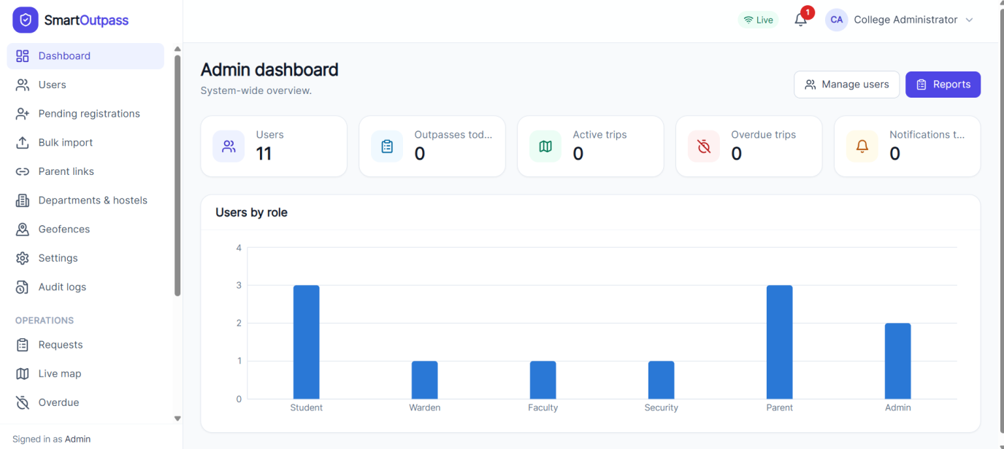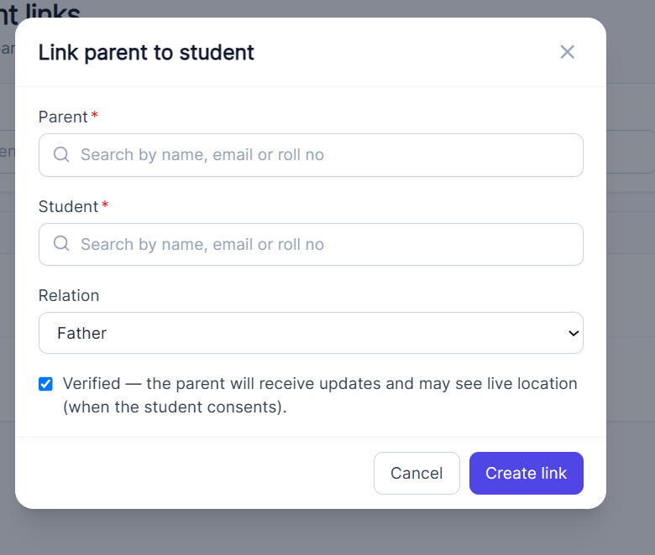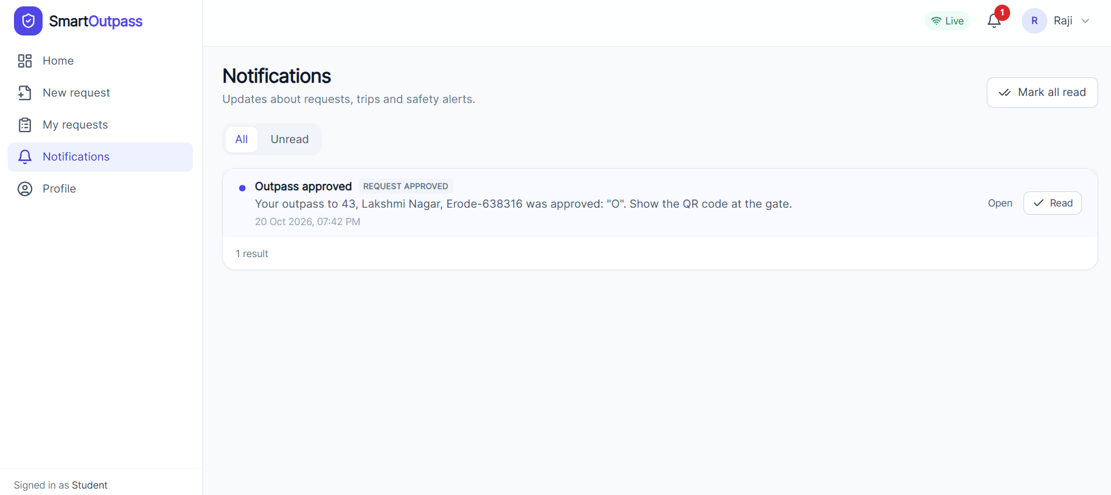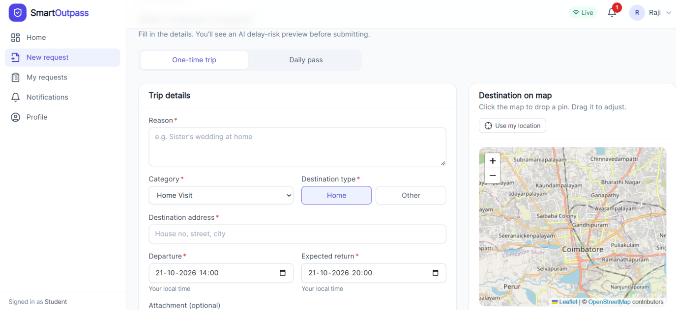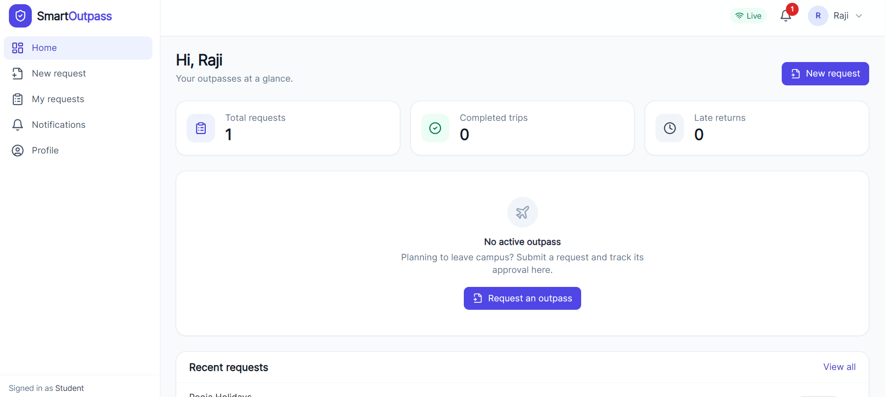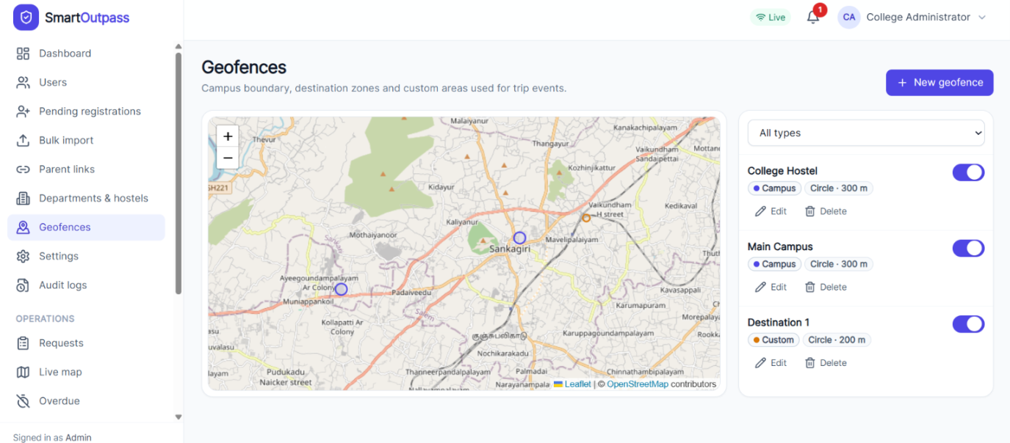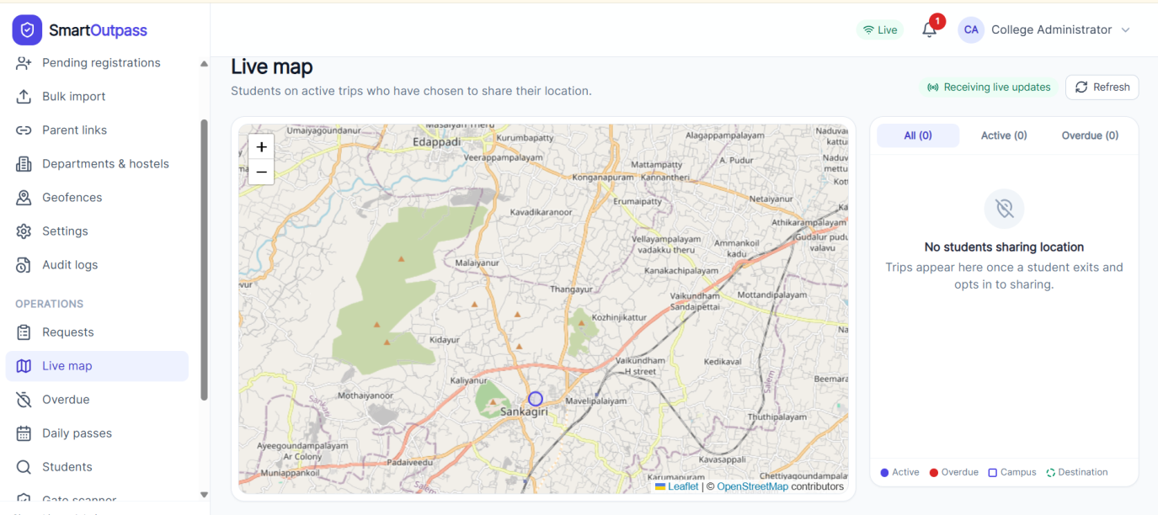
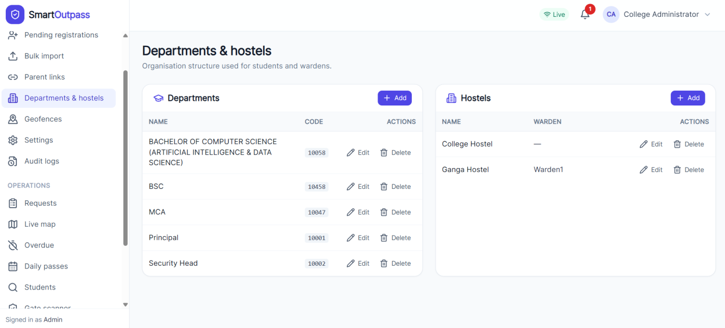
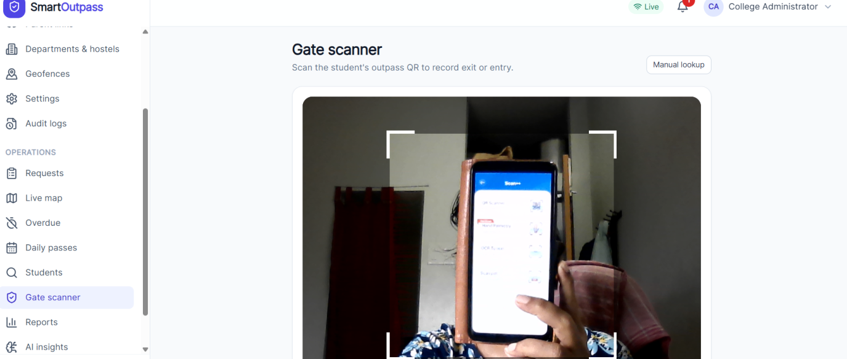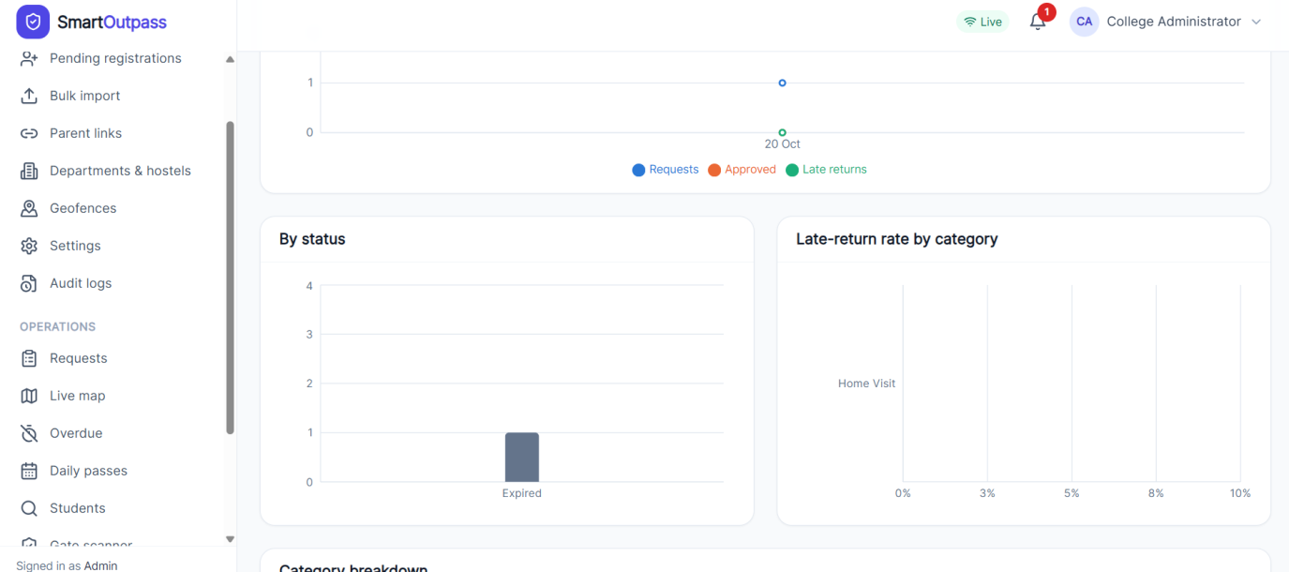
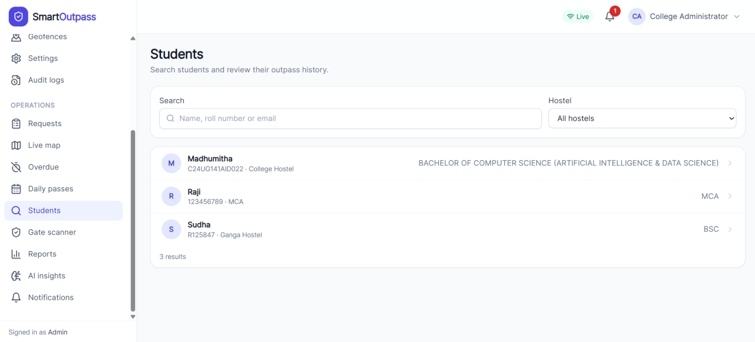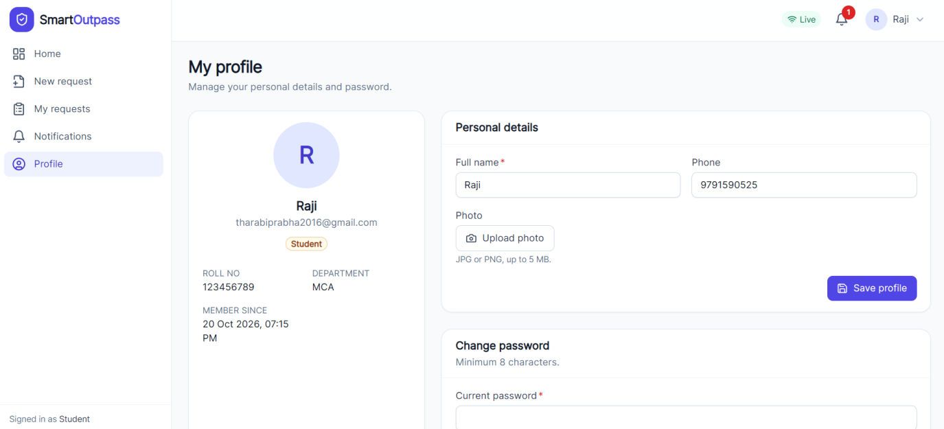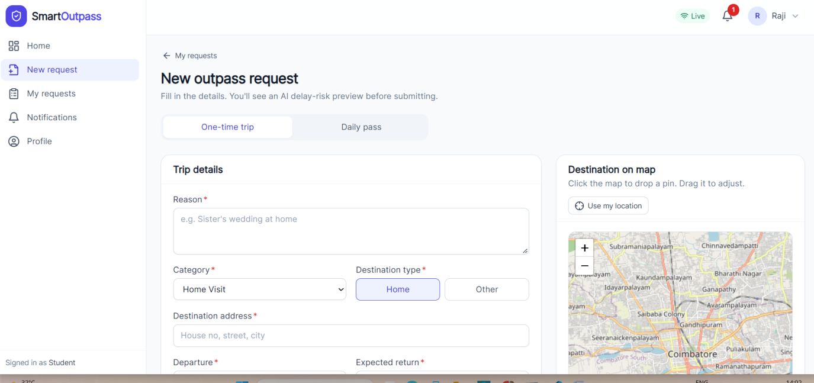

## SYSTEM REQUIREMENTS

### DEVELOPMENT MACHINE

| Component | Minimum / supported requirement | Used for |
| --- | --- | --- |
| Operating system | Windows 10/11, macOS, or a current Linux distribution | Development host |
| Node.js | 20 or newer (the root README notes testing on Node 24) | API, web tooling, Expo tooling |
| npm | Bundled with Node.js; use the lockfiles in each app | Install dependencies |
| MariaDB | 10.6 or newer; MariaDB 11.4 is configured in Docker Compose. MySQL 8+ is also documented as compatible | Application database |
| Docker Desktop / Docker Engine | Optional; required only for the supplied MariaDB container workflow | Local database |
| Git | Current version | Source control |
| Browser | Current Chrome, Edge, Firefox, or Safari | Web application; HTTPS or localhost for geolocation and camera |

nstall dependencies separately in `server`, `web`, and `mobile`; each has its own package lock. The web client can be built without the mobile toolchain. An Android emulator/device or iOS simulator/device is needed to exercise the mobile app. Native iOS builds require macOS and Xcode; Android native builds require Android Studio and its SDK. Expo Go supports the basic app flows, while background location and production push behavior require a development build and platform credentials.

### RUNTIME SERVICES AND CONFIGURATION

- MariaDB must be reachable by the server on the configured host and port (default 3306). The API defaults to port 4000 and the Vite development server to 5173.
- Copy `server/.env.example` to `server/.env`; configure database credentials and unique random `JWT_ACCESS_SECRET` and `QR_SIGNING_SECRET` values. Keep real credentials out of version control.
- Copy `web/.env.example` to `web/.env` only when its proxy/API targets need changing.
- Copy `mobile/.env.example` to `mobile/.env` and set `EXPO_PUBLIC_API_URL` to an address reachable from the phone (LAN IP, not `localhost`). Android emulator can use `10.0.2.2`.
- Push delivery, SMS, and external AI are optional integrations. The local app can use the configured console/no-SMS and built-in AI modes.
- Allow the browser/mobile client to reach the API and allow the API to reach MariaDB. Configure firewall/CORS rules for the chosen development addresses.

### DEPLOYMENT SIZING

The repository does not define a production workload or a measured minimum CPU/RAM/disk profile. For a small evaluation, start with a 2-vCPU, 4-GB-RAM host, SSD storage, and separate database backups; monitor the API, database, and uploaded files under real load before sizing production. This is a starting estimate, not a benchmark. Keep database storage persistent and backed up. Run scheduled jobs on exactly one API instance (`ENABLE_JOBS=true` on one instance only).

