(1)Create a database called person & create collection called details


(2)Create the above 6 person’s details documents.


(3)Find the persons following this conditions

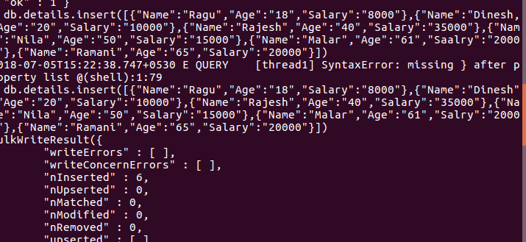
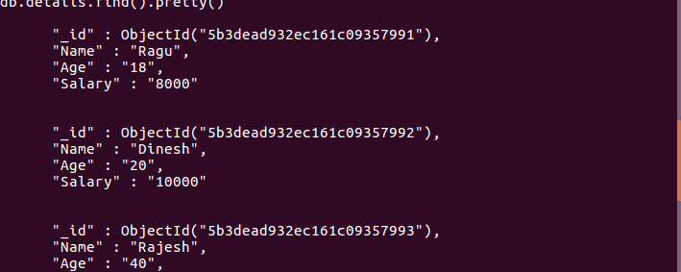
Age > 50
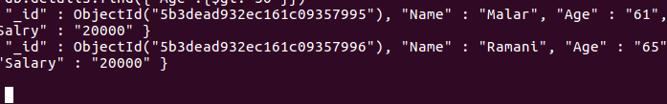
Age < 50
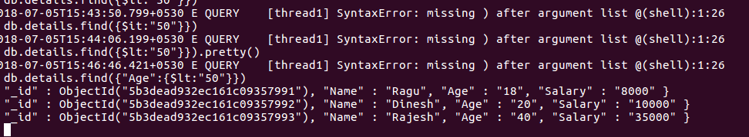
- Salary=20000/=
Salary < = 20000/=
Salary < 20000/=
Salary > 20000/=
Age < 50 & Salary > 20000/=
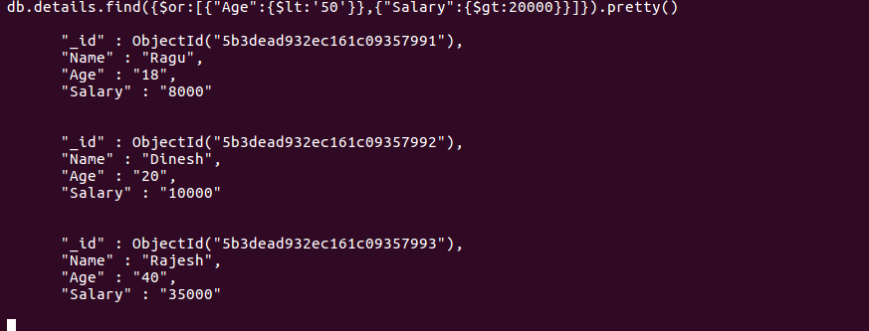
Age < 50 or Salary > 20000/=
Age < 20 or Salary >= 10000/=
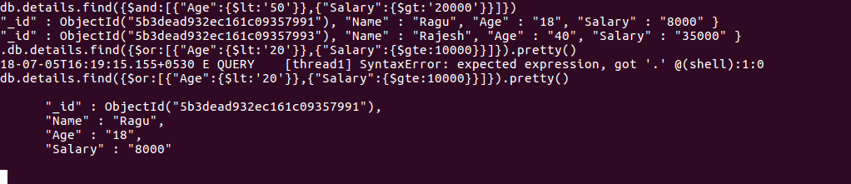
Age < = 20 and Salary >= 10000/=
