District 1 Road Condition Report

The Secretary of Transportation has asked you, the Maintenance District General Manager, to submit field reports so she can track road conditions across the state.

The GIS team has developed a web form that you can fill out from your smartphone.

Submit a report using this form:

<http://bit.ly/gmuhs>

Describe what you see in the photo on the back of the page





District 2 Road Condition Report

The Secretary of Transportation has asked you, the Maintenance District General Manager, to submit field reports so she can track road conditions across the state.

The GIS team has developed a web form that you can fill out from your smartphone.

Submit a report using this form:

<http://bit.ly/gmuhs>

Describe what you see in the photo on the back of the page





District 3 Road Condition Report

The Secretary of Transportation has asked you, the Maintenance District General Manager, to submit field reports so she can track road conditions across the state.

The GIS team has developed a web form that you can fill out from your smartphone.

Submit a report using this form:

<http://bit.ly/gmuhs>

Describe what you see in the photo on the back of the page



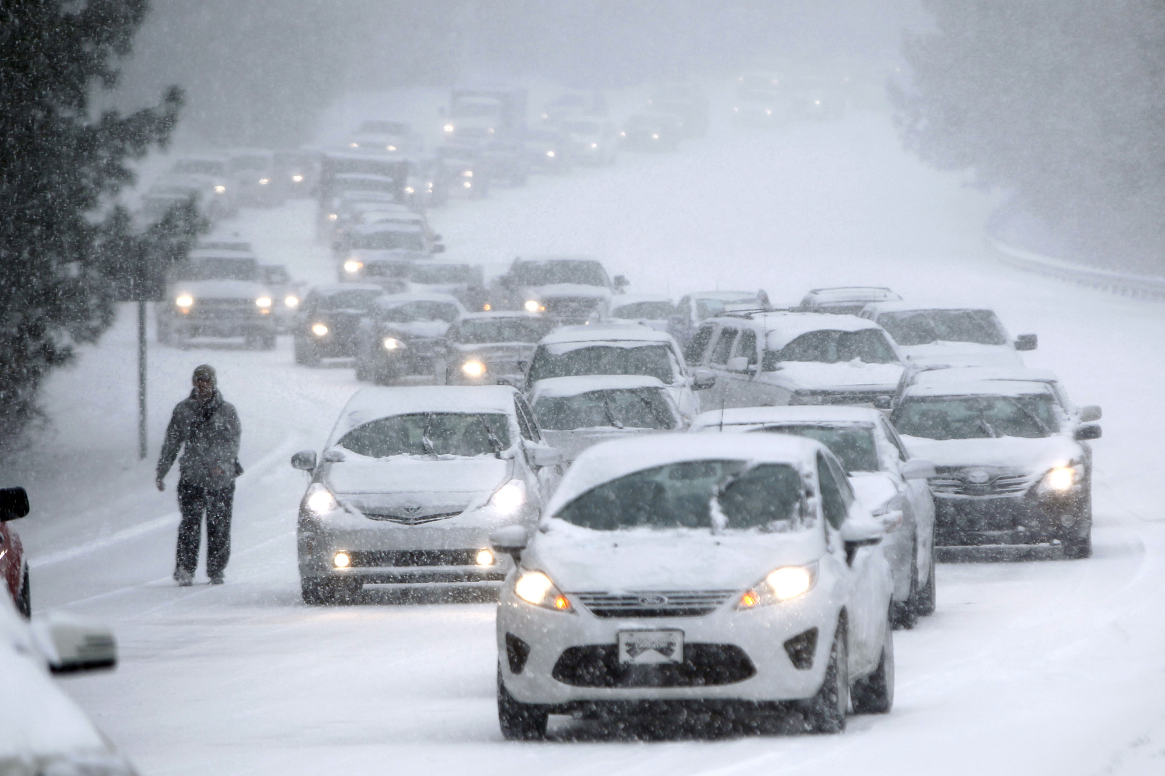

District 4 Road Condition Report

The Secretary of Transportation has asked you, the Maintenance District General Manager, to submit field reports so she can track road conditions across the state.

The GIS team has developed a web form that you can fill out from your smartphone.

Submit a report using this form:

<http://bit.ly/gmuhs>

Describe what you see in the photo on the back of the page



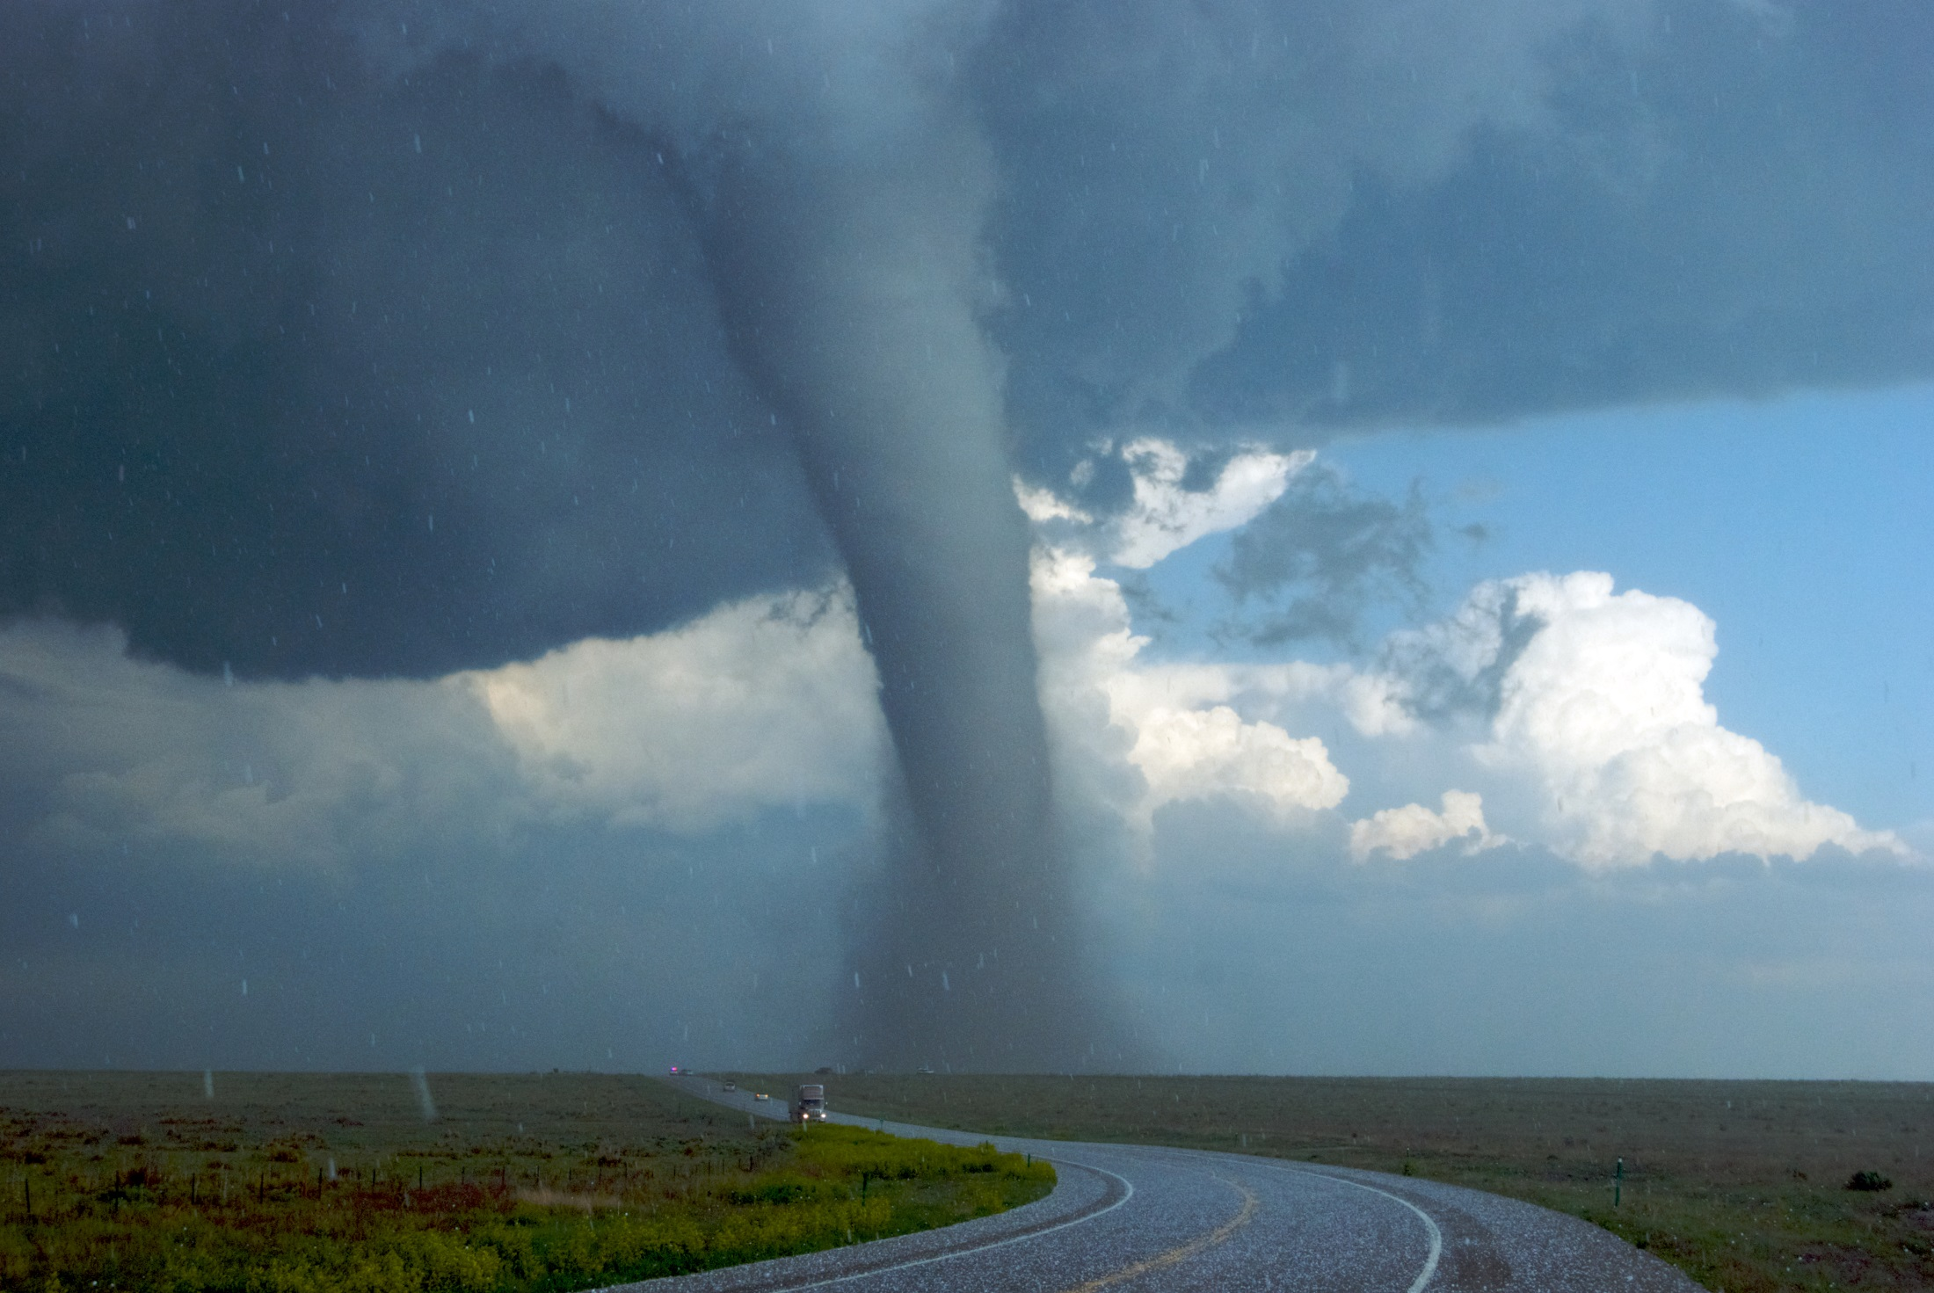

District 5 Road Condition Report

The Secretary of Transportation has asked you, the Maintenance District General Manager, to submit field reports so she can track road conditions across the state.

The GIS team has developed a web form that you can fill out from your smartphone.

Submit a report using this form:

<http://bit.ly/gmuhs>

Describe what you see in the photo on the back of the page





District 7 Road Condition Report

The Secretary of Transportation has asked you, the Maintenance District General Manager, to submit field reports so she can track road conditions across the state.

The GIS team has developed a web form that you can fill out from your smartphone.

Submit a report using this form:

<http://bit.ly/gmuhs>

Describe what you see in the photo on the back of the page



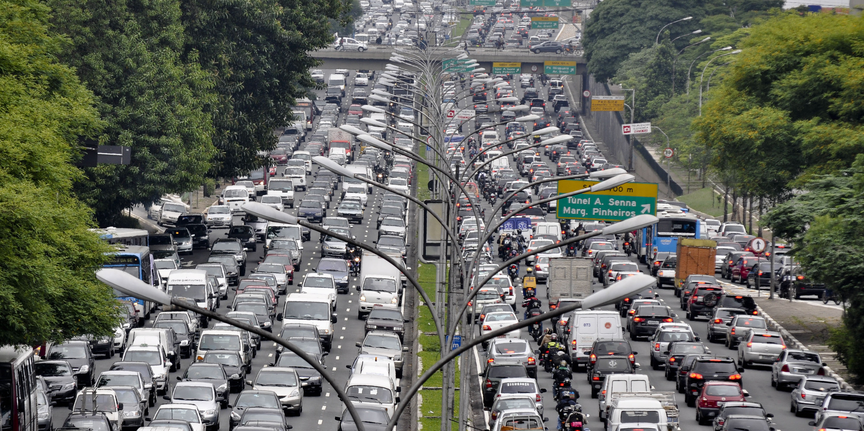

District 8 Road Condition Report

The Secretary of Transportation has asked you, the Maintenance District General Manager, to submit field reports so she can track road conditions across the state.

The GIS team has developed a web form that you can fill out from your smartphone.

Submit a report using this form:

<http://bit.ly/gmuhs>

Describe what you see in the photo on the back of the page



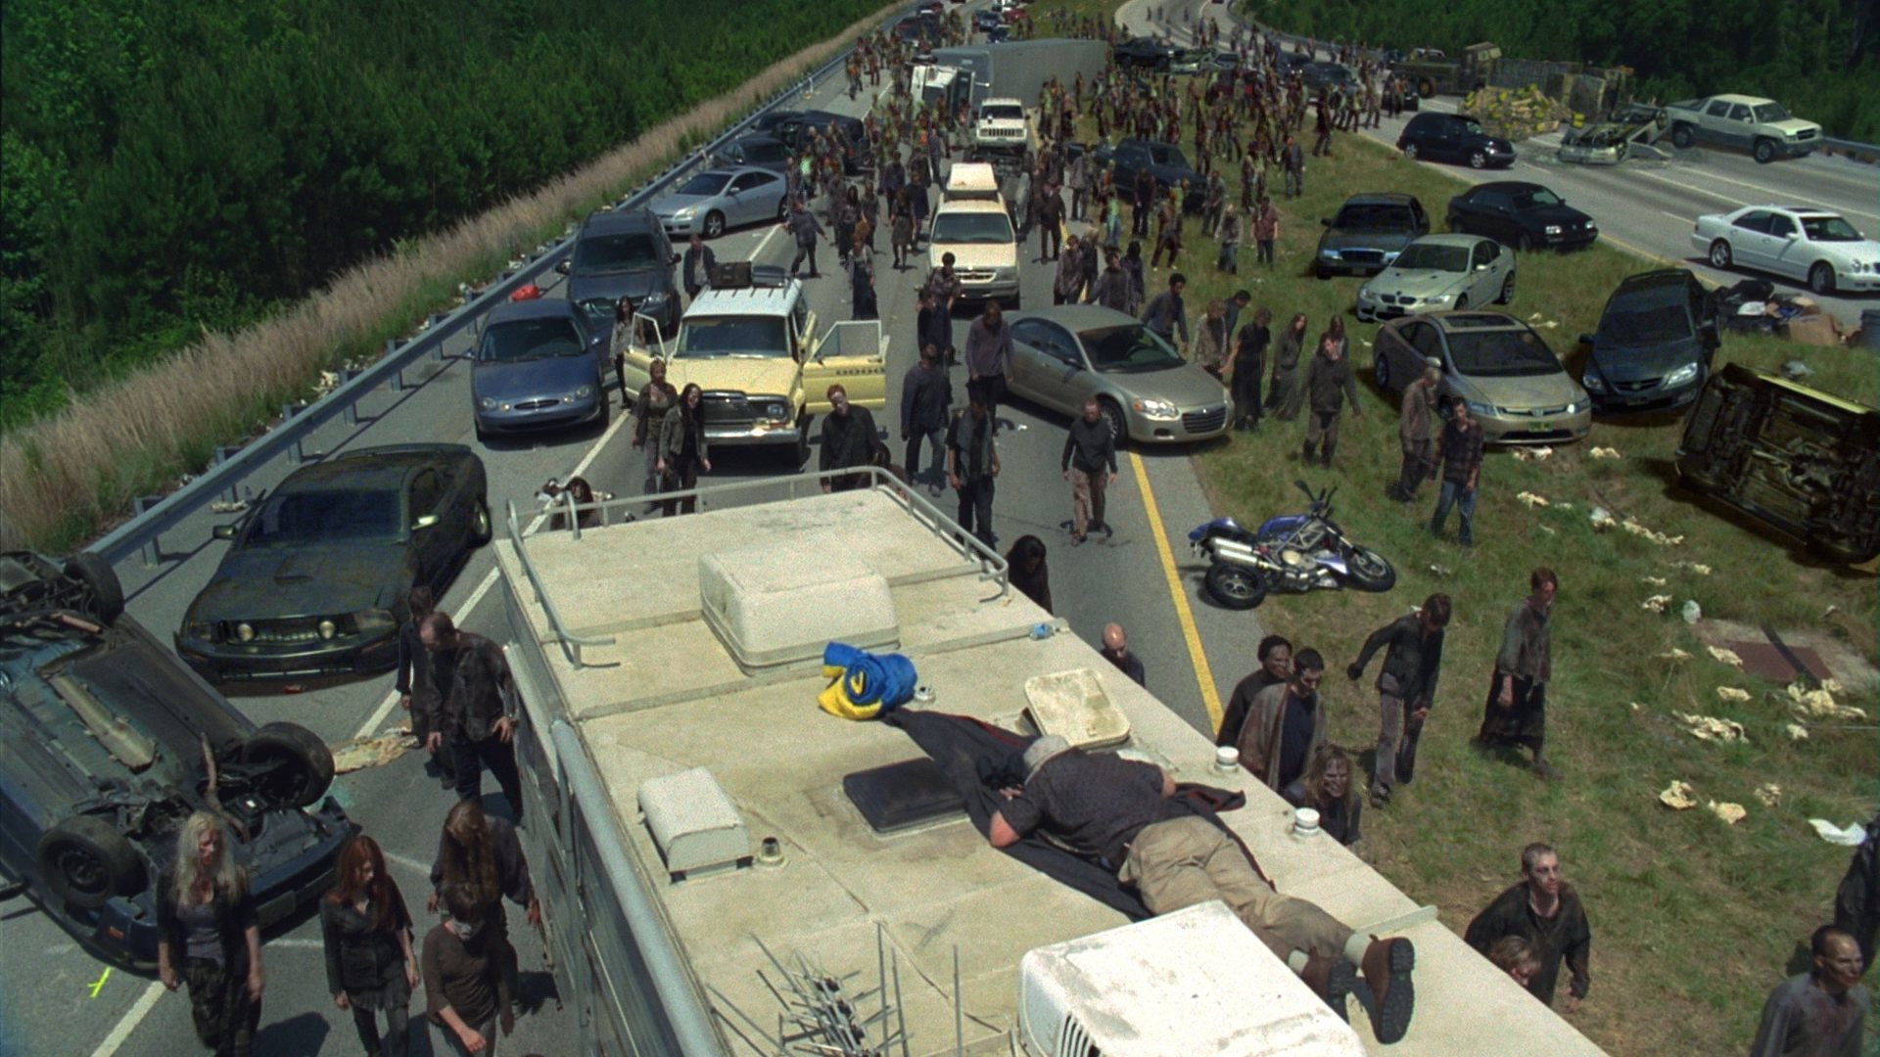

District 9 Road Condition Report

The Secretary of Transportation has asked you, the Maintenance District General Manager, to submit field reports so she can track road conditions across the state.

The GIS team has developed a web form that you can fill out from your smartphone.

Submit a report using this form:

<http://bit.ly/gmuhs>

Describe what you see in the photo on the back of the page



