|  |  |
| --- | --- |
| **Assignment Case** |  |
| COMP6708016 Object Oriented Programming |
| **Computer Science** | **E223-COMP6708016-LC02612-02** |
| ***Valid on*** *Even Semester Year 2021/2022* | **Revision 00** |

## Soal

*Case*

**QueensMan**

**QueensMan** is an application to help tailors manage their orders. As a programmer, you are tasked to create the program using **JAVA Programming** **Language** with **Object Oriented Programming** concepts such as **Encapsulation**, **Inheritance**, and **Polymorphism**. The requirements for the application are listed below:

* First, the program will **display main menu** consist of:
  + **View Clothes**
  + **Add Clothes**
  + **Remove Clothes**
  + **Exit**

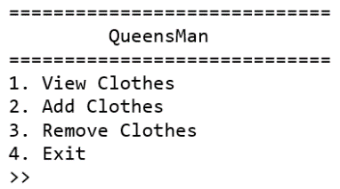

Figure . Main Menu

* If the user choose **menu 1 (“View Clothes”)**, then:
  + If there’s **no cloth** in the **list**. **Show** **message** and return to **main menu**.



Figure . View Clothes (Empty)

* + **Otherwise**. **Display** all cloth details.

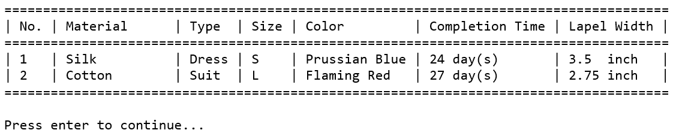

Figure . View Clothes

* If the user choose **menu 2 (“Add Clothes”)**, then:
  + The program will ask user to input:
    - **Size**

Validate the **value** must be **either ‘S’, ‘M’, or ‘L’** (**Case Insensitive**).

* + - **Material**

Validate the **value** must be **either** **‘Cotton’, or** ‘**Silk’** (**Case Sensitive**).

* + - **Color**

Validate the **length** must be **between 5 and 13 characters long (Inclusive)**.

* + - **Lapel** **Width**

Validate the **value** must be **between 2.25 and 4.50 (Inclusive)**.

* + - **Clothes Type**

Validate the **value** must be **either ‘Dress’, or ‘Suit’ (Case Sensitive)**.

* + Then, the program will:
    - **Determine** the **base** **working** **time** by using following conditions:

|  |  |
| --- | --- |
| Cloth Size | Base Working Time |
| S | 2 |
| M | 3 |
| L | 4 |

* + Then, the program will **calculate** the **completion** **time** using this **formula**:

If Clothes Type is “**Dress**”

* **Generate** **additional** **working** **time** using **Random number between (12 – 18) (Inclusive)**
* **Completion Time = (Base Working Time + Additional Working Time) * RoundUp(Lapel Width * 2.25)**

If Clothes Type is “**Suit**”

* **Generate additional working time** using **Random number between (14 – 21) (Inclusive)**
* **Completion Time = (Base Working Time + Additional Working Time) * RoundUp(Lapel Width * 1.75)**

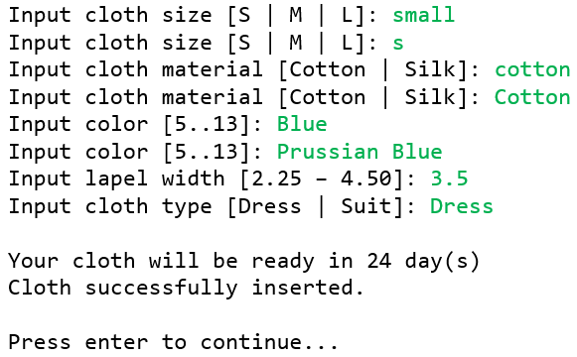

Figure . Add Clothes

* If the user choose **menu 3 (“Remove Clothes”)**, then:
  + If there’s **no cloth** in the **list**. **Show** **message** and return to **main menu**.



Figure . Remove Clothes (Empty)

* + **Otherwise**. **Display** all cloths’ details.
  + Then, the program will ask user which **cloth no.** will be removed from the list. Validate the **value** must be **between 1 and total clothes data**.
  + Finally, the program will **remove** **selected cloth** and return to **main menu**.

Figure . Remove Clothes

* If the user choose **menu 4 (“Exit”),** the program will **exit.**

**If you need any assistance, kindly ask your assistants for help.**