CAPSTONE title
From Manual Operations to Secure Digital Infrastructure: A Cybersecurity Integration Model for Medical Supply Enterprise

Presented by:
Christian James Dejapon
Arjun Deloterio
Amiel Christopher Castro
Charles Cabrira
Jules Archangel Dunca

CHAPTER 1 — INTRODUCTION

1.1 Background of the Study
The healthcare supply sector plays an important role in supporting home-based patient care in the Philippines by providing access to essential medical equipment such as wheelchairs, hospital beds, crutches, oxygen concentrators, and other recovery-related devices. Medical supply enterprises like CareMed primarily serve individuals recovering at home, elderly patients, persons with disabilities, and families who require medical equipment for daily care and rehabilitation.
As a provider of these essential resources, CareMed acts as a bridge between medical distributors and home-based consumers who depend on accessible and reliable medical supplies. Because these services directly support patient recovery and well-being, the business requires accurate, timely, and secure management of its operations.
Despite the growing prevalence of digital tools across various industries, many small and medium-sized medical supply enterprises in the Philippines continue to depend on traditional, paper-based methods to manage their day-to-day business activities. These methods include manual recording of sales and rental transactions in logbooks, tracking inventory levels through handwritten stock cards, and managing customer communications via messaging applications such as Facebook Messenger and SMS.
Manual processes inherently carry a number of operational risks. Human errors in recording data can lead to stock discrepancies, double-bookings, and inaccurate financial reports. The absence of a centralized database makes it difficult to retrieve historical records quickly, leading to delays in decision-making. Equipment rental management is especially vulnerable under manual systems — tracking return schedules across multiple customers becomes increasingly error-prone without automated reminders and monitoring tools. Additionally, physical records are susceptible to loss, damage from environmental factors such as flooding, or misplacement over time.
Beyond operational inefficiency, the lack of a formal digital infrastructure also exposes small businesses to cybersecurity vulnerabilities. As businesses gradually adopt digital communication tools, sensitive information such as customer contact details, transaction histories, and pricing data are often stored in unprotected messaging platforms or unencrypted spreadsheets. This lack of formal security controls increases the risk of unauthorized access, data manipulation, and privacy violations — risks that carry significant implications under the Philippine Data Privacy Act of 2012 (Republic Act No. 10173).
In response to these challenges, the integration of cybersecurity into business information systems has emerged as a critical priority across industries. The National Institute of Standards and Technology (NIST) Cybersecurity Framework recommends that organizations of all sizes — including small enterprises — implement identity management, access control, and monitoring mechanisms as foundational security practices.
This study proposes the design and development of a Cybersecurity-Integrated Digital Infrastructure Model for CareMed. The proposed system aims to automate key business functions — including inventory management, order processing, rental tracking, and reporting — while embedding cybersecurity mechanisms such as secure user authentication, role-based access control, and activity monitoring into the core system architecture.

1.2 Statement of the Problem

General Problem
CareMed currently operates through entirely manual processes, which creates significant limitations in operational efficiency, data accuracy, record security, and overall business responsiveness. The absence of a centralized digital system prevents the organization from scaling effectively and leaves it exposed to avoidable operational and cybersecurity risks. This study addresses the need for a secure, integrated digital management system that automates business processes while incorporating appropriate cybersecurity controls.

Specific Problems
Specifically, this study seeks to address the following problems:
- The current manual inventory system lacks real-time tracking capabilities, making it difficult to determine accurate stock levels, anticipate shortages, or prevent the over-renting of equipment to multiple customers simultaneously.
- Business records — including sales invoices, rental agreements, and customer profiles — are stored in physical formats that are vulnerable to loss, damage, unauthorized viewing, and human transcription errors, leading to inconsistencies in financial and operational reporting.
- The organization does not have formal cybersecurity mechanisms in place. There are no defined user roles, no authentication systems controlling access to sensitive records, and no monitoring of system activity — leaving the business exposed to risks such as unauthorized access, data leakage, and internal misuse of records.
- Customer service is slowed by the difficulty of retrieving historical transaction records manually, resulting in longer response times, miscommunication, and reduced customer satisfaction.

1.3 Objectives of the Study

1.3.1 General Objective
The general objective of this study is to design, develop, and evaluate a cybersecurity-integrated web-based management system that improves the operational efficiency, data accuracy, and information security of CareMed's medical supply sales and rental business processes.

1.3.2 Specific Objectives
Specifically, this study aims to:
- Conduct a comprehensive analysis of CareMed's existing manual workflows in the areas of inventory management, sales processing, and equipment rental tracking to identify operational inefficiencies and security gaps.
- Design and develop a web-based management system with dedicated modules for inventory control, customer management, order processing, rental tracking, and automated report generation.
- Integrate cybersecurity mechanisms into the system architecture, including secure user authentication, role-based access control (RBAC), session management, input validation, and system activity logging.
- Conduct functional testing, usability testing, and security assessment of the developed system using standardized evaluation instruments.
- Evaluate the overall performance of the system based on the ISO 25010 software quality criteria, specifically the dimensions of functionality, usability, reliability, efficiency, and security.

1.4 Scope and Delimitation
This study covers the design, development, testing, and evaluation of a web-based digital management system intended for CareMed's operational environment. The system's functional scope includes the following modules:

Module | Description
Inventory Management | Tracking of product stocks, recording of item quantities, and generation of low-stock alerts.
Customer Management | Creation and maintenance of customer profiles and purchase/rental histories.
Order & Sales Processing | Recording and monitoring of product sales and order statuses.
Rental Tracking | Management of rental agreements, rental periods, due dates, and equipment return monitoring.
Reports & Dashboard | Automated generation of sales summaries, rental status reports, and inventory reports accessible to authorized administrators.
Cybersecurity Controls | Secure login with hashed credentials, RBAC for administrators and customers, session timeout, input sanitization, and audit trail logging.

The system will support two primary user roles: the Administrator, who manages all back-end operations including inventory, transactions, user accounts, and reports; and the Customer, who may view available products and submit rental or purchase requests through the front-end interface.
The following delimitations apply to this study. The system will be developed as a web-based application and will not include a native mobile application for iOS or Android platforms, though the web interface will be designed to be mobile-responsive. External payment gateway integration will not be implemented within the scope of this project; payment confirmation will instead be handled through manual reference submission and administrative verification. The study is bounded to the operational requirements of CareMed and does not extend to broader electronic health record (EHR) systems, hospital information systems, or government healthcare databases.

1.5 Significance of the Study
The results of this study are expected to provide meaningful benefits to the following groups:

CareMed Management
The proposed system will provide management with a centralized, real-time view of all business operations. Automated inventory tracking and rental monitoring will reduce the likelihood of stock shortages or unreturned equipment going unnoticed. Report generation tools will allow management to make faster, data-driven decisions and reduce the administrative burden of manually compiling business records.

Employees and Staff
Staff members will benefit from streamlined workflows that reduce the repetitive and time-consuming aspects of manual data entry. Digital transaction records will be easier to search, retrieve, and update, allowing employees to respond more efficiently to customer inquiries and process orders with fewer errors.

Customers
Customers will experience improved service quality through faster transaction processing, reliable availability of product information, and more accurate tracking of their rental agreements. The system's customer-facing portal will provide a transparent and accessible platform for placing and monitoring orders.

Future Researchers
This study contributes to the growing body of literature on digital transformation in small and medium enterprises (SMEs) within the Philippine context, particularly in the healthcare supply sector. The cybersecurity-integrated development approach documented in this study may serve as a methodological reference for future researchers exploring similar implementations.

IT Practitioners and Developers
The system design, technology stack, and security integration strategies documented in this study may serve as a practical reference for software developers working on management systems for small businesses, particularly those in sensitive sectors requiring data protection measures.

1.6 Definition of Terms
The following terms are defined as used in this study:

Authentication – The process of verifying the identity of a user or system before granting access to protected resources. In this study, authentication is implemented through a secure login system that validates user credentials against hashed records stored in the database.
Authorization – The process of determining what actions or resources an authenticated user is permitted to access. This study implements authorization through role-based access control that assigns different permission levels to administrators and customers.
Cybersecurity – The practice of protecting computer systems, networks, databases, and digital data from unauthorized access, theft, damage, or disruption. In this study, cybersecurity mechanisms are embedded directly into the system architecture as integral design components rather than add-ons.
Digital Infrastructure – The collection of hardware, software, network components, and data management systems that form the technological foundation supporting an organization's digital operations.
Inventory Management System – A software module designed to record, track, and monitor the quantity, location, and status of products or equipment within a business. The system in this study includes inventory tracking for both saleable and rentable medical supplies.
ISO 25010 – An international standard for software product quality that defines a hierarchical quality model including characteristics such as functional suitability, performance efficiency, usability, reliability, security, and maintainability. This standard is used as the evaluation framework for the developed system.
OWASP Top 10 – A regularly updated list published by the Open Web Application Security Project (OWASP) identifying the ten most critical web application security risks. The system's security controls are designed with reference to this framework.
Role-Based Access Control (RBAC) – A security model that restricts system access based on the roles assigned to individual users. Each role is associated with a defined set of permissions, ensuring that users can only access the system functions relevant to their responsibilities.
Rental Management – The process of managing the lending, usage tracking, and return of equipment or products over a defined rental period. In this study, the rental management module tracks rental agreements, due dates, and equipment return status for CareMed's rental inventory.
Session Management – A mechanism that controls the lifecycle of a user's authenticated session within a system, including session creation upon login, activity timeout after periods of inactivity, and session termination upon logout.
Web-Based System – A software application that runs on a web server and is accessed by users through a standard web browser over a network. Unlike desktop applications, web-based systems do not require local installation and can be accessed from any internet-connected device.

CHAPTER 2 — REVIEW OF RELATED LITERATURE AND STUDIES

2.1 Foreign Studies

2.1.1 Cybersecurity of Small-to-Medium Businesses
Chidukwani, Zander, and Koutsakis (2022), in their study titled "A Survey on the Cybersecurity of Small-to-Medium Businesses: Challenges, Research Focus and Recommendations" published in IEEE Access, conducted a broad survey of literature on how small and medium-sized businesses approach cybersecurity. The study found that small businesses are disproportionately vulnerable to cyberattacks because they lack the dedicated IT security personnel, formal security policies, and technical controls that larger organizations typically maintain.
Among the key findings is that small businesses frequently fail to implement even basic access controls such as role-based permissions and multi-factor authentication. The authors argue that the adoption of structured cybersecurity frameworks — including mechanisms for authentication, access restriction, and activity monitoring — is critical for reducing the incidence of data breaches and internal system misuse in small enterprise environments.
This study is directly relevant to the CareMed system, which currently has no formal authentication or access control mechanisms in place. The findings reinforce the need for the cybersecurity-integrated design approach taken in this study.
Source: https://doi.org/10.1109/ACCESS.2022.3197899

2.1.2 Systematic Review of SME Cybersecurity
Rombaldo Junior, Becker, and Johnson (2025) reviewed 77 peer-reviewed studies published between 2017 and 2023 on the cybersecurity challenges facing small and medium enterprises. The review identified that the primary challenges are a lack of awareness of cybersecurity risks, limited cybersecurity literacy among staff and management, and constrained financial resources for investing in security tools and training.
Critically, the review found that limited literacy and resource constraints form a "vicious circle" — decision-makers with little cybersecurity knowledge invest less in security, which in turn limits their access to skilled security personnel and further deepens the organization's vulnerability. The review also found that the adoption of structured access controls, employee security training, and activity monitoring mechanisms are among the most consistently recommended and effective interventions for improving SME cybersecurity posture.
Source: https://arxiv.org/abs/2309.17186

2.1.3 Efficacy, Reliability, and Accuracy of Inventory Systems in SMEs
Mariani and Wacas (2022) evaluated the level of satisfaction among small and medium-sized enterprises in Tabuk City, Philippines regarding their use of inventory and point-of-sale systems. Using weighted mean, T-test, and F-test analysis, the study found that SME respondents were generally satisfied with the efficacy (mean: 3.0), reliability (mean: 3.05), and accuracy (mean: 3.21) of their digital inventory systems compared to prior manual methods.
The study concluded that digital inventory and POS systems provide measurable improvements in record accuracy and operational process efficiency, and that the adoption of such systems does not require significant capital expenditure — making them accessible to small enterprises with limited budgets. These findings validate the core premise of this study: that transitioning CareMed from manual to digital inventory systems produces demonstrable improvements.
Source: https://doi.org/10.22161/ijels.76.43

2.1.4 Design of a Web-Based Inventory Management System for SMEs
Otobo and Alegbe (2025) examined the design and implementation of cloud-based web inventory systems for small and medium enterprises. The study found that businesses adopting cloud-based enterprise resource planning systems achieved a 40% improvement in inventory accuracy compared to those using traditional or manual tracking methods. The authors identified that key non-functional system requirements — including scalability, reliability, and seamless integration with existing business processes — are critical for successful adoption.
The study also emphasized that user proficiency through structured training and ongoing post-deployment support are essential for sustaining the benefits of digital inventory systems over time. These findings support the system design approach taken in this research and inform the user acceptance testing component of the evaluation methodology.
Source: https://www.seahipublications.org/wp-content/uploads/2025/01/IJIISTR-M-15-2025.pdf

2.2 Local Studies

2.2.1 Web-Based Inventory Management System for a Philippine Small Enterprise
Tanaman, Baylosis, Abiles, Catungal, and Encarnacion (2023) developed and evaluated a web-based inventory management system for a small multi-branch business enterprise in Zamboanga del Sur. Their study documented the transition of a business that previously relied entirely on paper-based inventory records across four branches and a mobile store to a centralized digital platform. User evaluations yielded functionality and efficiency scores of 4.44 and 4.34 respectively out of 5.0, indicating high user satisfaction across both dimensions.
The context of this study closely mirrors the situation of CareMed — a small enterprise currently relying on manual, paper-based records across its sales and rental operations. The development approach, use of ISO-based evaluation criteria, and local Philippine setting make this study a particularly relevant precedent for the current research.
Source: https://doi.org/10.30534/ijsait/2023/021252023

2.2.2 Cybersecurity Landscape in the Philippines
The Asia Foundation (2022) provided a comprehensive assessment of the cybersecurity environment facing Filipino businesses and institutions. The report documented that small and medium enterprises in the Philippines are among the most vulnerable to cyberattacks, as they frequently adopt digital communication and transaction tools without implementing corresponding security measures. The report cited findings from Trend Micro (2021) indicating that the Philippines ranked fourth among Southeast Asian countries in exposure to Business Email Compromise (BEC) threats.
The Asia Foundation report also noted that many small businesses store sensitive customer data — including personal information and financial records — in unprotected digital environments, creating significant compliance risks under the Philippine Data Privacy Act of 2012. These findings directly describe the cybersecurity risk environment in which CareMed operates and underscore the urgency of the cybersecurity-integrated approach this study proposes.
Source: https://asiafoundation.org/wp-content/uploads/2022/03/Cybersecurity-in-the-Philippines-Global-Context-and-Local-Challenges-.pdf

2.2.3 Digital Transformation in Philippine Small Enterprises
A study published in the Proceedings of the 2024 International Conference on Computers in Management and Business (ACM, 2024) examined the factors influencing the digital transformation journeys of Philippine organizations. The study found that Philippine small enterprises frequently face barriers to digitalization including limited financial resources, lack of IT expertise, resistance to change among staff, and difficulty selecting appropriate digital solutions.
However, the study also documented that organizations which successfully implemented digital systems — particularly those that adopted a phased, step-by-step approach with accompanying staff training — achieved significant improvements in operational efficiency, data management quality, and market responsiveness. The barriers and enablers of digital adoption identified in this study directly inform the system design and implementation approach of this research.
Source: https://dl.acm.org/doi/10.1145/3647782.3647799

2.3 Related Literature

2.3.1 Management Information Systems
Laudon and Laudon (2020), in Management Information Systems: Managing the Digital Firm (16th edition, Pearson), define information systems as integrated sets of components designed to collect, store, process, and communicate data in support of organizational decision-making and control. They argue that modern information systems do not merely automate existing tasks but fundamentally reshape organizational workflows, redistribute decision-making authority, and create new forms of operational value.
Laudon and Laudon distinguish between transaction processing systems — which handle routine daily operations such as sales, inventory updates, and order processing — and management information systems, which aggregate transaction data to support higher-level decision-making and reporting. Their framework provides the conceptual foundation for the CareMed system's dual purpose: automating day-to-day operational transactions while generating management-level reports.

2.3.2 Network Security Essentials
Stallings (2018), in Network Security Essentials: Applications and Standards (6th edition, Pearson), provides a comprehensive treatment of network security principles and their practical application in information systems. Stallings defines a layered defense approach to information security, arguing that effective protection of digital systems requires the concurrent implementation of authentication mechanisms, access control, data integrity controls, and activity monitoring.
He distinguishes between security mechanisms — the specific technical controls implemented within a system — and security services — the broader protection outcomes these mechanisms are designed to achieve. Stallings' framework is directly applicable to the security architecture of the CareMed system, where each of these control categories is incorporated as a distinct but integrated component of the overall cybersecurity design.

2.3.3 Philippine Data Privacy Act of 2012 (Republic Act No. 10173)
The Philippine Data Privacy Act of 2012, enacted as Republic Act No. 10173, establishes the legal framework governing the collection, processing, storage, and protection of personal information in the Philippines. The Act mandates that all entities — including private businesses — that collect personal information must implement organizational, physical, and technical security measures adequate to protect that data from unauthorized access, disclosure, alteration, and destruction.
For CareMed, which collects and stores customer personal information including names, contact details, and transaction histories, compliance with the Data Privacy Act is both a legal obligation and an ethical responsibility. The proposed system's security architecture — including encrypted credential storage, role-based access control, and audit logging — is designed with the requirements of the Data Privacy Act as a baseline compliance standard.
Full text: https://www.privacy.gov.ph/data-privacy-act/

2.3.4 OWASP Top 10 Web Application Security Risks
The Open Web Application Security Project (OWASP) Top 10 is a regularly updated, consensus-based document that identifies the ten most critical security risks to web applications. The most recent edition identifies risks including broken access control, cryptographic failures, injection attacks, insecure design, security misconfiguration, and identification and authentication failures as the leading causes of web application security incidents.
The cybersecurity testing component of this study uses the OWASP Top 10 as its primary reference framework, with security test cases specifically designed to verify that the CareMed system is not vulnerable to the most commonly exploited web application security risks. This ensures that the system's security evaluation is grounded in internationally recognized, evidence-based standards.
Official documentation: https://owasp.org/www-project-top-ten/

2.4 Synthesis of the Reviewed Literature and Studies
The reviewed foreign studies, local studies, and related literature collectively establish a clear and consistent foundation for the proposed CareMed Cybersecurity-Integrated Digital Infrastructure Model. Across different geographic contexts, research methodologies, and publication types, several converging themes emerge that directly inform the objectives, design decisions, and evaluation approach of this study.
First, the reviewed studies consistently document that small and medium enterprises operating through manual processes face measurable disadvantages in operational efficiency, data accuracy, and record reliability compared to those using digital management systems. The work of Mariani and Wacas (2022) and Tanaman et al. (2023) — both conducted in Philippine settings — provides localized evidence that digital inventory and business management systems deliver statistically significant improvements in these dimensions even for small enterprises with limited resources.
Second, the foreign studies and related literature converge on the finding that the adoption of digital tools without corresponding cybersecurity integration creates a serious and often underappreciated risk for small enterprises. Chidukwani et al. (2022) and Rombaldo Junior et al. (2025) both document the systematic gap between digital adoption and security implementation among SMEs, and the Asia Foundation (2022) situates this problem specifically within the Philippine context. The regulatory requirements of the Data Privacy Act of 2012 add a legal dimension to this cybersecurity gap.
Third, the technical literature — particularly Stallings (2018) and the OWASP Top 10 — provides the normative security standards within which the cybersecurity components of the proposed system are designed and evaluated. By grounding the system's security architecture in established international frameworks, this study ensures that the security controls implemented for CareMed are consistent with globally recognized best practices.
Finally, the ACM (2024) study on digital transformation in the Philippines provides important contextual guidance on how digital adoption can be sustainably achieved within the resource constraints of Philippine small enterprises, specifically recommending phased implementation and staff training as key enablers of successful digital transition.
In summary, the reviewed literature validates the need for, and informs the design of, a system that integrates both operational efficiency improvements and cybersecurity protection within a single digital platform. The gap in the existing literature and practice, particularly the absence of cybersecurity-integrated management systems among small Philippine enterprises in the healthcare supply sector, defines the specific contribution this study seeks to make.

CHAPTER 3 — METHODOLOGY

3.1 Research Design
This study utilizes a developmental research design. Developmental research focuses on the design, development, and evaluation of systems intended to solve specific problems within an organization. The approach allows researchers to analyze existing processes, develop a proposed solution, and evaluate the effectiveness of the developed system.

3.2 System Development Methodology
The study follows the Agile development methodology, which allows iterative system development and continuous improvement throughout the project lifecycle. The Agile model consists of the following phases:

Phase | Description
Planning | Identifying system requirements and defining project objectives.
System Design | Designing the system architecture, database structure, and user interface.
Development | Implementing the system using selected programming languages and technologies.
Testing | Conducting unit testing and system testing to identify and fix errors.
Deployment | Implementing the system for actual use within the organization.
Evaluation | Assessing the system's performance based on functionality, usability, and security.

3.3 System Architecture
The proposed system follows a client-server architecture. Users access the system through a web browser, which sends requests to the server where the application processes data and interacts with the database. The system supports two primary user roles:
- Administrator – manages inventory, transactions, and system monitoring.
- Customer – views products and places rental or purchase requests.
Security controls such as authentication, role-based access control, and system activity logging are integrated within the system to protect data and manage user access.

3.4 Tools and Technologies Used

Category | Technology
Frontend | HTML, CSS, JavaScript
Backend | Python (Flask Framework)
Database | MySQL
IDE | Visual Studio Code
Version Control | Git

3.5 Data Gathering Techniques
The researchers will use the following data gathering methods:
- Interview – conducted with CareMed management to understand the current workflow and system requirements.
- Observation – analyzing the current manual processes used in managing inventory and transactions.
- Document Analysis – reviewing existing records and business processes to identify system needs.

3.6 Testing Procedures
The system will undergo several testing procedures to ensure proper functionality and performance:
- Unit Testing – testing individual system components.
- System Testing – evaluating the entire system to ensure all modules function correctly.
- User Acceptance Testing (UAT) – allowing users to test the system and confirm that it meets their operational needs.

3.7 Evaluation Criteria
The developed system will be evaluated based on the ISO 25010 software quality criteria, covering the following dimensions:

Criterion | Description
Functionality | The system performs all required operations correctly.
Usability | The system is easy to use and understand.
Reliability | The system consistently performs without errors.
Efficiency | The system processes data quickly and effectively.
Security | The system protects data and prevents unauthorized access.

Data Flow Diagram (DFD – Level 0)
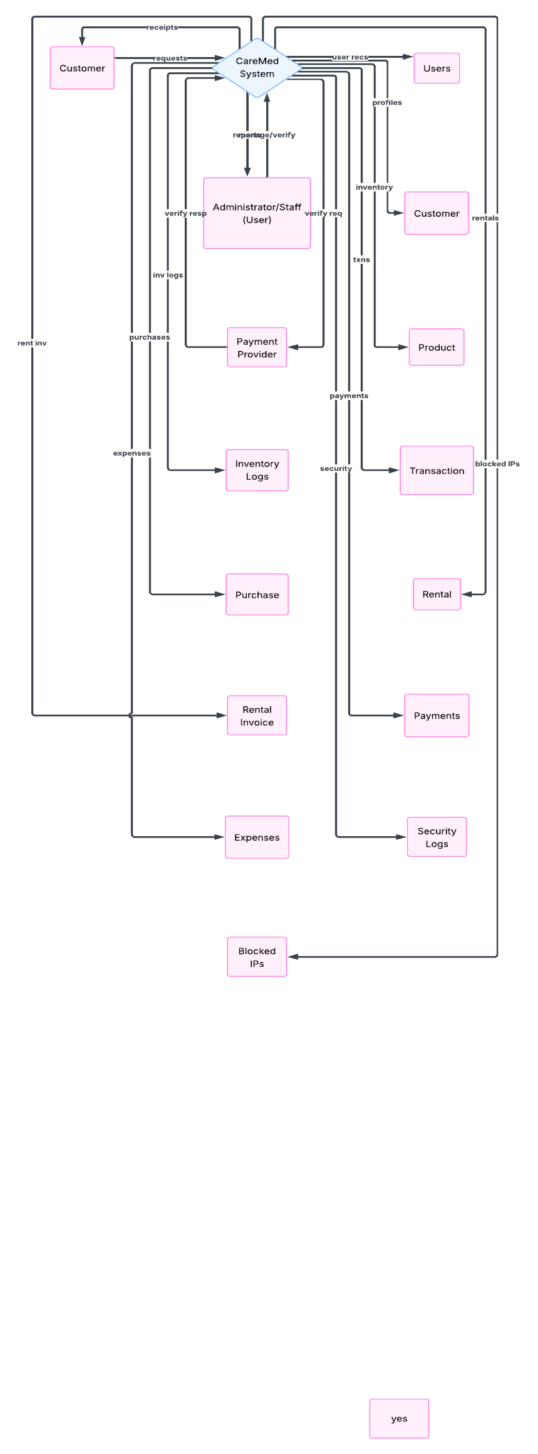
Figure 1. Data Flow Diagram (Level 0) – CareMed Management System

Entity Relationship Diagram (ERD)
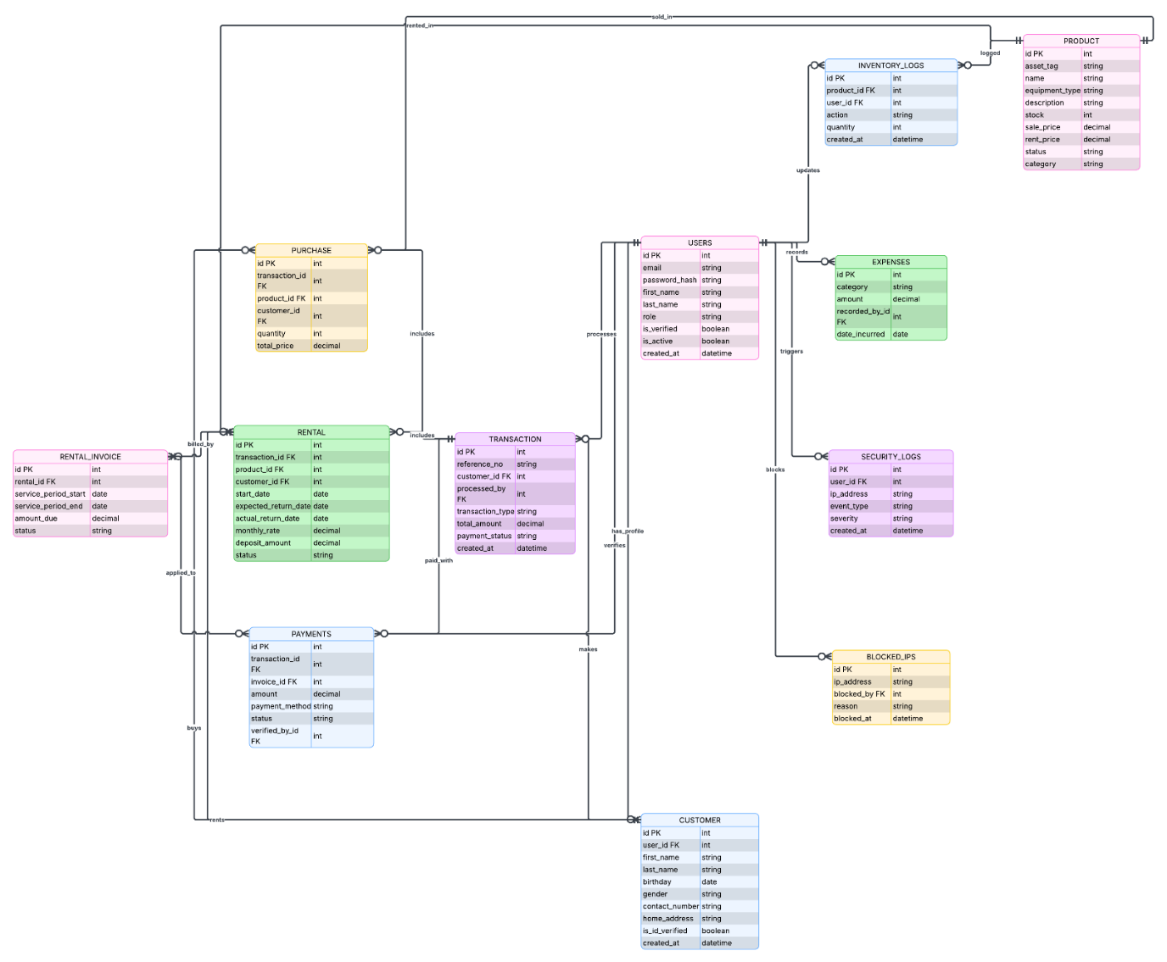
Figure 2. Entity Relationship Diagram (ERD) – CareMed Management System

Use Case Diagram
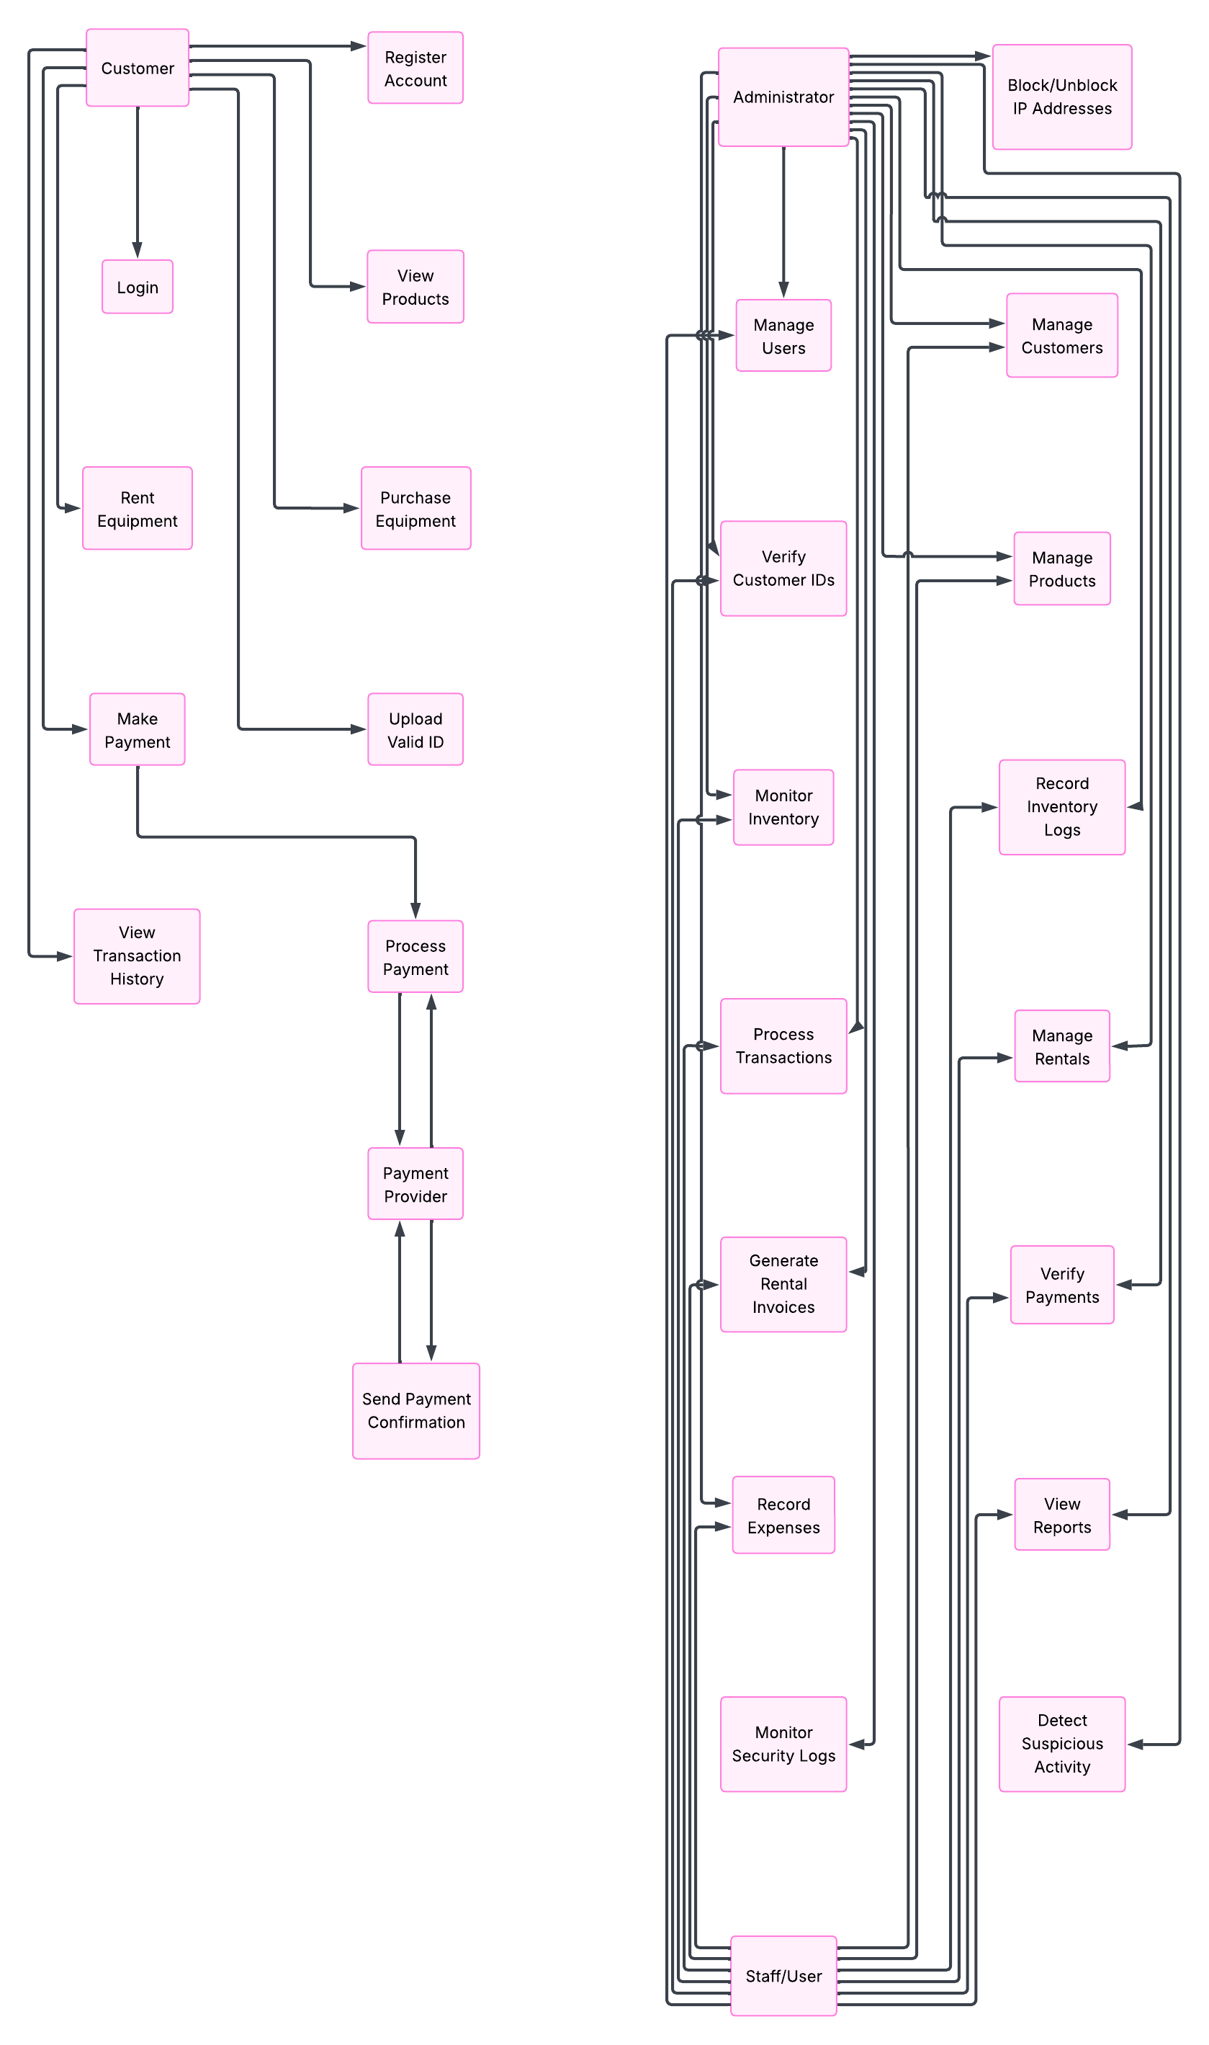
Figure 3. Use Case Diagram – CareMed Management System

