CHAPTER 1
INTRODUCTION
1.1 Background of the Study
Medical supply enterprises play a crucial role in supporting healthcare services by providing essential equipment such as wheelchairs, hospital beds, oxygen tanks, and other medical devices required for patient care. Many small and medium medical supply businesses still rely on manual processes to manage sales, rentals, inventory tracking, and customer records. These traditional methods often involve paper-based documentation, spreadsheet recording, and communication through messaging platforms.
Manual operations, while functional, introduce several operational challenges. These include delayed transaction processing, difficulty in tracking rental equipment, inaccurate inventory monitoring, and inefficient report generation. In addition, the absence of a centralized digital system increases the risk of data inconsistency, loss of important records, and limited visibility of business operations.
As businesses move toward digital transformation, the need for secure and structured information systems becomes increasingly important. Digital systems not only improve operational efficiency but also provide better data management and monitoring capabilities. However, transitioning from manual operations to digital infrastructure also introduces new concerns related to cybersecurity. Unauthorized access, data breaches, and system misuse can occur when proper security mechanisms are not integrated during system development.
Cybersecurity integration within business information systems is essential to ensure the protection of sensitive data, maintain system integrity, and support secure transactions. By incorporating security controls such as authentication, access control, and monitoring mechanisms, organizations can reduce risks associated with digital operations.
This study proposes the development of a cybersecurity-integrated digital infrastructure model for CareMed, a medical supply enterprise currently operating through manual processes. The proposed system aims to automate business operations such as inventory management, sales and rental transactions, and reporting, while integrating cybersecurity mechanisms to protect organizational data and ensure secure system usage.
Through this approach, the study seeks to demonstrate how a small medical supply enterprise can transition from manual operations to a secure digital environment that improves operational efficiency while maintaining strong information security practices.

1.2 Statement of the Problem
General Problem
CareMed currently relies on manual processes to manage its business operations, which limits efficiency, data accuracy, and security. There is a need to develop a secure digital infrastructure that can streamline operations while ensuring proper cybersecurity protection.
Specific Problems
- The current manual system makes it difficult to track inventory, sales, and rental transactions efficiently.
- Business records and reports are prone to errors, duplication, and possible data loss due to the lack of a centralized system.
- The absence of cybersecurity mechanisms exposes the organization to potential risks such as unauthorized access and data manipulation.

1.3 Objectives of the Study
1.3.1 General Objective
To develop a cybersecurity-integrated digital infrastructure model that improves the operational efficiency and data security of CareMed's medical supply sales and rental management processes.
1.3.2 Specific Objectives
- To analyze the current manual workflow of CareMed in managing inventory, sales, and rental operations.
- To design and develop a web-based management system that automates business processes.
- To integrate cybersecurity mechanisms such as authentication, access control, and activity monitoring within the system.
- To evaluate the functionality, usability, efficiency, and security of the developed system.

1.4 Scope and Delimitation
The study focuses on the development of a web-based management system designed for CareMed's medical supply sales and rental operations. The system will include modules for inventory management, customer management, order processing, rental tracking, and reporting. The system will also integrate cybersecurity controls such as secure authentication, role-based access control, and system activity monitoring to protect business data and user access.
The system will primarily serve two types of users: administrators and customers. Administrators will manage product listings, inventory records, customer data, and transaction monitoring. Customers will be able to view available medical supplies and place rental or purchase orders through the system.
The project is limited to the development of a web-based application and does not include a mobile application. Integration with external payment gateways will not be implemented, and payments may be recorded through manual confirmation methods such as payment reference submission.
The study is limited to the operational needs of CareMed and does not cover broader healthcare system integration or hospital management systems.

1.5 Significance of the Study
This study will benefit several groups:
CareMed Management
The system will help improve operational efficiency by automating record management, inventory tracking, and transaction monitoring.
Employees
Staff members will benefit from simplified workflows, faster access to records, and improved monitoring of rental and sales transactions.
Customers
Customers will experience improved service through easier access to product information and more efficient transaction processing.
Researchers
The study contributes to research related to digital transformation and cybersecurity integration in small business information systems.
Future Developers
The project may serve as a reference for future developers who aim to implement cybersecurity-focused systems in small and medium enterprises.

1.6 Definition of Terms
Authentication – A security process used to verify the identity of a user before granting system access.
Cybersecurity – The practice of protecting computer systems, networks, and data from unauthorized access or attacks.
Digital Infrastructure – The technological framework that supports digital operations within an organization.
Inventory Management System – A system used to monitor and control product stocks and supply levels.
Rental Management – A process used to track the lending and return of equipment or products for a specific period.
Role-Based Access Control (RBAC) – A security mechanism that restricts system access based on user roles.
Web-Based System – A software application that operates through a web browser over a network.

CHAPTER 2
REVIEW OF RELATED LITERATURE AND STUDIES
2.1 Foreign Studies
Several studies have explored the role of digital systems in improving business operations. According to Smith (2021), digital inventory systems significantly improve accuracy and reduce operational delays in small enterprises. Automated inventory systems allow businesses to track product availability, manage transactions efficiently, and generate real-time reports.
In another study conducted by Johnson and Miller (2020), the integration of cybersecurity controls within business systems was emphasized as a critical factor in protecting digital assets. Their research highlighted that organizations implementing role-based access control and authentication mechanisms experienced fewer cases of unauthorized access and data breaches.
Furthermore, Lee (2022) discussed the importance of digital transformation for small enterprises transitioning from manual processes. The study concluded that implementing structured information systems allows businesses to improve operational efficiency, data management, and decision-making processes.

2.2 Local Studies
Locally, several researchers have developed management systems aimed at improving business operations. A study conducted by Santos (2022) focused on developing a web-based inventory system for small retail businesses in the Philippines. The results showed improved transaction processing and reduced manual recording errors.
Another study by Cruz and Ramirez (2021) highlighted the need for secure digital systems in small enterprises. Their research emphasized that many small businesses adopt digital solutions without implementing proper security mechanisms, which increases vulnerability to cyber threats.
These studies demonstrate the growing importance of digital systems and cybersecurity integration in improving the efficiency and security of small business operations.

2.3 Related Literature
Information systems play a significant role in improving organizational efficiency. Laudon and Laudon (2020) explain that modern information systems enable organizations to process transactions, manage data, and generate reports more effectively compared to manual methods.
Cybersecurity is also an essential component of modern digital systems. According to Stallings (2018), implementing authentication, encryption, and monitoring mechanisms helps protect system data and prevent unauthorized access.
Additionally, inventory management systems are widely used to track product availability, monitor stock levels, and prevent shortages. These systems allow businesses to maintain accurate records and improve supply chain efficiency.

2.4 Synthesis of the Reviewed Literature
The reviewed studies and literature emphasize the importance of digital transformation in improving business operations and efficiency. Many existing systems focus primarily on automating business processes such as inventory management and transaction processing.
However, several studies also highlight the growing importance of cybersecurity in protecting digital systems and organizational data. While many systems provide operational improvements, some lack integrated security mechanisms that ensure data protection and secure system usage.
This study addresses this gap by proposing a cybersecurity-integrated digital infrastructure model for CareMed. The system not only automates business processes but also incorporates security mechanisms designed to protect system data and prevent unauthorized access.

CHAPTER 3
METHODOLOGY
3.1 Research Design
This study utilizes a developmental research design. Developmental research focuses on the design, development, and evaluation of systems intended to solve specific problems within an organization. The approach allows researchers to analyze existing processes, develop a proposed solution, and evaluate the effectiveness of the developed system.

3.2 System Development Methodology
The study will follow the Agile development methodology, which allows iterative system development and continuous improvement throughout the project lifecycle.
The Agile model consists of the following phases:
Planning – Identifying system requirements and defining project objectives.
System Design – Designing the system architecture, database structure, and user interface.
Development – Implementing the system using selected programming languages and technologies.
Testing – Conducting unit testing and system testing to identify and fix errors.
Deployment – Implementing the system for actual use within the organization.
Evaluation – Assessing the system’s performance based on functionality, usability, and security.

3.3 System Architecture
The proposed system will follow a client-server architecture. Users will access the system through a web browser, which sends requests to the server where the application processes data and interacts with the database.
The system will consist of two primary user roles:
Administrator – manages inventory, transactions, and system monitoring.
Customer – views products and places rental or purchase requests.
Security controls such as authentication, role-based access control, and system activity logging will be integrated within the system to protect data and manage user access.

3.4 Tools and Technologies Used
The system will be developed using the following tools and technologies:
Frontend Technologies
HTML
CSS
JavaScript
Backend Technology
Python (Flask Framework)
Database
MySQL
Development Tools
Visual Studio Code
Git for version control

3.5 Data Gathering Techniques
The researchers will use the following data gathering methods:
Interview – conducted with the CareMed management to understand the current workflow and system requirements.
Observation – analyzing the current manual processes used in managing inventory and transactions.
Document Analysis – reviewing existing records and business processes to identify system needs.

3.6 Testing Procedures
The system will undergo several testing procedures to ensure proper functionality and performance.
Unit Testing – testing individual system components.
System Testing – evaluating the entire system to ensure all modules function correctly.
User Acceptance Testing (UAT) – allowing users to test the system and confirm that it meets their operational needs.

3.7 Evaluation Criteria
The developed system will be evaluated based on the following criteria:
Functionality – the system performs all required operations correctly.
Usability – the system is easy to use and understand.
Reliability – the system consistently performs without errors.
Efficiency – the system processes data quickly and effectively.
Security – the system protects data and prevents unauthorized access.

Data Flow Diagram (DFD – Level 0)
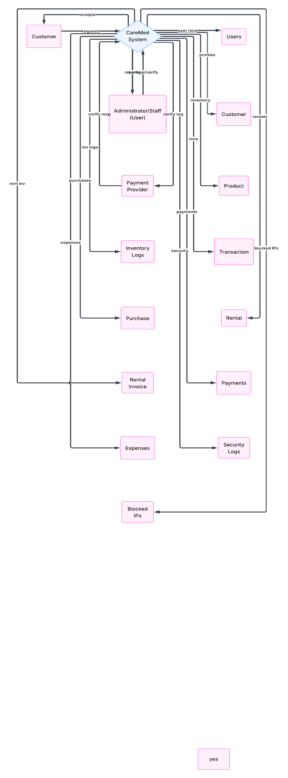
Figure 1. Data Flow Diagram (Level 0) – CareMed Management System

Entity Relationship Diagram (ERD)

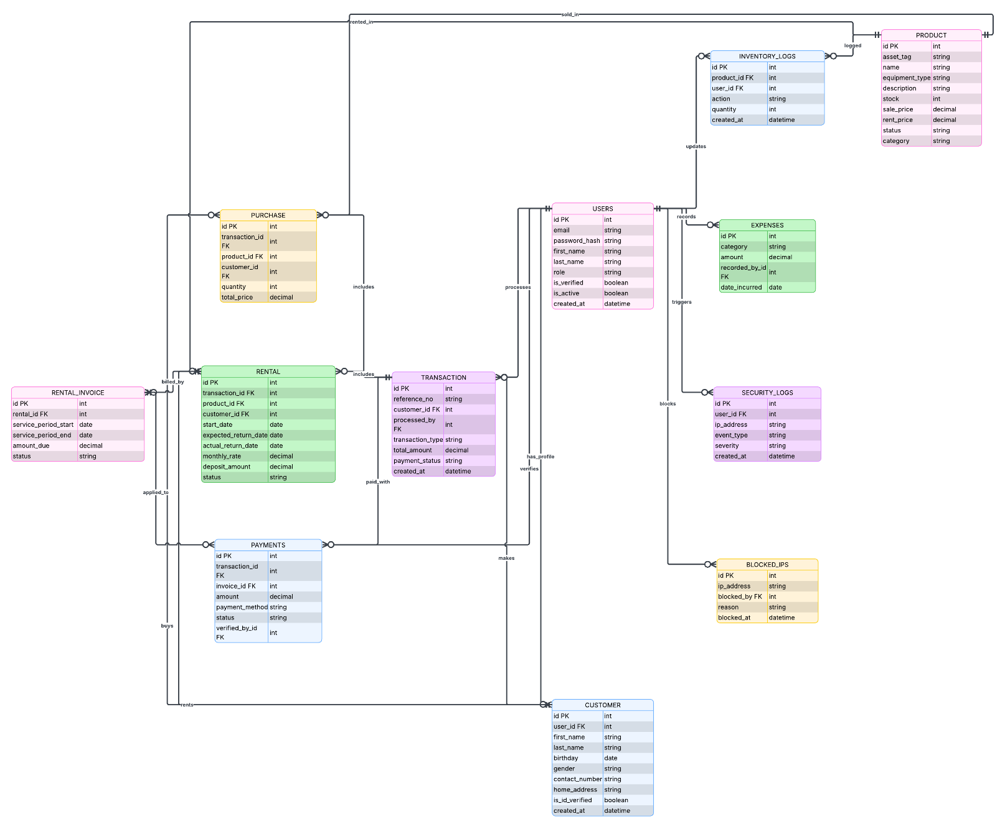
Figure 2. Entity Relationship Diagram (ERD) – CareMed Management System

Use Case Diagram
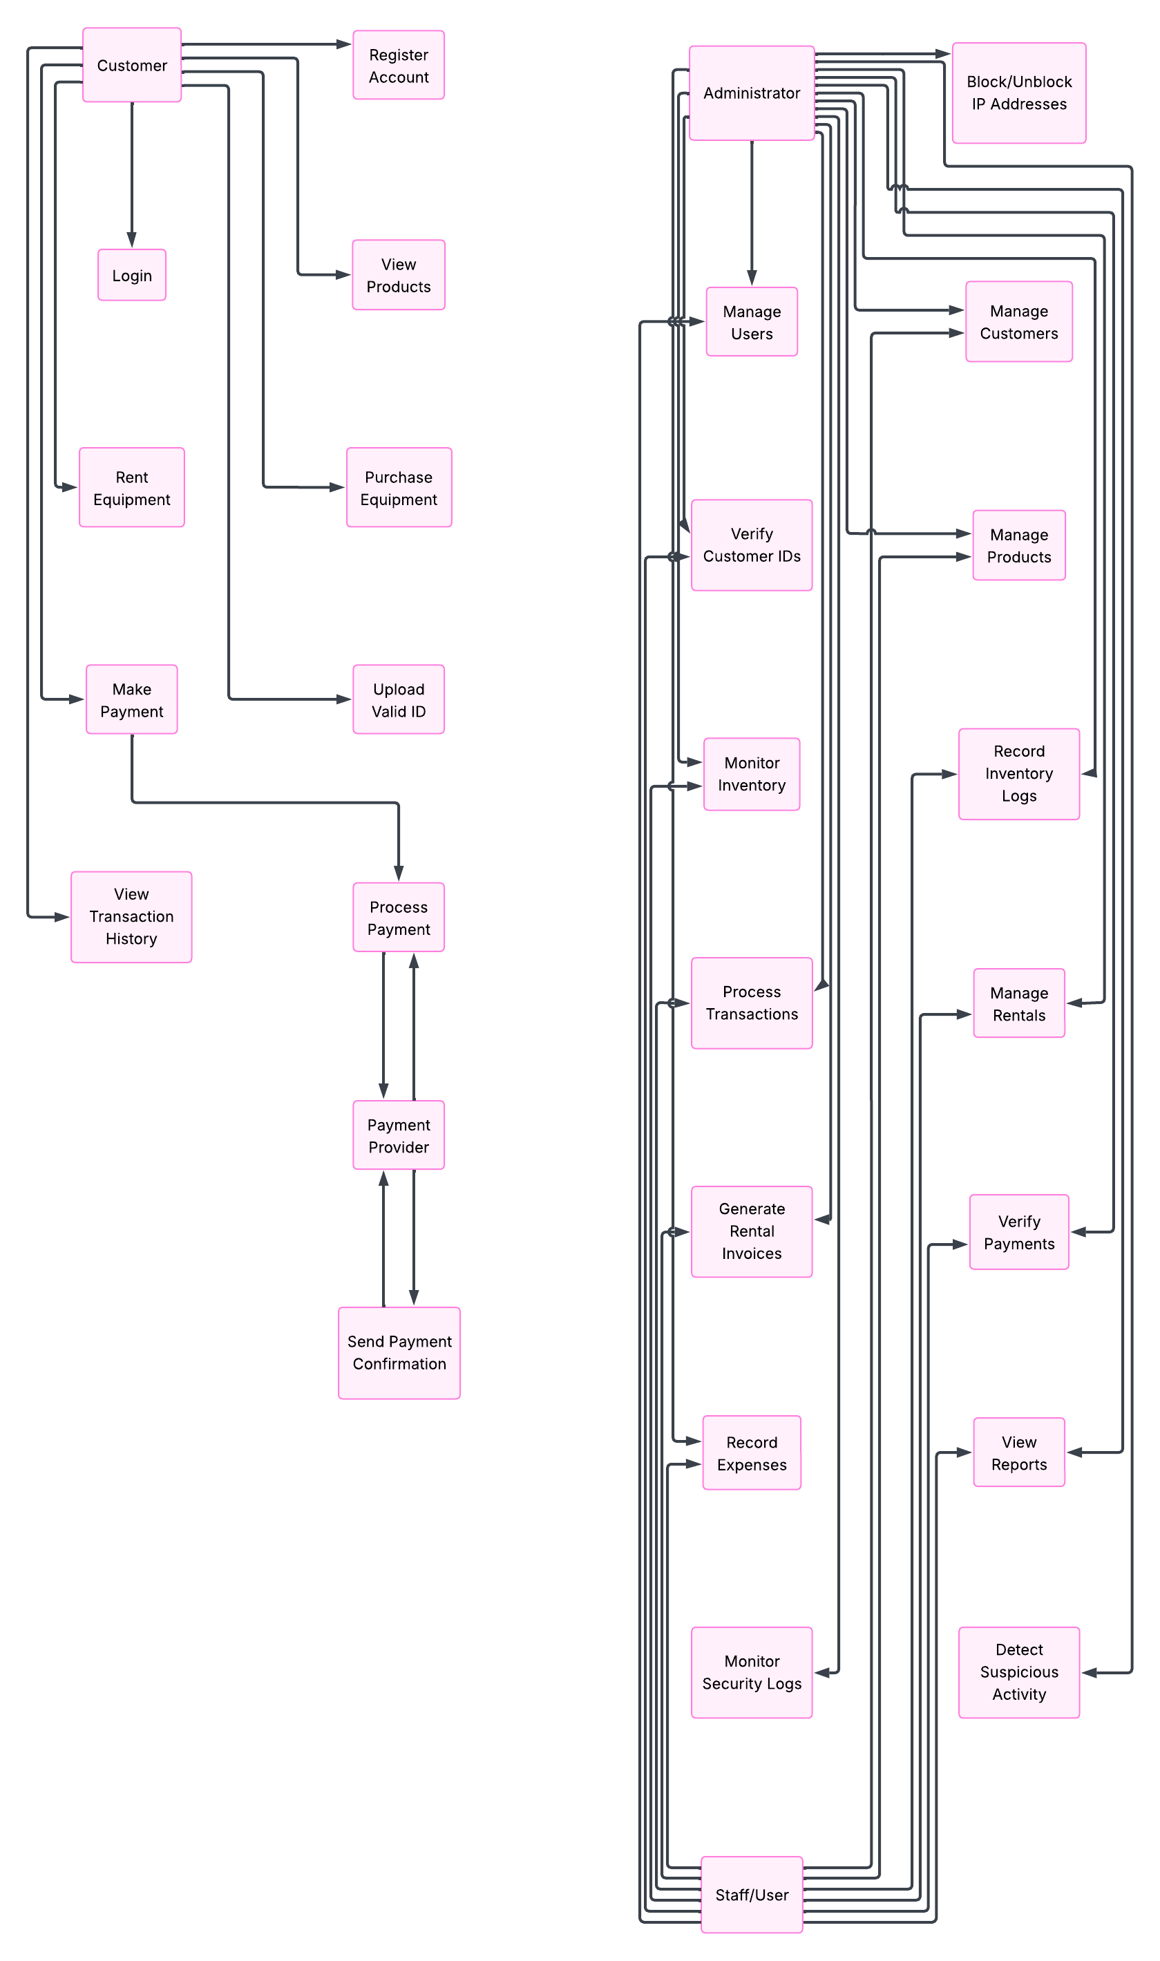
Figure 3. Use Case Diagram – CareMed Management System

