BACKGAMMON

BY TEAM MOTARO, JS UI & DOM, TELERIK ACADEMY 2014

Git: <https://github.com/dnmitev/Backgammon-Team-Motaro>

# The team

[HellFiend ( Ивайло Папазов )](http://telerikacademy.com/Users/HellFiend)

[slavi_slavchev ( Слави Славчев )](http://telerikacademy.com/Users/slavi_slavchev)

[desislava.plam ( Десислава Панайотова )](http://telerikacademy.com/Users/desislava.plam)

*[nina.krusteva ( Нина Маркова )](http://telerikacademy.com/Users/nina.krusteva)*

[Tanya ( Tanya Petkova )](http://telerikacademy.com/Users/Tanya)

[mita4itu ( Димитър Митев )](http://telerikacademy.com/Users/mita4itu)

# Game story

This is classical backgammon game that is played directly into your browser. It is a two player game. On welcome screen player can choose to start the game or quit and exit web page.

First of all each player rolls a dice and the player with bigger dice should throw first. Each player rolls a couple of dices. If a player rolls a pair he moves one more time and should roll the dices again.

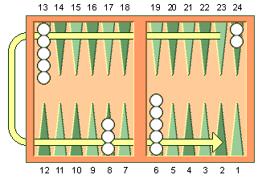

Each player chooses checkers color (black or white) and has to move counterclockwise his checkers from the top right corner to the bottom left one and after that get out all of them. The checkers movement Is according to the picture above.

# Implementation

The game is developed using vanilla JavaScript and some additional frameworks. It is used KineticJS to operate with the canvas elements and RaphaelJS to operate with the svg elements.

The Welcome screen is done with svg elements. Using the RaphaelJS framework is generated There are functions to draw text on the screen and image on the screen.

The game board is also generated using RaphaelJS. The gamefield is a rect object and the triangles are done using the path element in the svg element.

The dices are generated with KineticJS. It is used a sprite to generate their rolling animation. Their last value is preserved to be used in the program and game logic.

The checkers are also done using KineticJS. They are circle objects with given fill and stroke. They are drawn by functions. As arguments the drawing functions take color of the checker, count of the checkers and their coordinates. Their property draggable is set to true in order to be easily dragged and dropped.

JavaScript UI & DOM Course

Telerik Academy 2014