|  |  |  |  |
| --- | --- | --- | --- |
| NAME  DEPARTMENT  Faculty of Social Sciences  Vrije Universiteit Amsterdam | |  | |
| datE | our reference |  | your reference |
| DATE | REF |  |  |
|  |  |  |  |
| e-mail (secretaris) | telephone | fax |  |
| rerc.fsw@vu.nl | 020 59 84034 |  |  |
|  |  |  |
| Subject: Ethics review research project ‘TITLE’ | | | |

Dear NAME,

As part of the ethics review procedure at the Faculty of Social Sciences of Vrije Universiteit Amsterdam, you have completed the self-check for your project titled *‘TITLE’*. The check revealed no ethics issues, and the result of the check was that full review was not necessary. Herewith you assured the committee that the research proposal complies with the ethical guidelines of the faculty.

The committee has confidence in the preparations of the research and your team to conduct this study in a responsible manner.

With kind regards,

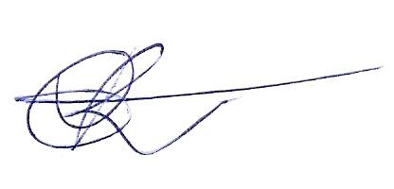

René Bekkers

*Chair RERC FSS*

**Please retain this letter for your records. We recommend that you save this email as a PDF for future reference.**