## Python short cuts (in spyder):

Run section:

#%%

Run only this part of the code, press *shift enter*

#%%

Run single (or selected) line(s):

Press f9

Run entire code:

Press f5

**Super basic Python:**

The Python language follows certain syntax rules and provides some basic functions (e.g. for loops, while loops, if statements, abs(), max(), etc..) and different object types (str, list, function, integer, float, class, dictionary, etc..) to write a code.

You can view what object type you are dealing with by type( *your_variable* ):

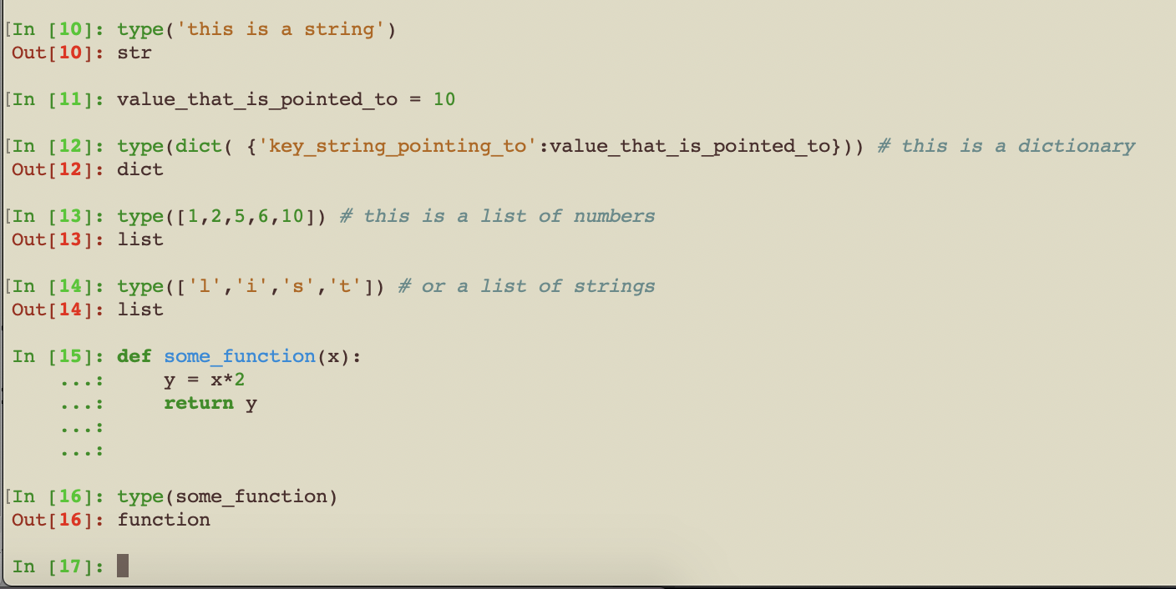

Python automatically assigns the data format.

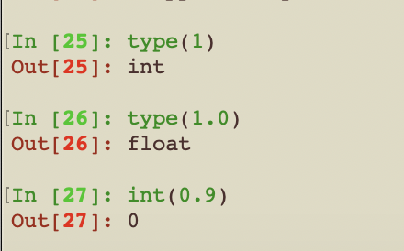

Note integers are rounded down: int(0.9) = 0.

**Importing libraries:**

Python Packages (or modules) are built by experts in C++ or Python and can be loaded by using the *import* function.

For example, the numpy package allows fast manipulation and handling of arrays (numpy.ndarray objects can be created which point to single and multi-dimensional arrays).

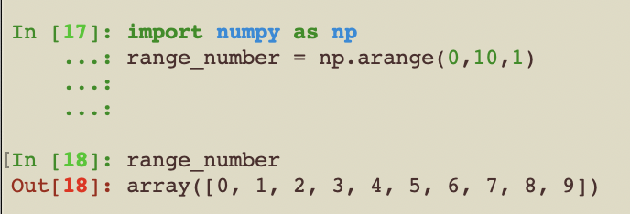

Note, Pythonic counting always starts at 0.

**For loops:**

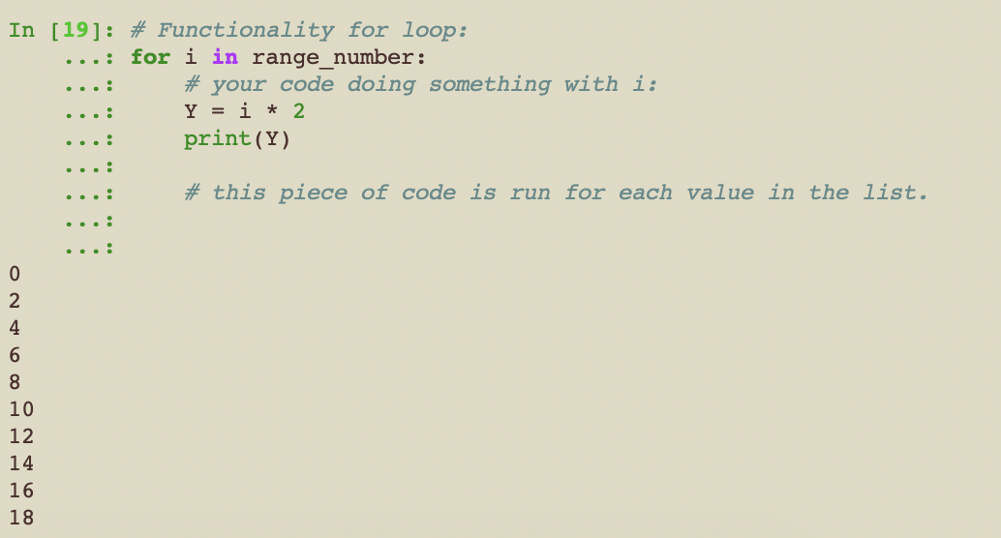

**While loop and if statement:**

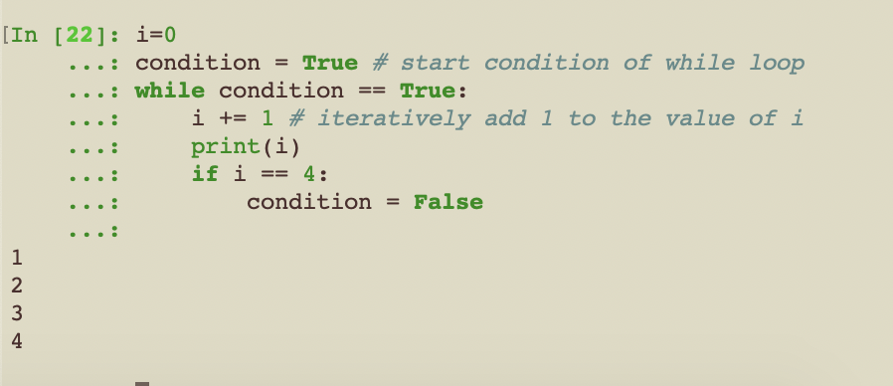

If you have any questions, just use the right words for your google search. Knowing these basic object types and python functions, you should be able to find the answer to 90% of the answers, e.g.

How to reverse list in Pyton: <https://www.google.com/search?client=safari&rls=en&q=reverse+list+python&ie=UTF-8&oe=UTF-8>

If statement with multiple conditions:

<https://www.google.com/search?client=safari&rls=en&q=if+statement+multiple+conditions+python&ie=UTF-8&oe=UTF-8>

How to add value to a list:

<https://www.google.com/search?client=safari&rls=en&q=add+value+to+list&ie=UTF-8&oe=UTF-8>

**Some ambiguity:**

A 1-dimensional array, like the number_range in the example above, is actually very similar to a list, but the functionality is different. A large number of numpy array manipulation will not work on a list. Vice versa, the .append() function or .index() function will not work on an array.

From a mathematics point of view, a 1-d array is called a vector, these are thus the same in programming. Similarly, a multi-dimensional array with dimensions (time, space), is also called a matrix.