**Report**

**MiniProject**

**Group 10**

Members:

Vũ Trí Sỹ 20194830

Cao Tiến Trung 20190098

Phạm Ngọc Thắng 20194840

Topic: 12

An application to (visually) demonstrate the optimization algoritms:

+Ant Colony Optimization

+Particle Swarm Optimization

+Simulated Anealling Optimization

**1.Guide to use**

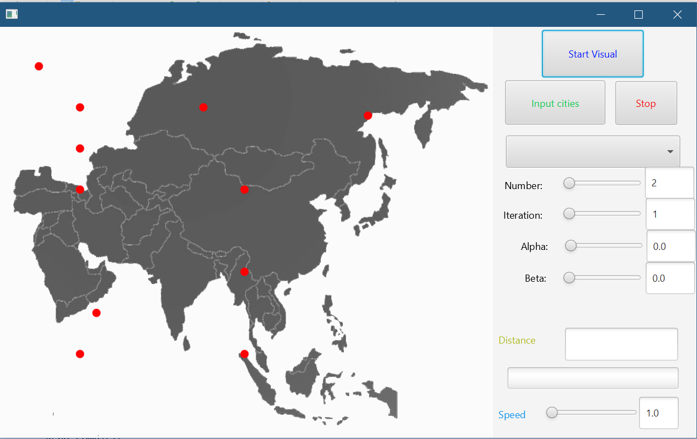

GUI of the Application

Start Visual: Start the visualization of the optimization

Note: Choose the optimization at Choice Box First

Stop: Cause the visualization to stop

Choice Box: Choose the optimization here. There are 3 choice:

Speed Slider: Change the speed of visualization. Available from 1.0 to 10.0.

Data Slider: Change the date of the optimization

For example: Alpha, Beta, W, Rho, Iteration, Number of Individuals, …

Input cities: Switch to Input Mode

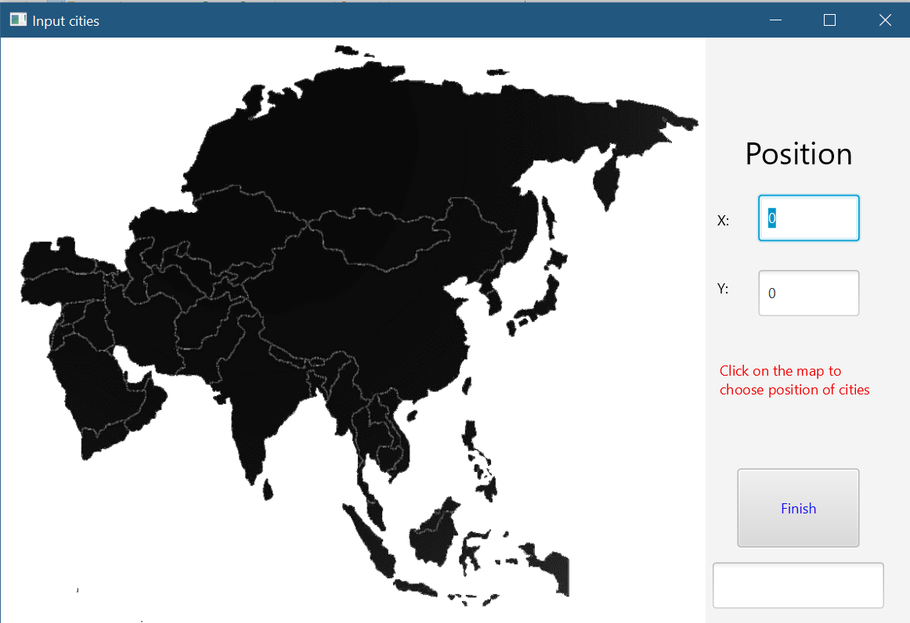

Input Mode of APP

Choose cities: Click on the map to choose the location of the city.

After choosing, click on buttion Finish to save the data for optimization and then click on X Button to exit Input Mode

**2.Package Diagrams**

+ Package oop.group10.aio.swap

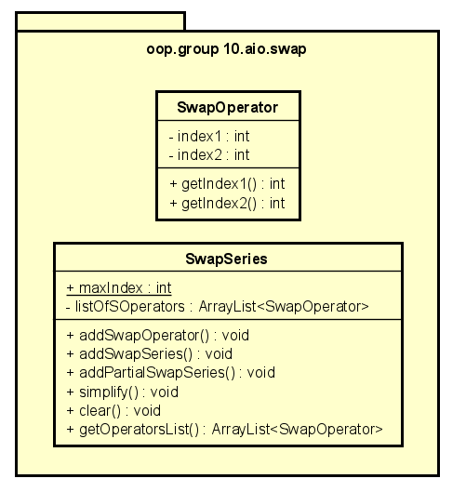

This package implements Swap Series and Swap Operator which is use for Particle Swarm Optimization

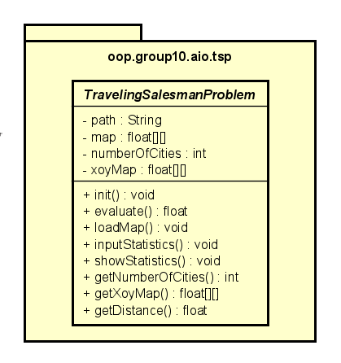+Package oop.group10.aio.tsp

This package store the data of map and perform evaluation of the solution each individual haves.

+Package oop.group10.aio.application

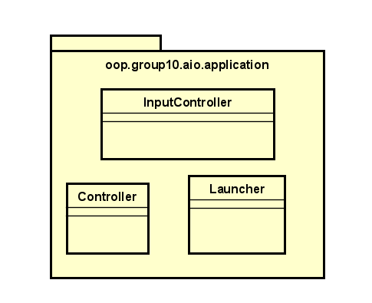

This package perform the visualization and GUI of the APP

+Package oop.group10.aio.utils

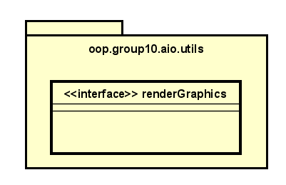

This package store utils

+Package oop.group10.aio.operation

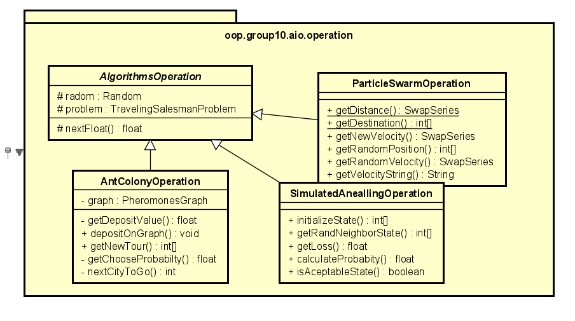

This package store the operation(mechanism) of all optimizations include how the individual moves and function to initialize data of individuals.

+Package oop.group10.aio.objects

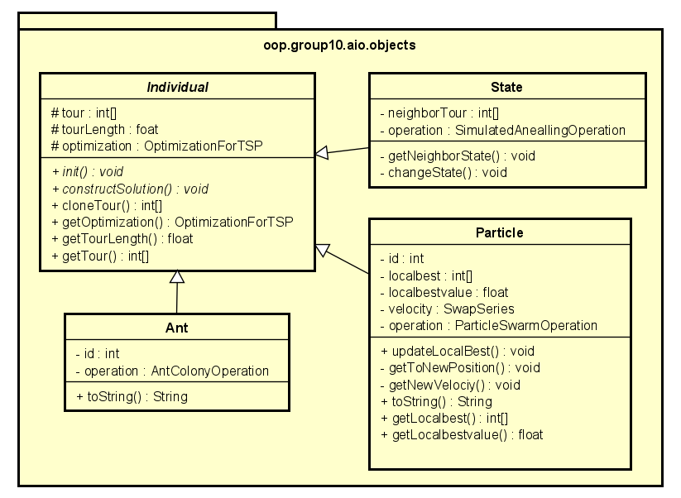

This package implement the three types of individual: State, Particle and Ant

Each Individual have the same operation is constructSolution to be use in the corresponding optimizations

+Package oop.group10.aio.optimization.sao

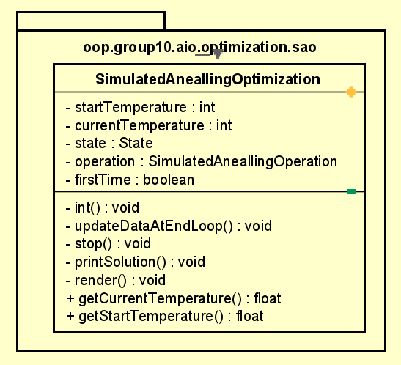This package performs the Simulated Anealling Optimization with startTemperature define as 400

+Package oop.group10.aio.optimization.pso

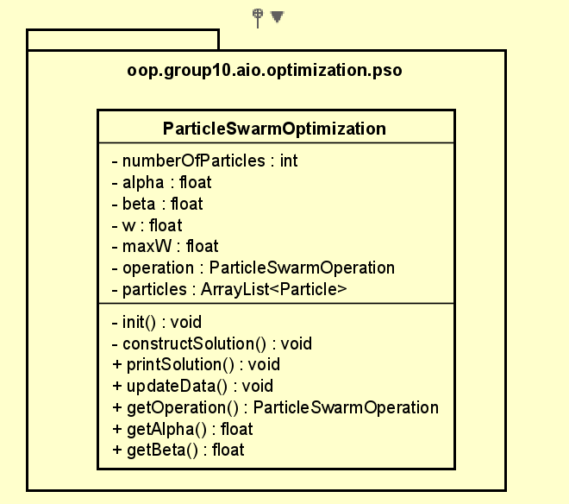 This package perfroms Particle Swarm Optimization

+Package oop.group10.aio.optimization.pso

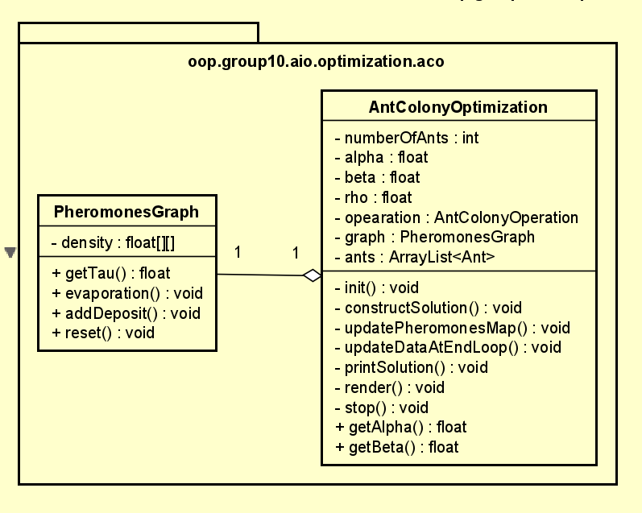This package performs Ant Colony Optimization

There are also PheromonesGraph class to make the graph of pheromones

+Package oop.group10.aio.optimization

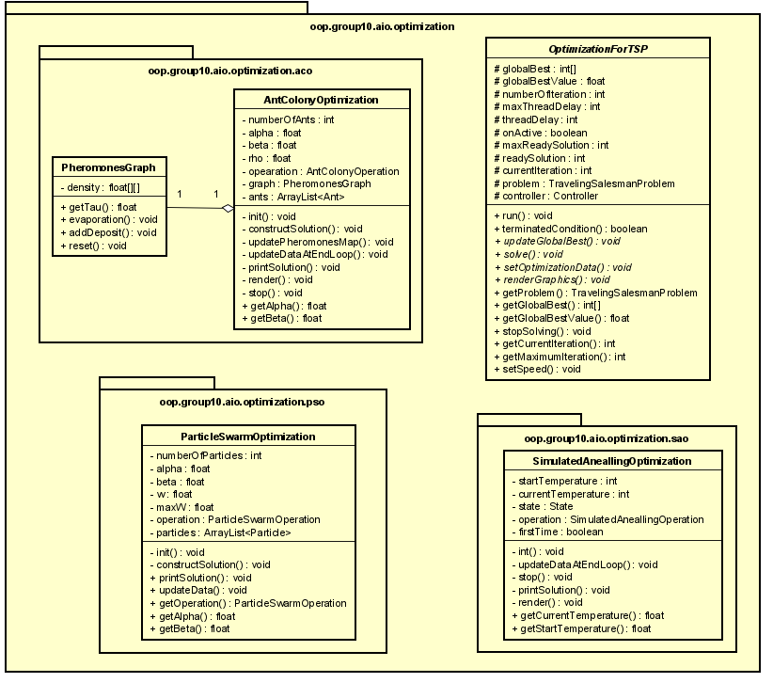

Store the 3 optimizations

+Full Package Diagram

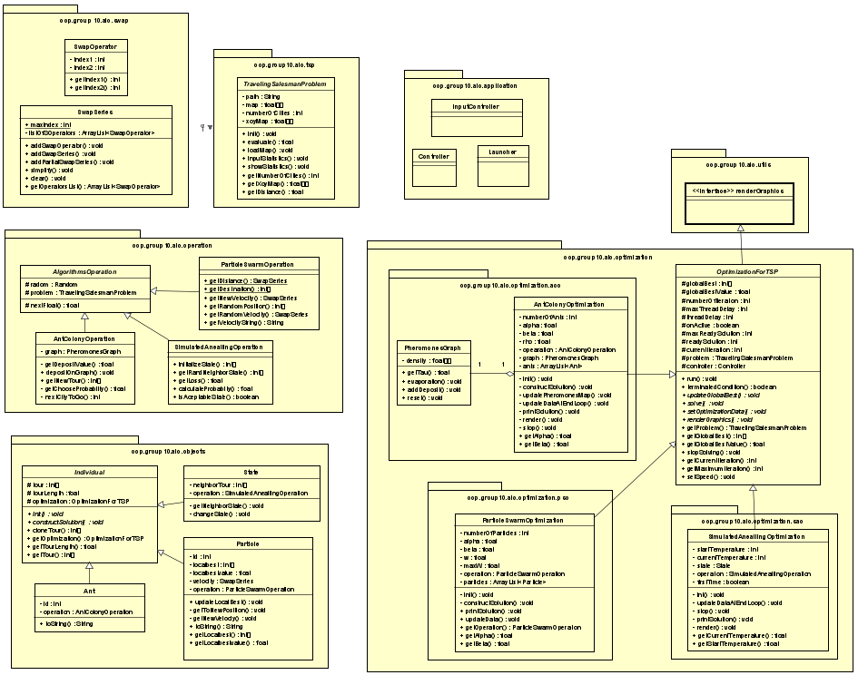

**3.Class diagram**

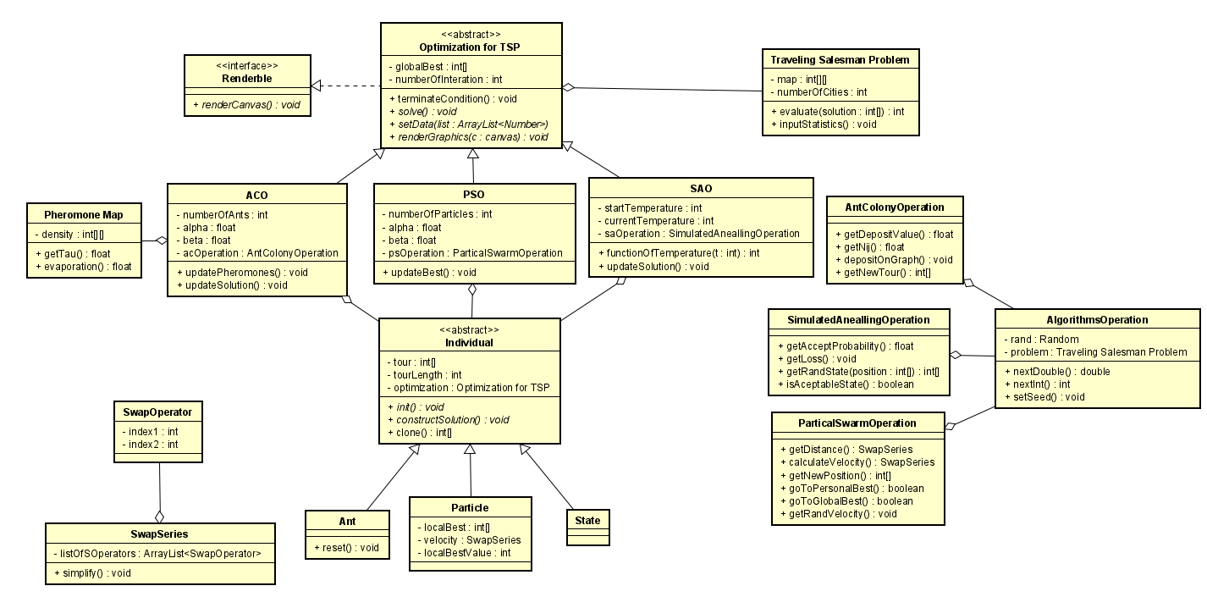

**4.How to run project .jar file**

Open CMD(Command Prompt) or Terminal

Move current directory to where the file MiniProject.jar located

Using: cd <location>

Run the command

**java --module-path "<path>" --add-modules javafx.controls,javafx.fxml -jar MiniProject.jar**

path is where your javafx lib locate

For example: **“C:\Program Files\Java\openjfx-11.0.2_windows-x64_bin-sdk\javafx-sdk-11.0.2\lib”**

To run in eclipse we need -vm run configuration

**--module-path "<path>" --add-modules javafx.controls,javafx.fxml**