**EXPERIMENT 5 Lobe.ai - Build custom models using the visual tool for Object recognition and sentiment analysis**

**Aim**

To convert facial expressions into emotions using the app Lobe.ai

**Theory**:

Lobe.ai has everything you need to bring your machine learning ideas to life. Just show it examples of what you want it to learn, and it automatically trains a custom machine learning model that can be shipped in your app. Lobe will automatically select the right machine learning architecture for your project. Lobe simplifies the process of machine learning into three easy steps. Collect and label your images. Train and understand your results. Then play with your model and improve it.

INSTALLING:

1. Download and install lobe.ai (~370MB). See Figure 1.

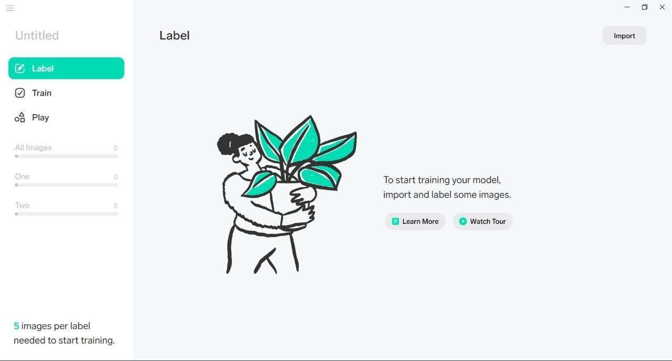

Figure 1

1. There will be dataset of total 5 emotions (5 folders)– anger, fear, happy, sadness and surprise. So number of categories/classes are 5 here. Total 50 images.
2. Open the installed Lobe.ai software now. From left side drop down menu, select new Project (say CK+48). Upload the above images using **Import -> dataset** button in this project.
3. Training happens automatically. The best model architecture, hyperparameters, etc are all investigated and the optimized model is produced. Figure 2.
4. 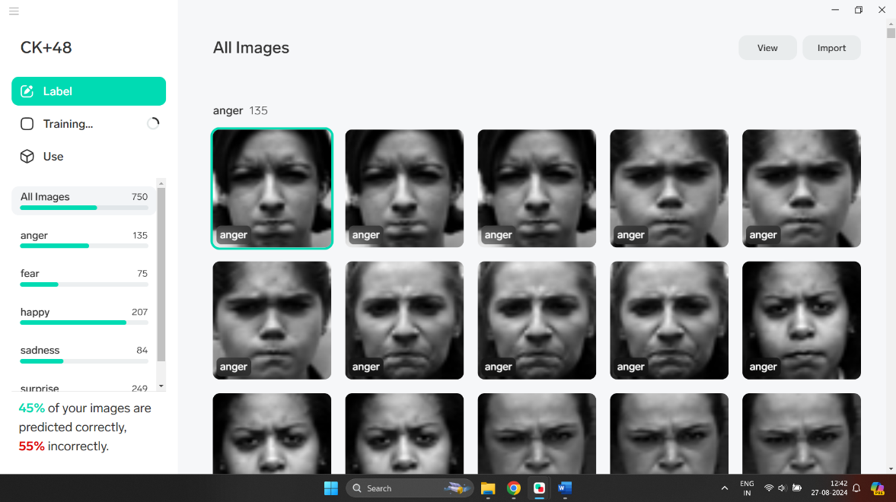You can export the export this saved model to any python program for later use (e.g. Lab 4). **Left side Menu bar -> Export**. Select **Model Files->Tensor Flow (Export) button.** Create a directory **Models** and save the mode there. The snapshot is shown in Figure 3.

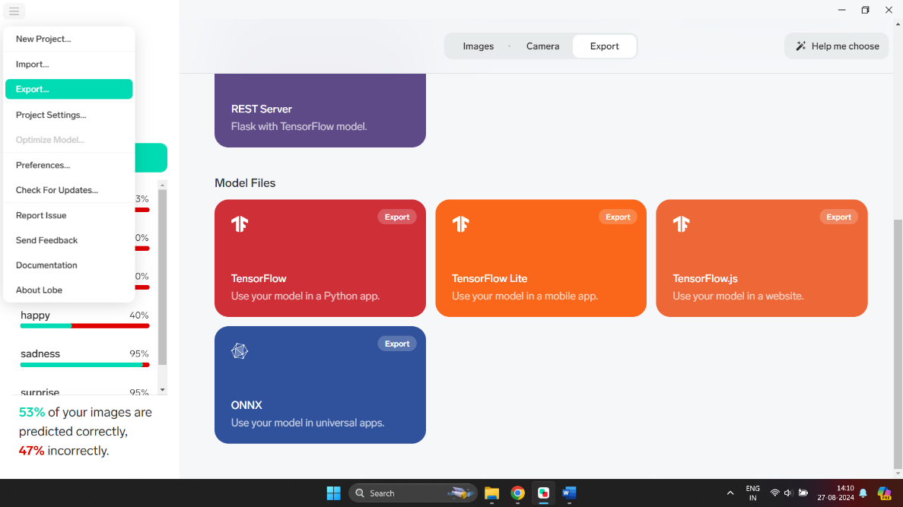Figure 2

Figure 3.

1. In the folder **Models**, the trained model, sample python program to use on new test data can be found. Figure 4.

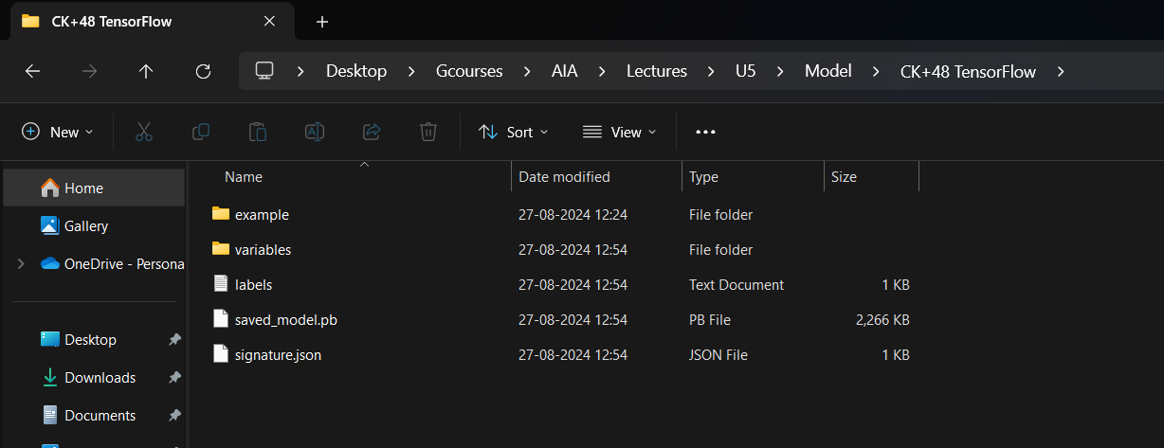

Figure 4

**Snapshot of outcomes:**

1. Code working successfully. Snapshot of saved model folder (Figure 4). (6 marks)

2. Repeat the same task on any other Image dataset. How many classes and how many files totally? (2 marks)

3. Create a dataset of drinking and not drinking with the help of this link <https://youtu.be/Mdcw3Sb98DA> (2 marks)