<< Course Code >>

Prepared by
<< Name (Complete Registration Number >>



Department of Computer Science and Engineering
GITAM
(Deemed to be University)
VISAKHAPATNAM
<< Duration of the Semester >>

ACKNOWLEDGEMENTS

Contents
Syllabus 4
Program-1 5
Decimal Number to Binary Number Conversion 6

Syllabus

Program-1

- Question / Problem Statement / Description
- Algorithm
- Flowchart
- Program
- Output
- Your understanding after completing the problem
- Any references for the problem or the solution

Decimal Number to Binary Number Conversion

Problem
Convert a given decimal number to its equivalent binary number.

Algorithm
- Start
- Accept the decimal number ← n
- Keep dividing n with 2 until it becomes zero
- At every step in the above operation store the reminder (0 or 1)
- To get the equivalent binary number read the reminders from last step to first.
- End

Flow Chart

- main sub-chart
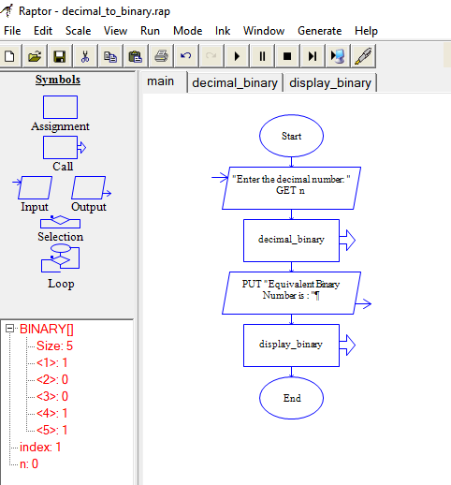

- decimal_binary sub-chart

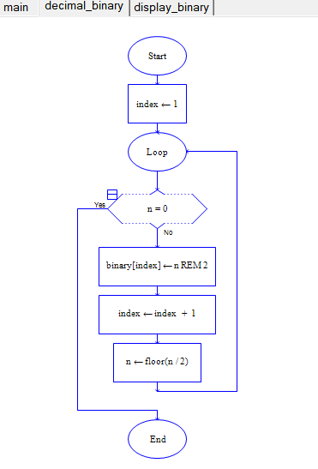

- display_binary sub-chart

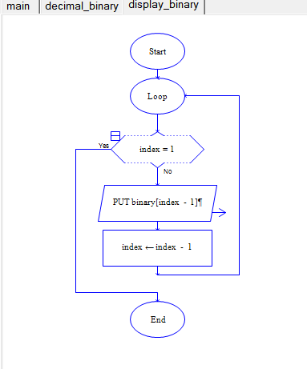
Output
For input 25, Equivalent Binary Number is : 11001
----Run complete. 60 symbols evaluated.----

My understanding of the problem or solution
- Binary numbers are used by computers.
- Usage of sub-charts in Raptor.
- Mathematical operator REM and mathematical function floor()
- Arrays in Raptor

References
- The flow charts are prepared using Raptor Tool

https://raptor.martincarlisle.com/

