**IoT-based smart parking system**

Vu Nguyen

1. **Code**
2. client.py

Explanation: main.py focus mainly on the UI constructed in GUI.py and how to display the required data on it. Main.py allows users to turn on or off the warning light publishing message to the raspberry pi. Main.py also let user input message and send them to the display board. Main.py also updates the parking indicator based on the required data received from raspberry pi by subscription.

1. client.py

Explanation: Rpi.py works on the raspberry pi side of the application, where it gathers the input data of the joystick and the temperature sensor, also in control of the warning light. Rpi.py sends the car’s position, parking request, and sensor data to the UI based on the user’s input with the joystick and temperature sensor. It also controls the on/off state of the warning light based on the warning light message received from UI. Rpi.py also display the display board which shows all the user input message sent from the UI.

1. **Terminal Outputs + UI Display**
2. **UI Screen**

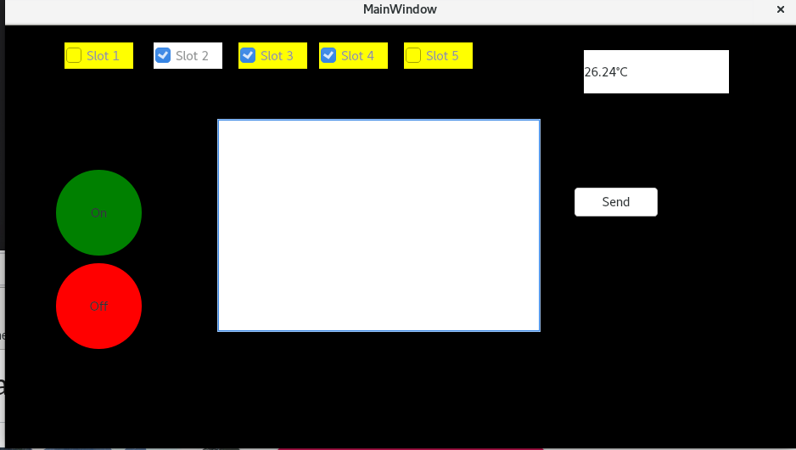

- On top of the UI is the parking indicator which contains 5 checkboxes, checked means the slot is occupied, empty otherwise. Checkbox color turns white to indicate that there is a car at that position. On the top right, there is a text lable that displays sensor data. In the middle of the screen is the Message box where user can input message, which will get send if they press the “Send” button on the right. On the left of the message box is the 2 buttons to turn the warning light on and off.

1. **Sending message to Display Board**

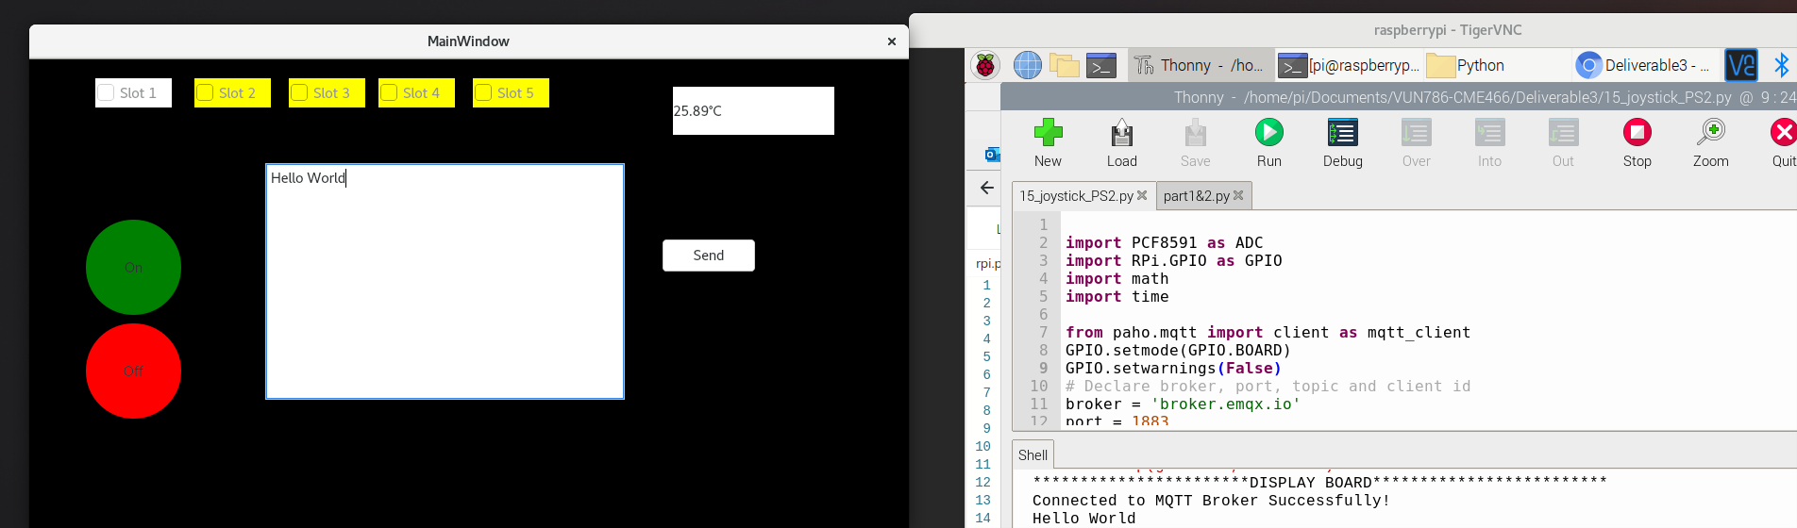

1. **Turn Warning Light On/Off**

**+) Warning light on:**

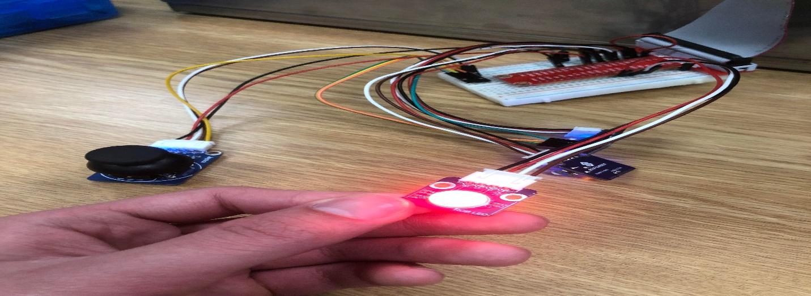

**+) Warning light off:**

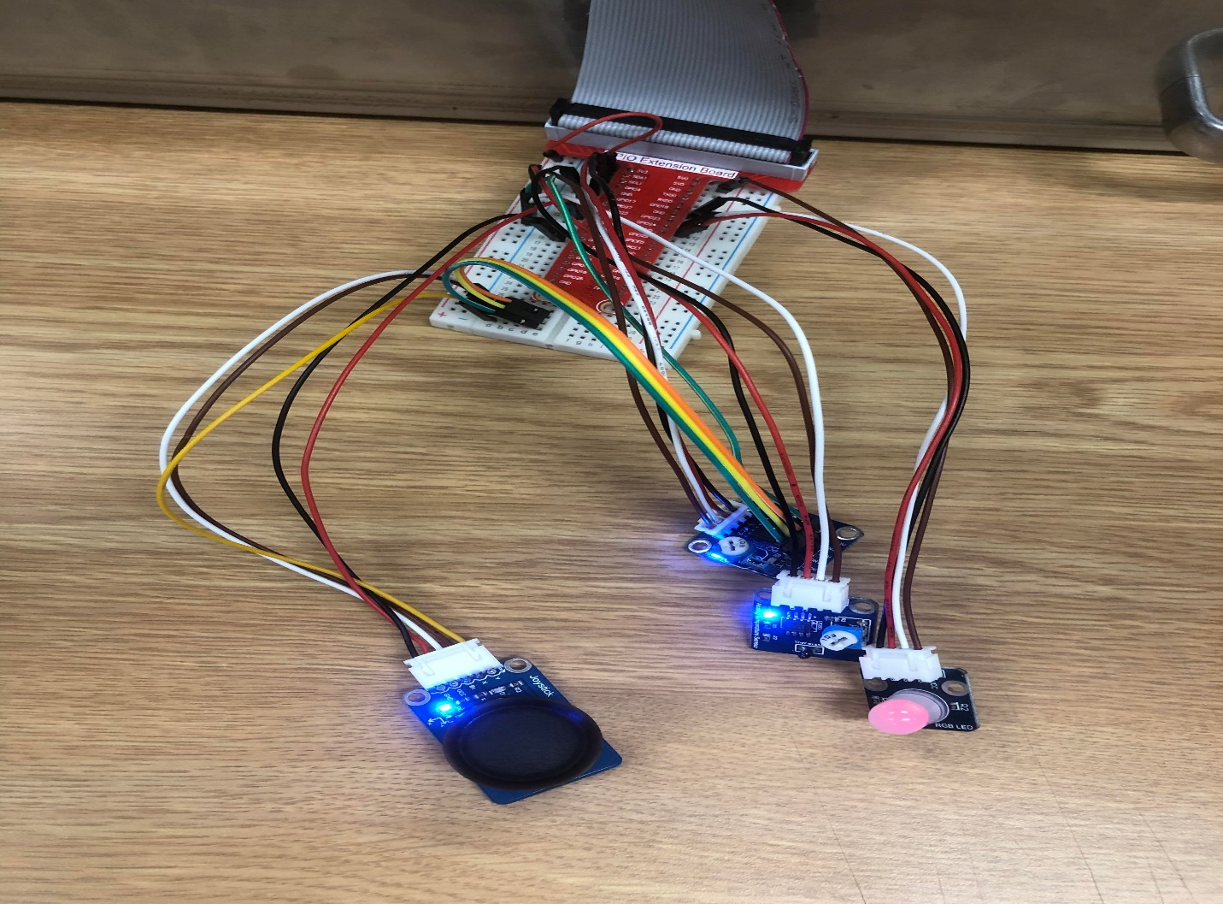

1. **Car Parking Slot**

**+) Car at parking slot but does not park into it**

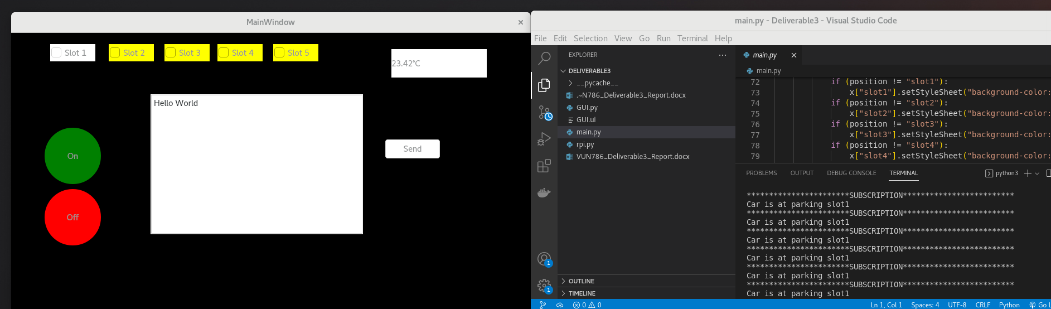

+) Car parks into parking slot 1

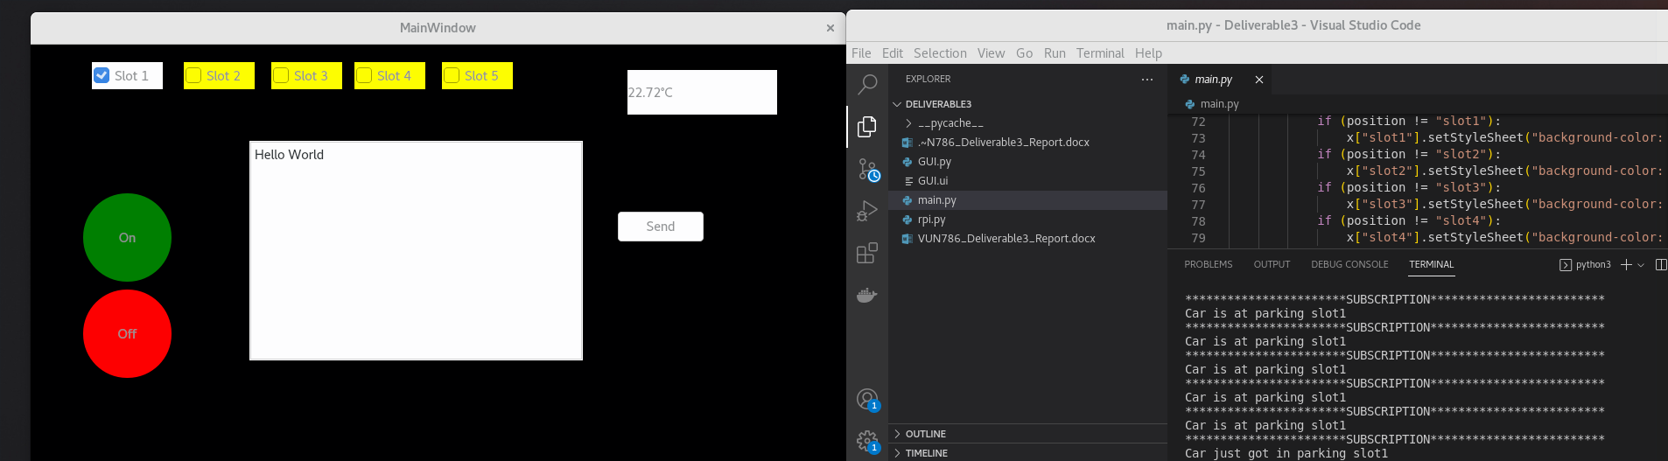

+) Car gets out of the parking slot

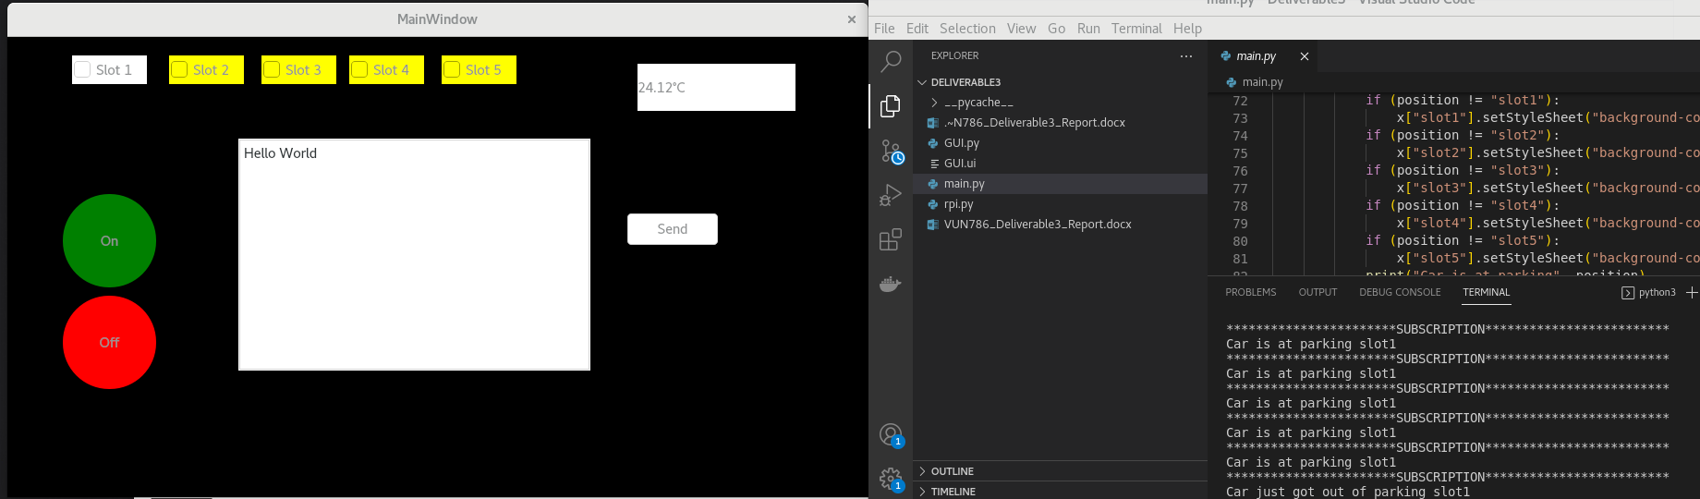

+) Car tries to park at the slot which already occupied

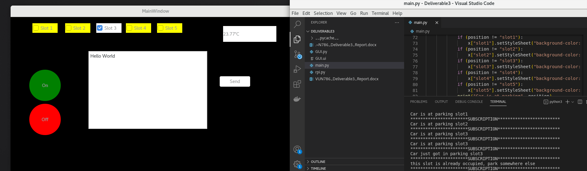

+) Car tries to park out from the empty slot

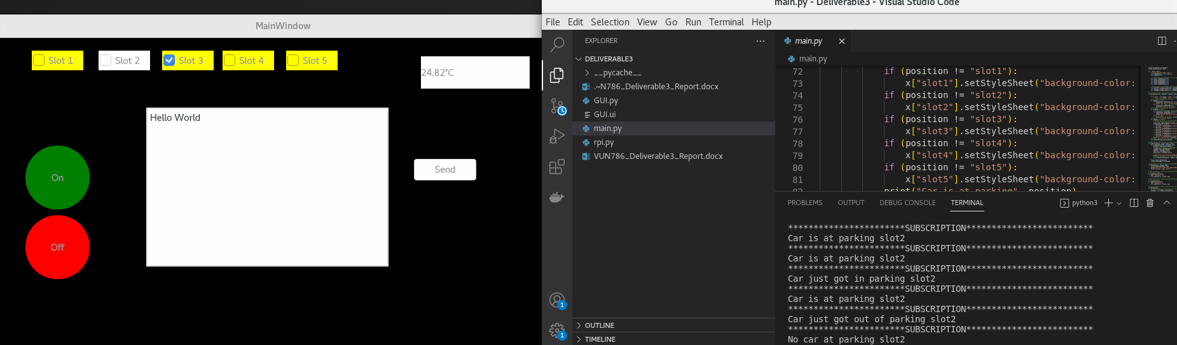

1. **List of Python Packages**
2. **PyQt5.Widget**
3. **Paho.mqtt**
4. **PCF8591**
5. **RPi.GPIO**
6. **Math**
7. **time**